**SLIPKNOT ANNOUNCE FIRST-EVER LIVESTREAM**

**FROM KNOTFEST LA 2021**

**Live From Banc Of California Stadium, Los Angeles, CA on November 5th**

**SLIPKNOT to headline along with bonus performances from KILLSWITCH ENGAGE,FEVER 333, CODE ORANGE, VENDED And Special Guests, CHERRY BOMBS**

**Tickets On Sale Today at** [**knotfest.veeps.com**](https://nam04.safelinks.protection.outlook.com/?url=http%3A%2F%2Fknotfest.veeps.com%2F&data=04%7C01%7CSydneyWorden%40elektra.com%7Cf6f47e58bb664955d50508d9958be08c%7C8367939002ec4ba1ad3d69da3fdd637e%7C0%7C0%7C637705250297492683%7CUnknown%7CTWFpbGZsb3d8eyJWIjoiMC4wLjAwMDAiLCJQIjoiV2luMzIiLCJBTiI6Ik1haWwiLCJXVCI6Mn0%3D%7C1000&sdata=tsTWnyZLaOFpspr8qsmfqyqZGKgvTcCJWauDSZKw%2Bao%3D&reserved=0)

**Discounted Price For Knotfest Members/Subscribers**

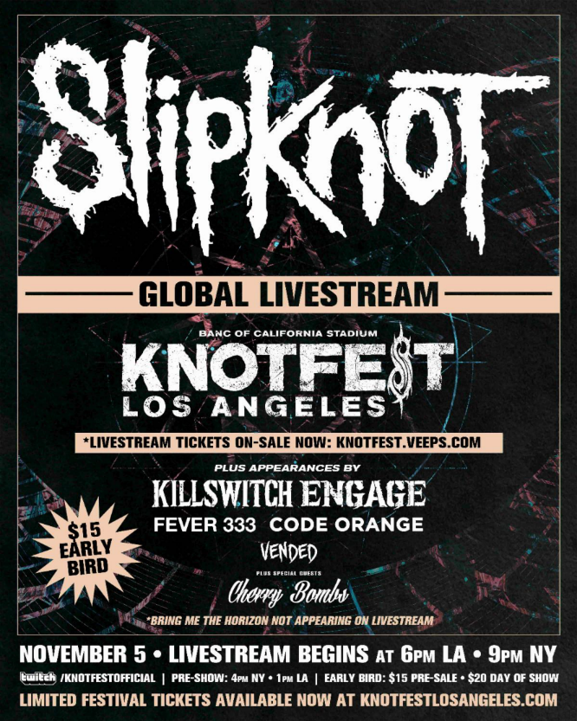

**Friday, October 22nd, 2021** - For all the fans around the globe unable to be present as SLIPKNOT perform the biggest headline performance of their career to date, the band have announced today that KNOTFEST LOS ANGELES at the Banc of California Stadium will be streamed LIVE on Friday November 5th.

SLIPKNOT’s first ever livestream, the event will allow fans to share all the excitement of a SLIPKNOT gig, both live as it happens, and for a full 72 hours after.  Tickets are on sale now at [knotfest.veeps.com](https://nam04.safelinks.protection.outlook.com/?url=http%3A%2F%2Fknotfest.veeps.com%2F&data=04%7C01%7CSydneyWorden%40elektra.com%7Cf6f47e58bb664955d50508d9958be08c%7C8367939002ec4ba1ad3d69da3fdd637e%7C0%7C0%7C637705250297502684%7CUnknown%7CTWFpbGZsb3d8eyJWIjoiMC4wLjAwMDAiLCJQIjoiV2luMzIiLCJBTiI6Ik1haWwiLCJXVCI6Mn0%3D%7C1000&sdata=h0kInR1ul6KVcLkFPNwbo%2FiBtxZBsNQABUpB3TCuhSQ%3D&reserved=0), priced at a discounted pre-sale cost of $15, with on-the-day tickets being $20.  [Knotfest Members](https://nam04.safelinks.protection.outlook.com/?url=https%3A%2F%2Fknotfest.com%2Fjoin%2F&data=04%7C01%7CSydneyWorden%40elektra.com%7Cf6f47e58bb664955d50508d9958be08c%7C8367939002ec4ba1ad3d69da3fdd637e%7C0%7C0%7C637705250297512668%7CUnknown%7CTWFpbGZsb3d8eyJWIjoiMC4wLjAwMDAiLCJQIjoiV2luMzIiLCJBTiI6Ik1haWwiLCJXVCI6Mn0%3D%7C1000&sdata=OcfgPZgpGhAci9P81KTAuwQVsTzyO3dG%2BIyvifP%2Fn%2Fo%3D&reserved=0) are eligible to purchase at a discounted price of $12.  Tickets bundled with event merch are also available.

As part of the broadcast, ticket holders not only get to see SLIPKNOT’s incendiary new production, live from Los Angeles, but also a selection of songs each from a stacked supporting bill of the hottest bands in heavy music, including KILLSWITCH ENGAGE, FEVER 333, CODE ORANGE, VENDED and a special performance from CHERRY BOMBS. Check out the trailer [HERE](https://nam04.safelinks.protection.outlook.com/?url=https%3A%2F%2Fwww.youtube.com%2Fwatch%3Fv%3D9qXnhQ0p7FA&data=04%7C01%7CSydneyWorden%40elektra.com%7Cf6f47e58bb664955d50508d9958be08c%7C8367939002ec4ba1ad3d69da3fdd637e%7C0%7C0%7C637705250297512668%7CUnknown%7CTWFpbGZsb3d8eyJWIjoiMC4wLjAwMDAiLCJQIjoiV2luMzIiLCJBTiI6Ik1haWwiLCJXVCI6Mn0%3D%7C1000&sdata=ecJqQItdCrX0MpHZEEY9ic8ioAdGeqzGRULRruEGsdQ%3D&reserved=0).

Ticket holders can still watch the stream up to 72 hours post event, so don’t worry if you can’t watch ‘live’ on the night.

In late August, the Grammy Award-winning Iowan icons took KNOTFEST back to their home state for KNOTFEST IOWA, selling out an expanded capacity show at the National Balloon Classic Field at Indianola, IA. The band are currently on the [KNOTFEST ROADSHOW](https://nam04.safelinks.protection.outlook.com/?url=https%3A%2F%2Fknotfest.com%2Froadshow%2F&data=04%7C01%7CSydneyWorden%40elektra.com%7Cf6f47e58bb664955d50508d9958be08c%7C8367939002ec4ba1ad3d69da3fdd637e%7C0%7C0%7C637705250297522663%7CUnknown%7CTWFpbGZsb3d8eyJWIjoiMC4wLjAwMDAiLCJQIjoiV2luMzIiLCJBTiI6Ik1haWwiLCJXVCI6Mn0%3D%7C1000&sdata=gj8H1HiL8LEz3q7c8a74GySEiGdm2yvrEhqIy1mFuKQ%3D&reserved=0) tour, which is snaking its way across the USA, culminating at the Banc Of California Stadium show for this very special event.  If you’re in Southern California, you can still pick up remaining tickets to attend in person.

Click [here](https://nam04.safelinks.protection.outlook.com/?url=https%3A%2F%2Fknotfest.com%2Ffestival%2F&data=04%7C01%7CSydneyWorden%40elektra.com%7Cf6f47e58bb664955d50508d9958be08c%7C8367939002ec4ba1ad3d69da3fdd637e%7C0%7C0%7C637705250297522663%7CUnknown%7CTWFpbGZsb3d8eyJWIjoiMC4wLjAwMDAiLCJQIjoiV2luMzIiLCJBTiI6Ik1haWwiLCJXVCI6Mn0%3D%7C1000&sdata=HqQTVYDPrwOBa6iDExtiQrQdwm0BxoqmSO7VOaHO2ek%3D&reserved=0) for KNOTFEST event information & tickets, [here](https://nam04.safelinks.protection.outlook.com/?url=https%3A%2F%2Fslipknotmerch.com%2F&data=04%7C01%7CSydneyWorden%40elektra.com%7Cf6f47e58bb664955d50508d9958be08c%7C8367939002ec4ba1ad3d69da3fdd637e%7C0%7C0%7C637705250297532656%7CUnknown%7CTWFpbGZsb3d8eyJWIjoiMC4wLjAwMDAiLCJQIjoiV2luMzIiLCJBTiI6Ik1haWwiLCJXVCI6Mn0%3D%7C1000&sdata=Ljw19EVKTdAWP6kzQHbxcFUUASN52cmwhajC4%2FxkXlw%3D&reserved=0) for the latest SLIPKNOT merch, and [here](https://nam04.safelinks.protection.outlook.com/?url=https%3A%2F%2Fshop.cedarridgewhiskey.com%2F&data=04%7C01%7CSydneyWorden%40elektra.com%7Cf6f47e58bb664955d50508d9958be08c%7C8367939002ec4ba1ad3d69da3fdd637e%7C0%7C0%7C637705250297532656%7CUnknown%7CTWFpbGZsb3d8eyJWIjoiMC4wLjAwMDAiLCJQIjoiV2luMzIiLCJBTiI6Ik1haWwiLCJXVCI6Mn0%3D%7C1000&sdata=FCDmQben6vW8zWHNnohrK7GBnhqgHjWy4Q2CMvUFWyk%3D&reserved=0) to pick up SLIPKNOT’s No.9 Whiskey, whilst stocks last.

**Find Knotfest Online**

[**Knotfest.com**](https://nam04.safelinks.protection.outlook.com/?url=http%3A%2F%2Fwww.knotfest.com%2F&data=04%7C01%7CSydneyWorden%40elektra.com%7Cf6f47e58bb664955d50508d9958be08c%7C8367939002ec4ba1ad3d69da3fdd637e%7C0%7C0%7C637705250297542651%7CUnknown%7CTWFpbGZsb3d8eyJWIjoiMC4wLjAwMDAiLCJQIjoiV2luMzIiLCJBTiI6Ik1haWwiLCJXVCI6Mn0%3D%7C1000&sdata=PxAhDttX3SkPAKx2J3rbhoB72DSCAxgH1nrBFp9qJk4%3D&reserved=0)

**ROSS ANDERSON**

[**ROSSANDERSON@ELEKTRA.COM**](mailto:ROSSANDERSON@ELEKTRA.COM)