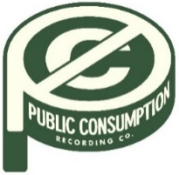
SYDNEY ROSE ANNOUNCES DEBUT EP YOU NEVER MET ME
ARRIVING JULY 8 VIA PUBLIC CONSUMPTION

NEW SINGLE AND OFFICIAL VIDEO
“I’LL NEVER GET OVER IT” AVAILABLE NOW
WATCH HERE

U.S. TOUR DATES SUPPORTING ADDISION GRACE KICK OFF
AUGUST 19 IN CHICAGO, IL

JUNE 3, 2022 – 18-year-old singer/songwriter Sydney Rose has announced her debut EP You Never Met Me, arriving July 8th via Public Consumption. The six-track collection includes previously released tracks “Phoebe Told Me” and “Things That Don’t Exist (feat. Zachary Knowles)” (tracklisting below). The news is heralded by the soothing new single and official music video for “I’ll Never Get Over It.” Directed by Syd Ostrander and shot in Los Angeles, the video is awash with warm tones and natural imagery as Sydney explores sea caves and surrounding greenery. You Never Met Me EP is available for presave now.
Sydney commented “Crafting an EP and shooting a music video was something I could never even dream about. I have never been so excited to show people this piece of art that I worked really hard on. I was really afraid of making both my EP and music video, but working on them and finally having them done, I can say it has been one of the most fun experiences I’ve ever had. And I am so so excited to make more.”
In August, Sydney will kick off U.S. tour dates supporting Addison Grace, beginning August 19th in Chicago, IL and making stops at Elsewhere in NYC and The Echo in Los Angeles before wrapping up September 26th in Phoenix, AZ. Tickets for all dates are available now (tour itinerary below).
Earlier this spring, Sydney shared “Phoebe Told Me,” the singer/songwriter’s first release via Public Consumption, a joint venture with Elektra Music Group. With breathy vocals and dreamy style inspired by the song’s namesake (Phoebe Bridgers), the track is a meditation on loving yourself and tuning out the pressures of the outside world. The release was followed by intimate ballad “Things That Don’t Exist (feat. Zachary Knowles)” in April.
Sydney Rose initially gained traction via her intimate YouTube channel covers as well as TikTok, where she has amassed over 200k followers on the platform. Her rendition of Sleeping At Last’s “Turning Page” has accumulated over 30 million streams.
(Tour Dates/EP Art/Tracklisting Below)

SYDNEY ROSE
2022 U.S TOUR DATES
All dates supporting Addison Grace

AUGUST
19 Chicago, IL Beat Kitchen
20 Detroit, MI The Shelter
21 Lakewood, OH Mahall’s
23 Boston, MA Brighton Music Hall
24 New York, NY Elsewhere Zone One
26 Philadelphia, PA The Foundry
27 Washington, DC Songbyrd

SEPTEMBER
15 Denver, CO Larimer Lounge
17 Salt Lake City, UT Kilby Court
19 Seattle, WA Madame Lou’s At The Crocodile
20 Portland, OR Polaris Hall
22 Oakland, CA Starline Social Club
23 Los Angeles, CA The Echo
25 San Diego, CA Voodoo Room at House of Blues
26 Phoenix, AZ The Rebel Lounge

SYDNEY ROSE
You Never Met Me EP – AVAILABLE JULY 8
PRESAVE NOW
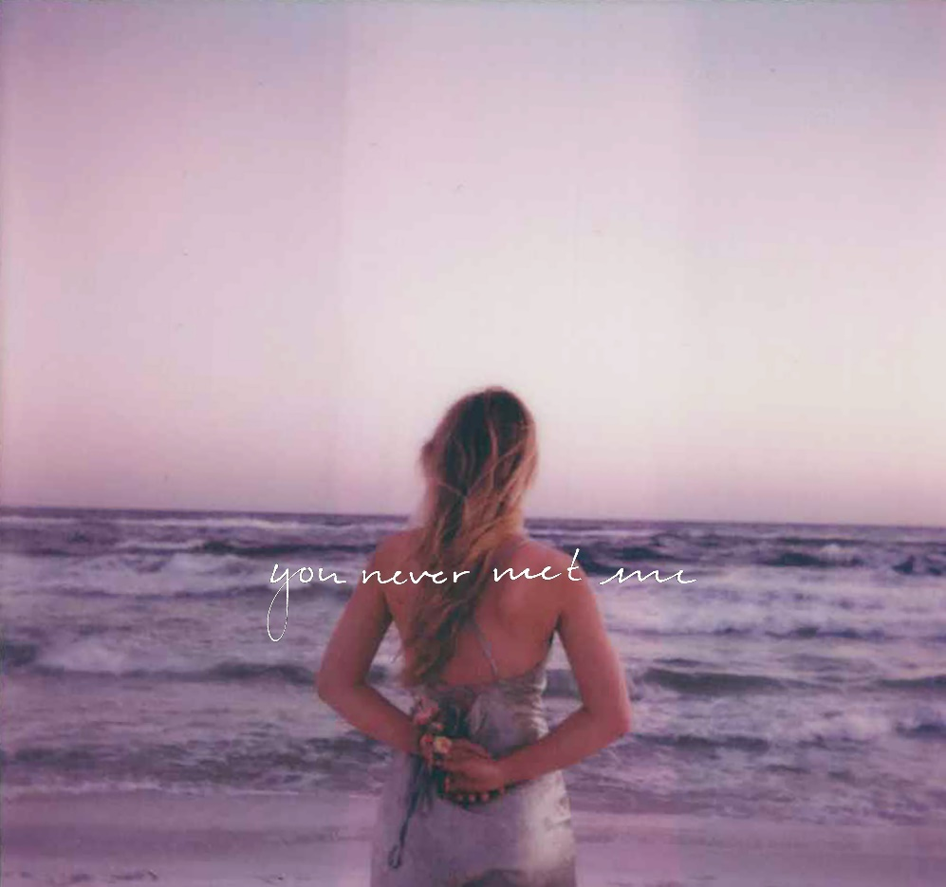
Tracklisting:
- Cellophane
- Phoebe Told Me
- Cutting Corners
- Things That Don’t Exist (feat. Zachary Knowles)
- We Don’t Talk Anymore
- I’ll Never Get Over It

CONNECT WITH Sydney Rose
TIKTOK
YOUTUBE
INSTAGRAM

CONTACT:
Sarah Goldstein
SarahGoldstein@elektra.com

