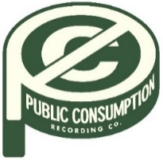
SYDNEY ROSE SHARES DEBUT EP YOU NEVER MET ME
OUT NOW VIA PUBLIC CONSUMPTION

U.S. TOUR DATES SUPPORTING ADDISION GRACE KICK OFF
AUGUST 19 IN CHICAGO, IL
JULY 8, 2022 – 18-year-old singer/songwriter Sydney Rose has shared debut EP You Never Met Me, out now via Public Consumption. The six-track collection arrives to critical acclaim, with Under The Radar attesting, “‘You Never Met Me’ is the sound of Rose finding herself in her music and introducing herself to the world, tracing all of the messy contours of teenage heartbreak in the process.” The You Never Met Me EP includes previously released tracks “Phoebe Told Me,” “Things That Don’t Exist (feat. Zachary Knowles),” and “I’ll Never Get Over It” (tracklisting below) and is available on all streaming platforms now.
In August, Sydney will kick off U.S. tour dates supporting Addison Grace, beginning August 19th in Chicago, IL and making stops at Elsewhere in NYC and The Echo in Los Angeles before wrapping up September 26th in Phoenix, AZ. Tickets for all dates are available now (tour itinerary below).
Earlier this spring, Sydney shared “Phoebe Told Me,” the singer/songwriter’s first release via Public Consumption, a joint venture with 300 Elektra Entertainment. With breathy vocals and dreamy style inspired by the song’s namesake (Phoebe Bridgers), the track is a meditation on loving yourself and tuning out the pressures of the outside world. The release was followed by intimate ballad “Things That Don’t Exist (feat. Zachary Knowles)” in April and “I’ll Never Get Over It” in June, which racked up praise from Sweety High for Sydney’s “gorgeously delicate voice” and arrived alongside a breezy, beachside music video directed by Syd Ostrander.

Sydney Rose initially gained traction via her intimate YouTube channel covers as well as TikTok, where she has amassed over 200k followers on the platform. Her rendition of Sleeping At Last’s “Turning Page” has accumulated over 30 million streams.
(Tour Dates/EP Art/Tracklisting Below)

SYDNEY ROSE
2022 U.S TOUR DATES
All dates supporting Addison Grace

AUGUST
19 Chicago, IL Beat Kitchen
20 Detroit, MI The Shelter
21 Lakewood, OH Mahall’s
23 Boston, MA Brighton Music Hall
24 New York, NY Elsewhere Zone One
26 Philadelphia, PA The Foundry
27 Washington, DC Songbyrd

SEPTEMBER
15 Denver, CO Larimer Lounge
17 Salt Lake City, UT Kilby Court
19 Seattle, WA Madame Lou’s At The Crocodile
20 Portland, OR Polaris Hall
22 Oakland, CA Starline Social Club
23 Los Angeles, CA The Echo
25 San Diego, CA Voodoo Room at House of Blues
26 Phoenix, AZ The Rebel Lounge

SYDNEY ROSE
You Never Met Me EP
AVAILABLE NOW
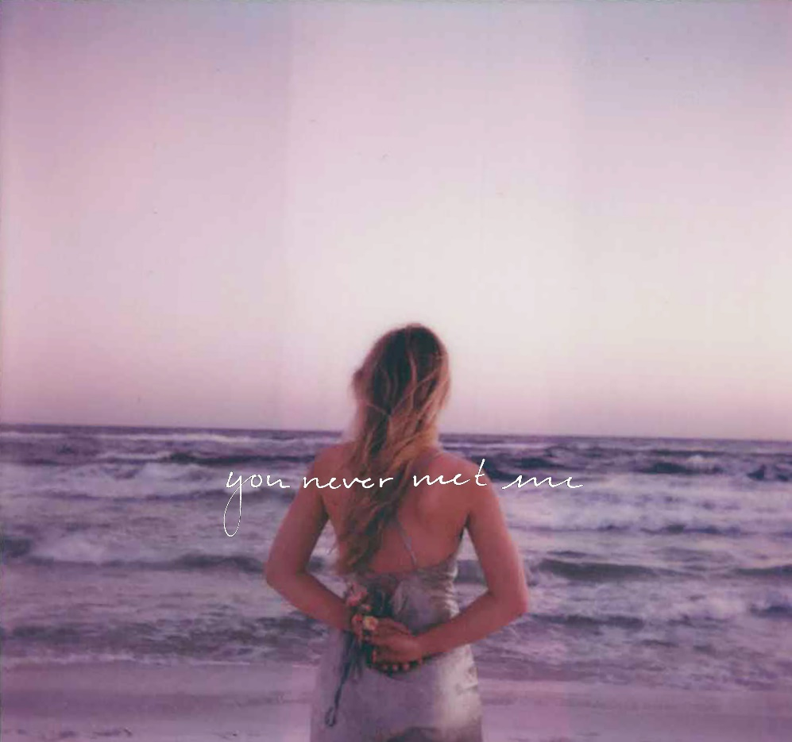
Tracklisting:
- Cellophane
- Phoebe Told Me
- Cutting Corners
- Things That Don’t Exist (feat. Zachary Knowles)
- We Don’t Talk Anymore
- I’ll Never Get Over It

CONNECT WITH Sydney Rose
TIKTOK
YOUTUBE
INSTAGRAM

CONTACT:
Sarah Goldstein
SarahGoldstein@elektra.com

