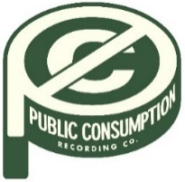
SYDNEY ROSE DEBUTS NEW SINGLE “PHOEBE TOLD ME”

ANNOUNCES SIGNING TO PUBLIC CONSUMPTION

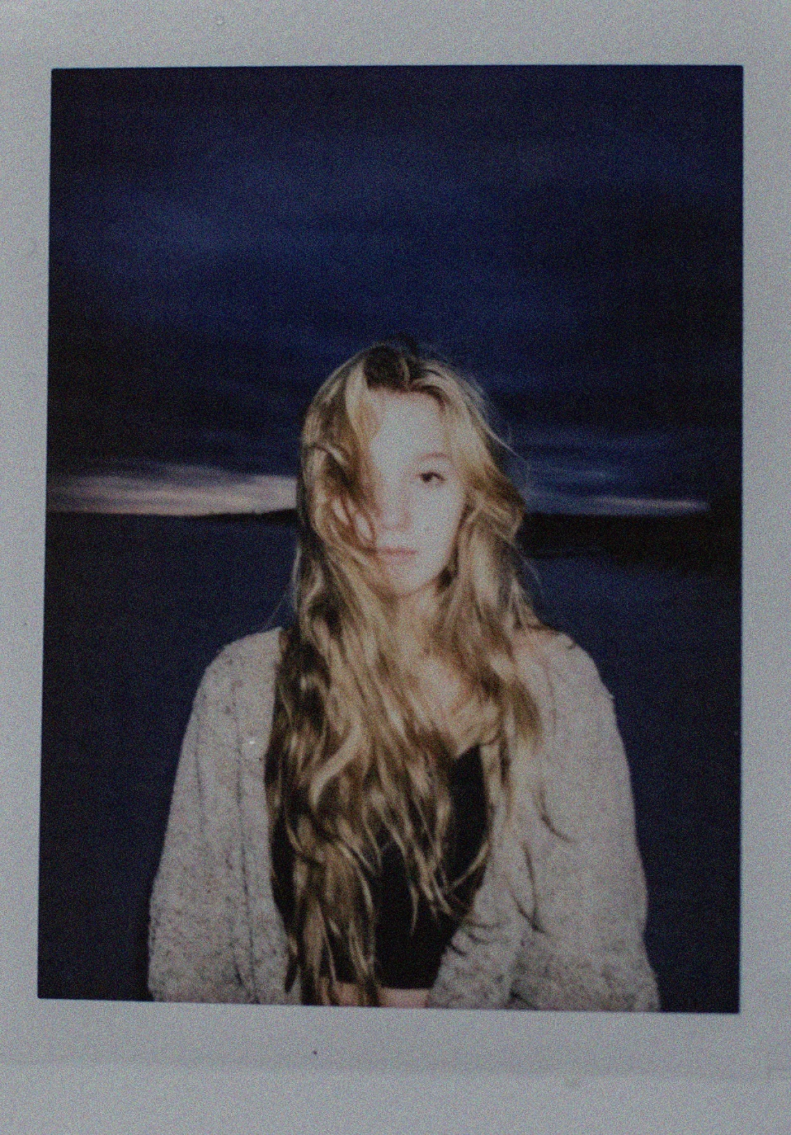
MARCH 4, 2022 – Eighteen-year-old Sydney Rose has shared “Phoebe Told Me,” the singer-songwriter’s first release via Public Consumption, a joint venture with Elektra Music Group. With breathy vocals and dreamy style inspired by the song’s namesake (Phoebe Bridgers), the track is a meditation on loving yourself and tuning out the pressures of the outside world. “Phoebe Told Me” is available now on all streaming services, with an accompanying visualizer streaming on Sydney’s official YouTube channel.
Rose added, “I wrote this song in a time where I felt like the only thing to keep me moving forward was to start loving myself. I wanted to do the things I loved without the pressure of anyone else telling me what to do. I got to a point in my life where I started to tell myself everything will eventually be fine in the end. I’m so so so excited to be signed with this label and I can’t wait for people to hear what I have to offer. Music is like therapy for me and I’m hoping that my music can do the same to others.”
Sydney Rose initially gained traction via her intimate YouTube channel covers as well as TikTok, where she has amassed over 200k followers on the platform. Her rendition of Sleeping At Last’s “Turning Page” has accumulated more than 25 million streams and she recently supported dates on Chloe Moriondo’s fall headline tour.
Stay tuned for more from Sydney Rose soon.
(Single Art Below)

Sydney Rose
“Phoebe Told Me”
AVAILABLE NOW
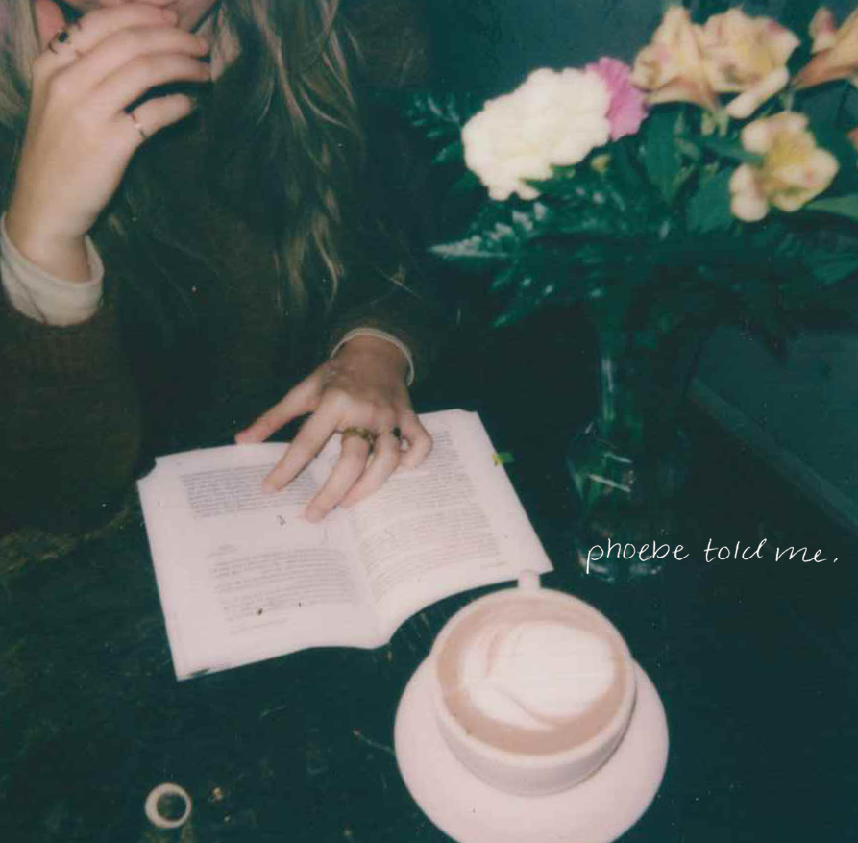

CONNECT WITH Sydney Rose
TIKTOK
YOUTUBE
INSTAGRAM

CONTACT:
Sarah Goldstein
SarahGoldstein@elektra.com

