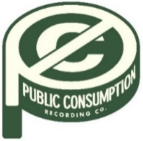
SYDNEY ROSE SHARES NEW SINGLE
“THINGS THAT DON’T EXIST (FEAT. ZACHARY KNOWLES)”
LISTEN HERE

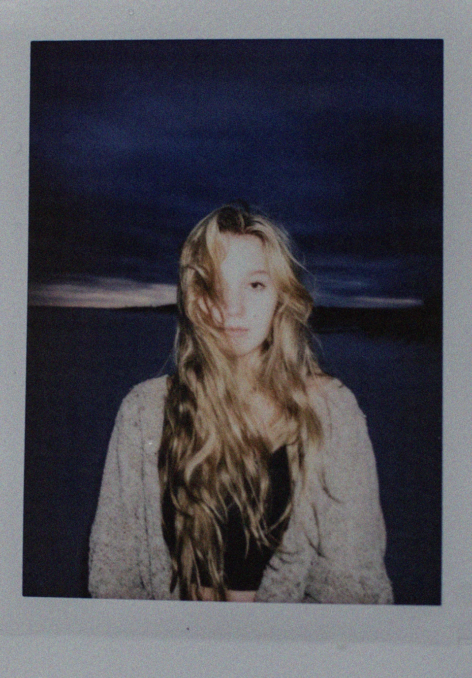
APRIL 1, 2022 – Public Consumption artist Sydney Rose has debuted “Things That Don’t Exist (feat. Zachary Knowles).” The intimate ballad is available now on all streaming services, with an accompanying visualizer streaming on Sydney’s official YouTube channel.
Rose commented, “I was so excited to work on this song and even more excited to work with Zach. Without his creative attributes, the song wouldn’t be nearly as perfect as how it ended up being. It’s such a beautiful song that tells a melancholy story and I’m so grateful to be a part of telling it.”
Knowles added, “I was really excited to be part of this song. Sydney is so talented. The stripped back production, lyrics and vocals give it this warmth and emotion that I hope listeners can feel when they hear it.”
Last month, Sydney Rose shared “Phoebe Told Me,” the singer-songwriter’s first release via Public Consumption, a joint venture with Elektra Music Group. With breathy vocals and dreamy style inspired by the song’s namesake (Phoebe Bridgers), the track is a meditation on loving yourself and tuning out the pressures of the outside world.
Sydney Rose initially gained traction via her intimate YouTube channel covers as well as TikTok, where she has amassed over 200k followers on the platform. Her rendition of Sleeping At Last’s “Turning Page” has accumulated nearly 30 million streams.
Stay tuned for more from Sydney Rose soon.
(Single Art Below)

Sydney Rose
“Things That Don’t Exist (feat. Zachary Knowles)”
AVAILABLE NOW [LINK]
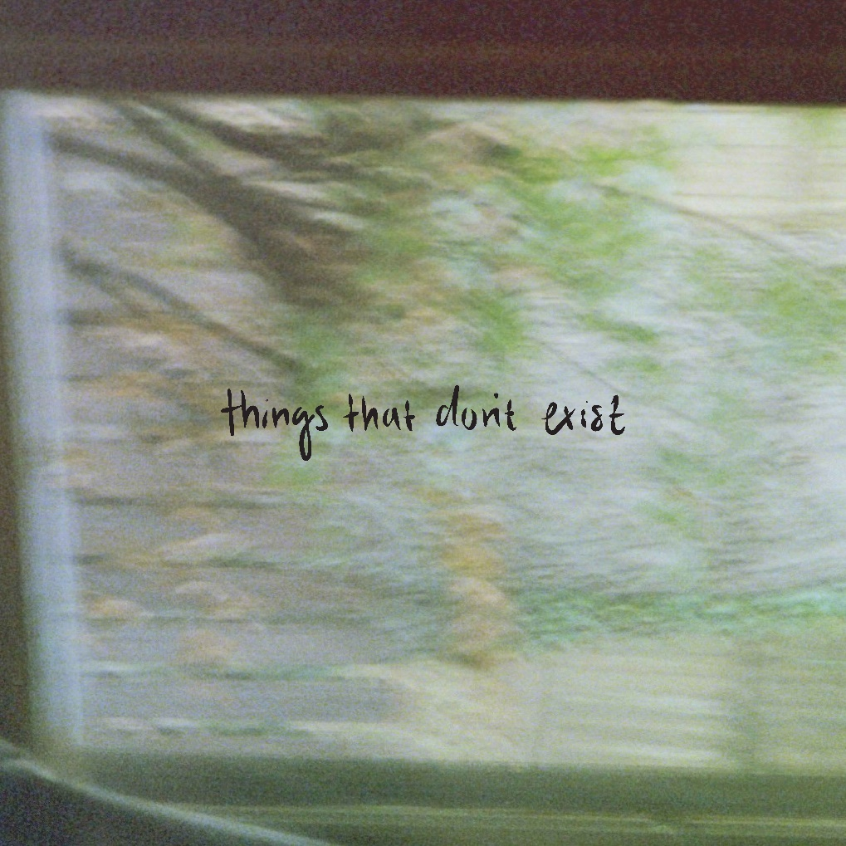

CONNECT WITH Sydney Rose
TIKTOK
YOUTUBE
INSTAGRAM

CONTACT:
Sarah Goldstein
SarahGoldstein@elektra.com

