POP-ROCK GROUP THE BAND CAMINO OFFERS A HEARTFELT APOLOGY WITH TIMELY NEW TRACK “SORRY MOM”

ARRIVING JUST AHEAD OF MOTHER’S DAY, THE SONG IS ACCOMPANIED BY AN INTIMATE MUSIC VIDEO

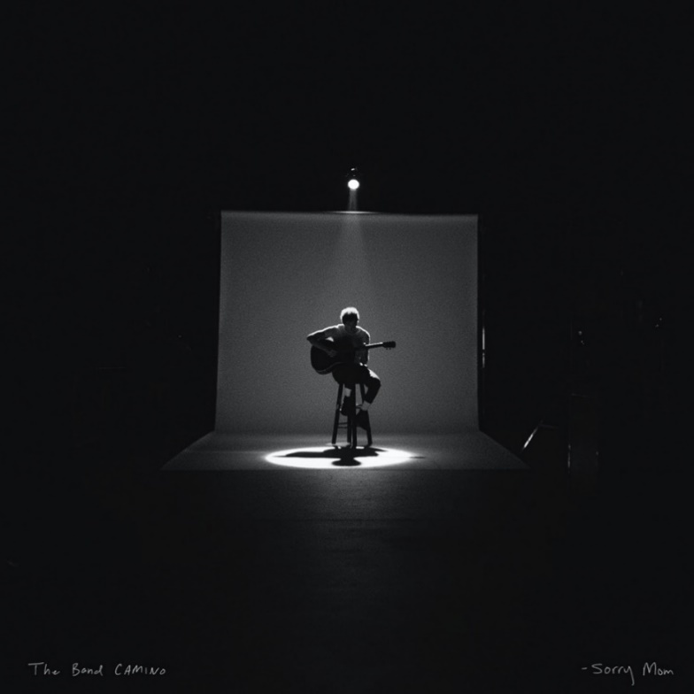

Photo Credit: Patrick Tracy| Hi-Res Art: LINK

LOS ANGELES (April 30, 2021)—Today, pop-rock group The Band CAMINO released their latest track, “Sorry Mom,” on dblblk/Elektra Records. The song arrives along with an accompanying music video, also debuting today. The latest release follows their previous singles, “1 Last Cigarette”, "Roses," and their Chelsea Cutler collaboration, “Crying Over You,” which have amassed more than 24 million global streams to date. The tracks preview The Band CAMINO's highly anticipated full-length album, which is expected later this year.
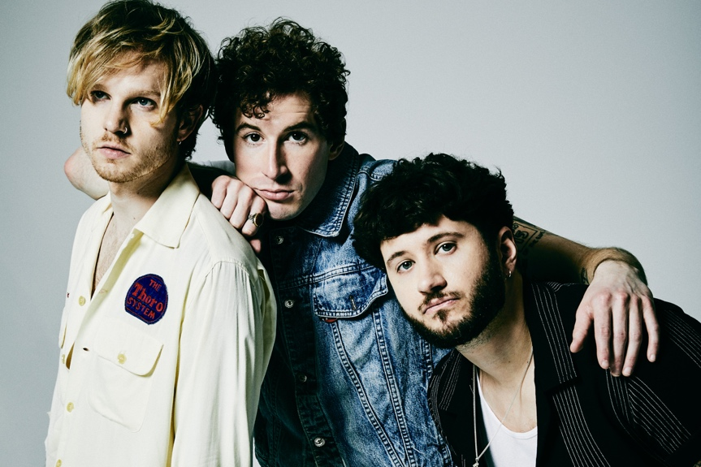
Arriving just ahead of the upcoming May 9th Mother’s Day holiday, “Sorry Mom” is The Band CAMINO’s penned apology for the ways they have let their mothers down. Deeply honest and lyrically intimate, the song reflects on a laundry list of personal regrets and admissions—from getting drunk to cursing too much. In an accompanying music video component, lead singer Jeffery Jordan lets “Sorry Mom’s” emotional candor speak for itself, with an intimate one-take performance in simple black and white. “I’m trying/I’m human/I don’t know what I’m doing,” Jordan sings admittedly, as the lens draws increasingly closer on him alone with his guitar.

“Everyone I know that's lucky enough to grow up with a mom has felt like they’ve let her down one way or another,” says Jordan. “Personally, I’ve always felt like I had to filter myself pretty heavily around mine. This song is just me being vulnerable and speaking openly about who I am -- flaws, doubts, and all.”

“Sorry Mom” STREAMING LINK: HERE
“Sorry Mom” VIDEO STREAMING LINK: HERE

The Band CAMINO

Dubbed "Rock's next big thing" by Billboard, The Band CAMINO writes electrifying songs with lovelorn lyrics about perseverance and personal growth. People’s “Ones to Watch” says: “These alternative rockers are verifiable masters at adding splashes of modernity to timeless rock ‘n’ roll soundscapes.”

Hailing from Memphis, The Band CAMINO’s founding members Jeffery Jordan (vocals, guitar) and Spencer Stewart (vocals, guitar) met at the University of Memphis. Garrison Burgess (drums) joined the band in 2018 after Jeffery and Spencer moved to Nashville.

The band’s Elektra Records debut EP, tryhard, featured fan-favorites "Daphne Blue," "See Through," and "Honest." "Daphne Blue" made waves on AltNation spending multiple weeks at #1 on the Alt18 countdown, while the band received additional media coverage from Billboard, Ones To Watch, LADYGUNN, Paste, Consequence of Sound, American Songwriter, Elite Daily, LA Weekly, and more. 2019 also saw The Band CAMINO embark on a completely sold-out U.S. headline tour, along with numerous festival appearances at Forecastle, Lollapalooza, and Austin City Limits, where they were named a "breakout act" by Grammy.com. Pre-Covid, The Band CAMINO was handpicked to be the main support on Dan + Shay's arena tour, and were tapped by 5 Seconds of Summer to support them stateside. With a highly anticipated album releasing later this year, a Saturday spot at Bonnaroo (September 2-5, 2021), and more to be announced soon, The Band CAMINO will continue to push boundaries as the rock band of the pop generation.

For more information on The Band CAMINO please visit: Instagram | Twitter | YouTube

