THE FRONT BOTTOMS
ANNOUNCE MARYLAND & CONNECTICUT SHOWS

PRE-SALE TICKETS AVAILABLE TODAY
GENERAL ON SALE BEGINS OCTOBER 2ND AT 12:00PM ET

NEW ALBUM IN SICKNESS & IN FLAMES OUT NOW

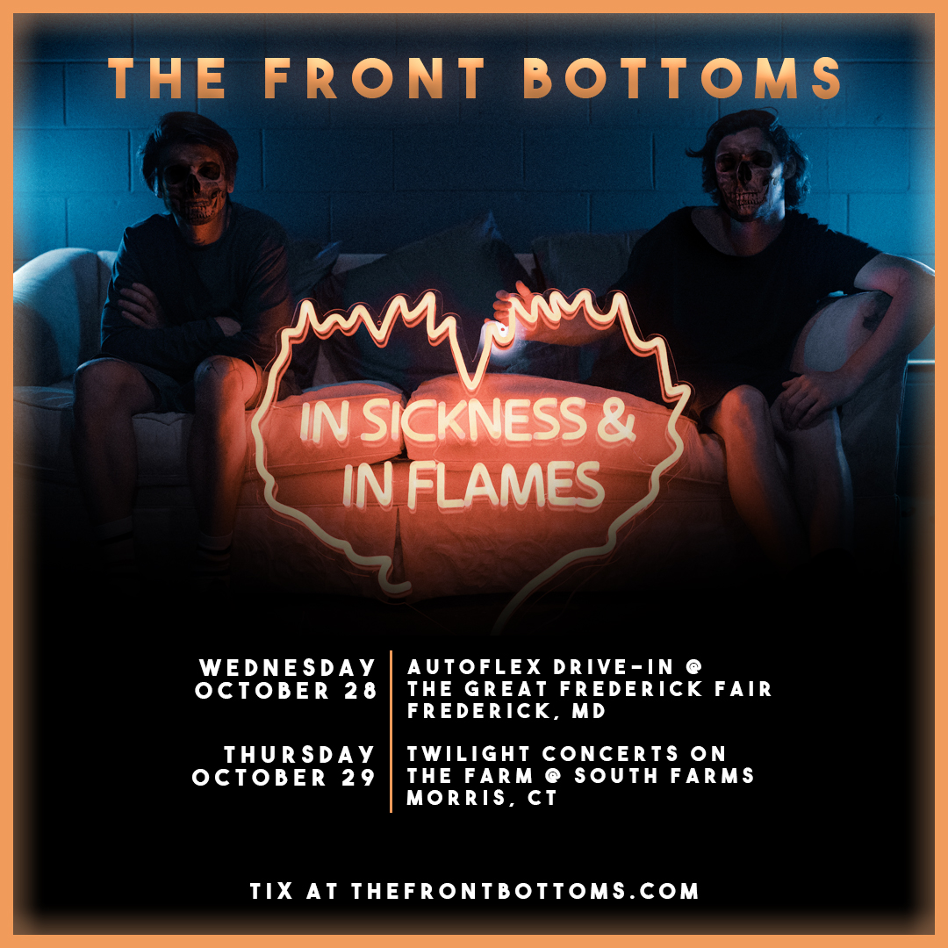

SEPTEMBER 30, 2020 – Having recently released their critically acclaimed new album, In Sickness & In Flames, The Front Bottoms have shared that they will perform a pair of concerts this October. Scheduled for October 28th in Frederick, MD and October 29th in Morris, CT, the concerts will see The Front Bottoms performing live for fans socially distanced or in their cars and following state recommended health protocols. The Maryland date will be a drive-in performance held at the Autoflex Drive-In @ The Great Frederick Fair, while the Connecticut date will be a socially distanced performance taking place at South Farms as part of their Twilight Concerts On The Farm series. Fan club presale tickets are available now with all remaining tickets going on sale to the general public on Friday, October 2nd, at 12:00PM ET. For tickets, safety guidelines and more information on the upcoming concerts, please visit www.thefrontbottoms.com.

Furthermore, with the 2020 Presidential Election quickly approaching, The Front Bottoms have unveiled a limited-edition, campaign inspired “Sella - Uychich 2020” t-shirt. The band shared the design and encouraged fans to register to vote at www.headcount.org, stating “In just over a month, the United States will elect the next President and Vice President. We are raising funds with this t-shirt to help make sure they are Joe Biden and Kamala Harris. All proceeds and sales will be donated to The Biden Victory Fund.”

Just last month The Front Bottoms released their brand-new album, In Sickness & In Flames, a twelve song collection produced by Mike Sapone. NME attested, “In Sickness & In Flames is a defining work that showcases a sonic universe, rather than a structured set of songs, expertly capturing the inescapable tension of 2020.” A.V. Club declared, “The Front Bottoms are as vibrant as ever on In Sickness & In Flames, a reliably great collection of folk-punk anthems that rattle the soul with crunchy riffs, electrifying hooks, and Brian Sella’s idiosyncratic lyricism, which remains as amiable as it is anxiety-ridden.” UPROXX added “In Sickness & In Flames features the band’s biggest choruses to date, anchored with hooks and deeply personal songwriting that will turn heads,” while The FADER hailed it as, “a celebration of sorts for a band perennially on the fringes of a major breakthrough.” The Alternative detailed, “While In Sickness & In Flames was written prior to the pandemic, so much of it feels so tethered to our present collective experience, from the introspection and reflective growth that is showcased in the songwriting, to the sweeping highs and lows of the music itself. This album is the perfect companion piece to the anxiety of standing in the face of uncertainty.”

“When you listen to this, we definitely want you to feel the anxiety. There are some pretty rock and roll songs and heavy moments on In Sickness & In Flames… we hope the tension comes across,” stated The Front Bottoms. In Sickness & In Flames features the celebrated singles “montgomery forever,” “camouflage,” “everyone blooms,” “Fairbanks, Alaska,” and finds the duo of Brian Sella and Mathew Uychich celebrating life and purging angst through introspection.

With touring abilities limited under the global pandemic, The Front Bottoms have taken to Twitch to broadcast short films and livestream performances to fans around the world on their official channel – www.Twitch.tv/TheFrontBottomsMusic. For formation on upcoming events and archived streams, please visit The Front Bottoms’ official Twitch channel.

ABOUT THE FRONT BOTTOMS:

Comprised of guitarist/vocalist Brian Sella and drummer Mathew Uychich, The Front Bottoms have gripped listeners and press around the world with their ragged honesty and emotional urgency. The New Jersey based band’s 2017 LP, GOING GREY, arrived to critical acclaim with lead single “Peace Sign” breaking into the Alternative Radio charts. GOING GREY is highlighted by a string of celebrated singles, among them “Vacation Town,” “Everyone But You,” and “Raining,” which NPR avowed as “…brutally honest, witty and confessional…” adding, “The group’s heart and humor shine… .” The FADER declared, “The Front Bottoms make memorable sing-a-longs that call back to a different, simpler, sadder era of confessional guitar music” with Stereogum praising the new music as, “grand and reflective and damn near arena-ready.” “…Submit to the awesome power of The Front Bottoms” stated VICE, while A.V. Club professed, “The Front Bottoms are more confident, and secure enough to confess to all they don’t yet know. It’s a privilege to listen in as they work it out.”

Following the release of GOING GREY, The Front Bottoms shared standalone single, “End of summer (now I know),” followed by Ann, the 2nd installment of their Grandma Series EPs. The six-track collection featured five new recordings of never before released fan favorite songs as well as the brand-new track, “Tie Dye Dragon.” The band also joined forces with Manchester Orchestra on the collaborative track, “Allentown,” and released a cover of Kevin Devine’s “Just Stay” as part of his Devinyl Splits releases.


PHOTO CREDIT: MARK JAWORSKI

IN SICKNESS & IN FLAMES
TRACKLIST
01. everyone blooms
02. camouflage
03. jerk
04. the truth
05. montgomery forever
06. the hard way
07. leaf pile
08. new song d
09. Fairbanks, Alaska
10. love at first sight
11. bus beat
12. make way

CONNECT WITH THE FRONT BOTTOMS:
WWW.THEFRONTBOTTOMS.COM
FACEBOOK
INSTAGRAM
TWITTER
FUELEDBYRAMEN.COM

FOR MORE INFORMATION, CONTACT:
ROSSANDERSON@ELEKTRA.COM

