THE FRONT BOTTOMS
RELEASE NEW ALBUM IN SICKNESS & IN FLAMES

AVAILABLE NOW ON ALL STREAMING PLATFORMS

VIRTUAL ALBUM LISTENING EVENT SET FOR TONIGHT AT 8:00PM ET ON TWITCH

DRIVE-IN CONCERT PERFORMANCES SET FOR
AUGUST 23RD IN PHILADELPHIA, PA & AUGUST 27TH IN OCEANPORT, NJ

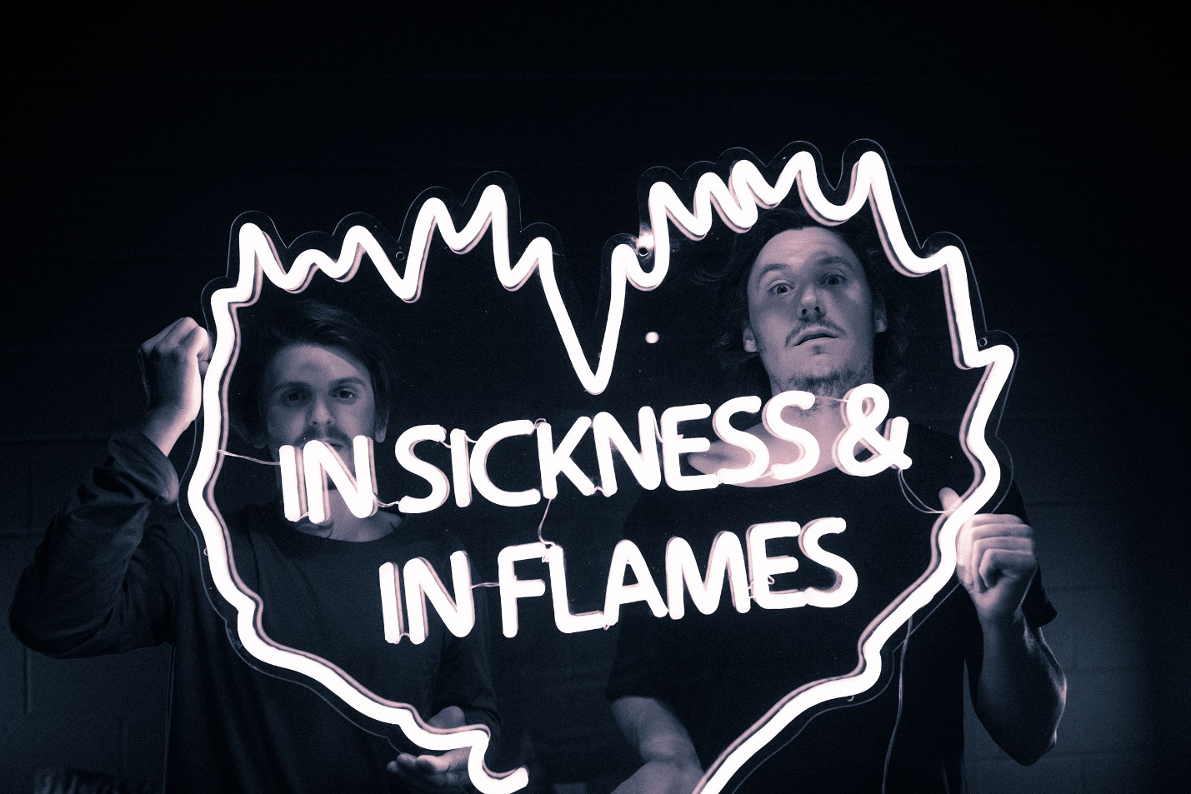

AUGUST 21, 2020 – The Front Bottoms have released their widely anticipated new album, In Sickness & In Flames. The twelve-song collection, which was produced by Mike Sapone, follows the band’s acclaimed 2017 LP Going Grey and is available today on all streaming platforms.

The Alternative declared, “While In Sickness & In Flames was written prior to the pandemic, so much of it feels so tethered to our present collective experience, from the introspection and reflective growth that is showcased in the songwriting, to the sweeping highs and lows of the music itself. This album is the perfect companion piece to the anxiety of standing in the face of uncertainty.” NME attested, “In Sickness & In Flames is a defining work that showcases a sonic universe, rather than a structured set of songs, expertly capturing the inescapable tension of 2020.”

To celebrate the release of In Sickness & In Flames, The Front Bottoms will host a virtual album listening event tonight, August 21st at 8:00PM ET at www.InSicknessAndInFlames.com. Fans will be able to logon and stream In Sickness & In Flames alongside an accompanying film which the band has created for the album. Up next The Front Bottoms will perform a pair of drive-in concerts - August 23rd in Philadelphia, PA and August 27th in Oceanport, NJ – which will see the band performing live for fans socially distanced in their cars and following state recommended health protocols. The Philadelphia date will be held in the parking lot of Citizens Bank Park as part of their “Live-In Drive-In” concert programming, while the New Jersey date will take place at Monmouth Park Racetrack for the nonprofit Count Basie Center’s “Drive-In Live” series. For tickets, safety guidelines and more information on the upcoming drive-in concerts, please visit www.thefrontbottoms.com.

“When you listen to this, we definitely want you to feel the anxiety. There are some pretty rock and roll songs and heavy moments on In Sickness & In Flames… we hope the tension comes across,” stated The Front Bottoms. In Sickness & In Flames features the celebrated singles “montgomery forever,” “camouflage,” “everyone blooms,” “Fairbanks, Alaska,” and finds the duo of Brian Sella and Mathew Uychich celebrating life and purging angst through introspection. Stereogum praised “montgomery forever” as “a big, soaring song about nostalgia and mental illness,” while FLOOD celebrated the track for reflecting, “a greater sign of the moment, of unrest and the sense that everything is crumbling around us through its alt-rock rhythms and effortlessly pragmatic storytelling.” The FADER declared “camouflage” “a celebration of sorts for a band perennially on the fringes of a major breakthrough,” while UPROXX placed “everyone blooms” in their ‘Best New Indie Music’ round-up. The Front Bottoms also recently launched “Ukulele Versions” of both “camouflage” and “everyone blooms” on their Bandcamp which raised a total of $10,000.00 in funds for The Center for Cultural Power, a women of color, artist-led organization, inspiring artists and culture makers to imagine a world where power is distributed equitably.

Having had to cancel a spring headline tour as well as summer co-headline dates with Jimmy Eat World due to the ongoing pandemic, The Front Bottoms have taken to Twitch to broadcast short films and live performances on their official channel – www.Twitch.tv/TheFrontBottomsMusic. For more information on upcoming events and archived streams, visit The Front Bottoms’ official Twitch channel.

ABOUT THE FRONT BOTTOMS:

Comprised of guitarist/vocalist Brian Sella and drummer Mathew Uychich, The Front Bottoms have gripped listeners and press around the world with their ragged honesty and emotional urgency. The New Jersey based band’s 2017 LP, GOING GREY, arrived to critical acclaim with lead single “Peace Sign” breaking into the Alternative Radio charts. GOING GREY is highlighted by a string of celebrated singles, among them “Vacation Town,” “Everyone But You,” and “Raining,” which NPR avowed as “…brutally honest, witty and confessional…” adding, “The group’s heart and humor shine… .” The FADER declared, “The Front Bottoms make memorable sing-a-longs that call back to a different, simpler, sadder era of confessional guitar music” with Stereogum praising the new music as, “grand and reflective and damn near arena-ready.” “…Submit to the awesome power of The Front Bottoms” stated VICE, while A.V. Club professed, “The Front Bottoms are more confident, and secure enough to confess to all they don’t yet know. It’s a privilege to listen in as they work it out.”

Following the release of GOING GREY, The Front Bottoms shared standalone single, “End of summer (now I know),” followed by Ann, the 2nd installment of their Grandma Series EPs. The six-track collection featured five new recordings of never before released fan favorite songs as well as the brand-new track, “Tie Dye Dragon.” The band also joined forces with Manchester Orchestra on the collaborative track, “Allentown,” and released a cover of Kevin Devine’s “Just Stay” as part of his Devinyl Splits releases.

[ALBUM ART / TRACKLISTING BELOW]

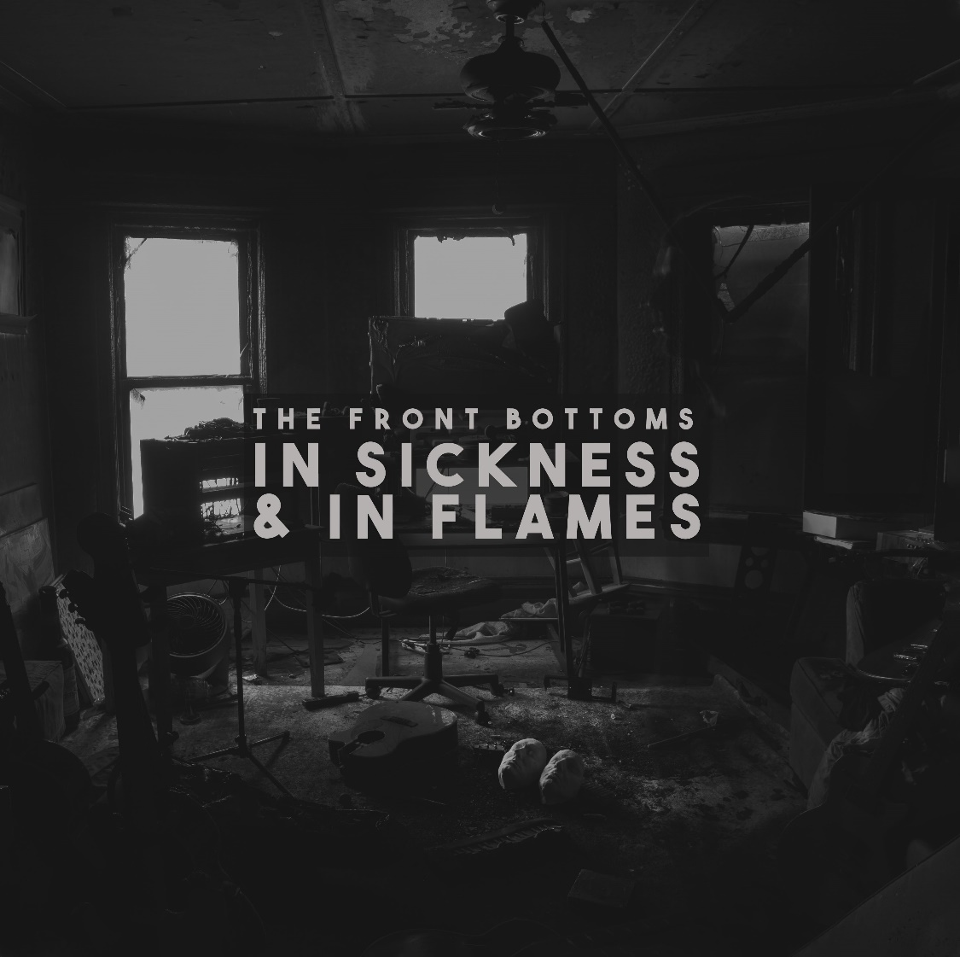

IN SICKNESS & IN FLAMES

01. everyone blooms
02. camouflage
03. jerk
04. the truth
05. montgomery forever
06. the hard way
07. leaf pile
08. new song d
09. Fairbanks, Alaska
10. love at first sight
11. bus beat
12. make way

CONNECT WITH THE FRONT BOTTOMS:
WWW.THEFRONTBOTTOMS.COM
FACEBOOK
INSTAGRAM
TWITTER
FUELEDBYRAMEN.COM

FOR MORE INFORMATION, CONTACT:
ROSSANDERSON@ELEKTRA.COM

