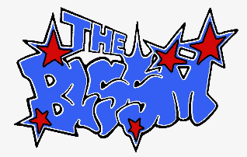
THE BLSSM ANNOUNCES HEADLINE SHOWS IN NEW YORK AND LOS ANGELES IN MAY
CONFIRMED TO PLAY HANGOUT & LIFE IS BEAUTIFUL MUSIC FESTIVALS
LISTEN TO “DIZZY” HERE | MORE NEW MUSIC COMING THIS YEAR
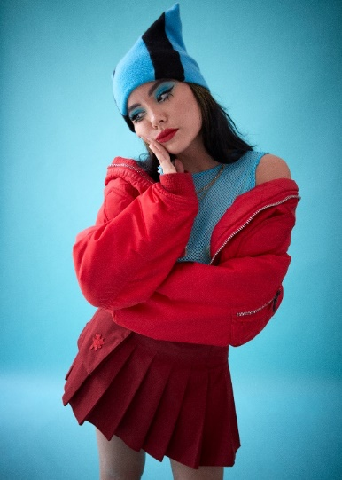
PHOTO CREDIT: JESSE LIZOTTE
PRESS ASSETS AVAILABLE HERE
“THE BLSSM is back and better than ever” –UPROXX
“…splitting and fun, while also unabashedly honest and kinetic” –HYPEBEAST
“[‘DIZZY’ is] an electrifying taste of what's to come from the rising rock act”
–CONSEQUENCE OF SOUND
(MARCH 16, 2022) – LOS ANGELES, CA – Genre-bending artist, songwriter, and fashion tastemaker THE BLSSM today announced two special headline shows in New York and Los Angeles in May. The musician (they/them) will hit Baby’s All Right in Brooklyn, NY on Monday, May 9 and the Moroccan Lounge in Los Angeles, CA on Monday, May 16. Clip will provide direct support for the Brooklyn date, while NITEFIRE will open at the LA show. Tickets for both concerts are available HERE, which go on sale Friday, March 18 at 10:00am local venue time. There will also be a separate artist pre-sale on Thursday, March 17 at 10:00am local.
Following the headline performances, THE BLSSM will also play Hangout Music Festival in Gulf Shores, Alabama on Saturday, May 21, alongside artists such as Halsey, Doja Cat, Chelsea Cutler, beabadoobee, and more. In September, they’ll also head to Las Vegas to perform at Life Is Beautiful Music & Art Festival. The forthcoming run of dates also follows their notable 2021 U.S. tours supporting Wolf Alice and Remi Wolf.
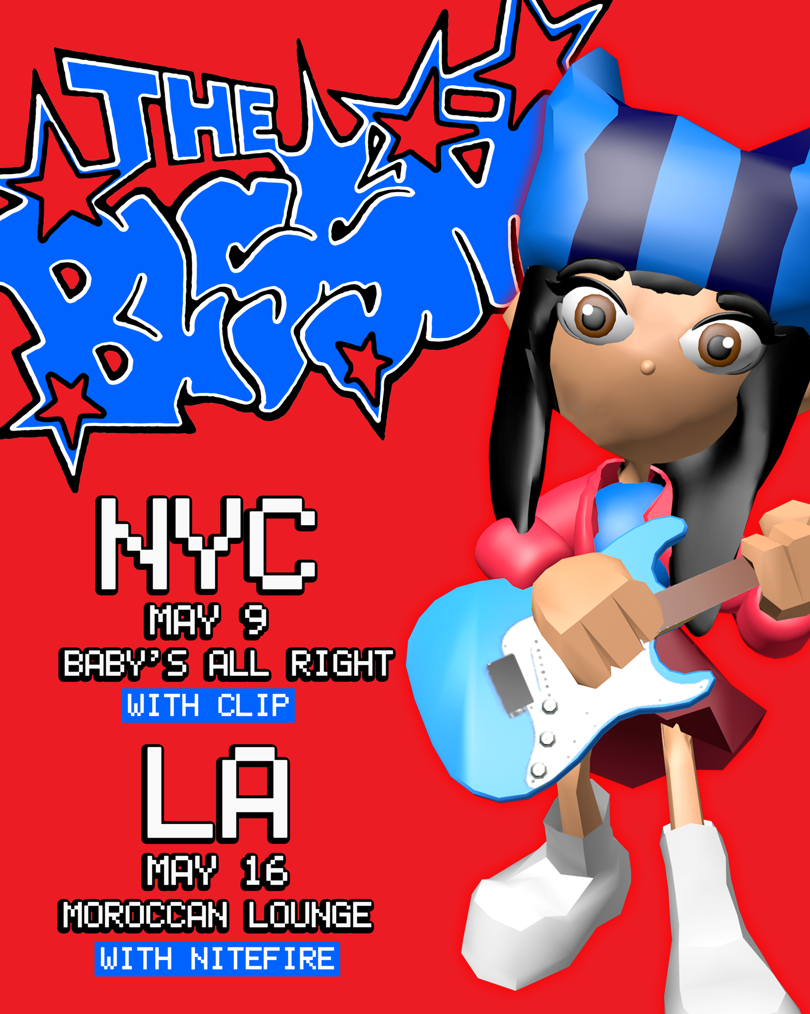
In February, THE BLSSM shared their introspective, dynamic, and unabashedly honest new single “DIZZY,” which garnered critical acclaim in the press and produced a captivating companion music video directed by visual artist and fashion photographer Sophie Hur (Louis Vuitton, Adidas). Created with Suzy Shinn (Dua Lipa, Panic! At the Disco), Nick Long (Machine Gun Kelly, LILHUDDY), and James Ivy, “DIZZY” is a hybrid of THE BLSSM’s diverse sonic influences – grunge, alternative, and indie – reimagined into a rendition of pop music that is uniquely their own. THE BLSSM also recently announced their signing to Fueled By Ramen – read more on Consequence of Sound.
Additionally, this year THE BLSSM changed their name from “THE BLOSSOM” to its current stylization, stating “I wanted to shorten it to something more abstract and less literal, and I like that it sounds like it has the word BLISS in it,” which is the artist’s favorite word.
THE BLSSM is currently in the studio working on more new original music – slated for release this year – which showcases a promising young artist fully at the helm of their sonic and creative vision. Stay tuned for more to come soon.
THE BLSSM ON TOUR
May 9, 2022 – Brooklyn, NY @ Baby’s All Right
May 16, 2022 – Los Angeles, CA @ Moroccan Lounge
May 21, 2022 – Gulf Shores, AL @ Hangout Music Festival
September 16-18 – Las Vegas, NV @ Life Is Beautiful Music & Art Festival
THE BLSSM
“DIZZY”
AVAILABLE HERE
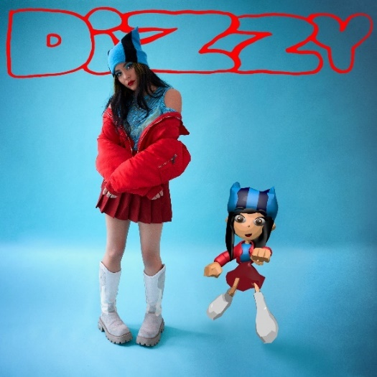
CREDIT: JESSE LIZOTTE (photo) & ELLIOT SHIELDS (design)
Connect with THE BLSSM:
Instagram
TikTok
YouTube
Twitter
# # #
PRESS CONTACT:
Nathalie Rubin
NathalieRubin@elektra.com

