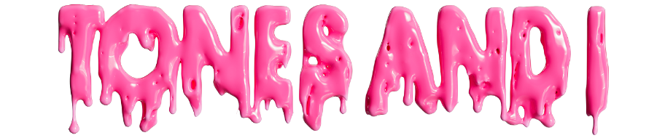

THE FORTNITE SOUNDWAVE SERIES CONTINUES WITH
TONES AND I IN AN INTERACTIVE MADHOUSE!
PHOTO CREDIT: GIULIA MCGAURAN

JANUARY 18, 2022 - Last year, Fortnite announced they would be bringing breakout music to the Metaverse with the Soundwave Series, a sensational series of in-game musical experiences featuring some of the most exciting artists from around the world.

While the Soundwave Series kicked off last October, Australia’s own Tones And I joins the series this month for an exclusive interactive experience that kicks off at 6pm ET on Friday January 21ST 2022 – 10am AEDT on Saturday January 22ND 2022 for Australian viewers – and repeats non-stop for 72 hours!
Tones And I said, “The Madhouse experience in Fortnite is sick and I can’t wait for you all to see it."

Within Fortnite, Tones will perform songs from her debut chart-topping album WELCOME TO THE MADHOUSE, a moving and magnetic 14-track collection including hits ‘Fly Away’, ‘Cloudy Day’, ‘Just A Mess’ and more, which was entirely written and co-produced by the Australian artist.
This interactive experience, brought to life by Fortnite community creators Team Alliance and TheBoyDilly, is an adventure through the madhouse — a tour inspired by the songs of the album. To jump in, players can enter the SOUNDWAVE SERIES: TONES AND I tile in Fortnite’s Discover menu (or enter the Island code 4161-9206-0181) starting Friday, January 21st at 6 PM ET // Saturday January 22nd at 10am AEDT.

Keep an eye on the Fortnite blog for more information: Fortnite blog / Epic Newsroom
ABOUT TONES AND I
Originally from Australia’s Mornington Peninsula, Tones And I travelled to Byron Bay in early 2018 to take a chance at busking. On the first day she had crowds spilling onto the street. Tones quit her retail job and decided to make Byron her new home where she lived out of her van for a year, honing her song writing and busking every weekend. A year later, she had one of the biggest songs in the world with her global smash ‘Dance Monkey’ and has since then notched over 8 billion global streams across all her music. Last year, Tones And I released her anxiously awaited debut album WELCOME TO THE MADHOUSE - a moving and magnetic 14-track collection written entirely by the Australian artist with her co-producing every song - which debuted at #1 on the ARIA Albums Chart.
CONNECT WITH TONES AND I

