TURNSTILE
SHARE NEW SONG & MUSIC VIDEO - “BLACKOUT”

NEW ALBUM GLOW ON ARRIVES AUGUST 27TH

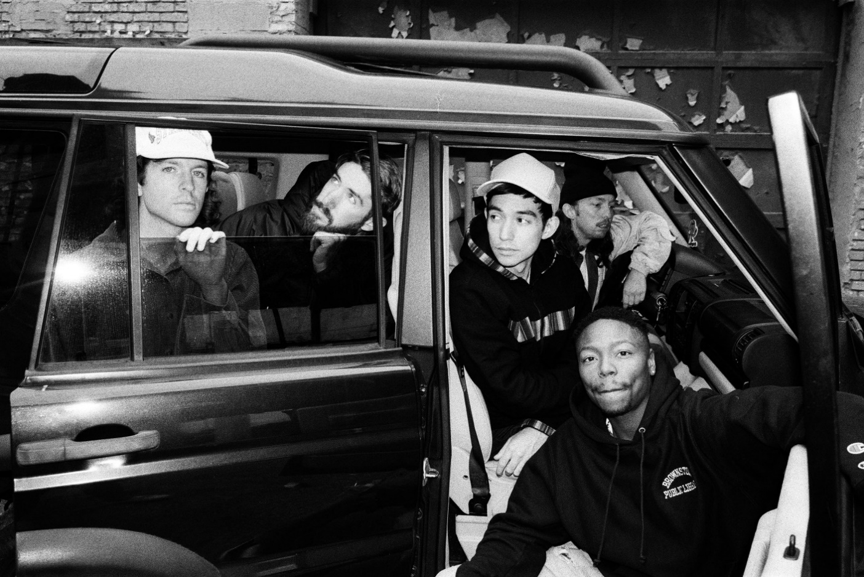
PHOTO CREDIT: JIMMY FONTAINE

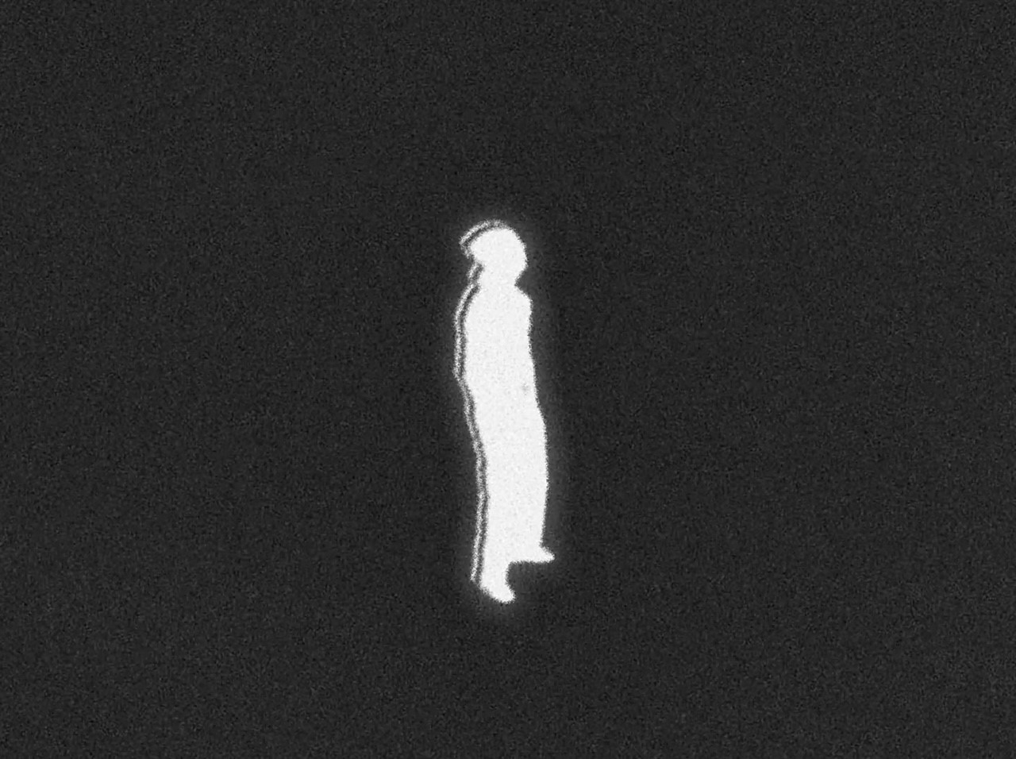
“BLACKOUT” VIDEO STILL

JULY 14, 2021 – TURNSTILE have shared “BLACKOUT,” a brand-new single off their forthcoming album GLOW ON, which will be released August 27th on Roadrunner Records (album art / tracklisting below). Available today on all streaming platforms, “BLACKOUT” is joined by an animated music video directed by TURNSTILE with Alexis Jamet and Logan Triplett heading the animation – watch it HERE.

Recorded with producer Mike Elizondo and co-produced by Yates, GLOW ON follows TURNSTILE’s 2018 album TIME & SPACE, which saw the Baltimore band charting new ground for hardcore, expanding stylistic boundaries and celebrating new possibilities. With GLOW ON that utopic vision is fully realized; 15 tracks devoid of borders, boundaries, or entry obstacles, only abundant imagination, heart, and grooves plucked from all corners of the musical spectrum. GLOW ON includes the singles “HOLIDAY,” “MYSTERY,” “NO SURPRISE,” and “T.L.C. (TURNSTILE LOVE CONNECTION) from TURNSTILE’s recent TURNSTILE LOVE CONNECTION EP and companion short film. GLOW ON also includes guest features from Blood Orange on “ALIEN LOVE CALL,” “LONELY DEZIRES,” with additional vocal contributions on “ENDLESS.”

“TURNSTILE has the ability to lure even the most poptimistic listener with spectacular hooks,” affirmed NPR remarking on the band’s single “HOLIDAY,” while The FADER named the track one of the 20 Best Rock Songs Right Now with Pitchfork adding it to their weekly Pitchfork Selects playlist. The New York Times applauded “ALIEN LOVE CALL” (feat. Blood Orange) as a “shoegaze space-soul collaboration” with PASTE affirming “the band can downshift from ‘explosive’ to ‘dreamy’ without missing a beat.” Rolling Stone praised album opener “MYSTERY” for its “no-nonsense barrage of chugging power chords, stadium-sized rock drums, and scorching guitar solos,” with Stereogum declaring, “If you’re gonna go big, you might as well go gigantic, and with ‘MYSTERY’ TURNSTILE sound like they’re about to be huge.”

Bringing superhuman energy to the stage, TURNSTILE are scheduled to perform a string of sold-out headline shows this summer, which kick off August 22nd at Irving Plaza in New York City and conclude with a performance on September 12th at The Basement East in Nashville, TN. Later this fall they are set for a series of festival performances, including Dover, Delaware’s Firefly Music Festival (9/23), Louisville, Kentucky’s Louder Than Life (9/24), Indianola, Iowa’s Knotfest (9/25), followed by appearances next year at Spain’s Primavera Sound on 6/5, France’s Hellfest on 6/23, and the united Kingdom’s Outbreak Festival on 6/24. Full Tour dates can be found HERE.

Always more appeal than demand, more liberation than limitation, TURNSTILE extended their hand in 2018 with TIME & SPACE. Recorded with producer Will Yip, TIME & SPACE marked Turnstile’s Roadrunner Records debut and saw the band exploding the most outsized tropes of hardcore with tremendous heart. The album earned “Best of 2018” honors from The New Yorker, The New York Times, Rolling Stone, NPR Billboard and more, with GQ naming TIME & SPACE one of “The Best Albums That Shaped the 2010s.”

Reminding us that all music is dance music, TURNSTILE linked up with Australian producer Mall Grab in 2020 to release SHARE A VIEW, a collaborative EP of three reimagined TIME & SPACE tracks – “Generator,” “Real Thing,” and “I Don’t Wanna Be Blind.”

Comprised of Brendan Yates (Vocals), Franz Lyons (Bass/Vocals), Brady Ebert (Guitars), Pat McCrory (Guitars), and Daniel Fang (Drums), TURNSTILE’s brand of youth-minded, youth-driven hardcore punk is intent on breaking down barriers, sonically and ideologically.

GLOW ON
ALBUM ARTWORK + TRACKLIST

1. MYSTERY
2. BLACKOUT
3. DON’T PLAY
4. UNDERWATER BOI
5. HOLIDAY
6. HUMANOID / SHAKE IT UP
7. ENDLESS
8. FLY AGAIN
9. ALIEN LOVE CALL (FEAT. BLOOD ORANGE)
10. WILD WRLD
11. DANCE-OFF
12. NEW HEART DESIGN
13. T.L.C. (TURNSTILE LOVE CONNECTION)
14. NO SURPRISE
15. LONELY DEZIRES (FEAT. BLOOD ORANGE)

Connect with TURNSTILE:
WEBSITE / INSTAGRAM / FACEBOOK / TWITTER / YOUTUBE / SPOTIFY / APPLE MUSIC

