TURNSTILE
SURPRISE RELEASE NEW EP & SHORT FILM – TURNSTILE LOVE CONNECTION

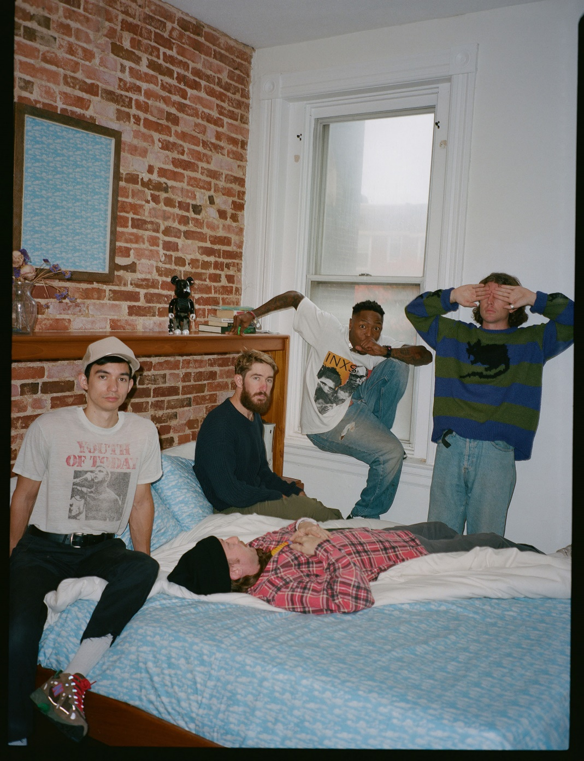
PHOTO CREDIT: JIMMY FONTAINE

JUNE 28, 2021 – TURNSTILE have surprise released a new four-track EP called TURNSTILE LOVE CONNECTION, which is available today on all streaming platforms [artwork / tracklist below]. The EP is joined by a companion short film of the same name directed by TURNSTILE vocalist Brendan Yates. TURNSTILE LOVE CONNECTION made theatrical debuts across the U.S. last week including premieres at Los Angeles’ Brain Dead Studios, Brooklyn’s Nitehawk Cinema, Baltimore’s Charles Theater, and Columbus’ Studio 35 Cinema - watch it HERE.

Earlier this month, TURNSTILE shared the EP’s lead track “MYSTERY” which marked the first new music from the Baltimore band since the release of their 2018 breakthrough LP, TIME & SPACE. The FADER named “MYSTERY” one of the 20 Best Rock Songs Right Now, while Pitchfork added the song to their weekly Pitchfork Selects playlist. Rolling Stone praised the track’s “no-nonsense barrage of chugging power chords, stadium-sized rock drums, and scorching guitar solos,” with Stereogum declaring, “If you’re gonna go big, you might as well go gigantic, and with ‘MYSTERY’ TURNSTILE sound like they’re about to be huge.”

Bringing superhuman energy to the stage, TURNSTILE are scheduled to perform a string of sold-out headline shows this summer, which kick off August 28th at the Garden Amphitheatre in Garden Grove, CA and conclude with a performance on September 2nd at Mohawk Austin in Austin, TX. Later this fall they are set for a series of festival performances, including Dover, Delaware’s Firefly Music Festival (9/23), Louisville, Kentucky’s Louder Than Life (9/24), Indianola, Iowa’s Knotfest (9/25), followed by appearances next year at Spain’s Primavera Sound on 6/5 and France’s Hellfest on 6/23. Full Tour dates can be found HERE.

Always more appeal than demand, more liberation than limitation, TURNSTILE extended their hand in 2018 with TIME & SPACE. Recorded with producer Will Yip, TIME & SPACE marked Turnstile’s Roadrunner Records debut and saw the band exploding the most outsized tropes of hardcore with tremendous heart. The album earned “Best of 2018” honors from The New Yorker, The New York Times, Rolling Stone, NPR Billboard and more, with GQ naming TIME & SPACE one of “The Best Albums That Shaped the 2010s.” Continuously looking outward, TIME & SPACE presented the sound of a band operating without boundaries, always growing, always in super-motion.

Reminding us that all music is dance music, TURNSTILE linked up with Australian producer Mall Grab in 2020 to release SHARE A VIEW, a collaborative EP of three reimagined TIME & SPACE tracks – “Generator,” “Real Thing,” and “I Don’t Wanna Be Blind.”

Comprised of Brendan Yates (Vocals), Franz Lyons (Bass/Vocals), Brady Ebert (Guitars), Pat McCrory (Guitars), and Daniel Fang (Drums), TURNSTILE’s brand of youth-minded, youth-driven hardcore punk is intent on breaking down barriers, sonically and ideologically.

TURNSTILE LOVE CONNECTION
EP ARTWORK + TRACKLIST

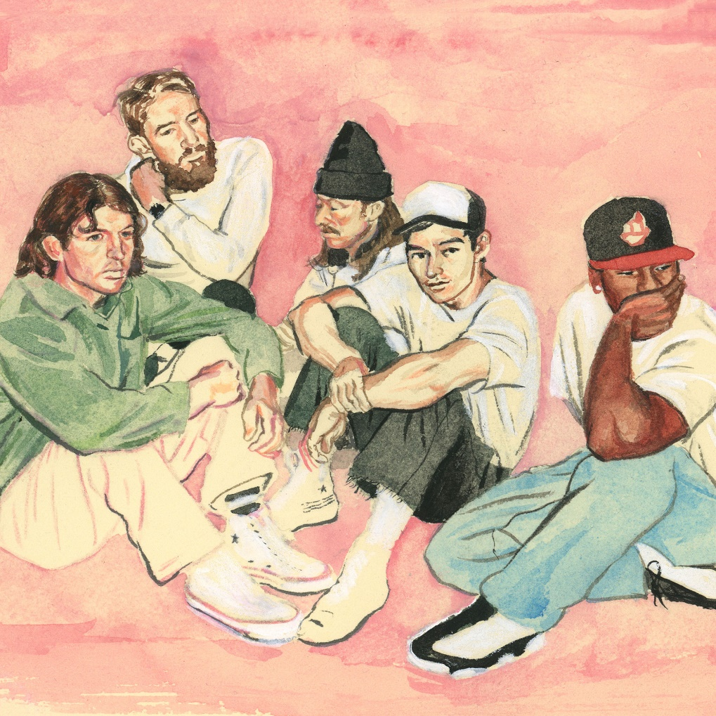

1. HOLIDAY
2. NO SURPRISE
4. MYSTERY
3. T.L.C. (TURNSTILE LOVE CONNECTION)

Connect with TURNSTILE:
WEBSITE / INSTAGRAM / FACEBOOK / TWITTER / YOUTUBE / SPOTIFY / APPLE MUSIC

