THE FRONT BOTTOMS
ANNOUNCE CHAMPAGNE JAM 2021

YEAR-END BASH SET FOR DECEMBER 18TH IN PROVIDENCE, RI

PRE-SALE TICKETS AVAILABLE TODAY

GENERAL ON SALE BEGINS SEPTEMBER 10TH AT 10:00AM ET

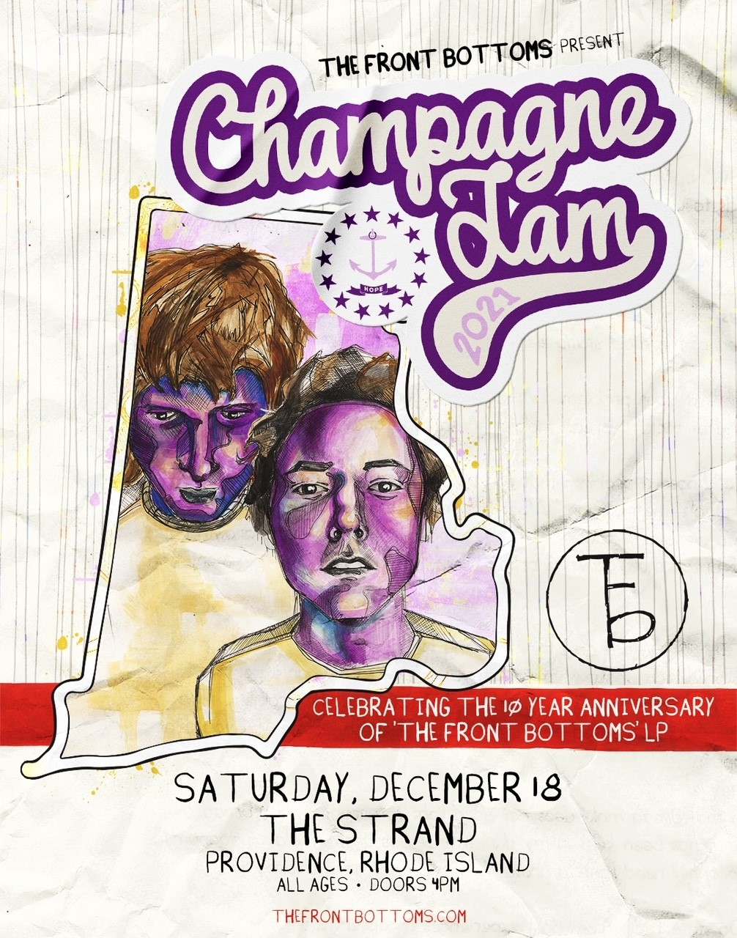

SEPTEMBER 7, 2021 – Fueled By Ramen band The Front Bottoms have announced details of the 2021 iteration of their popular year-end bash, Champagne Jam. This year, the annual holiday festival will happen on December 18th at The Strand in Providence, RI with the full line-up to be announced in the coming weeks. Furthermore, the one night only event will see The Front Bottoms celebrating the 10 year anniversary of their breakthrough self-titled debut album.

Pre-sale tickets for Champagne Jam 2021 will be available now to members of The Front Bottoms’ Motorcycle Club, with general on sale for tickets starting Friday, September 10th at 10:00AM ET. For tickets and more information visit, www.thechampagnejam.com.

Just last week The Front Bottoms returned with the release of “Lover Boy,” a brand-new single. Up next, The Front Bottoms will head out on a U.S. headline tour alongside special guests Oso Oso and Sydney Sprague. The fall dates kick off September 14th in New Haven, CT at College Street Music Hall and will see The Front Bottoms visiting major markets coast to coast before concluding the tour with a performance at Starland Ballroom in Sayreville, NJ on October 24th [full itinerary below]. For tickets and more information on the upcoming dates visit www.thefrontbottoms.com.

Earlier this year The Front Bottoms released the standalone single “Voodoo Magic” which arrived with an accompanying animated music video. The band enlisted Matt Skiba of Blink-182 and Alkaline Trio to play guitar on “Vodoo Magic” and recruited director James Blagden - renowned for his infamous viral Sundance Film Festival short Dock Ellis & The LSD No-No – to helm the track’s accompanying visual.

Comprised of guitarist/vocalist Brian Sella and drummer Mathew Uychich, The Front Bottoms have gripped listeners and press around the world with their ragged honesty and emotional urgency. In 2020, The Front Bottoms released their celebrated new album, In Sickness & In Flames, a twelve song collection produced by Mike Sapone. NME attested, “In Sickness & In Flames is a defining work that showcases a sonic universe, rather than a structured set of songs, expertly capturing the inescapable tension of 2020.” A.V. Club declared, “The Front Bottoms are as vibrant as ever on In Sickness & In Flames, a reliably great collection of folk-punk anthems that rattle the soul with crunchy riffs, electrifying hooks, and Brian Sella’s idiosyncratic lyricism, which remains as amiable as it is anxiety-ridden.” UPROXX added “In Sickness & In Flames features the band’s biggest choruses to date, anchored with hooks and deeply personal songwriting that will turn heads,” while The FADER hailed it as, “a celebration of sorts for a band perennially on the fringes of a major breakthrough.” The Alternative detailed, “While In Sickness & In Flames was written prior to the pandemic, so much of it feels so tethered to our present collective experience, from the introspection and reflective growth that is showcased in the songwriting, to the sweeping highs and lows of the music itself. This album is the perfect companion piece to the anxiety of standing in the face of uncertainty.”

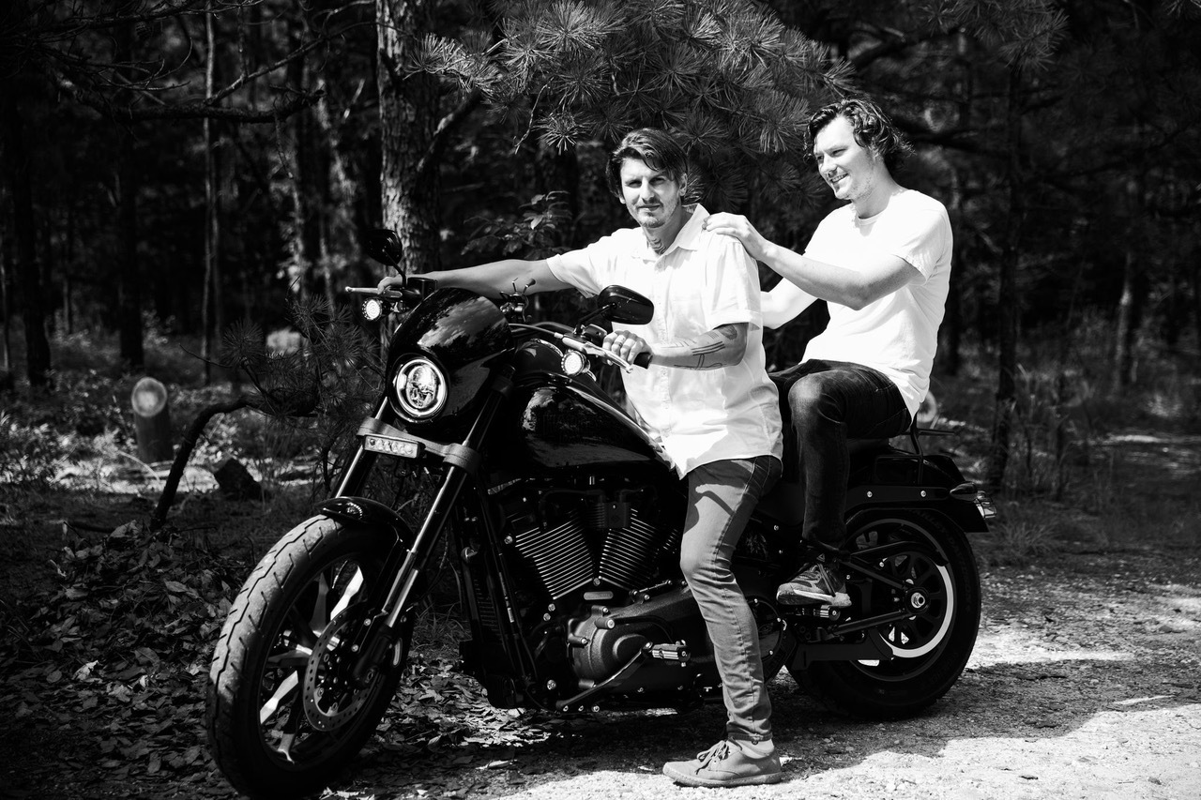
PHOTO CREDIT: MARK JAWORSKI

2021 U.S. HEADLINE TOUR DATES
FEATURING SPECIAL GUESTS OSO OSO & SYDNEY SPRAGUE

9/14 New Haven, CT College Street Music Hall
9/15 New York, NY Pier 17
9/17 Silver Spring, MD Fillmore Silver Spring
9/18 Richmond, VA The National
9/19 Asheville, NC The Orange Peel
9/21 Tampa, FL The Ritz Ybor
9/22 Orlando, FL Hard Rock Live
9/23 Atlanta, GA The Masquerade
9/24 Nashville, TN Brooklyn Bowl
9/26 Houston, TX White Oak Music Hall
9/27 Dallas, TX Gas Monkey Live
9/28 Austin, TX Stubb’s
9/30 Phoenix, AZ The Van Buren
10/1 Anaheim, CA House of Blues Anaheim
10/2 Las Vegas, NV Brooklyn Bowl
10/3 Los Angeles, CA The Fonda Theatre
10/5 San Francisco, CA The Warfield
10/7 Portland, OR Roseland Theater
10/8 Seattle, WA Neptune Theatre
10/10 Salt Lake City, UT The Union
10/11 Denver, CO Mission Ballroom
10/13 Minneapolis, MN First Avenue
10/14 Lawrence, KS The Granada
10/15 Chicago, IL Radius
10/16 St. Louis, MO The Pageant
10/18 Detroit, MI The Fillmore Detroit
10/19 Cleveland, OH Agora Ballroom
10/21 Pittsburgh, PA Stage AE
10/22 Philadelphia, PA The Fillmore Philadelphia
10/23 Worcester, MA The Palladium
10/24 Sayreville, NJ Starland Ballroom
12/18 Providence, RI The Strand – Champagne Jam 2021*

*Festival Date

CONNECT WITH THE FRONT BOTTOMS:
WWW.THEFRONTBOTTOMS.COM
FACEBOOK
INSTAGRAM
TWITTER
WWW.FUELEDBYRAMEN.COM

FOR MORE INFORMATION, CONTACT:
ROSSANDERSON@ELEKTRA.COM

