THE FRONT BOTTOMS
TEAM UP WITH BLINK-182’S MATT SKIBA ON NEW SINGLE “VOODOO MAGIC”

ANIMATED MUSIC VIDEO STREAMING NOW

ANNOUNCE NORTH AMERICAN HEADLINE TOUR

PRE-SALE TICKETS AVAILABLE TODAY
GENERAL ON SALE BEGINS JUNE 11th AT 12:00PM LOCAL TIME

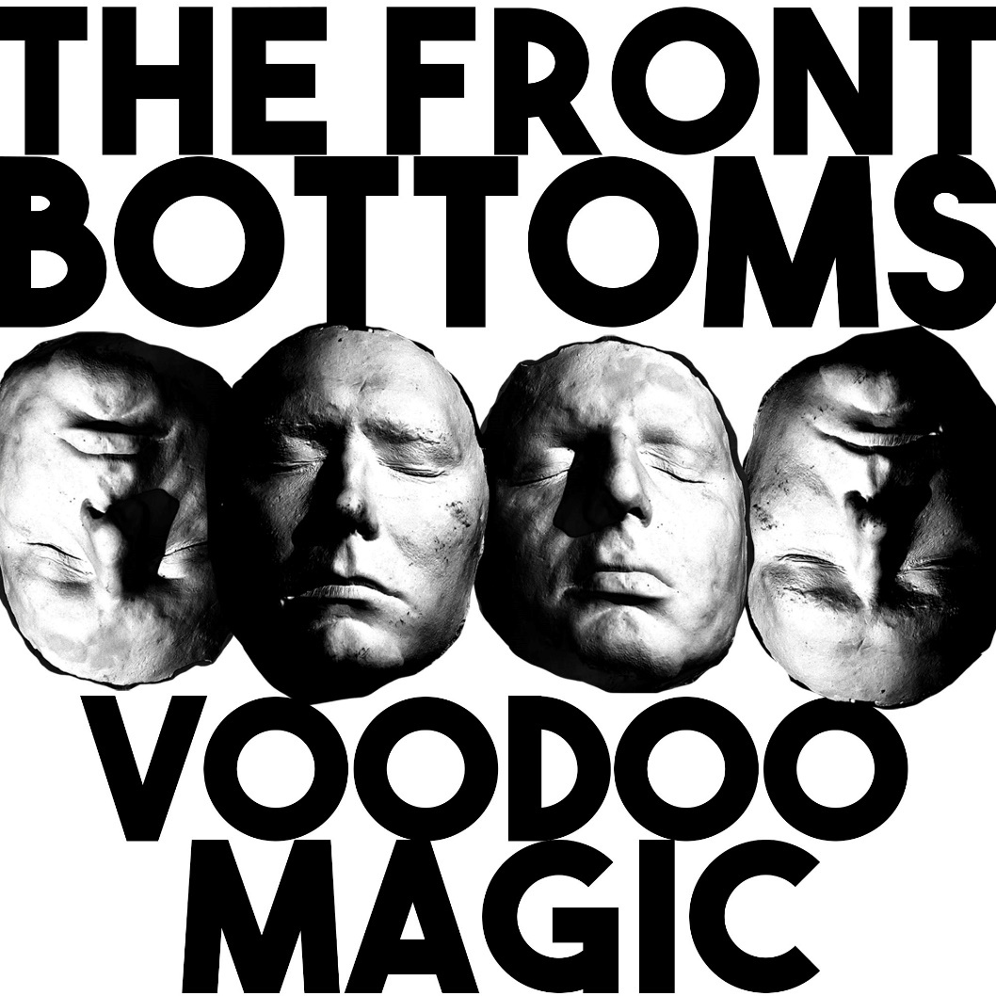

JUNE 9, 2021 – Fueled By Ramen band The Front Bottoms have released a new single “Voodoo Magic.” The track is available today on all streaming platforms with an accompanying animated music video streaming on The Front Bottoms’ YouTube channel.

“Day in, day out. The same old voodoo follows us about,” remarked The Front Bottoms’ Brian Sella and Mathew Uychich.

For “Voodoo Magic,” the band enlisted Matt Skiba of Blink-182 and Alkaline Trio to play guitar on the gleefully ironic, yet infectious punk anthem. Renowned for his infamous viral Sundance Film Festival short Dock Ellis & The LSD No-No, the band then recruited director James Blagden to helm the visual, animating two perspectives of a day where absolutely nothing can go right in his signature style.

The Front Bottoms have also revealed details for a 2021 U.S. headline tour, which marks their first proper headline run in support of last year’s critically acclaimed In Sickness & In Flames. Coming off the heels of a performance at Lollapalooza later this August, they’ll hit the road on September 14th in New Haven, CT at College Street Music Hall and visit major markets coast to coast before concluding the tour with a show at Starland Ballroom in Sayreville, NJ on October 24th. A special presale for members of The Front Bottoms’ Motorcycle Club goes live today at 10:00AM ET. Local presales will begin at 12:00PM ET on June 10th with general on sale commencing Friday June 11th at 12:00 PM local time. Support for the upcoming dates will be announced in the coming weeks.

Comprised of guitarist/vocalist Brian Sella and drummer Mathew Uychich, The Front Bottoms have gripped listeners and press around the world with their ragged honesty and emotional urgency. In 2020, The Front Bottoms released their celebrated new album, In Sickness & In Flames, a twelve song collection produced by Mike Sapone. NME attested, “In Sickness & In Flames is a defining work that showcases a sonic universe, rather than a structured set of songs, expertly capturing the inescapable tension of 2020.” A.V. Club declared, “The Front Bottoms are as vibrant as ever on In Sickness & In Flames, a reliably great collection of folk-punk anthems that rattle the soul with crunchy riffs, electrifying hooks, and Brian Sella’s idiosyncratic lyricism, which remains as amiable as it is anxiety-ridden.” UPROXX added “In Sickness & In Flames features the band’s biggest choruses to date, anchored with hooks and deeply personal songwriting that will turn heads,” while The FADER hailed it as, “a celebration of sorts for a band perennially on the fringes of a major breakthrough.” The Alternative detailed, “While In Sickness & In Flames was written prior to the pandemic, so much of it feels so tethered to our present collective experience, from the introspection and reflective growth that is showcased in the songwriting, to the sweeping highs and lows of the music itself. This album is the perfect companion piece to the anxiety of standing in the face of uncertainty.”

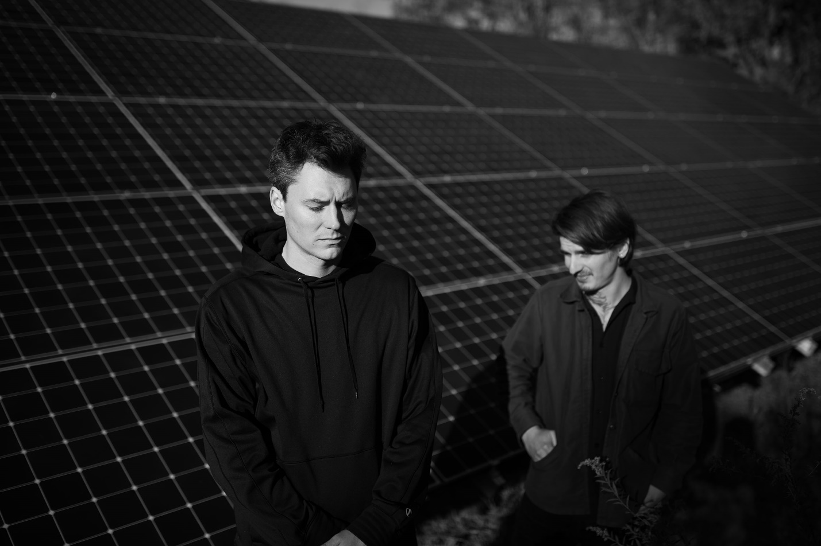
PHOTO CREDIT: MARK JAWORSKI

2021 TOUR DATES
9/14 – 10/24: Headline Dates

8/1 Chicago, IL Lollapalooza
9/14 New Haven, CT College Street Music Hall
9/15 New York, NY Pier 17
9/17 Silver Spring, MD Fillmore Silver Spring
9/18 Richmond, VA The National
9/19 Asheville, NC The Orange Peel
9/21 Tampa, FL The Ritz Ybor
9/22 Orlando, FL Hard Rock Live
9/23 Atlanta, GA The Masquerade (Heaven)
9/24 Nashville, TN Brooklyn Bowl
9/26 Houston, TX White Oak Music Hall
9/27 Dallas, TX Gas Monkey Live
9/28 Austin, TX Stubb’s
9/30 Phoenix, AZ The Van Buren
10/1 Anaheim, CA House of Blues Anaheim
10/2 Las Vegas, NV Brooklyn Bowl
10/3 Los Angeles, CA The Fonda Theatre
10/5 San Francisco, CA The Warfield
10/7 Portland, OR Roseland Theater
10/8 Seattle, WA Neptune Theatre
10/10 Salt Lake City, UT The Union
10/11 Denver, CO Mission Ballroom
10/13 Minneapolis, MN First Avenue
10/14 Lawrence, KS The Granada
10/15 ???????, IL Venue TBD
10/16 St. Louis, MO The Pageant
10/18 Detroit, MI The Fillmore Detroit
10/19 Cleveland, OH Agora Ballroom
10/21 Pittsburgh, PA Stage AE
10/22 Philadelphia, PA The Fillmore Philadelphia
10/23 Worcester, MA The Palladium
10/24 Sayreville, NJ Starland Ballroom

CONNECT WITH THE FRONT BOTTOMS:
WWW.THEFRONTBOTTOMS.COM
FACEBOOK
INSTAGRAM
TWITTER
FUELEDBYRAMEN.COM

FOR MORE INFORMATION, CONTACT:
ROSSANDERSON@ELEKTRA.COM

