THE FRONT BOTTOMS
ANNOUNCE SPECIAL THREE SHOW RESIDENCY AT WHITE EAGLE HALL

HOMETOWN PERFORMANCES SET FOR MAY 18TH, 19TH, & 20TH

PRE-SALE TICKETS AVAILABLE TODAY

GENERAL ON SALE BEGINS SEPTEMBER 10TH AT 12:00PM ET

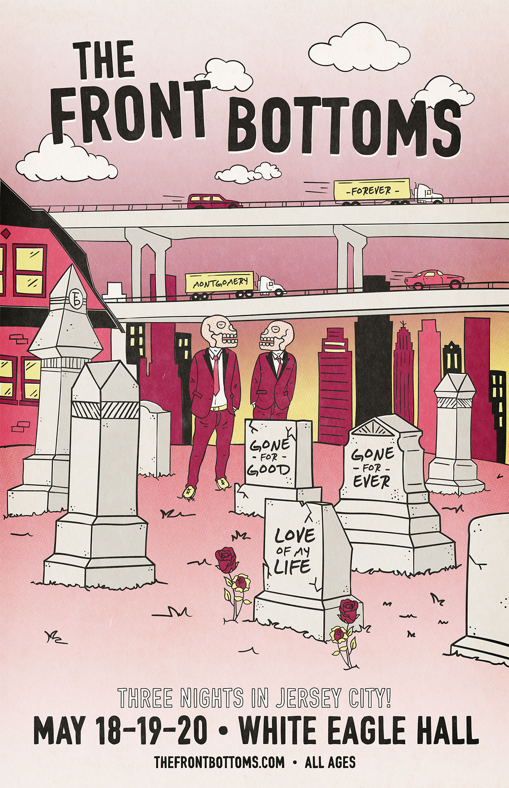

MARCH 11, 2022 – Fueled By Ramen band The Front Bottoms have announced a special three show residency at Jersey City’s White Eagle Hall. A celebratory homecoming for the New Jersey based band, the three night run will see The Front Bottoms delivering a unique set each night packed full of fan favorite tracks and rarities from their catalog. The three night run is slated to kick off on Wednesday May 18th and continue through Friday May 20th with pre-sale tickets available today via the band’s official fan club. An additional Brooklyn Vegan pre-sale will launch tomorrow, Thursday March 10th at 12:00PM ET with all remaining tickets for the three shows going on sale Friday March 11th at 12:00PM ET. For tickets and more information visit, www.thefrontbottoms.com.

The Jersey City shows will mark the first live performances from The Front Bottoms since the 2021 iteration of their popular year-end bash, Champagne Jam. Last years’ annual holiday festival was held at The Strand in Providence, RI and saw The Front Bottoms celebrating the 10 year anniversary of their breakthrough self-titled debut album.

The Front Bottoms recently shared the standalone singles “Lover Boy” and “Voodoo Magic,” the latter of which the band enlisted Matt Skiba of Blink-182 and Alkaline Trio to play guitar on.

Comprised of guitarist/vocalist Brian Sella and drummer Mathew Uychich, The Front Bottoms have gripped listeners and press around the world with their ragged honesty and emotional urgency. In 2020, The Front Bottoms released their celebrated new album, In Sickness & In Flames, a twelve song collection produced by Mike Sapone. NME attested, “In Sickness & In Flames is a defining work that showcases a sonic universe, rather than a structured set of songs, expertly capturing the inescapable tension of 2020.” A.V. Club declared, “The Front Bottoms are as vibrant as ever on In Sickness & In Flames, a reliably great collection of folk-punk anthems that rattle the soul with crunchy riffs, electrifying hooks, and Brian Sella’s idiosyncratic lyricism, which remains as amiable as it is anxiety-ridden.” UPROXX added “In Sickness & In Flames features the band’s biggest choruses to date, anchored with hooks and deeply personal songwriting that will turn heads,” while The FADER hailed it as, “a celebration of sorts for a band perennially on the fringes of a major breakthrough.” The Alternative detailed, “While In Sickness & In Flames was written prior to the pandemic, so much of it feels so tethered to our present collective experience, from the introspection and reflective growth that is showcased in the songwriting, to the sweeping highs and lows of the music itself. This album is the perfect companion piece to the anxiety of standing in the face of uncertainty.”

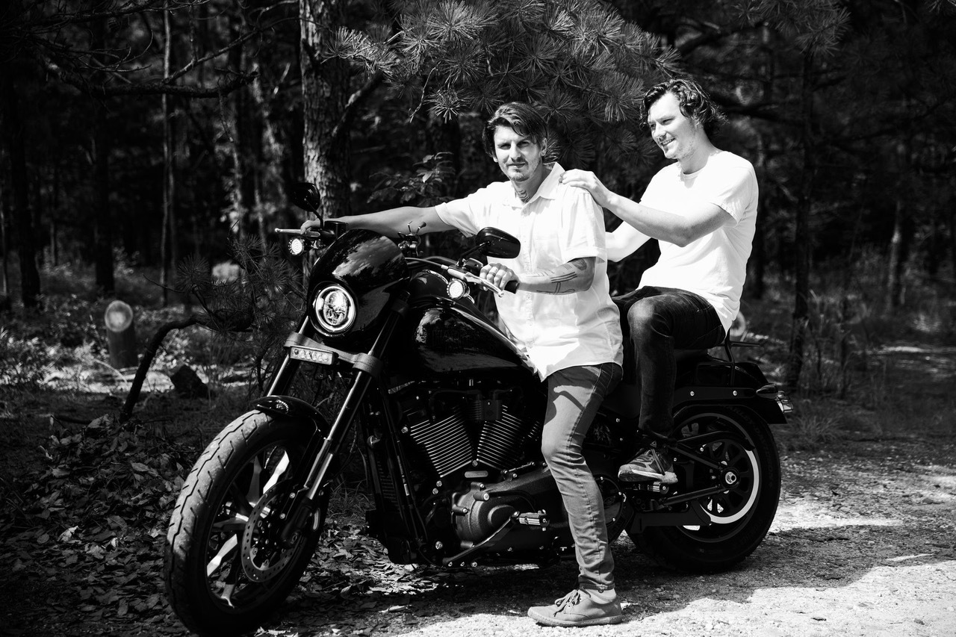
PHOTO CREDIT: MARK JAWORSKI

CONNECT WITH THE FRONT BOTTOMS:
WWW.THEFRONTBOTTOMS.COM
FACEBOOK
INSTAGRAM
TWITTER
WWW.FUELEDBYRAMEN.COM

FOR MORE INFORMATION, CONTACT:
ROSSANDERSON@ELEKTRA.COM

