SHARES NEW SINGLE “HOW DO I KNOW?”

ANNOUNCES FIRST-EVER NORTH AMERICAN HEADLINE TOUR
DATES KICK OFF MARCH 24TH IN NEW YORK CITY

NEW EP VICTORIA ARRIVES MARCH 11TH

DOWNLOAD PRESS ASSETS HERE

"pop prodigy" – NOTION

“fast rising star” – DIY

"alt-pop A-list" – DORK

“bubbling new bedroom pop” – CLASH

JANUARY 21, 2022 – Thomas Headon has shared “How Do I Know?,” the latest single from his upcoming EP Victoria, which arrives March 11th and is available for preorder now. Fueled with beachy chords, “How Do I Know?” comes accompanied by a live video reminiscent of early ‘00s garage bands, and sees Thomas perform in his backyard on a sunny day with his band while he navigates the confusing feelings between young love and lust. The artist also announced his first-ever North American headline tour, which kicks off March 24th at New York City’s Mercury Lounge and wraps up April 6th at Echo in Los Angeles, CA. General on-sale begins Tuesday, January 24th at 10am local time. For up-to-date ticketing information, please visit www.thomasheadon.com.

Headon expanded on the track, adding, “I wrote 'How Do I Know' after going on a first date. It's basically a song about questioning whether you're in love with someone or whether it's just an in-the-moment feeling lol. It was written back in Australia when I was home for the summer. I think it's super bright and fun for that reason and makes me glad I'm starting off the year by releasing this. It's one of the first songs I made off this EP and definitely one of my favourites.”

“How Do I Know?” follows Thomas’ recent hits “Nobody Has To Know” and the BBC Radio 1-playlisted “Strawberry Kisses” - which was also dubbed BBC Radio 1’s Hottest Record - as the third offering from his upcoming Victoria EP. Headon also collaborated with Chloe Moriondo and Alfie Templeton on November single “Dizzy,” which racked up praise from Billboard, E!, Entertainment Tonight, FLOOD Magazine, and more. Hundreds of lucky fans already got a chance to preview the new EP at Reading & Leeds festival, where Thomas played his first UK festival to a packed stage.

Born in London and raised in Melbourne, Thomas Headon dreamed of moving back to the city to pursue music and was told by his mom that he had a year to get a “proper job,” otherwise he would have to return home. Arriving in London just before the pandemic hit, Thomas started to build a community online – blowing up on TikTok with 15M likes and over 400K followers to date – with his off-kilter live sessions, tongue-in-cheek charm and remarkable songwriting ability. Learning to write and produce on his own in his late teens, Thomas has already released self-written and self-produced debut EP, The Greatest Hits, and dropped The Goodbye EP last year, amassing 55 million streams worldwide, all before his 21st birthday.

Building an incredibly loyal fanbase over lockdown, Thomas’ blend of playful alternative pop that speaks to the Gen-Z experience has been compared to the likes of the 1975’s Matty Healy, and critically praised by Triple J, naming him a “seriously impressive force in pop music.” Thomas performed a charmingly energetic live session on Jack Saunders’ BBC Radio 1 show, which followed his “Living Room Shows” tour, where he played an intimate acoustic series to thousands of fans across the UK. One of the first artists to curate Spotify’s Our Generation playlist, the 21-year-old has also collaborated with singer-songwriter Lizzy McAlpine on his single “Bored,” and gained over 50M global streams.

THOMAS HEADON
2022 NORTH AMERICAN HEADLINE TOUR DATES
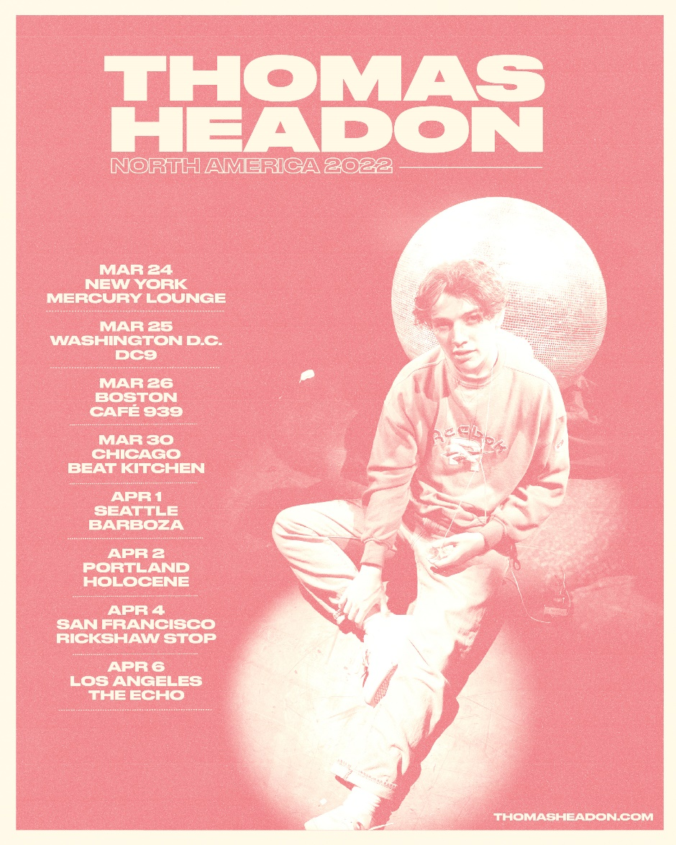

March 24 New York, NY Mercury Lounge
March 25 Washington, DC DC9
March 26 Boston MA Café 939
March 30 Chicago, IL Beat Kitchen
April 1 Seattle, WA Barboza
April 2 Portland, OR Holocene
April 4 San Francisco, CA Rickshaw
April 6 Los Angeles, CA Echo

THOMAS HEADON
VICTORIA EP – ARRIVING MARCH 11, 2022
PREORDER NOW

CONNECT WITH THOMAS HEADON
WEBSITE | INSTAGRAM | TIKTOK | TWITTER | YOUTUBE

For US press inquiries, please contact:
Sarah Goldstein
sarahgoldstein@elektra.com

