SHARES NEW SINGLE “NOBODY HAS TO KNOW”
OUT NOW VIA ELEKTRA RECORDS

OFFICIAL MUSIC VIDEO STREAMING NOW

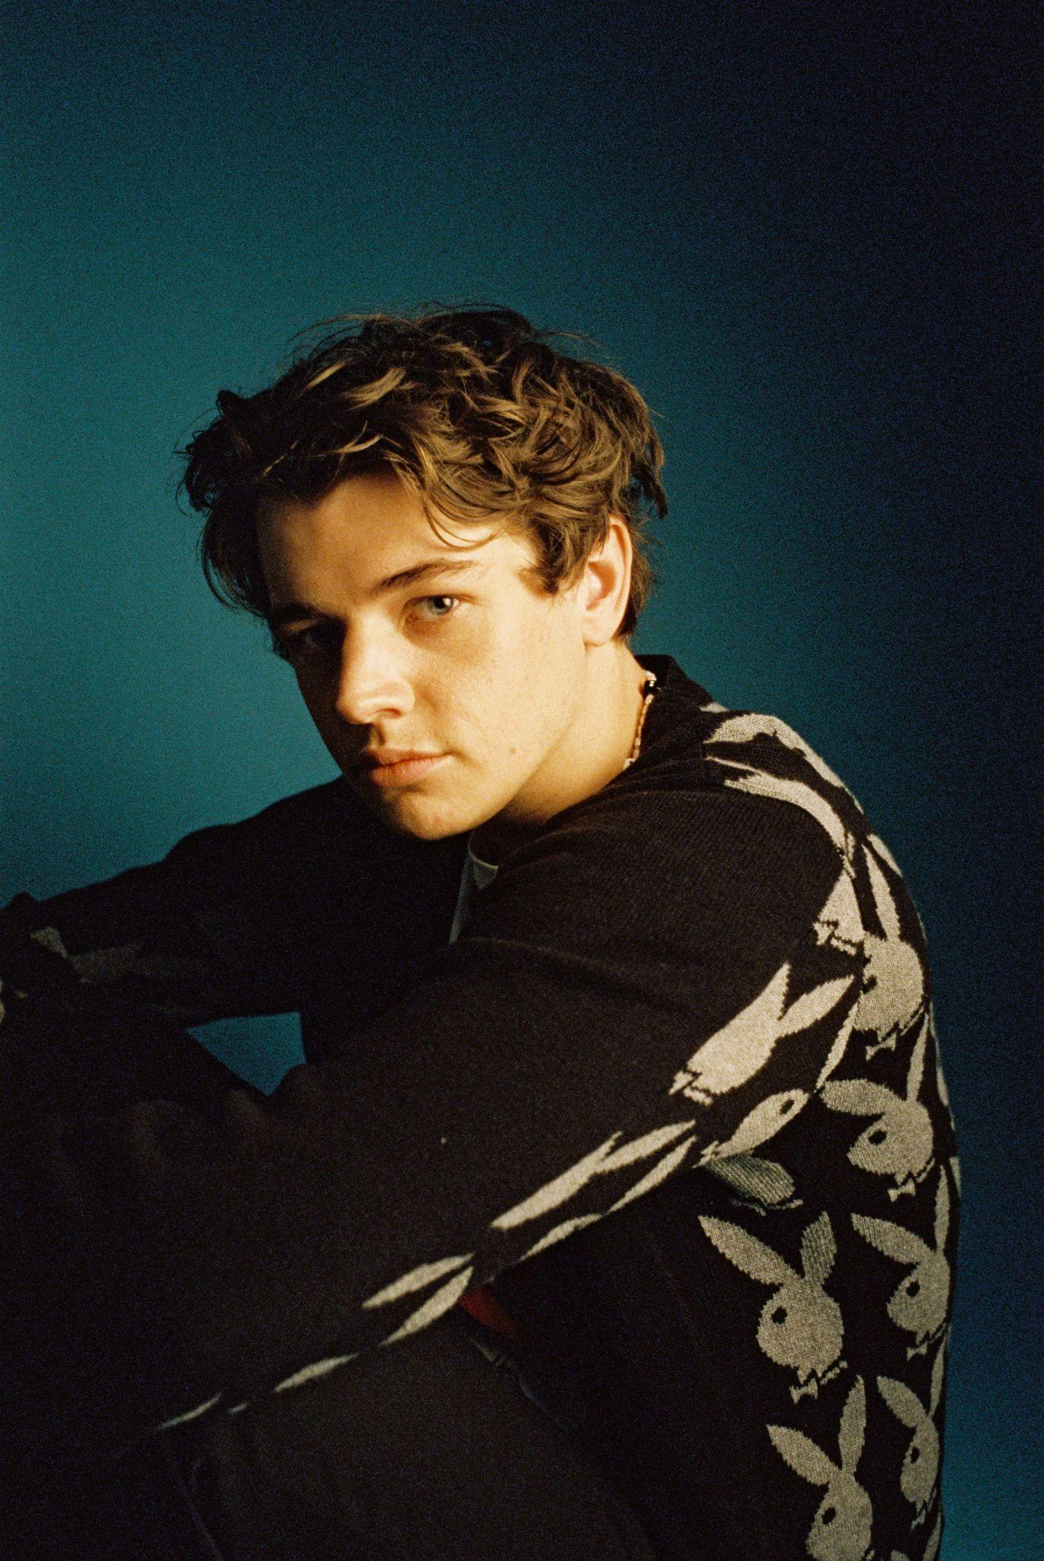
Photo by Jordan Curtis Hughs - download here

SEPTEMBER 10, 2021 – Thomas Headon has shared new single “Nobody Has To Know,” which premiered last night on Clara Amfo’s BBC Radio 1 show. The track is heralded by an official music video, streaming now on the artist’s official YouTube channel. Directed by Thomas and British photographer Jordan Curtis Hughes, the video is reminiscent of 90s garage rock bands in teen romcoms and sets the scene for a new star ready to break away from his parents’ garage and get a “proper job.” “Nobody Has To Know” is available now on all streaming platforms via Elektra Records.

Thomas elaborated on the single’s inspiration, commenting “I wrote ‘Nobody Has To Know’ in London when I was seeing someone, and we kept it cool with no emotional strings attached. I often find myself getting into those kinda situations and it gets really messy, but this one felt really fun and was exactly what the two of us wanted at the time. The song follows the innocence of that relationship, but I also wanted it to be a banging tune that was really fun to listen to and play live. It feels so good to finally have it out and moving in this direction, especially now that live shows are coming back and I have teased it to a point where everyone already knows the words.”

Born in London and raised in Melbourne, Thomas Headon dreamed of moving back to the city to pursue music and was told by his mom that he had a year to get a “proper job,” otherwise he would have to return home. Arriving in London just before the pandemic hit, Thomas started to build a community online with his off-kilter live sessions, tongue-in-cheek charm and remarkable songwriting ability. Learning to write and produce on his own in his late teens, Thomas has already released self-written and self-produced debut EP, The Greatest Hits, which has gained over 27 million streams, and dropped The Goodbye EP last year, all before his 20th birthday.

About Thomas Headon:
Building an incredibly loyal fanbase over lockdown, Thomas’ blend of playful alternative pop speaks to the Gen-Z experience and has earned him comparisons to the likes of the 1975’s Matty Healy and critical praise from Australia’s Triple J, who named him a “seriously impressive force in pop music.” Already performing a charmingly energetic live session on Jack Saunders’ BBC Radio 1 show, Thomas will head out on a UK headline tour in November. The new dates follow his “Living Room Shows” tour, where he played an intimate acoustic series to thousands of fans across the UK. One of the first artists to curate Spotify’s Our Generation playlist, the 20-year-old has also gained over 40M global streams, and his last single “Bored,” featuring singer-songwriter, Lizzy McAlpine, was praised by Thomas’s biggest fan – his mom, as “a pretty cute song.”

THOMAS HEADON
“NOBODY HAS TO KNOW”
AVAILABLE NOW

CONNECT WITH THOMAS HEADON
FACEBOOK | INSTAGRAM | TWITTER | YOUTUBE

Press contact:
Sarah Goldstein
sarahgoldstein@elektra.com

