ANNOUNCES NEW EP VICTORIA
ARRIVING MARCH 11, 2022

NEW SINGLE “STRAWBERRY KISSES” OUT NOW
WATCH THE OFFICIAL VIDEO HERE

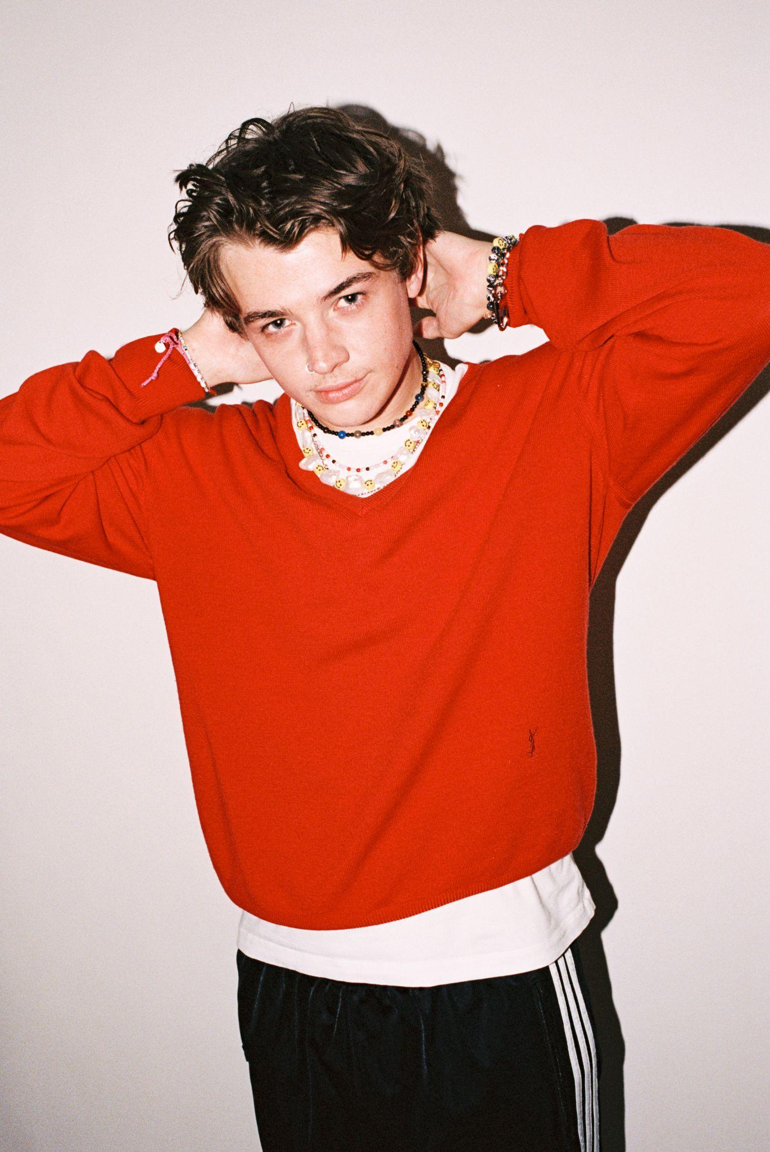
DOWNLOAD PRESS ASSETS HERE

“I’ve written the ‘Victoria’ EP over the course of 6 months in a bunch of different places. Musically it’s somewhere I’ve always wanted to be and I’m really glad that I’ve done it with this record. It’s basically a look into my diary over the past half year, being hopelessly f*cking in love and hopelessly in love with f*cking. It’s been quite a big step for me, putting out songs that are super honest and mean so much to me, but it feels great and I hope there’s a teenager somewhere experiencing what I did making this EP and relates to it in the same way.” - Thomas Headon

NOVEMBER 5, 2021 – Thomas Headon has announced new EP, Victoria, arriving March 11, 2022 and available to pre-order now. Alongside the announcement, he drops new single “Strawberry Kisses” which debuted as Clara Amfo’s Radio 1 Hottest Record in the World. The official video for “Strawberry Kisses,” directed by Thomas and British photographer Jordan Curtis Hughes, lets us spend an evening at the fairground with Thomas. We join him as he clambers onto various rides and eats at the food stalls. It's a fast-paced sugar rush, matching the dizziness of the upbeat banger.

PRE-ORDER VICTORIA EP

WATCH / LISTEN TO ‘STRAWBERRY KISSES’ HERE

“‘Strawberry Kisses’ is my experience of spending a night with someone who I didn’t really expect to. It was the classic experience of “they’re out of my league” suddenly turning into “never mind, this might be going somewhere.” I’ve been playing this song live for a while now, it feels good to finally have it out so people can hear it outside of the shows. I think it’s the most honest and straightforward I’ve been in a song, in a way that’s pushed me out of my comfort zone a bit, my mum doesn’t really like it for that reason.” - Thomas Headon

“Strawberry Kisses” follows recent single “Nobody Has To Know” as the second offering from his new body of work – but not before hundreds of fans got a preview of it at Reading & Leeds festival, where Thomas played his first UK festival to a packed out Dance Stage. Having instantly sold out his “Nobody Has To Know” poster merch, Thomas has now decided to one up himself and play delivery man as he plans to hand deliver a sofa to one lucky fan.

Born in London and raised in Melbourne, Thomas Headon dreamed of moving back to the city to pursue music and was told by his mom that he had a year to get a “proper job,” otherwise he would have to return home. Arriving in London just before the pandemic hit, Thomas started to build a community online – blowing up on TikTok with 14.7M likes and nearly 400K followers to date – with his off-kilter live sessions, tongue-in-cheek charm and remarkable songwriting ability. Learning to write and produce on his own in his late teens, Thomas has already released self-written and self-produced debut EP, The Greatest Hits, and dropped The Goodbye EP last year, amassing 50 million streams worldwide, all before his 21st birthday.

Building an incredibly loyal fanbase over lockdown, Thomas’ blend of playful alternative pop that speaks to the Gen-Z experience has been compared to the likes of the 1975’s Matty Healy, and critically praised by Triple J, naming him a “seriously impressive force in pop music.” Already performing a charmingly energetic live session on Jack Saunders’ BBC Radio 1 show, Thomas will head out on a 17-date European tour this month, including two sold out nights at London’s Heaven. The trek follows his “Living Room Shows” tour, where he played an intimate acoustic series to thousands of fans across the UK. One of the first artists to curate Spotify’s Our Generation playlist, the 21-year-old has also collaborated with singer-songwriter Lizzy McAlpine on his single “Bored,” and gained over 50M global streams.

THOMAS HEADON
VICTORIA EP – ARRIVING MARCH 11, 2022
PREORDER NOW

CONNECT WITH THOMAS HEADON
FACEBOOK | INSTAGRAM | TWITTER | TIKTOK | YOUTUBE

For US press inquiries, please contact:
Sarah Goldstein
sarahgoldstein@elektra.com

