TONES AND I
RETURNS WITH NEW SINGLE “EYES DON’T LIE”

OFFICIAL MUSIC VIDEO STREAMING NOW

INTERNATIONAL FESTIVAL PERFORMANCES SLATED FOR THIS SUMMER

NORTH AMERICAN HEADLINE TOUR DATES KICK OFF JULY 23RD

PHOTO CREDIT: GIULIA MCGAURAN

MARCH 17, 2022 – Global superstar Tones And I has returned with her new single “Eyes Don’t Lie,” available today on all streaming platforms. The single notably marks the first new music from Tones And I since the release of her celebrated debut album, Welcome To The Madhouse. Joined by an official music video directed by Tones And I, Nick Kozakis and Liam Kelly, “Eyes Don’t Lie” finds the Australian artist letting go of a toxic relationship and pushing forward through the wreckage.

Elaborating on the new track, Tones And I explained, “‘Eyes Don't Lie' is written about a large loss of someone / something. Resenting the person / feeling you get and realizing it was a toxic person / feeling all along. Someone taking advantage of you and you taking advantage of yourself. Feeling better off and putting that last bit of bitterness behind you.” Commenting on the song’s companion visual she added, “The music video reflects being alone, but not lonely. Escaping something that hurt and happy to be wherever else, even though it's over. I am still reflecting and telling my story one last time, before I move on.”

This summer, Tones And I will embark on a slate of global performances including a run of international festival dates which will include appearances at Mexico’s Tecate Emblema Festival, The Netherlands’ Pinkpop Festival, Spain’s Mad Cool Festival and more. Tones And I will also make a handful of headline European appearances in Belgium, France, Austria, and the United Kingdom before heading across the Atlantic for the North American leg of her headline tour which will get underway July 23rd in Philadelphia, PA [full tour itinerary below]. For more information on Tones And I’s tour dates and tickets to upcoming shows, visit www.tonesandi.com [full itinerary below].

Released this past July, Welcome To The Madhouse debuted at #1 on Australia’s ARIA Albums Chart continuing an incredible string of successes for Tones And I. The record details an intimately honest and vivid journey from busking in Byron Bay to international stardom to saying goodbye to her best friend. Tones And I weaves it all together into a moving and magnetic 14-track collection written entirely by the Australian artist with her co-producing every song. The album is highlighted by the single “Fly Away,” a poetic and powerful composition which Tones And I delivered performances of on Jimmy Kimmel Live! and The Ellen DeGeneres Show. Welcome To The Madhouse also features “Won’t Sleep,” which arrived alongside a Tones And I, Nick Kozakis and Liam Kelly directed official music video, and “Cloudy Day,” which VARIETY hailed as “the perfect pandemic anthem” with Tones And I performing the song on The Late Show with Stephen Colbert and TODAY.

Tones And I exploded in to pop culture’s consciousness with her global smash “Dance Monkey,” the most Shazamed single of all time, and officially the 3rd most streamed song of all time on Spotify making the track the most streamed song ever by a female artist on the platform. Since its release, the “Dance Monkey” official music video has surpassed 1.8 billion views on YouTube, while the track has eclipsed seven billion streams globally and earned 6x platinum certification from the RIAA in the US as well as multi-platinum or diamond certification in sixteen other countries. Plus, “Dance Monkey” hit #4 on Billboard’s Hot 100 chart, making “Dance Monkey” the first top five Hot 100 hit solely written by a woman in over eight years. In Australia, “Dance Monkey” holds the all-time record for the most weeks spent at #1 on the ARIA Singles Chart, while in the UK “Dance Monkey” has made Tones And I the longest running #1 of all time by a female artist on the Official Singles Chart. The New York Times detailed the making of “Dance Monkey” in their Diary of a Song video series, speaking with Tones And I about her journey from local busker to global star.

“Dance Monkey” is featured on Tones And I’s RIAA gold certified debut EP The Kids Are Coming which earned her four major wins back home at last year’s ARIA Awards including: “Breakthrough Artist,” “Best Female Artist,” “Best Pop Release,” and “Best Independent Release.” Following the EP’s release Tones And I showcased her staggering voice across performances of “Dance Monkey” and standout single “Never Seen The Rain,” appearing on The Tonight Show Starring Jimmy Fallon, The Voice, The Ellen DeGeneres Show and The Today Show.

Originally from Australia’s Mornington Peninsula, Tones And I traveled to Byron Bay in early 2018 to take a chance at busking. On the first day she had crowds spilling onto the street. Tones quit her retail job and decided to make Byron her new home where she lived out of her van for a year, honing her songwriting and busking every weekend. A year later, she had one of the biggest songs in the world with her global smash “Dance Monkey.”

[SINGLE ART / TOUR ITINERARY BELOW]

“EYES DON’T LIE”
SINGLE ARTWORK

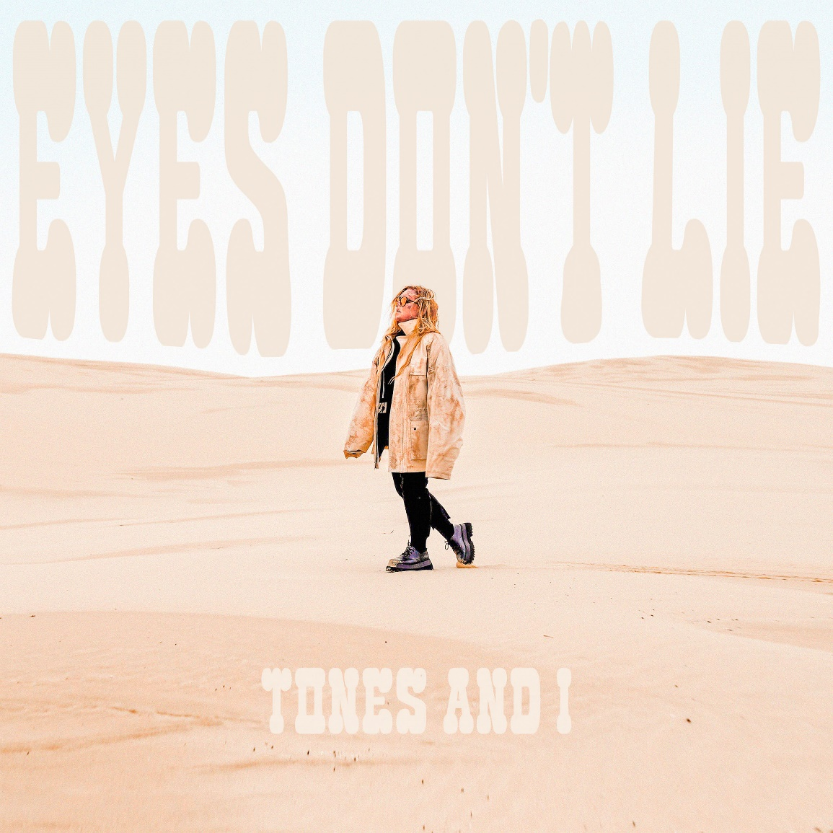

2022 WORLD TOUR DATES

May 13-14 - Mexico City, Mexico - Tecate Emblema Festival 2022*
June 17 - Neuhausen OB Eck, Germany - Southside Festival 2022*
June 18 - Landgraaf, Netherlands - Pinkpop Festival 2022*
June 19 - Scheessel, Germany - Hurricane Festival 2022*
June 29 - Brussels, Belgium - Ancienne Belgique (AB)
June 30 - Paris, France - Le Bataclan
July 2 - St. Gallen, Switzerland - Open Air St. Gallen 2022*
July 3 - Arras, France - Main Square Festival 2022*
July 5 - Vienna, Austria - Planet TT
July 7 - Aix Les Bains, France - Musilac 2022*
July 8 - Perpignan, France - Les Deferlantes 2022*
July 10 - Madrid, Spain - Mad Cool Festival 2022*
July 12 - London, United Kingdom - O2 Shepherds Bush Empire
July 14 - Dublin, Ireland - National Stadium
July 15 - Glasgow, United Kingdom - Barrowlands 2
July 17 - Joensuu, Finland - Ilosaarirock 2022*
July 23 - Philadelphia, PA - Union Transfer
July 24 - Boston, MA - House of Blues
July 26 - New York, NY - Terminal 5
July 28 - Toronto, ON - The Danforth Music Hall
July 30 - Baltimore, MD - Baltimore Soundstage
August 2 - Denver, CO - Ogden Theatre
August 5 - Seattle, WA - The Showbox
August 6 - Portland, OR - Wonder Ballroom
August 7 - Vancouver, BC - Commodore Ballroom
August 10 - Los Angeles, CA - The Wiltern
August 11 - San Diego, CA - SOMA
August 13 - San Francisco, CA - The Independent
August 14 - San Francisco, CA - Bimbo's 365 Club

*Festival Performance

FOR MORE INFORMATION ON TONES AND I:
FACEBOOK / TWITTER / INSTAGRAM / YOUTUBE / SPOTIFY / APPLE MUSIC / AMAZON MUSIC

CONTACT FOR TONES AND I:
Ross Anderson
RossAnderson@Elektra.com

Glenn Fukushima
GlennFukushima@Elektra.com

