TWENTY ONE PILOTS
SHARE NEW TRACK & OFFICIAL VIDEO - “CHOKER”

“SHY AWAY” HITS #1 AT ALTERNATIVE RADIO

“TWENTY ONE PILOTS - LIVESTREAM EXPERIENCE”
BROADCASTING WORLDWIDE MAY 21ST AT 8PM ET / 5PM PT

GLOBAL SMASH “STRESSED OUT” CERTIFIED DIAMOND BY RIAA

NEW ALBUM SCALED AND ICY ARRIVES MAY 21ST

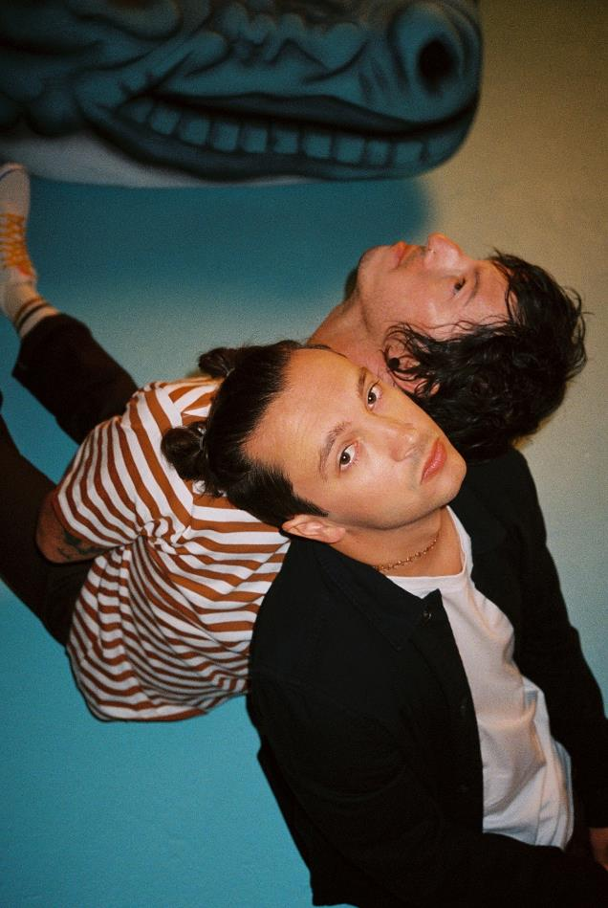
PHOTO CREDIT: ASHLEY OSBORN

APRIL 30, 2021 – GRAMMY® Award winning duo Twenty One Pilots have released “Choker” today on all streaming platforms, the second track from their widely anticipated new album, Scaled And Icy, which arrives May 21st via Fueled By Ramen [album artwork / tracklist below]. “Choker” is accompanied by an official music video directed by Mark Eshleman for Reel Bear Media and shot in the band’s hometown of Columbus, OH.

“Choker” follows on the heels of Scaled And Icy’s lead single, “Shy Away,” which rapidly ascended to #1 at the Alternative Radio format in only three weeks since its debut. The achievement places the duo in an elite group of acts with multiple songs to rise to #1 at the format in three weeks or less including: U2, R.E.M., The Cure, Linkin Park, Red Hot Chili Peppers, and Foo Fighters. “Shy Away” was released with a Miles & AJ directed official music video and is available as an instant grat download alongside “Choker” with all pre-orders of Scaled And Icy , which is available in a variety of formats including a special edition box set limited to 35,000 copies worldwide. Scaled And Icy is Twenty One Pilots’ first studio album in three years and follows their RIAA Platinum certified LP, Trench.

Twenty One Pilots first-ever global streaming event, “Twenty One Pilots - Livestream Experience,” will broadcast worldwide on Friday, May 21st at 8:00PM ET / 5:00PM PT. “Twenty One Pilots - Livestream Experience” promises to be an unforgettable live performance from the duo, with a catalog spanning setlist and the live debut of new material from Scaled And Icy. A Team Twenty One Pilots Production, the multi-dimensional live performance is being produced by longtime collaborators and creative partners: TNSN DVSN, Reel Bear Media, Element1, lili STUDIOS, and hosted on Maestro’s livestream platform. Sponsored by Chipotle and Hot Topic, tickets for the groundbreaking global streaming event are on sale today at live.twentyonepilots.com where ticket holders can access an interactive virtual experience and immerse themselves in exclusive merch, content, and more as they move toward the official live date and performance.

Furthermore, Twenty One Pilots’ global smash “Stressed Out” is now certified Diamond (10x Platinum) by the RIAA. The breakthrough single earned Twenty One Pilots a GRAMMY® Award for “Best Pop Duo / Group Performance” and was featured on their 2015 LP Blurryface - the first album of the digital era with every individual track from the album receiving Gold, Platinum or Multi-Platinum certification from the RIAA. In 2019 Twenty One Pilots announced that their 2013 LP Vessel achieved the same milestone, making the duo the first artist / group with two albums to reach this landmark achievement.

Written and largely produced by Joseph in isolation over the course of the past year at his home studio, with Dun engineering the album’s drums from across the country, Scaled And Icy is the product of long-distance virtual sessions and finds the duo processing their upended routines along with the prevailing emotions of 2020 - anxiety, loneliness, boredom, and doubt. The duo had to forgo their normal studio sessions but reached a new of level of introspection in the process, adopting a more imaginative and bold approach to their songwriting. The result is a collection of songs that push forward through setbacks and focus on the possibilities worth remembering.

In 2020, Twenty One Pilots surprised fans with standalone singles “Level of Concern” and “Christmas Saves The Year.” “Level of Concern” reigned at Alternative Radio for 12 weeks straight and cracked the Top 25 on Billboard’s “Hot 100” chart, while also achieving RIAA Gold certification, and propelling the band to victory at last year’s American Music Awards where they took home the award for “Favorite Artist – Alternative Rock.” “Christmas Saves The Year” arrived at the tail end of 2020 and debuted on Billboard’s “Alternative Airplay” chart becoming the first holiday-themed song to make the list since 2012.

Twenty One Pilots scored one final accolade in the final moments of 2020, officially breaking the GUINNESS WORLD RECORD™ for the longest music video with their history-making regenerative visual for “Level of Concern.” Conceived by the band with interactive director Jason Nickel, and award-winning storyteller / director Jason Zada, the first-ever ‘Never-Ending Music Video’ pulled in fan created content from over 162,000 user submissions, in real time, live on YouTube. Powered by Imposium, every three minutes and forty seconds a new music video was created and streamed live to YouTube, containing brand new content from fans. Besting the previous record holder, Pharrell and his 24-hour long video for “Happy,” Twenty One Pilots’ ‘Never-Ending Music Video’ for “Level of Concern” broadcasted for 177 days straight with a total run time of 4,264 hours, 10 mins, 25 seconds.

Twenty One Pilots’ 2018 LP Trench ushered in a new era for the duo from Ohio. Earning Platinum certification from the RIAA, the album was met with critical acclaim with Billboard declaring, “Trench revels in the confounding genre-blurring and cavernous conceptualism that has defined Twenty One Pilots.” A true global phenomenon having surpassed two billion streams worldwide, Trench is highlighted by the RIAA Gold and Platinum certified alternative hits “The Hype,” “Chlorine,” and “Jumpsuit.” “Jumpsuit” stands as the decade’s fastest rising song to reach #1 on Billboard’s “Alternative Songs” chart and earned the duo their fourth GRAMMY® nomination (Best Rock Song). The acclaimed conceptual collection also features the RIAA Gold-certified “Nico And The Niners” and the RIAA Platinum-certified single “My Blood.”

Twenty One Pilots
Scaled And Icy

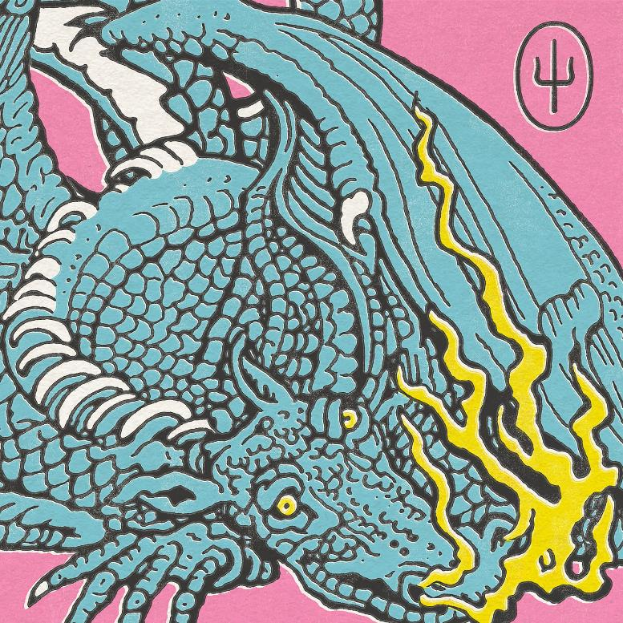
- Good Day
- Choker
- Shy Away
- The Outside
- Saturday
- Never Take It
- Mulberry Street
- Formidable
- Bounce Man
- No Chances
- Redecorate

“Twenty One Pilots – Livestream Experience”
Tickets: live.twentyonepilots.com

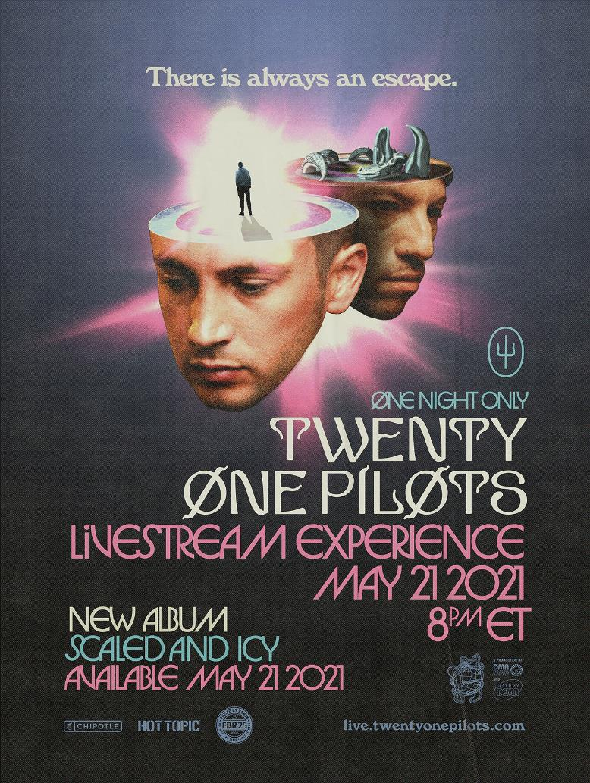

###

For more information on Twenty One Pilots, contact:
Ross Anderson | RossAnderson@Elektra.com

Follow Twenty One Pilots:
Official | Facebook | Instagram | Twitter | YouTube

