TWENTY ONE PILOTS
RETURN WITH NEW ALBUM SCALED AND ICY

SHARE LEAD SINGLE & MUSIC VIDEO - “SHY AWAY”

ANNOUNCE “TWENTY ONE PILOTS - LIVESTREAM EXPERIENCE”

IMMERSIVE LIVE PERFORMANCE TO BROADCAST WORLDWIDE
MAY 21ST AT 8:00PM ET

ALBUM PRE-ORDERS & LIVESTREAM TICKETS AVAILABLE TODAY

SCALED AND ICY ARRIVES MAY 21ST

PHOTO CREDIT: ASHLEY OSBORN

APRIL 7, 2021 – GRAMMY® Award winning duo Twenty One Pilots have announced their new album, Scaled And Icy, which will be released May 21st via Fueled By Ramen [album artwork / tracklist below]. Today, the band has shared the forthcoming album’s first single, “Shy Away,” which is available on all streaming platforms and is accompanied by a Miles & AJ directed official music video. Available for pre-order today in a variety of formats, with a special edition box set pre-order launching on April 9th, Scaled And Icy is Twenty One Pilots’ first studio album in three years and follows their RIAA Platinum certified LP, Trench.

In addition to the news of the forthcoming album, Twenty One Pilots have also announced their first-ever global streaming event, “Twenty One Pilots - Livestream Experience,” which is scheduled to broadcast worldwide on Friday, May 21st at 8:00PM ET. “Twenty One Pilots - Livestream Experience” promises to be an unforgettable performance from the duo, with a catalog spanning setlist that will also mark the live debut of new material from Scaled And Icy. Tickets for the groundbreaking global streaming event are on sale today at live.twentyonepilots.com where the band has also launched a special pre-show virtual experience for fans to immerse themselves in as they move toward the official live date and performance. The livestream is sponsored by Chipotle and Hot Topic, while the interactive and immersive experiences are conceived and produced by lili STUDIOS, and powered by Maestro’s livestream platform [livestream admat below].

Written and largely produced by Joseph in isolation over the course of the past year at his home studio, with Dun engineering the album’s drums from across the country, Scaled And Icy is the product of long-distance virtual sessions and finds the duo processing their upended routines along with the prevailing emotions of 2020 - anxiety, loneliness, boredom, and doubt. The duo had to forgo their normal studio sessions but reached a new of level of introspection in the process, adopting a more imaginative and bold approach to their songwriting. The result is a collection of songs that push forward through setbacks and focus on the possibilities worth remembering.

In 2020, Twenty One Pilots surprised fans with standalone singles “Level of Concern” and “Christmas Saves The Year.” “Level of Concern” reigned at Alternative Radio for 12 weeks straight and cracked the Top 25 on Billboard’s “Hot 100” chart, while also achieving RIAA Gold certification, and propelling the band to victory at last year’s American Music Awards where they took home the award for “Favorite Artist – Alternative Rock.” “Christmas Saves The Year” arrived at the tail end of 2020 and debuted on Billboard’s “Alternative Airplay” chart becoming the first holiday-themed song to make the list since 2012.

Furthermore, Twenty One Pilots scored one final accolade in the final moments of 2020, officially breaking the GUINNESS WORLD RECORD™ for the longest music video with their history-making regenerative visual for “Level of Concern.” Conceived by the band with interactive director Jason Nickel, and award-winning storyteller / director Jason Zada, the first-ever ‘Never-Ending Music Video’ pulled in fan created content from over 162,000 user submissions, in real time, live on YouTube. Powered by Imposium, every three minutes and forty seconds a new music video was created and streamed live to YouTube, containing brand new content from fans. Besting the previous record holder, Pharrell and his 24-hour long video for “Happy,” Twenty One Pilots’ ‘Never-Ending Music Video’ for “Level of Concern” broadcasted for 177 days straight with a total run time of 4,264 hours, 10 mins, 25 seconds.

Twenty One Pilots’ 2018 LP Trench ushered in a new era for the duo from Ohio. Earning Platinum certification from the RIAA, the album was met with critical acclaim with Billboard declaring, “Trench revels in the confounding genre-blurring and cavernous conceptualism that has defined Twenty One Pilots.” A true global phenomenon having surpassed two billion streams worldwide, Trench is highlighted by the RIAA Gold and Platinum certified alternative hits “The Hype,” “Chlorine,” and “Jumpsuit.” “Jumpsuit” stands as the decade’s fastest rising song to reach #1 on Billboard’s “Alternative Songs” chart and earned the duo their fourth GRAMMY® nomination (Best Rock Song). The acclaimed conceptual collection also features the RIAA Gold-certified “Nico And The Niners” and the RIAA Platinum-certified single “My Blood.”

In 2019 Twenty One Pilots announced that their 2013 LP Vessel achieved a Gold & Platinum milestone with every individual track from the album receiving Gold, Platinum or Multi-Platinum certification from the RIAA. Twenty One Pilots’ 2015 LP Blurryface was the first album of the digital era to achieve this feat back in 2018, making the duo the first artist / group with two albums to reach this landmark achievement.

Twenty One Pilots
Scaled And Icy

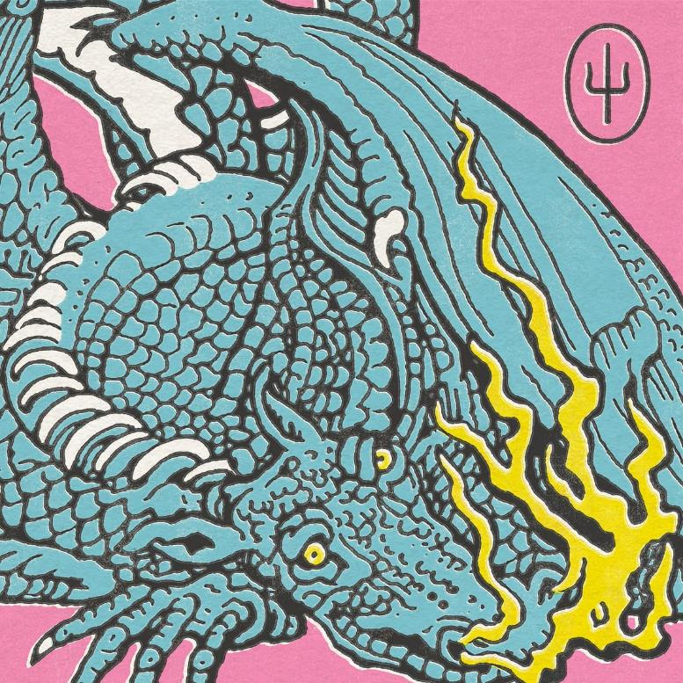
- Good Day
- Choker
- Shy Away
- The Outside
- Saturday
- Never Take It
- Mulberry Street
- Formidable
- Bounce Man
- No Chances
- Redecorate

“Twenty One Pilots – Livestream Experience”

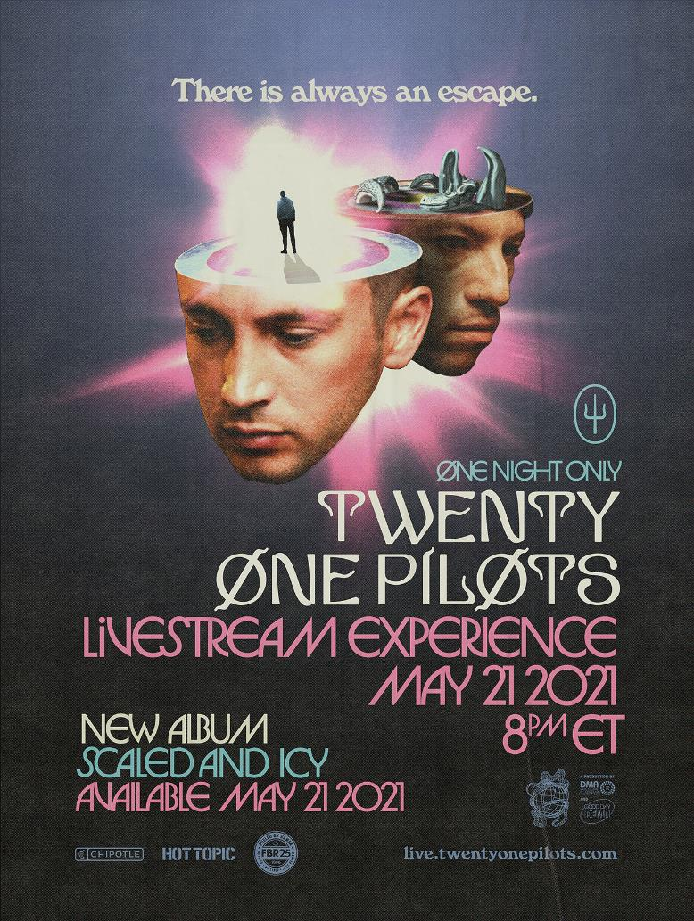

###

For more information on Twenty One Pilots, contact:
Ross Anderson | RossAnderson@Elektra.com

Follow Twenty One Pilots:
Official | Facebook | Instagram | Twitter | YouTube

