TWENTY ONE PILOTS
SHARE “SATURDAY” OFFICIAL MUSIC VIDEO

2021-2022 “TAKEØVER TOUR” KICKS OFF SEPTEMBER 21ST

NEW DATES INCLUDE MULTIPLE SOLD-OUT NIGHTS IN DENVER, LOS ANGELES, CHICAGO, BOSTON, COLUMBUS, ATLANTA & LONDON INCLUDING RARE INTIMATE CLUB SHOWS

TICKETS AVAILABLE HERE

NEW ALBUM SCALED AND ICY OUT NOW

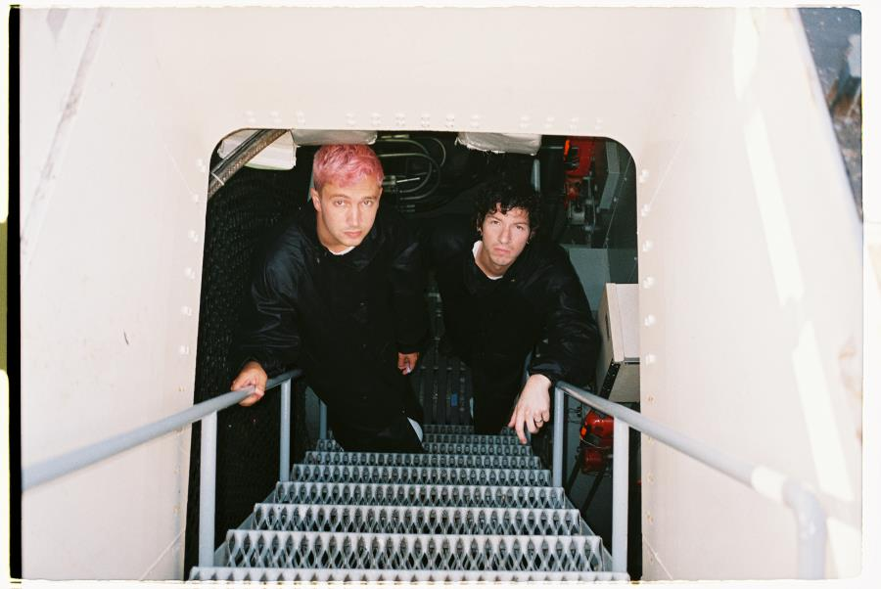
PHOTO CREDIT: ASHLEY OSBORN

JULY 8, 2021 – GRAMMY® Award winning duo Twenty One Pilots have shared an official music video for their single “Saturday,” which is featured on their new album Scaled And Icy. Directed by Andrew Donoho, the “Saturday” official music video was shot over the course of a week this past May, utilizing multiple locations including a custom underwater set and an operating submarine. The video sees the band submerging for a literal underwater performance at a deep sea party before an unexpected visitor crashes the celebration. Watch the “Saturday” official music video now on Twenty One Pilots’ YouTube channel.

The “Saturday” video arrives on the heels of Twenty One Pilots’ 2021 - 2022 “Takeøver Tour” announcement. Largely sold-out, the upcoming, dates are set to kick off on September 21st and will see Twenty One Pilots performing multiple nights in Denver, Los Angeles, Chicago, Boston, Columbus, Atlanta, and London, scaling in each market from rare and intimate club performances to full-on arena spectacles [tour itinerary / admat below]. For complete details and ticket availability for Twenty One Pilots’ “Takeøver Tour” visit www.twentyonepilots.com/takeovertour.

Twenty One Pilot’s acclaimed new album, Scaled And Icy is available on all streaming platforms and in a variety of formats at store.twentyonepilots.com. Scaled And Icy debuted at No. 1 on Billboard's Top “Rock Albums” and “Alternative Albums” charts while landing at No. 3 on the “Billboard 200,” marking the biggest opening week for a rock album in 2021. The new record is highlighted by standouts “Saturday,” “Choker” and lead single “Shy Away,” which is currently #1 at Alternative Radio for an eighth consecutive week. Having ascended to #1 at the format in just three weeks, “Shy Away” places the duo in an elite group of acts with multiple songs to rise to #1 at the format in three weeks or less including: U2, R.E.M., The Cure, Linkin Park, Red Hot Chili Peppers, and Foo Fighters.

Furthermore, Twenty One Pilots recently shared a performance of “Shy Away” from their first-ever global streaming event, “Twenty One Pilots - Livestream Experience.” Originally broadcasted around the globe on May 21st, “Twenty One Pilots - Livestream Experience” ushered in a new standard in the livestreaming space with Billboard declaring, “After seven months of meticulous planning and two weeks of marathon rehearsals, Twenty One Pilots pulled off a home-brewed Las Vegas-worthy spectacle.”

Written and largely produced by Tyler Joseph in isolation over the course of the past year at his home studio, with Dun engineering the album’s drums from across the country, Scaled And Icy is the product of long-distance virtual sessions and finds the duo processing their upended routines along with the prevailing emotions of 2020 - anxiety, loneliness, boredom, and doubt. The duo had to forgo their normal studio sessions but reached a new of level of introspection in the process, adopting a more imaginative and bold approach to their songwriting. The result is a collection of songs that push forward through setbacks and focus on the possibilities worth remembering. Scaled And Icy is Twenty One Pilots’ first studio album in three years and follows their RIAA Platinum certified LP, Trench.

In 2020, Twenty One Pilots surprised fans with standalone singles “Level of Concern” and “Christmas Saves The Year.” “Level of Concern” reigned at Alternative Radio for 12 weeks straight and cracked the Top 25 on Billboard’s “Hot 100” chart, while also achieving RIAA Gold certification. The track propelled the band to victory at the 2021 iHeartRadio Music Awards where they took home “Alternative Rock Song” and “Alternative Rock Artist Of The Year” awards, in addition to an American Music Award in 2020 for “Favorite Artist – Alternative Rock.” Furthermore, the history making regenerative video for “Level of Concern” broke the GUINNESS WORLD RECORD™ for the longest music video. “Christmas Saves The Year” arrived at the tail end of 2020 and debuted on Billboard’s “Alternative Airplay” chart becoming the first holiday-themed song to make the list since 2012.

Twenty One Pilots’ 2018 LP Trench ushered in a new era for the duo from Ohio. Earning Platinum certification from the RIAA, the album was met with critical acclaim with Billboard declaring, “Trench revels in the confounding genre-blurring and cavernous conceptualism that has defined Twenty One Pilots.” A true global phenomenon having surpassed two billion streams worldwide, Trench is highlighted by the RIAA Gold and Platinum certified alternative hits “The Hype,” “Chlorine,” and “Jumpsuit.” “Jumpsuit” stands as the decade’s fastest rising song to reach #1 on Billboard’s “Alternative Songs” chart and earned the duo their fourth GRAMMY® nomination (Best Rock Song). The acclaimed conceptual collection also features the RIAA Gold-certified “Nico And The Niners” and the RIAA Platinum-certified single “My Blood.”

TWENTY ONE PILOTS
“TAKEØVER TOUR”
www.twentyonepilots.com/takeovertour

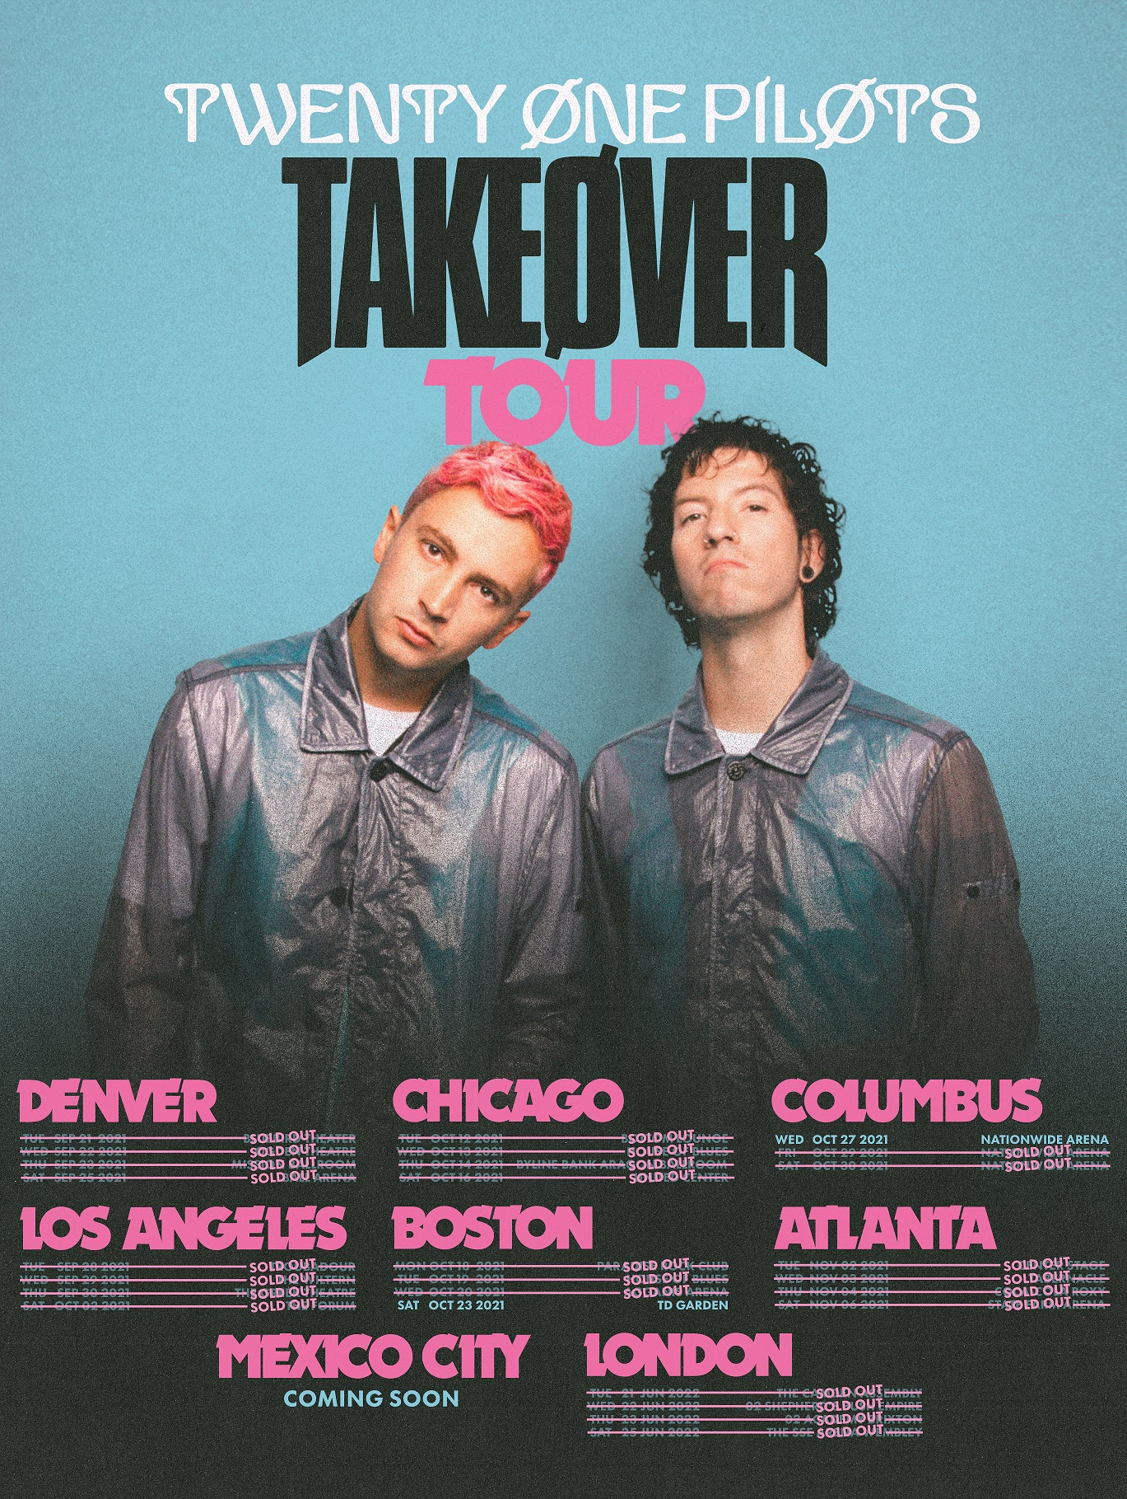

Sep 21: Denver, CO @ Bluebird Theater (SOLD OUT)
Sep 22: Denver, CO @ Ogden Theatre (SOLD OUT)
Sep 23: Denver, CO @ The Mission Ballroom (SOLD OUT)
Sep 25: Denver, CO @ Ball Arena (SOLD OUT)

Sep 28: Los Angeles, CA @ Troubadour (SOLD OUT)
Sep 29: Los Angeles, CA @ The Wiltern (SOLD OUT)
Sep 30: Los Angeles, CA @ The Greek Theatre (SOLD OUT)
Oct 02: Los Angeles, CA @ The Forum (SOLD OUT)

Oct 12: Chicago, IL @ Bottom Lounge (SOLD OUT)
Oct 13: Chicago, IL @ House of Blues (SOLD OUT)
Oct 14: Chicago, IL @ Byline Bank Aragon Ballroom (SOLD OUT)
Oct 16: Chicago, IL @ United Center (SOLD OUT)

Oct 18: Boston, MA @ Paradise Rock Club (SOLD OUT)
Oct 19: Boston, MA @ House of Blues (SOLD OUT)
Oct 20: Boston, MA @ Agganis Arena (SOLD OUT)
Oct 23: Boston, MA @ TD Garden

Oct 27: Columbus, OH @ Nationwide Arena
Oct 29: Columbus, OH @ Nationwide Arena (SOLD OUT)
Oct 30: Columbus, OH @ Nationwide Arena (SOLD OUT)

Nov 02: Atlanta, GA @ Center Stage (SOLD OUT)
Nov 03: Atlanta, GA @ Tabernacle (SOLD OUT)
Nov 04: Atlanta, GA @ Coca-Cola Roxy (SOLD OUT)
Nov 06: Atlanta, GA @ State Farm Arena (SOLD OUT)

Mexico City
Coming soon

Jun 21: London, UK @ The Camden Assembly (SOLD OUT)
Jun 22: London, UK @ O2 Shepherd’s Bush Empire (SOLD OUT)
Jun 23: London, UK @ O2 Academy Brixton (SOLD OUT)
Jun 25: London, UK @ The SSE Arena Wembley (SOLD OUT)

###

For more information on Twenty One Pilots, contact:
Ross Anderson | RossAnderson@Elektra.com

Follow Twenty One Pilots:
Official | Facebook | Instagram | Twitter | YouTube

