UNTO OTHERS
RELEASE NEW ALBUM STRENGTH

ANNOUNCE 2021 U.S. HEADLINE TOUR WITH SPECIAL GUESTS BLOOD STAR

FALL DATES GET UNDERWAY NOVEMBER 1ST IN SEATTLE, WA

LISTEN TO UNTO OTHERS’ NEW ALBUM STRENGTH

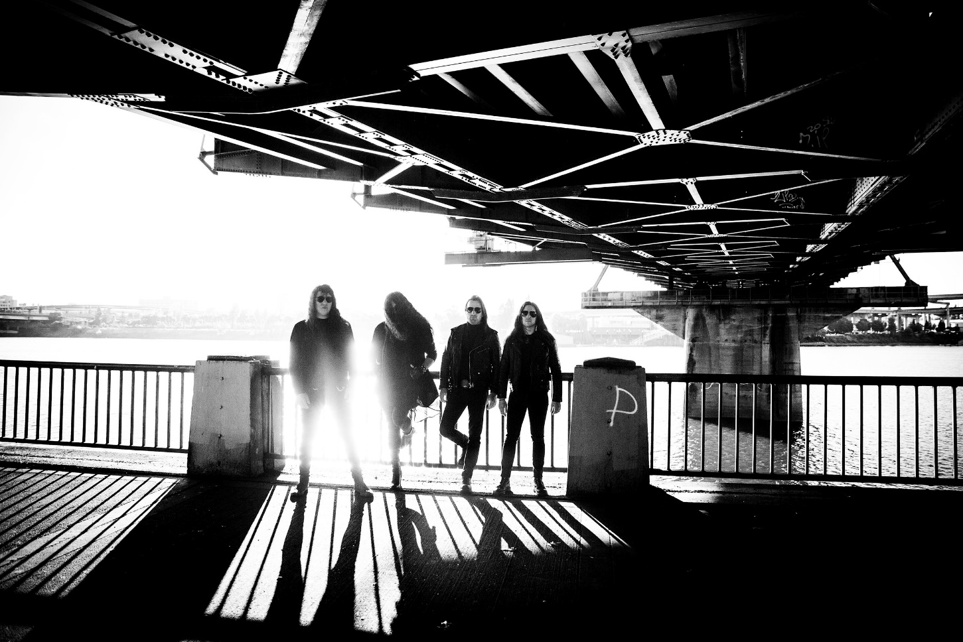
PHOTO CREDIT: PETER BESTE

SEPTEMBER 24, 2021 – Portland, Oregon’s Unto Others have released their widely-anticipated new album STRENGTH. Available today on all streaming platforms, STRENGTH is Unto Others’ debut album on Roadrunner Records and features the early singles “When Will Gods Work Be Done,” “Downtown,” and “No Children Laughing Now.”

Furthermore, Unto Others have announced a U.S. headline tour for the fall in support of STRENGTH. The coast-to-coast run, which will feature special guests Blood Star, is set to kick off on November 1st in Seattle, WA and will see the band making stops in major markets across the country including; Brooklyn, NY, Austin, TX, Chicago, IL, San Francisco, CA and more (full itinerary below). Tickets for the upcoming dates are on sale now. For tickets and more information on Unto Others’ upcoming live schedule, visit www.untoothers.us.

Produced and mixed by Arthur Rizk, STRENGTH was recorded between June 2020 and April 2021 at Redwood Studio in Philadelphia, PA and Falcon Studios in Portland, OR. In a glowing review of STRENGTH, Decibel affirmed “it’s obvious that Unto Others are aiming high. Lucky for us, they have the songs to back it up,” while Metal Hammer declared Unto Others “the underground's next breakout band.” “For a metal metal album that will define 2021, look no further,” raved SPIN with Heaviest of Art proclaiming, “With this album, Unto Others takes a bold and dangerous step towards stadiums everywhere.” Slam attested “STRENGTH is an outstanding album,” while Stereogum praised “When Will Gods Work Be Done” noting, “Unto Others build and build, showing mastery in setting a scene, stretching tension to its breaking point, and then blowing it to smithereens with panache.” REVOLVER included the track in their weekly ‘Best New Songs Right Now’ round-up calling it “undeniable,” while “Downtown” made UPROXX’s ‘Best New Indie Music’ recap.

Comprised of Gabriel Franco (Vocals / Guitar), Brandon Hill (Bass), Sebastian Silva (Guitar), and Colin Vranizan (Drums), Unto Others formed in Portland, OR in 2017 and quickly made waves out of the Pacific Northwest under their previous band name Idle Hands. Following 2018’s Don’t Waste Your Time EP, they released their debut full-length album Mana in 2019 to widespread acclaim. Citing their harmonious marriage of goth rock and traditional heavy metal, Stereogum named Unto Others one of the “40 Best New Bands of 2019” noting, “In an alternate reality where the ‘80s dalliance with both genres took hold into future decades, nearly every song on the band’s debut would be a hit.” The impact of Mana was immediate earning “Best of 2019” album accolades from Metal Hammer, Decibel Magazine, Invisible Oranges, Treble, Stereogum and Heavy Consequence with the latter observing, “Franco sounds more like Robert Smith than he does Bruce Dickinson, even though one can hear The Cure and Iron Maiden both in his band’s sound.” Unto Others joined King Diamond and Uncle Acid & The Deadbeats on a sold-out coast-to-coast tour across North America in support of Mana and returned in 2020 with the surprise release of Don’t Waste Your Time II.

[TOUR ITINERARY / ADMAT / ALBUM ART / TRACKLISTING BELOW]

UNTO OTHER 2021 U.S. HEADLINE TOUR
WITH SPECIAL GUESTS BLOOD STAR

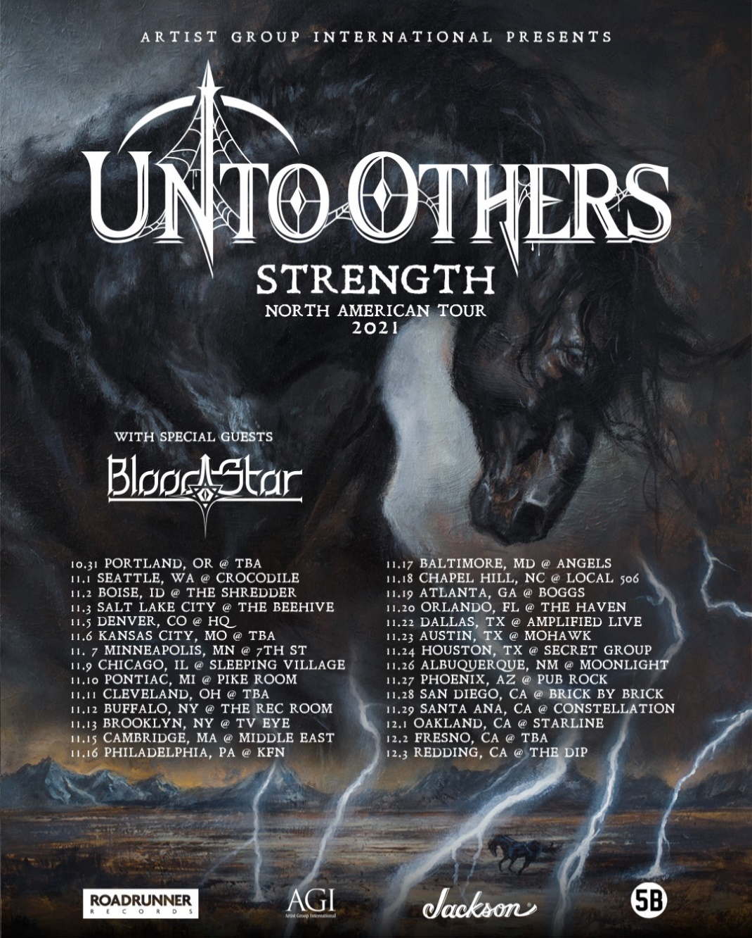
10/31 - Portland, OR - TBA
11/1 - Seattle, WA -The Crocodile
11/2 - Boise, ID - The Shredder
11/3 - Salt Lake City, UT - The Beehive
11/5 - Denver, CO - HQ Denver
11/6 – Kansas City, MO - TBA
11/7 - Minneapolis, MN - 7th St. Entry
11/9 - Chicago, IL - Sleeping Village
11/10 - Detroit, MI - Pike Room @ The Crofoot
11/11 - Cleveland, OH - TBA
11/12 - Buffalo, NY - Rec Room
11/13 - Brooklyn, NY - TV Eye
11/15 - Cambridge, MA - The Middle East (Upstairs)
11/16 - Philadelphia, PA - Kung Fu Necktie
11/17 - Baltimore, MD - Angels Rock Bar
11/18 - Charlotte, NC - Local 506
11/19 - Atlanta, GA - Boggs
11/20 - Orlando, FL - The Haven
11/22 - Dallas, TX – Amplified Live
11/23 - Austin, TX - The Mohawk
11/24 - Houston, TX - The Secret Group
11/26 - Albuquerque, NM - Moonlight Lounge
11/27 - Phoenix, AZ - Pub Rock Live
11/28 - San Diego, CA - Brick by Brick
11/29 - Santa Ana, CA - The Constellation Room
12/1 - San Francisco, CA - Starline Social Club
12/2 - Fresno, CA - TBA
12/3 - Redding, CA - The Dip

UNTO OTHERS
STRENGTH

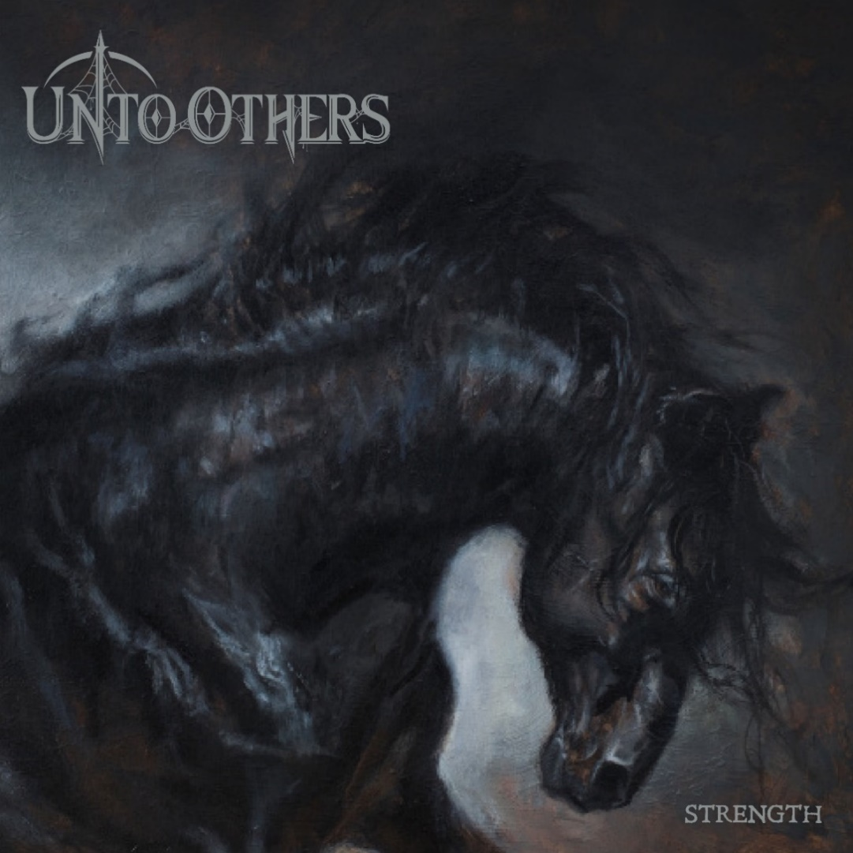
1. Heroin
2. Downtown
3. When Will Gods Work Be Done
4. No Children Laughing Now
5. Destiny
6. Little Bird
7. Why
8. Just a Matter of Time
9. Hell is For Children
10. Summer Lightning
11. Instinct
12. Strength

CONNECT WITH UNTO OTHERS:
WEBSITE / INSTAGRAM / FACEBOOK / TWITTER / YOUTUBE / SPOTIFY / APPLE MUSIC

