UNTO OTHERS
SHARE NEW SINGLE “NO CHILDREN LAUGHING NOW”

NEW ALBUM STRENGTH ARRIVES SEPTEMBER 24TH

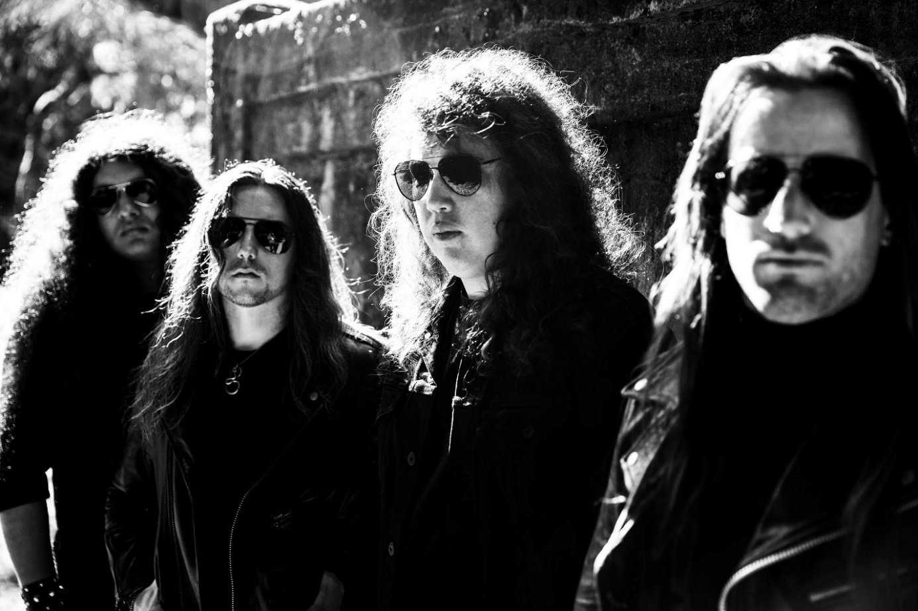
PHOTO CREDIT: PETER BESTE

SEPTEMBER 10, 2021 – Portland, Oregon’s Unto Others have shared “No Children Laughing Now,” the third single to be released off their widely-anticipated forthcoming album STRENGTH. “No Children Laughing Now” is available today on all streaming platforms with STRENGTH set to arrive worldwide on September 24th via Roadrunner Records.

STRENGTH is available for pre-order and is highlighted by the early singles “Downtown” and “When Will Gods Work Be Done,” both of which are joined by Brock Grossl directed official music videos.

Produced and mixed by Arthur Rizk, STRENGTH was recorded between June 2020 and April 2021 at Redwood Studio in Philadelphia, PA and Falcon Studios in Portland, OR. The forthcoming release marks Unto Others’ debut album on Roadrunner Records and the follow-up to their critically acclaimed 2019 LP Mana. In a glowing review of STRENGTH, Decibel affirmed “it’s obvious that Unto Others are aiming high. Lucky for us, they have the songs to back it up,” while Metal Hammer declared “The unique style mix of Fields Of The Nephilim, Killing Joke and New Wave British Heavy Metal is convincing in every moment." Slam attested “STRENGTH is an outstanding album,” while Stereogum praised “When Will Gods Work Be Done” noting, “Unto Others build and build, showing mastery in setting a scene, stretching tension to its breaking point, and then blowing it to smithereens with panache.” REVOLVER included the track in their weekly ‘Best New Songs Right Now’ round-up calling it “undeniable,” while “Downtown” made UPROXX’s ‘Best New Indie Music’ recap.

Comprised of Gabriel Franco (Vocals / Guitar), Brandon Hill (Bass), Sebastian Silva (Guitar), and Colin Vranizan (Drums), Unto Others formed in Portland, OR in 2017 and quickly made waves out of the Pacific Northwest under their previous band name Idle Hands. Following 2018’s Don’t Waste Your Time EP, they released their debut full-length album Mana in 2019 to widespread acclaim. Citing their harmonious marriage of goth rock and traditional heavy metal, Stereogum named Unto Others one of the “40 Best New Bands of 2019” noting, “In an alternate reality where the ‘80s dalliance with both genres took hold into future decades, nearly every song on the band’s debut would be a hit.” The impact of Mana was immediate earning “Best of 2019” album accolades from Metal Hammer, Decibel Magazine, Invisible Oranges, Treble, Stereogum and Heavy Consequence with the latter observing, “Franco sounds more like Robert Smith than he does Bruce Dickinson, even though one can hear The Cure and Iron Maiden both in his band’s sound.” Unto Others joined King Diamond and Uncle Acid & The Deadbeats on a sold-out coast-to-coast tour across North America in support of Mana and returned in 2020 with the surprise release of Don’t Waste Your Time II.

UNTO OTHERS
STRENGTH

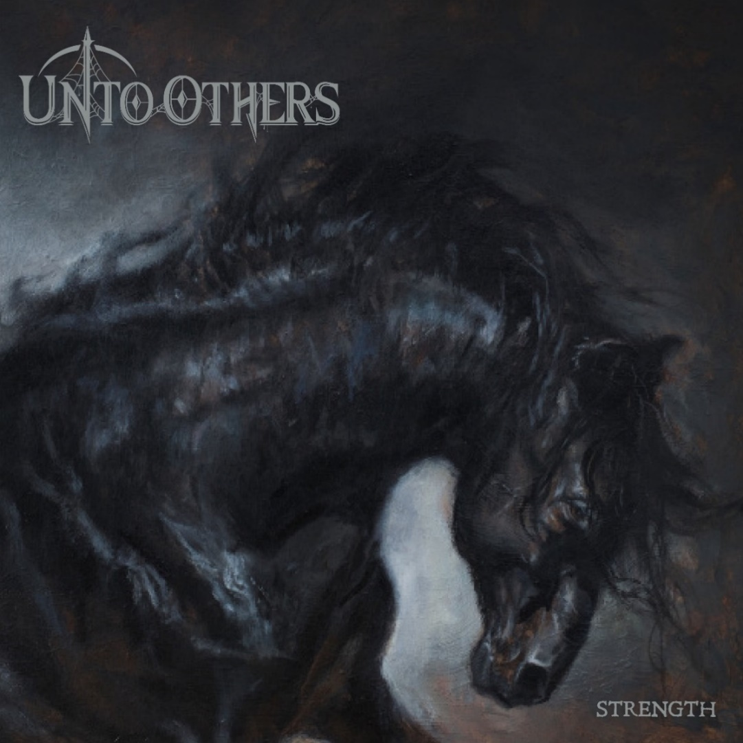
1. Heroin
2. Downtown
3. When Will Gods Work Be Done
4. No Children Laughing Now
5. Destiny
6. Little Bird
7. Why
8. Just a Matter of Time
9. Hell is For Children
10. Summer Lightning
11. Instinct
12. Strength

CONNECT WITH UNTO OTHERS:
WEBSITE / INSTAGRAM / FACEBOOK / TWITTER / YOUTUBE / SPOTIFY / APPLE MUSIC

