UNTO OTHERS
SIGN TO ROADRUNNER RECORDS

SHARE NEW SINGLE & MUSIC VIDEO - “WHEN WILL GODS WORK BE DONE”

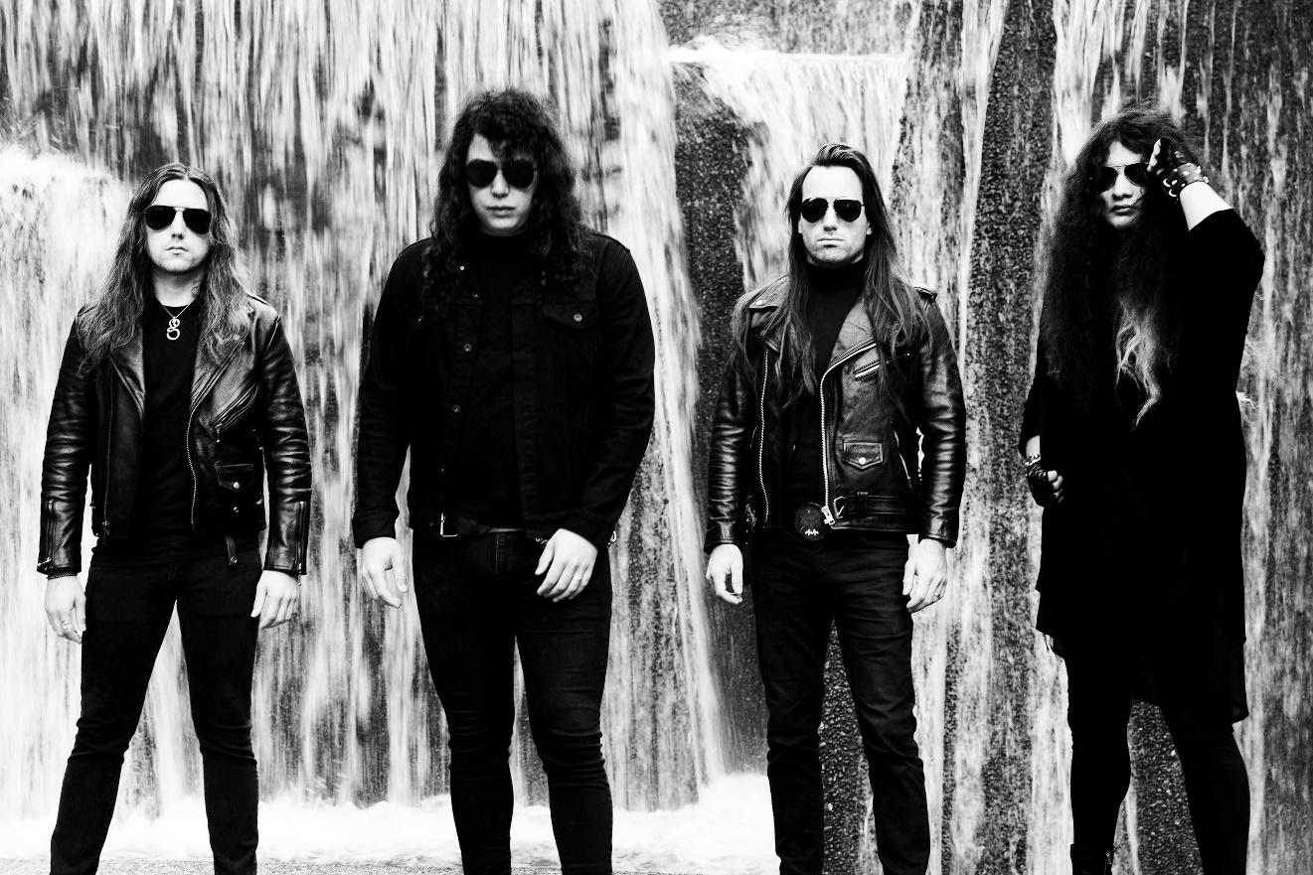
PHOTO CREDIT: PETER BESTE

JUNE 16, 2021 – Portland, Oregon’s Unto Others have announced their signing to Roadrunner Records and shared a brand-new single, “When Will Gods Work Be Done.” Available today on all streaming platforms, “When Will Gods Work be Done” was produced and mixed by Arthur Rizk and is joined by an official music video directed by Brock Grossl. The track and video premiered today via Decibel Magazine alongside a Q&A with Unto Others’ vocalist / guitarist Gabriel Franco - read it HERE.

Commenting on the new release and news of the signing, Franco remarked “Our last full length came out over two years ago and much has changed, including the band and I, our name, etc... so I consider this a reintroduction of ‘us’ to those who connected with our music in the past, as well as a debut for the many who haven't. We did our best, and that's all we can do. So out of the frying pan, and into the fire, I think we have all been frying long enough."

Roadrunner Records SVP of A&R Dave Rath added, “Having Unto Others join us at Roadrunner Records feels like a ‘welcome home’ to a family member we’ve been waiting for - for a very long time. Unto Others’ innovative combination of goth, rock and metal brings the genre to entirely new and unique places. They are pushing the genre beyond the expected to create a blend of heavy, dark, melodic songs combined with traditional metal we haven’t heard in quite some time. We are incredibly excited for this band to be part of the label’s storied legacy.”

Comprised of Gabriel Franco (Vocals / Guitar), Brandon Hill (Bass), Sebastian Silva (Guitar), and Colin Vranizan (Drums), Unto Others formed in Portland, OR in 2017 and quickly made waves out of the Pacific Northwest under their previous band name Idle Hands. Following 2018’s Don’t Waste Your Time EP, they released their debut full-length album Mana in 2019 to widespread acclaim. Citing their harmonious marriage of goth rock and traditional heavy metal, Stereogum named Unto Others one of the “40 Best New Bands of 2019” noting, “In an alternate reality where the ‘80s dalliance with both genres took hold into future decades, nearly every song on the band’s debut would be a hit.” The impact of Mana was immediate earning “Best of 2019” album accolades from Metal Hammer, Decibel Magazine, Invisible Oranges, Treble, Stereogum and Heavy Consequence with the latter observing, “Franco sounds more like Robert Smith than he does Bruce Dickinson, even though one can hear The Cure and Iron Maiden both in his band’s sound.” Unto Others joined King Diamond and Uncle Acid & The Deadbeats on a sold-out coast-to-coast tour across North America in support of Mana and returned in 2020 with the surprise release of Don’t Waste Your Time II.

Next up, Unto Others will join Behemoth, Arch Enemy, and Carcass for a massive European fall tour, kicking off September 28th in Dublin, Ireland and running for six weeks through November 7 at Rockefeller in Oslo, Norway [itinerary below]. For tickets and more information on Unto Others’ upcoming live dates, visit www.untoothers.us.

UNTO OTHERS
“WHEN WILL GODS WORK BE DONE”
SINGLE ART

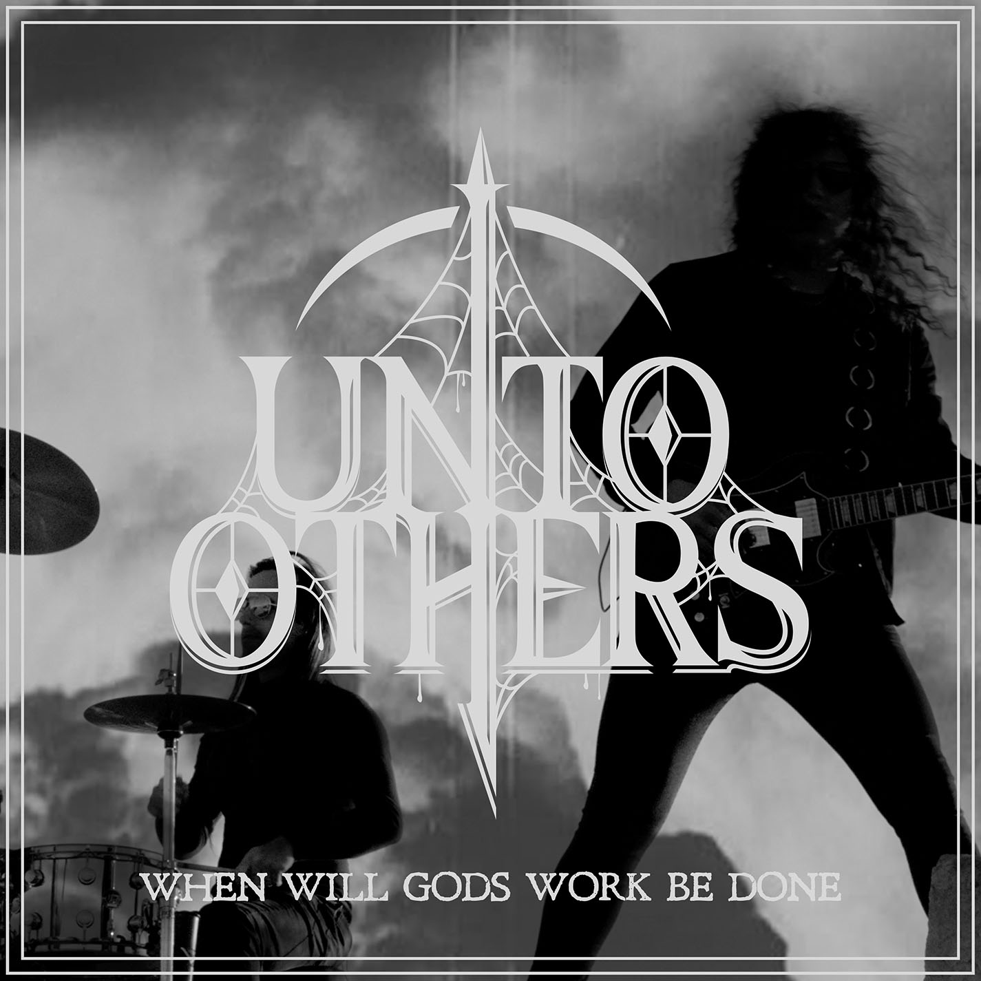

UNTO OTHER 2021 TOUR DATES
With Behemoth, Arch Enemy, and Carcass

9/28 Dublin, IE @ Olympia
9/30 Glasgow, UK @ o2 Academy
10/1 Manchester, UK @ o2 Apollo
10/2 Birmingham, UK @ o2 Academy
10/3 London, UK @o2 Brixton Academy
10/5 Paris, FR @ Zenith
10/6 Toulouse, FR @ Bikini
10/8 Lisbon, PT @ Sala Tejo
10/9 Madrid, ES @ Vistalegre Arena
10/10 Barcelona, ES @ Sant Jordi Club
10/12 Lyon, FR @ Le Radiant
10/13 Milano, IT @ Alcatraz
10/15 Berlin, DE @ Columbiahalle
10/16 Prague, CZ @ Tipsport Arena
10/17 Katowice, PL @ MCK
10/19 Budapest, HU @ Barba Negra
10/20 Vienna, AT @ Gasometer
10/22 Ludwigsburg, DE @ MHP Arena
10/23 Den Bosch, NL @ Main Stage
10/24 Brussels, BE @ Forest National
10/26 Zurich, CH @ Samsung Hall
10/27 Frankfurt, DE @Jahrhunderthalle
10/29 Munich, DE @ Zenith
10/30 Dusseldorf, DE @ Mitsubishi Hall
10/31 Hamburg, DE @ Edel Optics Arena
11/1 Gothenburg, SE @ Partille Arena
11/3 Helsinki, FI @ Black Box Ice Hall
11/5 Stockholm, SE @ Annexet
11/6 Copenhagen, DK @ Forum Black Box
11/7 Oslo, NO @ Rockefeller

CONNECT WITH UNTO OTHERS:
WEBSITE / INSTAGRAM / FACEBOOK / TWITTER / YOUTUBE / SPOTIFY / APPLE MUSIC

