UNTO OTHERS
ANNOUNCE NEW ALBUM STRENGTH

SHARE NEW SINGLE & MUSIC VIDEO - “DOWNTOWN”

STRENGTH ARRIVES SEPTEMBER 24TH

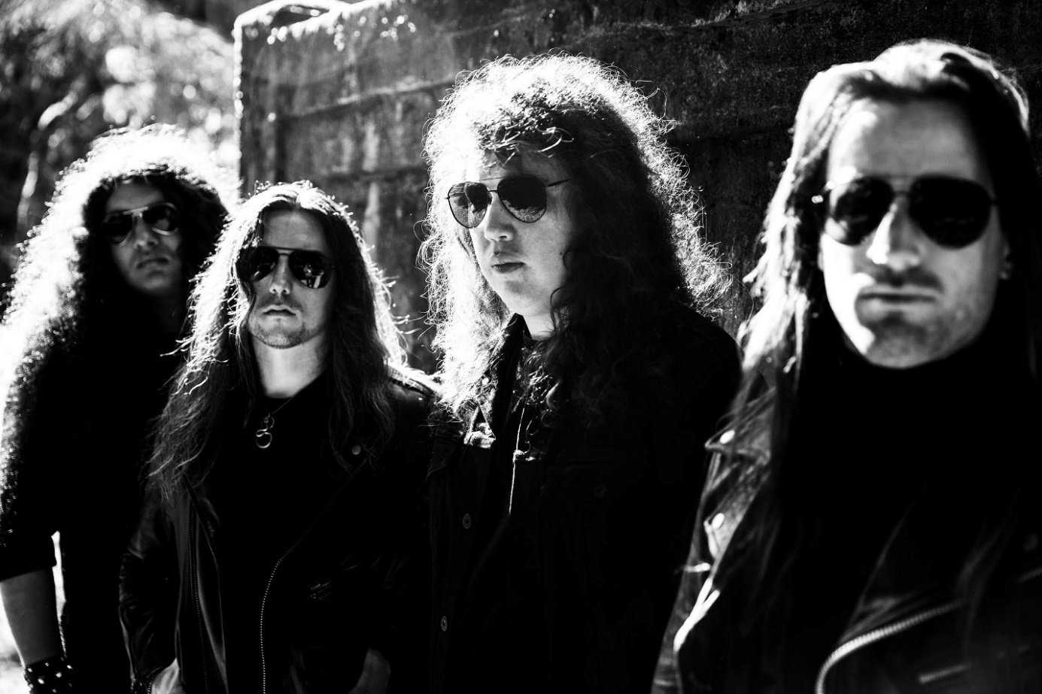
PHOTO CREDIT: PETER BESTE

AUGUST 6, 2021 – Portland, Oregon’s Unto Others have announced details of their new album STRENGTH, which will be released September 24th on Roadrunner Records and is available for pre-order today (album art / track listing below). The band have also shared the new song, “Downtown” which is streaming today on all platforms and joined by an official music video directed by Brock Grossl – watch it HERE.

Unto Others’ vocalist / guitarist Gabriel Franco elaborated on the genesis of STRENGTH sharing, “I wish I could say it came to me like a bolt of lightning, but the record was a process. A challenging process, to write, record and mix. It was 10 months from beginning to end, and the most time I’ve ever spent on an album. You can decide if that's good or bad. Arthur did a great job giving the record an organic heavy sound and it was a privilege to work with him. What we have at the end is something I am extremely proud of, for better or worse, and a constant reminder to myself that we don't do things because they are easy, we do them because they are hard.”

Produced and mixed by Arthur Rizk, STRENGTH was recorded between June 2020 and April 2021 at Redwood Studio in Philadelphia, PA and Falcon Studios in Portland, OR. The forthcoming release marks Unto Others’ debut album on Roadrunner Records and the follow-up to their critically acclaimed 2019 LP Mana. STRENGTH also features the single “When Will Gods Work Be Done” which arrived earlier this summer alongside news of the band’s signing. Stereogum praised the single attesting, “Unto Others build and build, showing mastery in setting a scene, stretching tension to its breaking point, and then blowing it to smithereens with panache,” while REVOLVER included the track in their weekly “Best New Songs Right Now,” round-up. Decibel affirmed “(it) continues right where Mana left off, built around a hard-driving groove, some mean palm-muted riffs, and of course, the baritone bellow of singer/guitarist Gabriel Franco.”

Comprised of Gabriel Franco (Vocals / Guitar), Brandon Hill (Bass), Sebastian Silva (Guitar), and Colin Vranizan (Drums), Unto Others formed in Portland, OR in 2017 and quickly made waves out of the Pacific Northwest under their previous band name Idle Hands. Following 2018’s Don’t Waste Your Time EP, they released their debut full-length album Mana in 2019 to widespread acclaim. Citing their harmonious marriage of goth rock and traditional heavy metal, Stereogum named Unto Others one of the “40 Best New Bands of 2019” noting, “In an alternate reality where the ‘80s dalliance with both genres took hold into future decades, nearly every song on the band’s debut would be a hit.” The impact of Mana was immediate earning “Best of 2019” album accolades from Metal Hammer, Decibel Magazine, Invisible Oranges, Treble, Stereogum and Heavy Consequence with the latter observing, “Franco sounds more like Robert Smith than he does Bruce Dickinson, even though one can hear The Cure and Iron Maiden both in his band’s sound.” Unto Others joined King Diamond and Uncle Acid & The Deadbeats on a sold-out coast-to-coast tour across North America in support of Mana and returned in 2020 with the surprise release of Don’t Waste Your Time II.

Next up, Unto Others will join Behemoth, Arch Enemy, and Carcass for a massive European fall tour, kicking off September 28th in Dublin, Ireland and running for six weeks through November 7 at Rockefeller in Oslo, Norway [itinerary below]. For tickets and more information on Unto Others’ upcoming live dates, visit www.untoothers.us.

UNTO OTHERS
STRENGTH

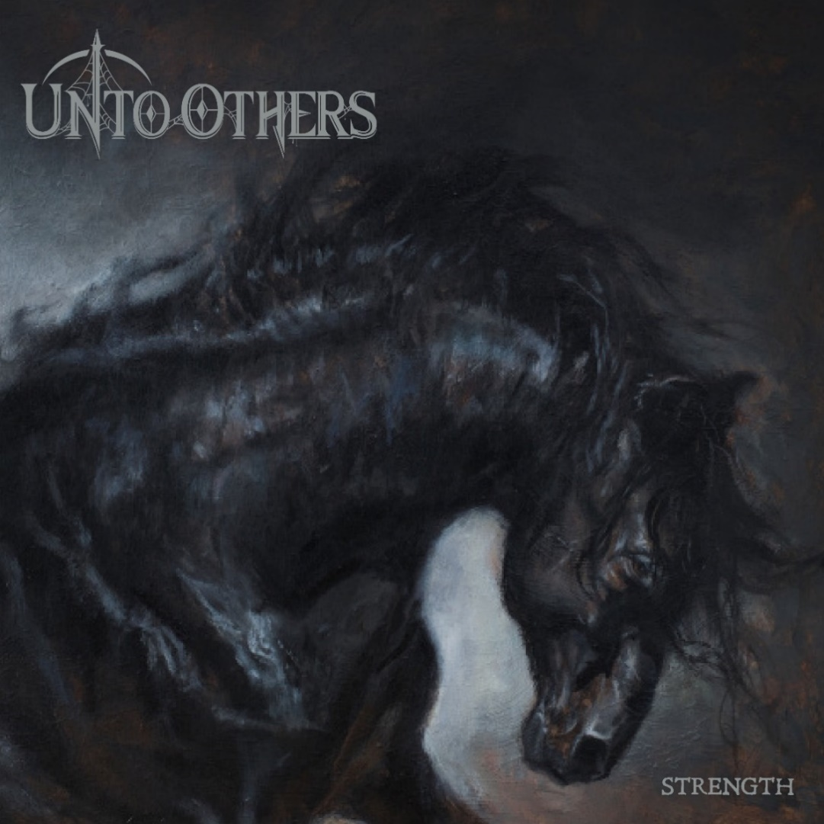
1. Heroin
2. Downtown
3. When Will Gods Work Be Done
4. No Children Laughing Now
5. Destiny
6. Little Bird
7. Why
8. Just a Matter of Time
9. Hell is For Children
10. Summer Lightning
11. Instinct
12. Strength

UNTO OTHER 2021 TOUR DATES
All Dates with Behemoth, Arch Enemy, and Carcass except*

8/23 Los Angeles, CA @ Catch One*
9/28 Dublin, IE @ Olympia
9/30 Glasgow, UK @ o2 Academy
10/1 Manchester, UK @ o2 Apollo
10/2 Birmingham, UK @ o2 Academy
10/3 London, UK @o2 Brixton Academy
10/5 Paris, FR @ Zenith
10/6 Toulouse, FR @ Bikini
10/8 Lisbon, PT @ Sala Tejo
10/9 Madrid, ES @ Vistalegre Arena
10/10 Barcelona, ES @ Sant Jordi Club
10/12 Lyon, FR @ Le Radiant
10/13 Milano, IT @ Alcatraz
10/15 Berlin, DE @ Columbiahalle
10/16 Prague, CZ @ Tipsport Arena
10/17 Katowice, PL @ MCK
10/19 Budapest, HU @ Barba Negra
10/20 Vienna, AT @ Gasometer
10/22 Ludwigsburg, DE @ MHP Arena
10/23 Den Bosch, NL @ Main Stage
10/24 Brussels, BE @ Forest National
10/26 Zurich, CH @ Samsung Hall
10/27 Frankfurt, DE @Jahrhunderthalle
10/29 Munich, DE @ Zenith
10/30 Dusseldorf, DE @ Mitsubishi Hall
10/31 Hamburg, DE @ Edel Optics Arena
11/1 Gothenburg, SE @ Partille Arena
11/3 Helsinki, FI @ Black Box Ice Hall
11/5 Stockholm, SE @ Annexet
11/6 Copenhagen, DK @ Forum Black Box
11/7 Oslo, NO @ Rockefeller

CONNECT WITH UNTO OTHERS:
WEBSITE / INSTAGRAM / FACEBOOK / TWITTER / YOUTUBE / SPOTIFY / APPLE MUSIC

