WATERPARKS LAUNCH HIGHLY-ANTICIPATED NEW ERA WITH “FUNERAL GREY”
LISTEN HERE
WATCH HERE
+ “FUNERAL GREY” MARKS THE BAND’S DEBUT RELEASE ON FUELED BY RAMEN +

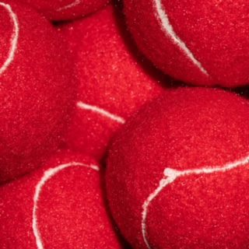
May 13, 2022 – Today, Waterparks enter their highly-anticipated new era with its lead single “FUNERAL GREY,” their debut release on Fueled By Ramen. The vibrant pop-punk track is out now alongside the official video, directed by Awsten Knight himself and Erik Rojas (24kGoldn, Rich Brian, Chase Atlantic, etc.), featuring Awsten’s signature new hair color that saturates the song’s visuals - Watch HERE.
Its infectious guitar riff and Awsten’s bright, energetic vocals, culminate in a perfect pop-punk summer anthem. The track’s playful and clever lyricism chronicle the pursuit of a girl at a party he deems his “next mistake”, complete with cleverly-crafted imagery and an iconic Kim Possible reference. “FUNERAL GREY” has been heavily teased on socials over the last month and reached the #1 Trending Topic on Twitter in the US.
This new era will see Waterparks step into a more mature sound and look, elevating the image and sonics that have already accumulated over half a billion career streams to date, with over 2MM monthly listeners and 400,000 Spotify followers. Their last album, Greatest Hits, debuted with over 15,000 album-unit equivalents in the US, earning it the no. 5 spot on Billboard’s Alt/Rock chart.
This summer, Waterparks will be headlining the Sad Summer Festival, presented by Journeys, at all eighteen stops across the US as well as touring across the US. Check out the full list of tour dates HERE.
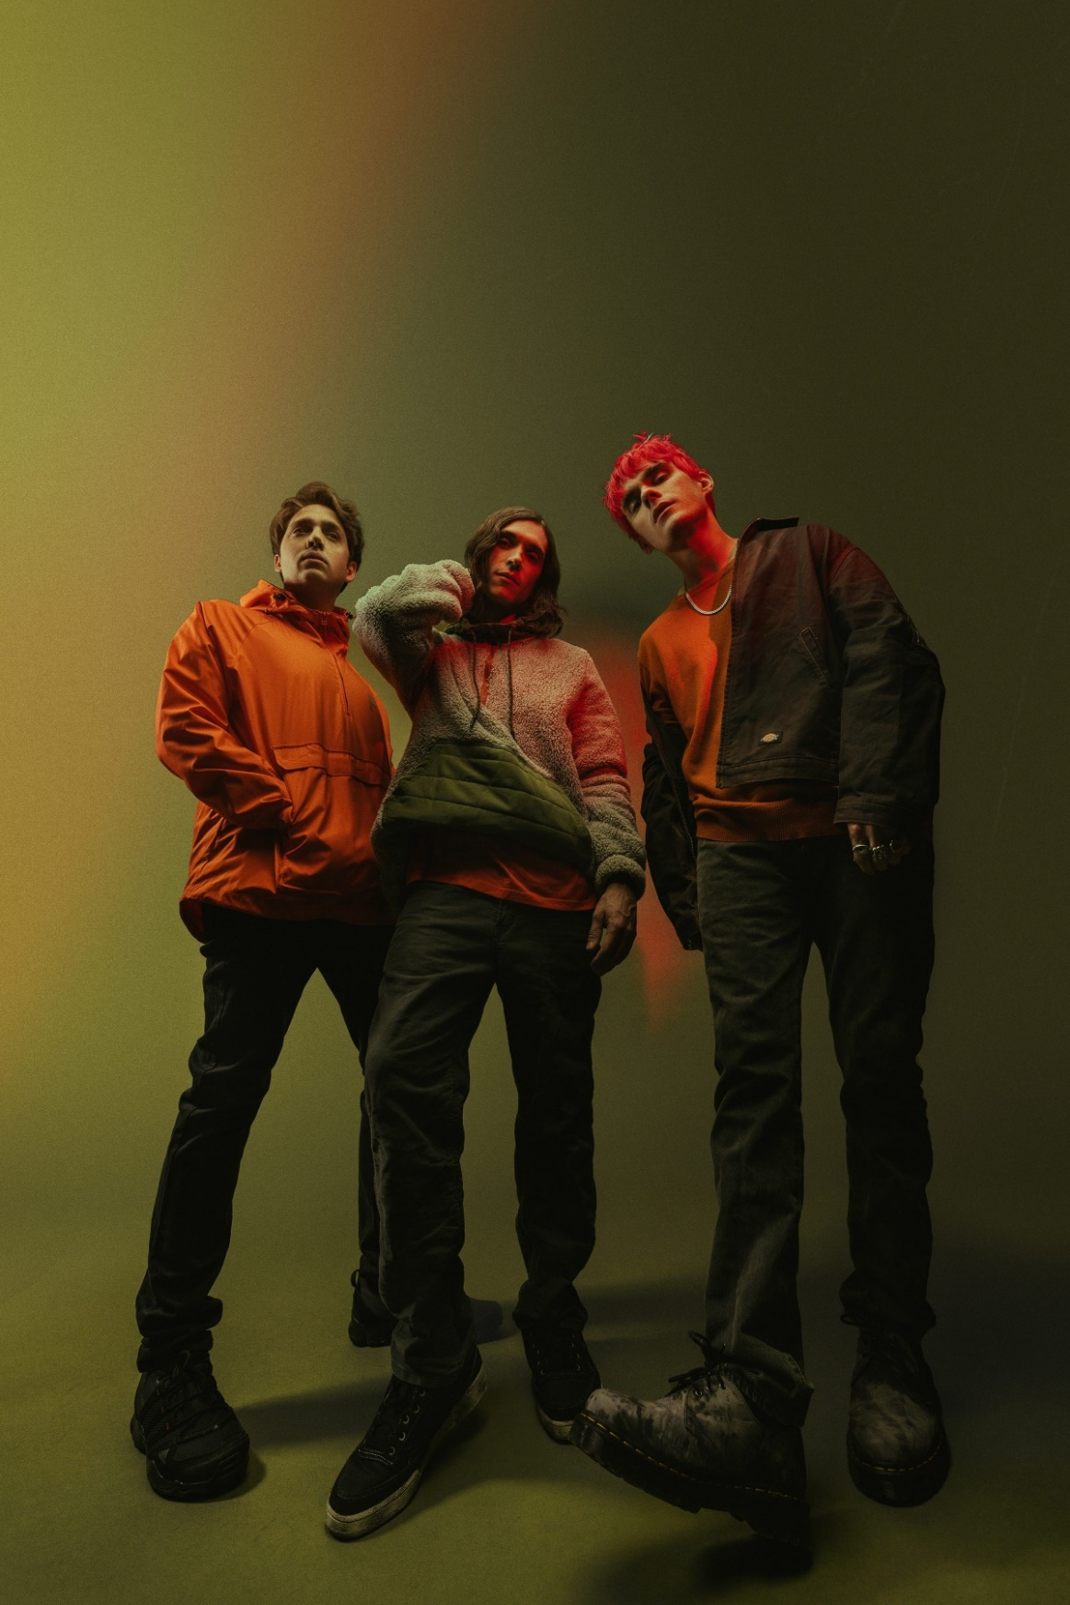
Credit: Jawn Rocha
Download Hi-Res Promo Images HERE
About Waterparks
Waterparks, composed of Awsten Knight [vocals, guitar], Otto Wood [drums], and Geoff Wigington [guitar]—manically move forward, shucking and jiving between fits of rock, alternative, and electronic with pop ambition and hip-hop’s bold and blatant disregard for the rules. The Houston trio has landed the covers of Alternative Press, V Magazine, Kerrang!, Rock Sound, and more and have garnered support from Spotify, Apple Music, and Amazon Music, finding themselves on numerous New Music Fridays and countless rock/alt playlists. The band has also topped the Billboard 200 chart. Waterparks’ unique and genre-blending sound puts them in a lane all their own, melding rock, pop, hip-hop, alternative, indie, electronic, and even R&B.
View this email in your browser
