BRANDI CARLILE’S “YOU AND ME ON THE ROCK” MUSIC VIDEO DEBUTS TODAY
“BEYOND THESE SILENT DAYS” HEADLINE TOUR UNDERWAY
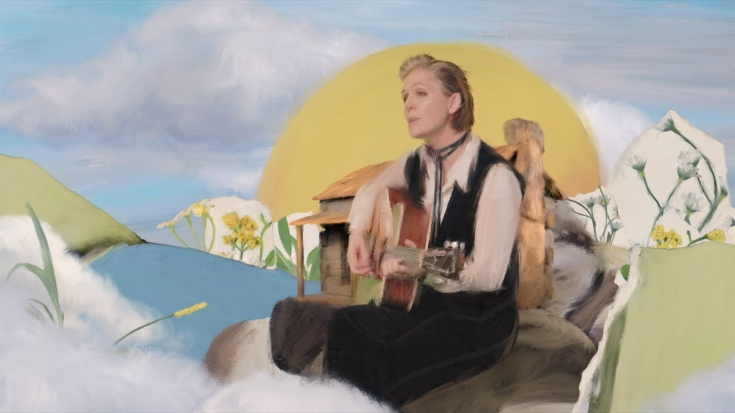
June 29, 2022—The official music video for Brandi Carlile’s new single, “You And Me On the Rock,” is debuting today. Watch/share the video, which was created, animated and directed by Computer Team, HERE.
Of the song, Carlile reflects, “This song is for my wife, Catherine. When life changed during quarantine and everything that I identify myself by went away, I was left with a question of ‘is what I’ve built my life on really a solid foundation?’ I wrote this song and realized that even the most intensely self-identifying things can go away, but what my life is really built on, which is faith and my family, it’s a rock, and it’s solid.”
“You And Me On The Rock,” which NPR Music calls, “a heartwarming ode to domesticity, with gently strummed acoustic guitar and a mellifluous vocal reminiscent of Carlile’s friend [Joni] Mitchell,” is from Carlile’s widely acclaimed #1 album, In These Silent Days, which is out now via Low Country Sound/Elektra Records (stream/purchase here).
In celebration of the record, Carlile is currently in the midst of her extensive “Beyond These Silent Days” headline tour with upcoming shows at Nashville’s Ascend Amphitheater (two nights), Austin’s Moody Amphitheater, Chicago’s Huntington Bank Pavilion at Northerly Island, Colorado’s Red Rocks Amphitheatre (two nights) and New York’s Madison Square Garden among many others. Of Carlile’s recent sold-out show at Los Angeles’ Greek Theatre, Variety praises, “It’s hard to think of any other current rock star who so successfully puts heart at, well, the heart of her proceedings…the fact that this is a rock show, even as much as a singer/songwriter showcase, was felt from the beginning at Friday’s show.” Special guests featured on the tour include Allison Russell, Ani DiFranco, Brittany Howard, Celisse, Indigo Girls, Katie Pruitt, Lake Street Dive, Lucius, Sarah McLachlan, Brittney Spencer, Tanya Tucker and Yola. See below for complete itinerary.
Produced by Dave Cobb and Shooter Jennings, In These Silent Days was inspired by the mining of Carlile’s own history while writing last year’s #1 New York Times Best Selling memoir, Broken Horses (Crown. Conceived of while she was quarantined at home with longtime collaborators and bandmates Tim and Phil Hanseroth, the ten songs chronicle acceptance, faith, loss and love, and channel icons like David Bowie, Freddie Mercury, Elton John and Joni Mitchell—the latter two who, by some sort of cosmic alignment of the stars, have turned out to be close friends in addition to being her biggest heroes and inspirations.
Released to overwhelming acclaim, Variety praises, “Carlile effortlessly glides between octaves while, somehow, still sounding completely conversational—the everyday diva we didn’t know we needed until she showed up at our door…a vocal tour de force,” while Billboard asserts, “the emotion that Carlile projects is unbridled, unfettered joy in the face of hard times—and it’s the exact boost of positivity that will make you want to listen again and again” and Vulture declares, “one of the biggest voices in the genre.” The album also appeared on “Best of 2021” lists at NPR Music, Variety, Rolling Stone, Billboard, Entertainment Weekly, SPIN, USA Today, Stereogum and many more.
In the months since the release, the six-time Grammy Award-winning singer, songwriter, performer, producer and New York Times Best Selling author made her debut as the musical guest on NBC’s “Saturday Night Live” (performing “Broken Horses” and “Right On Time”), returned to “The Ellen DeGeneres Show” to guest host and debut “You And Me On The Rock,” and debuted “This Time Tomorrow” on “The Late Show with Stephen Colbert.” She also performed “Right On Time” during the 64th Annual GRAMMY Awards earlier this year, where the song was nominated for Record of the Year and Song of the Year. Additionally, this past November, Carlile performed Mitchell’s legendary album Blue in its entirety at Carnegie Hall. Of the sold-out performance, Billboard proclaims, “an extraordinary concert…who better to take on this homage but Carlile, who has taken up Mitchell’s still brightly burning torch, as one of the finest songwriters and singers of this era.”
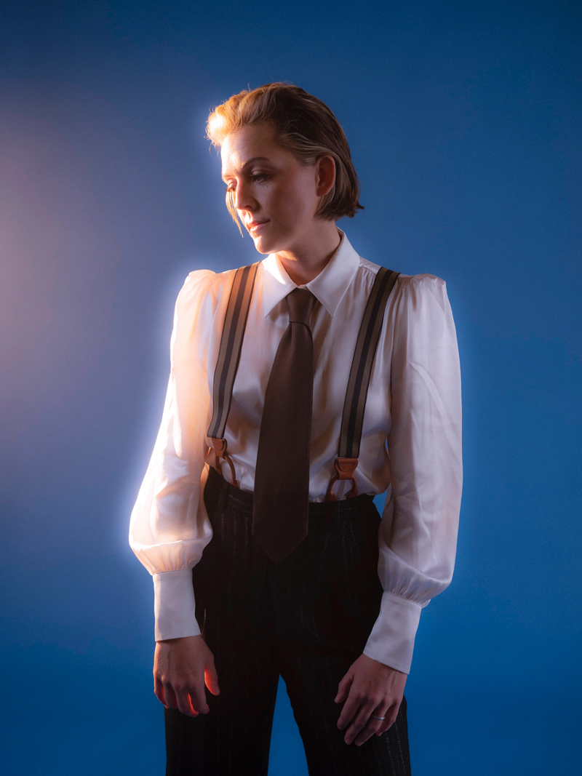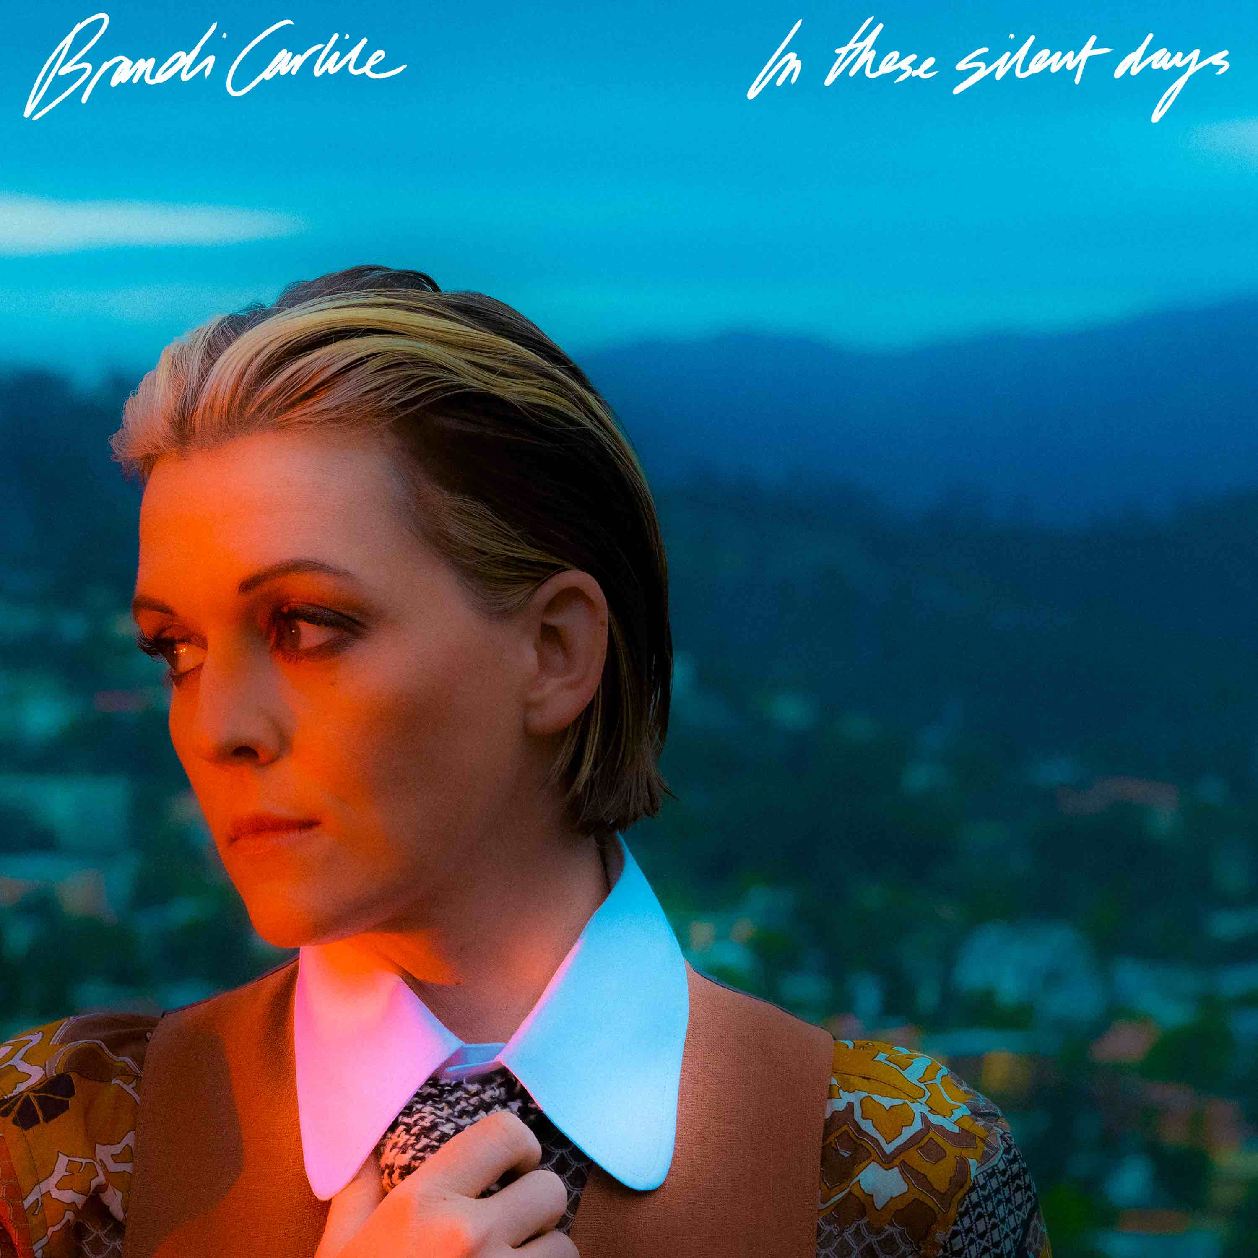
photo credit: Neil Krug // album artwork
In These Silent Days follows Carlile’s 2018 breakthrough GRAMMY Award-winning album, By The Way, I Forgive You, which Rolling Stone declared, “…an Adele-meets Joni Mitchell tour de force.” In the years since—in addition to collaborative projects with Elton John, The Highwomen, Tanya Tucker, Soundgarden, Alicia Keys, Dolly Parton, Barry Gibb, Leslie Jordan, Brandy Clark and more—she has earned six Grammy Awards recognizing her work as a performer, songwriter and producer, was awarded Billboard’s Women In Music “Trailblazer Award,” CMT’s Next Women of Country “Impact Award” and received multiple recognitions from the Americana Music Association Honors & Awards including 2021’s Artist of the Year, 2020’s Album of the Year (Highwomen), Group of the Year (The Highwomen) and Song of the Year (“Crowded Table”) and 2019’s Artist of the Year. Moreover, the audiobook version of Carlile’s memoir was recently highlighted as one of Libro.fm’s top 10 bestselling audiobooks of 2021.
In addition to their work as a band, Carlile and the Hanseroth twins remain committed to social activism and advocacy. Together they are founders of the Looking Out Foundation, which amplifies the impact of music by empowering those without a voice with varied initiatives including campaigns focused on Children in Conflict/War Child, The IF Project, Fund Racial Justice and more. To date, they have raised over $3 million for grassroots causes.
IN THESE SILENT DAYS TRACKLIST
1. Right On Time
2. You And Me On The Rock
3. This Time Tomorrow
4. Broken Horses
5. Letter To The Past
6. Mama Werewolf
7. When You’re Wrong
8. Stay Gentle
9. Sinners Saints And Fools
10.Throwing Good After Bad
BRANDI CARLILE CONFIRMED TOUR DATES
July 6—Kansas City, MO—Starlight Theatre*
July 8—Nashville, TN—Ascend Amphitheatre†
July 9—Nashville, TN—Ascend Amphitheatre†
July 15—Austin, TX—Moody Amphitheater=
July 16—Dallas, TX—Dos Equis Pavilion×
July 30—St. Paul, MN—Xcel Energy Center‡
July 31—Bayfield, WI—Lake Superior Big Top Chautauqua+
August 1—Bayfield, WI—Lake Superior Big Top Chautauqua+
August 5—Milwaukee, WI—Fiserv Forum‡
August 6—Chicago, IL—Huntington Bank Pavilion at Northerly Island¤
August 11—Salt Lake City, UT—Vivint Arena#
August 13—Big Sky, MT—Wildlands Festival at Big Sky Events Center§
August 18—Columbia, MD—Merriweather Post Pavilion**
August 19—Bethel, NY—Bethel Woods Center for the Arts††
August 20—Philadelphia, PA—TD Pavilion at The Mann~
August 30—Lenox, MA—Tanglewood§
August 31—Portland, ME—Thompson’s Point§
September 9—Morrison, CO—Red Rocks Amphitheatre^
September 10—Morrison, CO—Red Rocks Amphitheatre**
September 16—Louisville, KY—Bourbon & Beyond Festival
September 18—Los Angeles, CA—BeachLife Ranch
September 21—Richmond, VA—Music At Maymont+
September 22—Atlanta, GA—Fox Theatre
September 24—Franklin, TN—Pilgrimage Festival
September 25—Bridgeport, CT—Sound on Sound Festival
October 7—Durham, NC—Durham Performing Arts Center+
October 8—Greenville, SC—Peace Center Concert Hall+
October 21—Boston, MA—TD Garden++
October 22—New York, NY—Madison Square Garden++
January 9-13, 2023—Rivirea Maya, Mexico—Girls Just Wanna Weekend 4
*with special guests Tanya Tucker and Katie Pruitt
†with special guests Indigo Girls and Celisse and featuring Lucius
=with special guest Lucius
×with special guests Lucius and Celisse
‡with special guests Lake Street Dive and Celisse
+a special solo performance
¤with special guests Ani DiFranco and Celisse
#with special guests Indigo Girls and Celisse
§with special guest Indigo Girls
**with special guests Indigo Girls and Allison Russell
††with special guests Yola and Allison Russell
~with special guests Allison Russell and Celisse
^with special guests Lucius and Allison Russell
++with special guest Brittany Howard
www.brandicarlile.com

