ZERO 9:36
RELEASES NEW EP …IF YOU DON’T SAVE YOURSELF

AVAILABLE NOW ON ALL STREAMING PLATFORMS

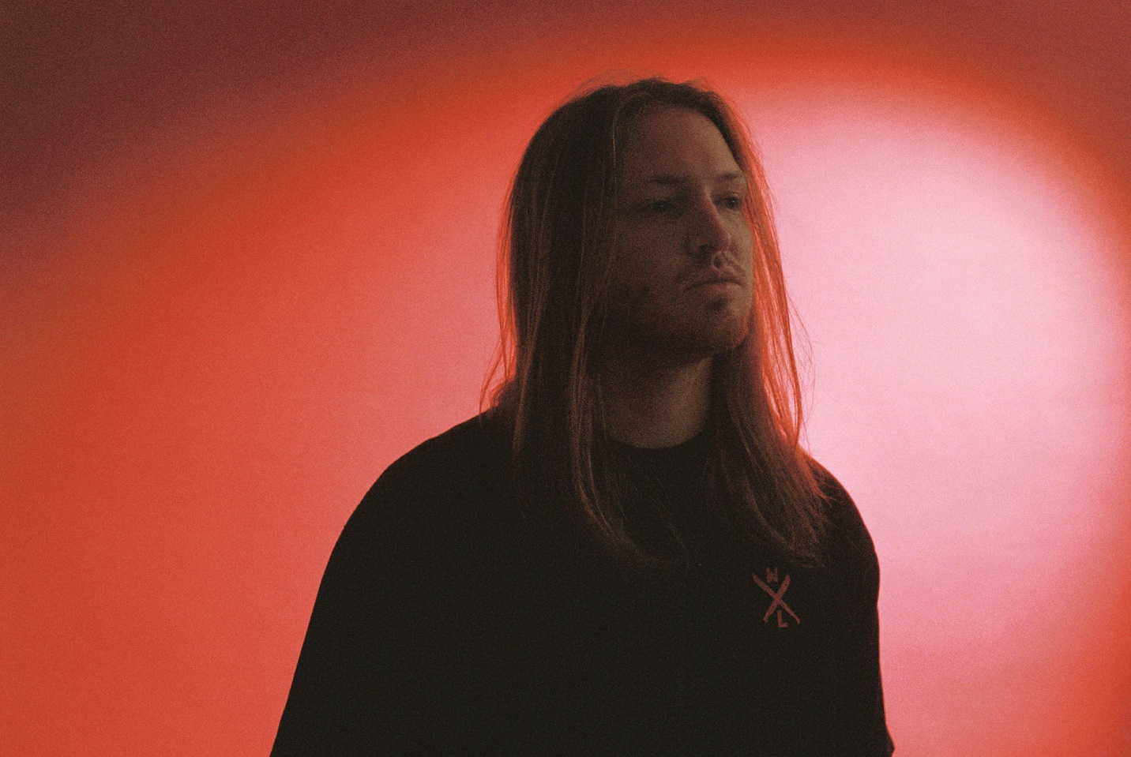

FEBRUARY 26, 2021 – ATCO Records artist Zero 9:36 has released his highly anticipated new EP, …If You Don’t Save Yourself. It is available now on all streaming platforms.
Presenting a peerless sonic collage of alternative, rock, hip-hop, and glitch architected by hand, he bulldozed the way for the EP with a series of scorching songs. Most recently, Zero 9:36 released “In My Hands” [feat. Travis Barker & Clever] which followed early singles “The End” and “Adrenaline.” In advance of the EP’s arrival, the tracks have impressively accumulated 15 million total streams, cementing Zero 9:36 as rock’s hottest new artist to watch.
…If You Don’t Save Yourself tosses and turns between sonic extremes. Rapping breathlessly, he rips through airtight rhymes on the confessional opener “ii x two,” while the powerful “Take Me Instead” seesaws between moments of intensity and infectiousness. Delicate clean guitar underscores haunting melodies on the standout “Tragedy,” which culminates on a stark contrast between airy electronics and bare emotion.
In 2019, Zero 9:36 shared his debut EP, You Will Not Be Saved – the first release on the newly relaunched ATCO Records. The EP includes lead single “Leave The Light On” – produced by Mark Jackson and Ian Scott (Bishop Briggs) with Boonn (grandson), and is also accompanied by an official video directed by Matthew Gold. Following the EP release Zero 9:36 shared the collaborative single with No Love For The Middle Child titled “Come Thru,” and linked up with Fueled By Ramen artist grandson on his track “Again” (Text Voter XX to 40649). More recently, Zero 9:36 released Barebones Vol. 1, an eight song all acoustic EP featuring stripped back performances of fan favorites “WWYDF,” “Reset,” and more.
Growing up in the city of Brotherly Love, Zero 9:36 took to music at an early age. He entered his first studio at 10-years-old and never looked back. The alternative artist has since amassed over 40 Million streams through a prolific body of work.
ZERO 9:36
…IF YOU DON’T SAVE YOURSELF

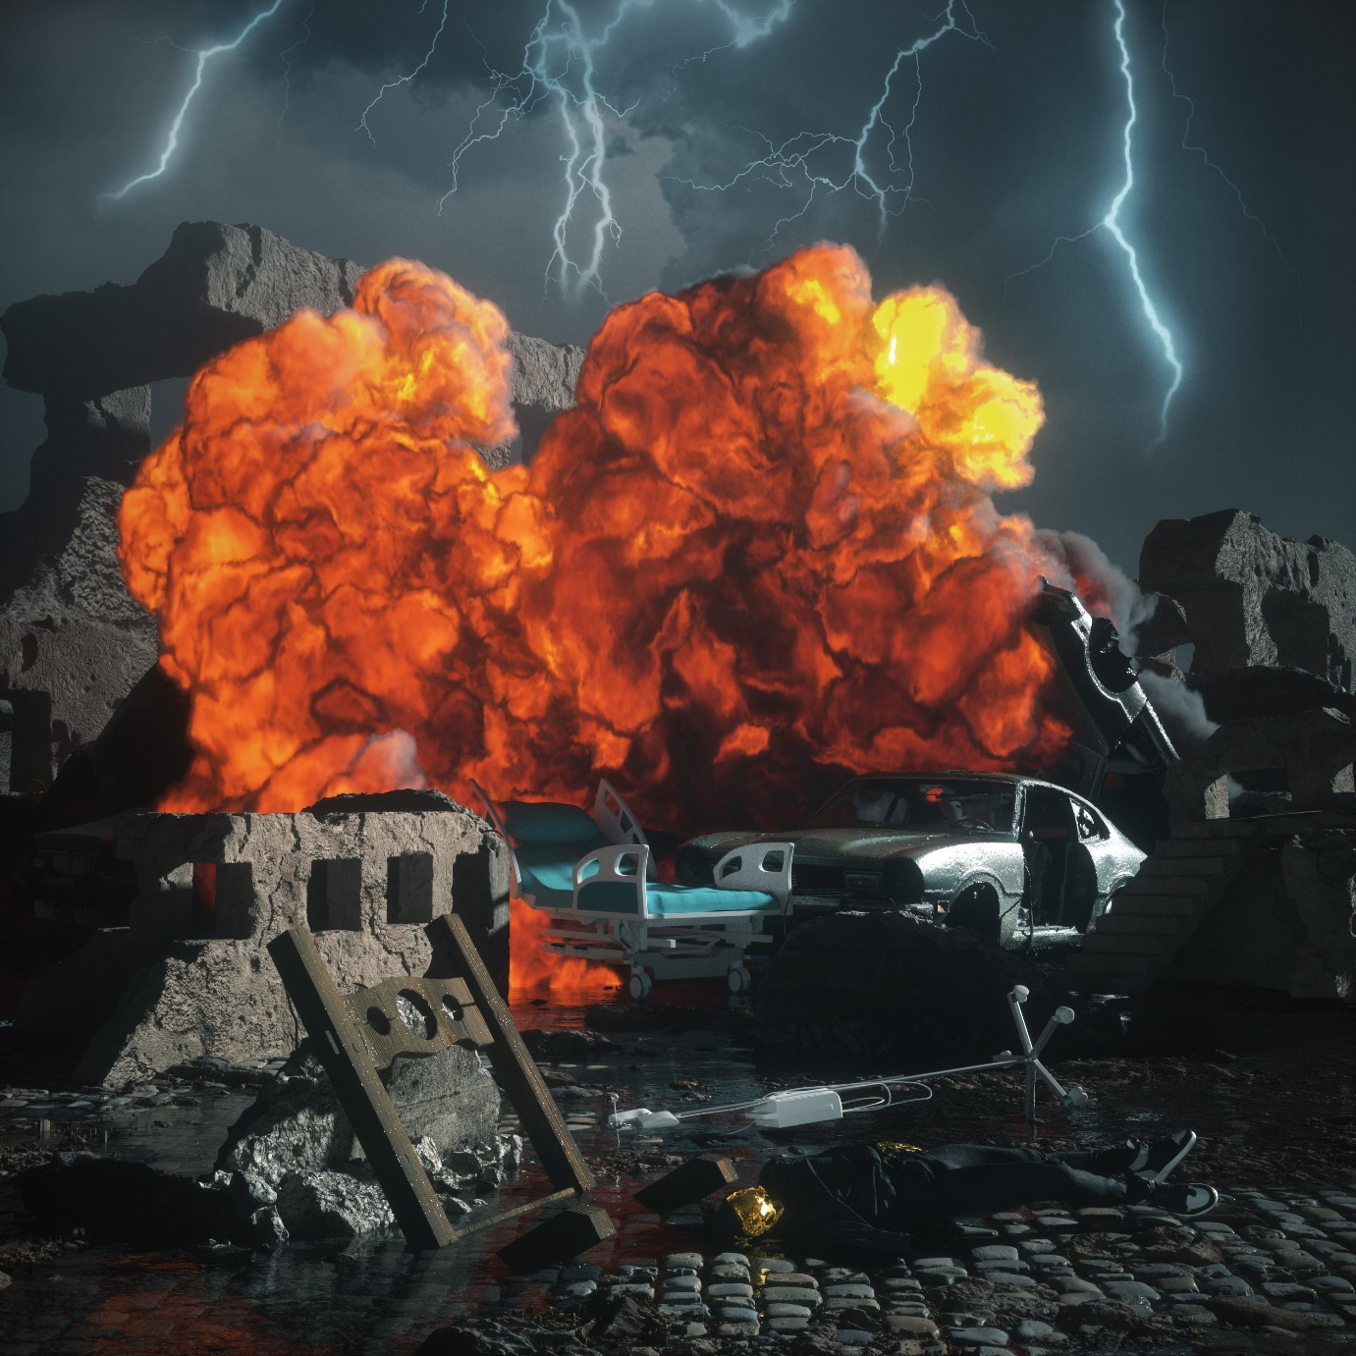

- ii x two
- The End
- Adrenaline
- Take Me Instead
- Fade Out
- In My Hands [feat. Travis Barker & Clever]
- Tragedy
- The End /Undead [with The Hollywood Undead]

ABOUT ZERO 9:36
Siphoning precise raps through a battlefield of distorted guitars and glitchy hues, Zero 9:36 holds up a mirror in his music and beckons reflection. The Philadelphia post-genre sonic insurgent, singer, creative, and rapper rhymes with the force and fire of a prizefighter as he lands hard-hitting hooks meant to explode on impact. After grinding under-the-radar for years and augmenting his signature style with cybernetic beats and guitar transmissions from frequent collaborator and producer No Love For The Middle Child, he caught the attention of ATCO Records in 2019. Signed personally by C.E.O. and industry legend Pete Ganbarg as the relaunched label’s flagship act, he metamorphosized again. Powered by highlights such as “Leave The Light On” and “WWYDF,” the You Will Not Be Saved EP introduced him as it generated 25 million-plus streams.
On its heels, he joined forces with grandson on “Again (Text Voter XX to 40649)” in addition to dropping the acoustic Barebones Vol. 1 EP in 2020. Zero 9:36 unleashed “The End” and its companion remix “The End/Undead” [feat. Hollywood Undead] and the anthemic “Adrenaline,” racking up another 9 million cumulative streams. Adapting to any setting, he’s amassed 40 million-plus streams and collaborated with everyone from PnB Rock to grandson and Theory of a Deadman. Zero 9:36 proudly occupies a lane of his own on the 2021 EP, …IF YOU DON’T SAVE YOURSELF [ATCO Records], led by the single “In My Hands” [feat. Travis Barker & Clever].

FOR MORE INFORMATION ON ZERO 9:36:
WEBSITE
FACEBOOK
INSTAGRAM
TWITTER
SPOTIFY
APPLE MUSIC
AMAZON

CONTACT:
ROSS ANDERSON
ROSSANDERSON@ELEKTRA.COM

