ZERO 9:36
RELEASES NEW SINGLE “IN MY HANDS” FEATURING TRAVIS BARKER & CLEVER

AVAILABLE NOW ON ALL STREAMING PLATFORMS

ANNOUNCES NEW EP …IF YOU DON’T SAVE YOURSELF OUT JANUARY 22ND

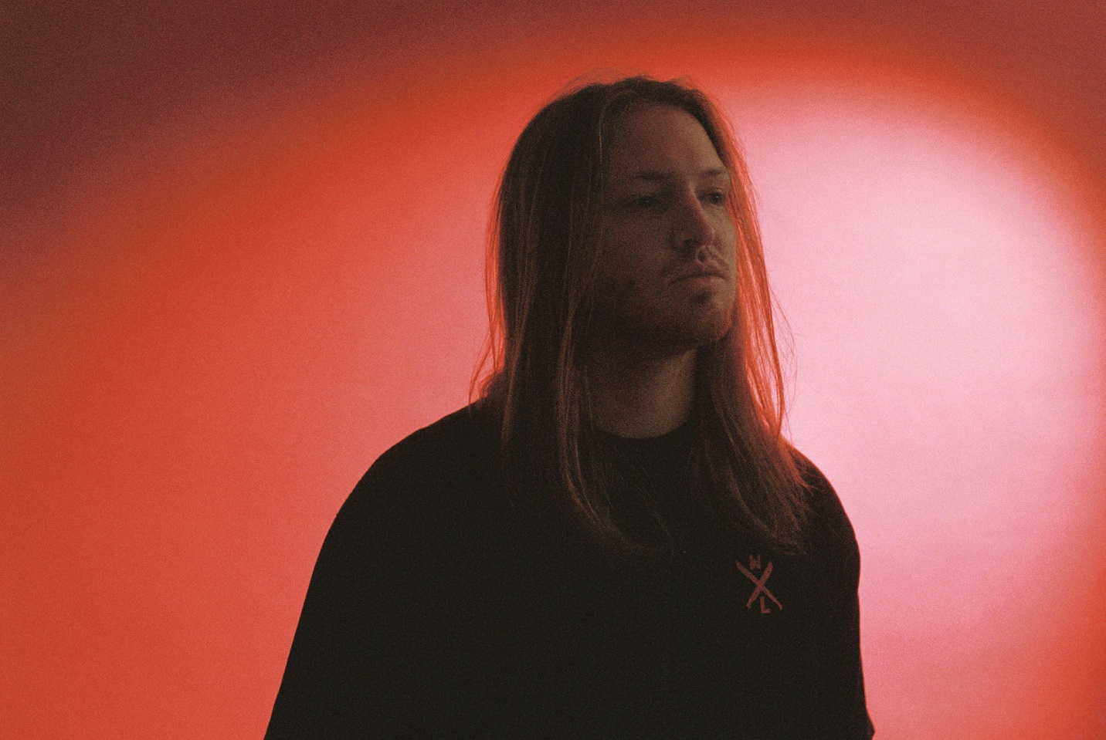

DECEMBER 18, 2020 – Philadelphia, PA’s Zero 9:36 has revealed a new single, “In My Hands” [feat. Travis Barker & Clever]. It is available now on all streaming platforms.
The track illuminates Zero 9:36’s genre-blurring fluidity, fusing alternative, rock, and hip-hop all at once. Legendary Blink-182 drummer Travis Barker contributes a signature live beat, while Alabama rapper Clever cameos with a verse. The song initially came to life remotely on ZOOM in sessions between Zero 9:36, frequent collaborator and producer No Love For The Middle Child, producer Keith Varon [FEVER333, Martin Garrix], and Krupa [grandson, YONAKA] with mixing by Drew Fulk [Lil Wayne, Beartooth, Lil Peep].
About “In My Hands,” Zero 9:36 said, “Everybody really took it to the next level. Clever brought the hip-hop side, Krupa put all of those glitches and effects on there, and Travis being Travis just killed it. It’s like we made a rock song with trap drums and then kicked it up a notch.” He adds, “Lyrically, it’s open for interpretation, but for me, it’s about a relationship. When the other person finally leaves you, you want her to come back, because you know you fucked up. However, it’s better if she doesn’t, because you’d still probably let her down. It’s recognizing the problems are your fault.”
“In My Hands” heralds the release of Zero 9:36’s anxiously awaited new EP, …If You Don’t Save Yourself, arriving on all streaming platforms January 22, 2021. The seven-track project includes recent favorites such as “The End,” “Adrenaline,” and more. Songs from the EP have already amassed 10 million total streams and counting, building excitement for its forthcoming arrival [TRACKLIST BELOW].
Last year, Zero 9:36 shared his debut EP, You Will Not Be Saved – the first release on the newly relaunched ATCO Records. The EP includes lead single “Leave The Light On” – produced by Mark Jackson and Ian Scott (Bishop Briggs) with Boonn (grandson), and is also accompanied by an official video directed by Matthew Gold. Following the EP release Zero 9:36 shared the collaborative single with No Love For The Middle Child titled “Come Thru,” and linked up with Fueled By Ramen artist grandson on his track “Again” (Text Voter XX to 40649). More recently, Zero 9:36 released Barebones Vol. 1, an eight song all acoustic EP featuring stripped back performances of fan favorites “WWYDF,” “Reset,” and more.
Growing up in the city of Brotherly Love, Zero 9:36 took to music at an early age. He entered his first studio at 10-years-old and never looked back. The alternative artist has since amassed over 30 Million streams through a prolific body of work.

ZERO 9:36
…IF YOU DON’T SAVE YOURSELF

- Intro
- Adrenaline
- The End
- In My Hands [feat. Travis Barker & Clever]
- Take Me Instead
- Tragedy
- Fade Out
- The End / Undead [with The Hollywood Undead]

FOR MORE INFORMATION ON ZERO 9:36:
WEBSITE
FACEBOOK
INSTAGRAM
TWITTER
SPOTIFY
APPLE MUSIC
AMAZON

CONTACT:
ROSS ANDERSON
ROSSANDERSON@ELEKTRA.COM

