ZERO 9:36 UNLEASHES NEW SINGLE “I’M NOT”

AVAILABLE TODAY ON ALL STREAMING PLATFORMS

ON TOUR WITH NECK DEEP ACROSS NORTH AMERICA

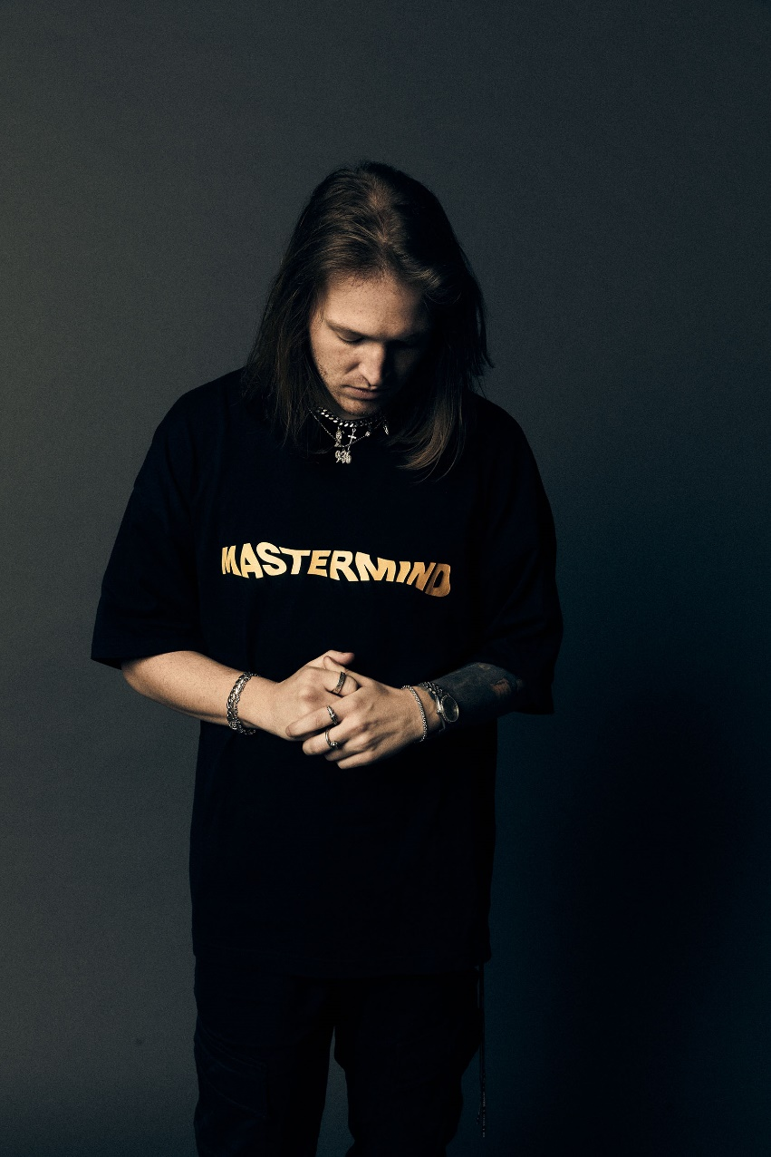
PHOTO CREDIT: JIMMY FONTAINE

DECEMBER 3, 2021 – ATCO Records artist Zero 9:36 has unveiled a brand-new single entitled “I’m Not” which is available now on all streaming platforms.

Storming out of the gate, “I’m Not” hinges on a hard-hitting guitar riff as Zero 9:36 spits intense bars laced with a spirit of raw defiance. The track culminates on the infectiously anthemic refrain where he unapologetically assures, “I am not making your decisions, because you’re everything I’m not,” before dipping back down into an acoustic bridge. With no holds barred, it illuminates the power of his rap and rock alchemy.

Recently, he joined forces with We Came As Romans for the single “Daggers.” Earning critical acclaim, Guitar World hailed it as one of “this week’s essential guitar tracks” and went on to dub it “a certified pit-spinner.” Loudwire called it a “brutal banger,” and Alternative Press noted, “The song centers around navigating self-doubt and coming out the other side with a stronger sense of self.” Not to mention, it has already tallied north of 1 million total streams and counting.

Right now, Zero 9:36 is on the road supporting Neck Deep. The tour takes over Stage AE in Pittsburgh, PA on December 2 before crisscrossing the East Coast and concluding in Worcester, MA at The Palladium on December 11.

Earlier this year, he served up Live from SiriusXM, a brand-new live EP featuring performances of his singles “Adrenaline,” “The End,” and “In My Hands,” which were recorded for SiriusXM’s Octane. Live from SiriusXM is available now all streaming platforms with each track from the EP arriving accompanied by an official live performance video on Zero 9:36’s YouTube channel.

Live From SiriusXM followed Zero 9:36’s celebrated EP, …If You Don’t Save Yourself, which sees him presenting a peerless sonic collage of alternative, rock, hip-hop, and glitch. Architected by hand, Zero 9:36 bulldozed the way for the EP with a series of scorching tracks including “In My Hands” [feat. Travis Barker & Clever], “The End,” and “Adrenaline,” the latter of which hit #1 on Mediabase’s Active Rock airplay chart earlier this year and stands as the #1 most played current or recurrent at the format in 2021.

In 2019, Zero 9:36 shared his debut EP, You Will Not Be Saved – the first release on the newly relaunched ATCO Records. The EP includes lead single “Leave The Light On” – produced by Mark Jackson and Ian Scott (Bishop Briggs) with Boonn (grandson), and is also accompanied by an official video directed by Matthew Gold. Following the EP release Zero 9:36 shared the collaborative single with No Love For The Middle Child titled “Come Thru,” and linked up with Fueled By Ramen artist grandson on his track “Again” (Text Voter XX to 40649). Prior, Zero 9:36 released Barebones Vol. 1, an eight song all acoustic EP featuring stripped back performances of fan favorites “WWYDF,” “Reset,” and more.

ZERO 9:36
“I’M NOT” SINGLE ARTWORK

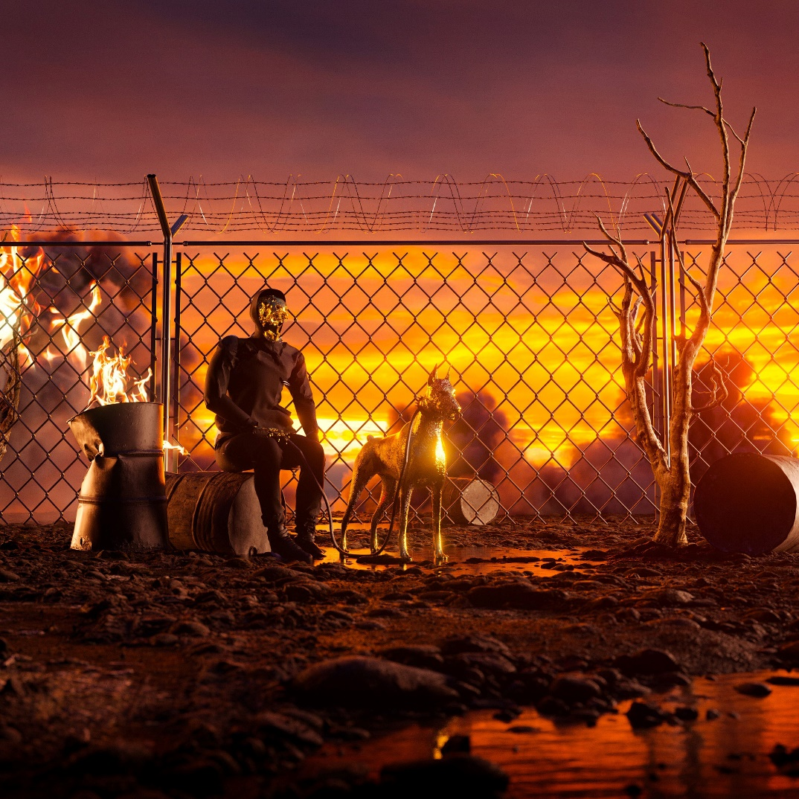

ZERO 9:36
2021 TOUR DATES

12/2 Pittsburgh, PA Stage AE
12/3 Sayreville, NJ Starland Ballroom
12/4 Philadelphia, PA Franklin Music Hall
12/6 Charlotte, NC The Fillmore Charlotte
12/7 Norfolk, VA The Norva
12/8 Baltimore, MD Rams Head Live!
12/10 New York, NY Terminal 5
12/11 Worcester, MA Palladium

ABOUT ZERO 9:36
Siphoning precise raps through a battlefield of distorted guitars and glitchy hues, Zero 9:36 holds up a mirror in his music and beckons reflection. The Philadelphia post-genre sonic insurgent, singer, creative, and rapper rhymes with the force and fire of a prizefighter as he lands hard-hitting hooks meant to explode on impact. After grinding under-the-radar for years and augmenting his signature style with cybernetic beats and guitar transmissions from frequent collaborator and producer No Love For The Middle Child, he caught the attention of ATCO Records in 2019. Signed personally by C.E.O. and industry legend Pete Ganbarg as the relaunched label’s flagship act, he metamorphosized again. Powered by highlights such as “Leave The Light On” and “WWYDF,” the You Will Not Be Saved EP introduced him as it generated 25 million-plus streams.
On its heels, he joined forces with grandson on “Again (Text Voter XX to 40649)” in addition to dropping the acoustic Barebones Vol. 1 EP in 2020. Zero 9:36 unleashed “The End” and its companion remix “The End/Undead” [feat. Hollywood Undead] and the anthemic “Adrenaline,” the latter of which hit #1 on Mediabase’s Active Rock airplay chart earlier this year and stands as the #1 most played current or recurrent at the format in 2021. Adapting to any setting, Zero 9:36 has toured alongside Shinedown, Neck Deep, and Pop Evil, made festival appearances at Welcome to Rockville, Inkcarceration, and Rocklahoma, and collaborated with everyone from Travis Barker and grandson to Hollywood Undead and Theory of a Deadman. Zero 9:36 proudly occupies a lane of his own on the 2021 EP, …IF YOU DON’T SAVE YOURSELF [ATCO Records], which has amassed over 41 million streams led by the single “In My Hands” [feat. Travis Barker & Clever].

FOR MORE INFORMATION ON ZERO 9:36:
WEBSITE
FACEBOOK
INSTAGRAM
TWITTER
SPOTIFY
APPLE MUSIC
AMAZON

CONTACT:
ROSS ANDERSON
ROSSANDERSON@ELEKTRA.COM

