FOR IMMEDIATE RELEASE
NOVEMBER 22, 2019

CHRISTINA PERRI RELEASES
“a very merry perri christmas (extra presents)”

SPECIAL RE-RELEASE OF THE MULTI-PLATINUM SINGER-SONGWRITER’S 2012 HOLIDAY EP
FEATURES TWO NEW COVERS OF CHRISTMAS CLASSICS

“a very merry perri christmas (extra presents)”
AVAILABLE NOW

STREAM/DOWNLOAD HERE

Photo Credit: Emily Winiker
PRESS ASSETS HERE

Elektra recording artist Christina Perri rings in the holiday season with today’s release of
“a very merry perri Christmas (extra presents).” The special re-issue of her 2012 EP features two brand new covers of Christmas classics “Let It Snow” and “I’ll Be Home For Christmas.” “a very merry perri christmas (extra presents)” is available at all DSPs and streaming services now.

Produced by Perri’s longtime collaborator David Hodges, “a very merry perri christmas” includes renditions of some of Christina’s all-time favorite Christmas songs including The Carpenters’ “merry christmas darling,” Charles Brown’s “please come home for christmas,” and John & Yoko/Plastic Ono Band’s “Happy Xmas (War Is Over).” The now-eight song collection also features an original track – “something about December” – written by Perri and her brother Nick (see attached tracklisting).

***
Multi-platinum singer-songwriter Christina Perri has earned critical applause and an increasingly fervent fan following since the arrival of her extraordinary, platinum-certified, 2011 debut, lovestrong, which featured the 5x-platinum certified smash, “Jar of Hearts” and gold-certified “arms.” Perri followed lovestrong. with the worldwide hit single, “A Thousand Years,” exclusively featured on THE TWILIGHT SAGA: BREAKING DAWN – PART 1 & 2– ORIGINAL MOTION PICTURE SOUNDTRACKS. The 7x-Platinum certified track was a multi-format radio favorite, and accompanied by an equally popular companion video, now boasting over 1.3 billion individual views via YouTube alone HERE. HEAD OR HEART, Perri’s acclaimed gold-certified, second album, arrived in 2014, highlighted by the RIAA 2X platinum certified single, “Human.” Perri kicked off 2019 with songs for carmella: lullabies & sing-a-longs, a collection of songs the acclaimed singer-songwriter sang to her daughter everyday, released on Carmella’s first birthday. Most recently, Perri released the poignant single “Tiny Victories,” a track she wrote for the HBO documentary FOSTER, which made its premiere this spring.

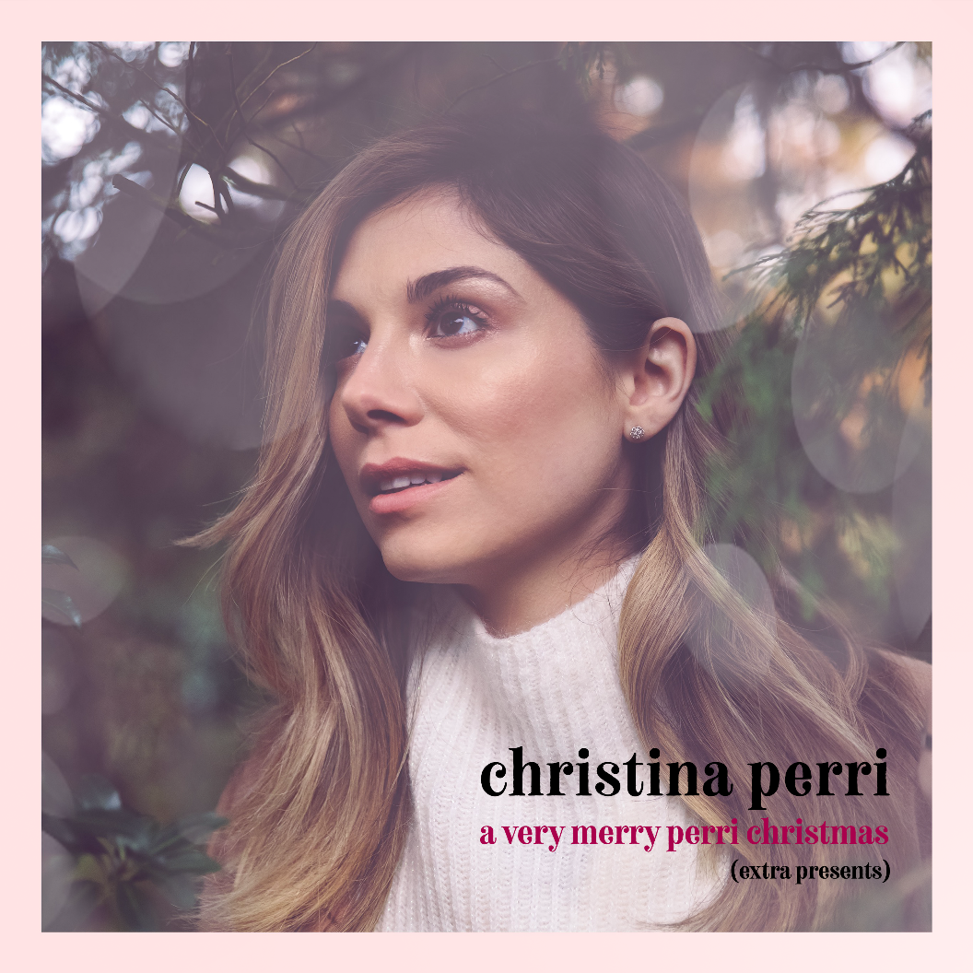
“a very merry perri christmas (extra presents)”
Track Listing

- something about december
- merry christmas darling
- please come home for christmas
- ave maria
- Happy Xmas (War Is Over)
- have yourself a merry little christmas
- let it snow
- i’ll be home for christmas

