FOR IMMEDIATE RELEASE

MARCH 23, 2022

**FLOR ANNOUNCE NEW ALBUM *FUTURE SHINE***

**OUT MAY 6 ON FUELED BY RAMEN - PRE-ORDER** [**HERE**](https://nam04.safelinks.protection.outlook.com/?url=https%3A%2F%2Fflor.lnk.to%2Ffutureshine&data=04%7C01%7CSydneyWorden%40elektra.com%7Cc2a217e46ea34e22654a08da0cd5734b%7C8367939002ec4ba1ad3d69da3fdd637e%7C0%7C0%7C637836408172713925%7CUnknown%7CTWFpbGZsb3d8eyJWIjoiMC4wLjAwMDAiLCJQIjoiV2luMzIiLCJBTiI6Ik1haWwiLCJXVCI6Mn0%3D%7C3000&sdata=9fHQg9Gt%2B3zy3rkOlNxDgWUS772nGgdsiKYMAT%2F89SE%3D&reserved=0)

**BAND SHARES TWO NEW TRACKS “**[**SKATE**](https://nam04.safelinks.protection.outlook.com/?url=https%3A%2F%2Fyoutu.be%2F3Qx52YKKSIs&data=04%7C01%7CSydneyWorden%40elektra.com%7Cc2a217e46ea34e22654a08da0cd5734b%7C8367939002ec4ba1ad3d69da3fdd637e%7C0%7C0%7C637836408172713925%7CUnknown%7CTWFpbGZsb3d8eyJWIjoiMC4wLjAwMDAiLCJQIjoiV2luMzIiLCJBTiI6Ik1haWwiLCJXVCI6Mn0%3D%7C3000&sdata=SIWivpBDuoYNbdrmepVpvztgnnQ2b22DTZ%2Fg6pzn52s%3D&reserved=0)**” AND “**[**BIG SHOT**](https://nam04.safelinks.protection.outlook.com/?url=https%3A%2F%2Fyoutu.be%2FGAIKF7xUawE&data=04%7C01%7CSydneyWorden%40elektra.com%7Cc2a217e46ea34e22654a08da0cd5734b%7C8367939002ec4ba1ad3d69da3fdd637e%7C0%7C0%7C637836408172870169%7CUnknown%7CTWFpbGZsb3d8eyJWIjoiMC4wLjAwMDAiLCJQIjoiV2luMzIiLCJBTiI6Ik1haWwiLCJXVCI6Mn0%3D%7C3000&sdata=6ZQcVZylSdKX5dKOyIg32XsujuIwI81RSbE3JGNlx9g%3D&reserved=0)**”**

**NORTH AMERICAN TOUR SUPPORTING THE BAND CAMINO KICKS OFF TONIGHT**

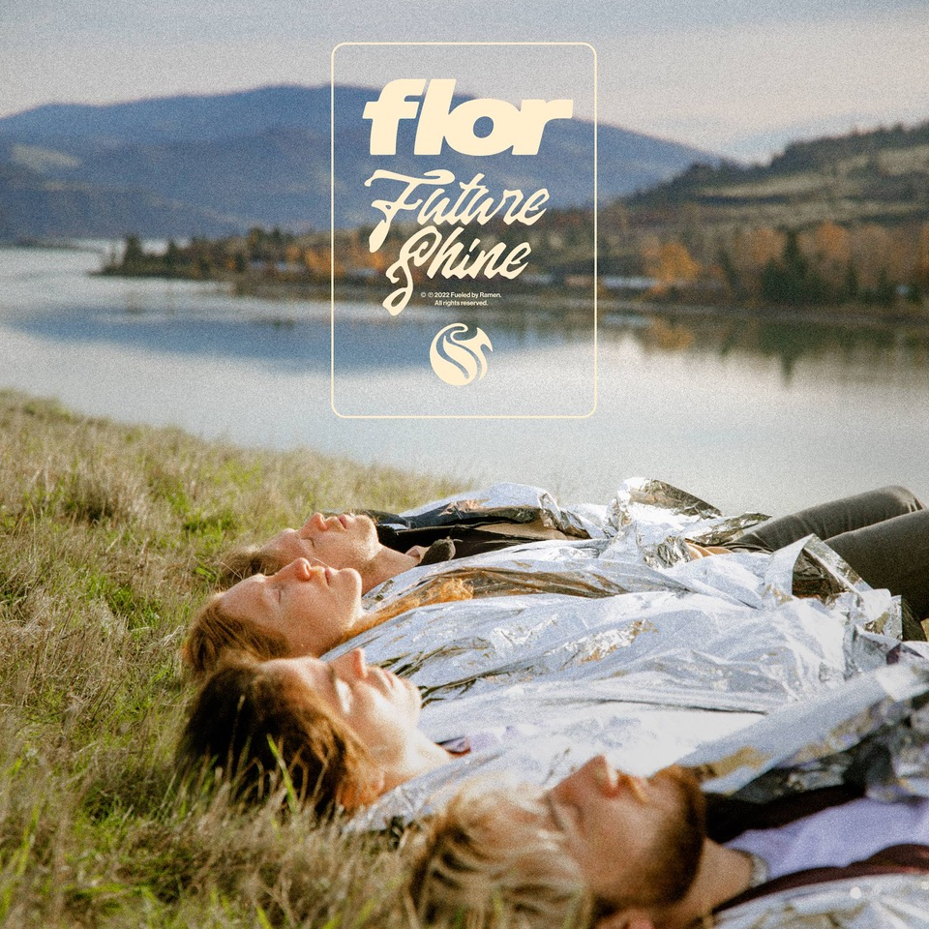

Hood River, OR alt-pop band **flor** have announced they will release their eagerly anticipated new album ***Future Shine***on May 6th via Fueled By Ramen. The album is available to pre-order and pre-save beginning today [HERE](https://nam04.safelinks.protection.outlook.com/?url=https%3A%2F%2Fflor.lnk.to%2Ffutureshine&data=04%7C01%7CSydneyWorden%40elektra.com%7Cc2a217e46ea34e22654a08da0cd5734b%7C8367939002ec4ba1ad3d69da3fdd637e%7C0%7C0%7C637836408172870169%7CUnknown%7CTWFpbGZsb3d8eyJWIjoiMC4wLjAwMDAiLCJQIjoiV2luMzIiLCJBTiI6Ik1haWwiLCJXVCI6Mn0%3D%7C3000&sdata=59EZf0BQFeq4INh0hBS8gdUIuqZF6ohfmXHUkdC2vwY%3D&reserved=0). CDs, cassettes, and limited edition merch bundles are available for pre-order exclusively through flor’s online store [HERE](https://nam04.safelinks.protection.outlook.com/?url=https%3A%2F%2Fwww.florsounds.com%2F&data=04%7C01%7CSydneyWorden%40elektra.com%7Cc2a217e46ea34e22654a08da0cd5734b%7C8367939002ec4ba1ad3d69da3fdd637e%7C0%7C0%7C637836408172870169%7CUnknown%7CTWFpbGZsb3d8eyJWIjoiMC4wLjAwMDAiLCJQIjoiV2luMzIiLCJBTiI6Ik1haWwiLCJXVCI6Mn0%3D%7C3000&sdata=0X2fzTuZMFqpGxXxoh6mr3L4XIEIz%2FncwcYhb9MOjBs%3D&reserved=0).

Alongside the announcement, flor has unveiled two brand new tracks off the album. On “[Skate](https://nam04.safelinks.protection.outlook.com/?url=https%3A%2F%2Fyoutu.be%2F3Qx52YKKSIs&data=04%7C01%7CSydneyWorden%40elektra.com%7Cc2a217e46ea34e22654a08da0cd5734b%7C8367939002ec4ba1ad3d69da3fdd637e%7C0%7C0%7C637836408172870169%7CUnknown%7CTWFpbGZsb3d8eyJWIjoiMC4wLjAwMDAiLCJQIjoiV2luMzIiLCJBTiI6Ik1haWwiLCJXVCI6Mn0%3D%7C3000&sdata=vrErnZLBJYKMgkV0RJEnS3QSdLjEI7MOz%2FAAeXtNkbU%3D&reserved=0)”, a glossy melody wraps around a laidback sunny beat, before culminating in a chantable chorus. Watch an accompanying visual for the song on the band’s YouTube channel [HERE](https://nam04.safelinks.protection.outlook.com/?url=https%3A%2F%2Fyoutu.be%2F3Qx52YKKSIs&data=04%7C01%7CSydneyWorden%40elektra.com%7Cc2a217e46ea34e22654a08da0cd5734b%7C8367939002ec4ba1ad3d69da3fdd637e%7C0%7C0%7C637836408172870169%7CUnknown%7CTWFpbGZsb3d8eyJWIjoiMC4wLjAwMDAiLCJQIjoiV2luMzIiLCJBTiI6Ik1haWwiLCJXVCI6Mn0%3D%7C3000&sdata=vrErnZLBJYKMgkV0RJEnS3QSdLjEI7MOz%2FAAeXtNkbU%3D&reserved=0). On the other end of the spectrum, the irresistible anthem “[Big Shot](https://nam04.safelinks.protection.outlook.com/?url=https%3A%2F%2Fyoutu.be%2FGAIKF7xUawE&data=04%7C01%7CSydneyWorden%40elektra.com%7Cc2a217e46ea34e22654a08da0cd5734b%7C8367939002ec4ba1ad3d69da3fdd637e%7C0%7C0%7C637836408172870169%7CUnknown%7CTWFpbGZsb3d8eyJWIjoiMC4wLjAwMDAiLCJQIjoiV2luMzIiLCJBTiI6Ik1haWwiLCJXVCI6Mn0%3D%7C3000&sdata=6ZQcVZylSdKX5dKOyIg32XsujuIwI81RSbE3JGNlx9g%3D&reserved=0)” is punctuated by shimmering distortion and a bombastic guitar solo. Watch the track’s visualizer [HERE](https://nam04.safelinks.protection.outlook.com/?url=https%3A%2F%2Fyoutu.be%2FGAIKF7xUawE&data=04%7C01%7CSydneyWorden%40elektra.com%7Cc2a217e46ea34e22654a08da0cd5734b%7C8367939002ec4ba1ad3d69da3fdd637e%7C0%7C0%7C637836408172870169%7CUnknown%7CTWFpbGZsb3d8eyJWIjoiMC4wLjAwMDAiLCJQIjoiV2luMzIiLCJBTiI6Ik1haWwiLCJXVCI6Mn0%3D%7C3000&sdata=6ZQcVZylSdKX5dKOyIg32XsujuIwI81RSbE3JGNlx9g%3D&reserved=0).

“I was thinking about people who present solutions for today’s problems to help ensure a brighter future,” shares flor vocalist/guitarist Zach Grace. “I wanted to emulate that energy, optimism, and desire for a better world. The album is us chasing the goal we’ve been after since high school: to share our art, bring joy, and connect with as many people as possible.”

*Future Shine* represents flor’s most collaborative body of work to date. Feeling uninspired to write while alone during quarantine, Grace gathered his bandmates - Dylan Bauld [bass], McKinley Kitts [guitar], and Kyle Hill [drums] - at Bauld’s Los Angeles studio for a series of writing sessions as soon as it became safe to do so. This time around, they built the bulk of the songs face-to-face, inspired by favorite records from the likes of MGMT, Phoenix, The Killers, and M83. “There was immediate magic. Imagine if we went back in time to my garage, but we had all of this experience writing songs and touring together? That’s what it was like. All of these years culminated in feeling like kids again,” adds Kitts.

Across the album’s 11 tracks, flor excavate unshakable melodies from jubilant synths, buoyant beats, and lush guitars as they relay a coming-of-age story all their own. flor previewed the album with the February release of lead single “[Play Along](https://nam04.safelinks.protection.outlook.com/?url=https%3A%2F%2Fyoutu.be%2Fl1_2oEcEXeI&data=04%7C01%7CSydneyWorden%40elektra.com%7Cc2a217e46ea34e22654a08da0cd5734b%7C8367939002ec4ba1ad3d69da3fdd637e%7C0%7C0%7C637836408172870169%7CUnknown%7CTWFpbGZsb3d8eyJWIjoiMC4wLjAwMDAiLCJQIjoiV2luMzIiLCJBTiI6Ik1haWwiLCJXVCI6Mn0%3D%7C3000&sdata=DzTJLspSf%2Ber%2Bj8B%2FC1h1mzY2SQB%2BXVInp82mfPs1EY%3D&reserved=0)”, which *Variance Magazine* praised as “the perfect introduction to their next chapter as a band.” The song is available to stream and download now [HERE](https://nam04.safelinks.protection.outlook.com/?url=https%3A%2F%2Fflor.lnk.to%2Fplayalong&data=04%7C01%7CSydneyWorden%40elektra.com%7Cc2a217e46ea34e22654a08da0cd5734b%7C8367939002ec4ba1ad3d69da3fdd637e%7C0%7C0%7C637836408172870169%7CUnknown%7CTWFpbGZsb3d8eyJWIjoiMC4wLjAwMDAiLCJQIjoiV2luMzIiLCJBTiI6Ik1haWwiLCJXVCI6Mn0%3D%7C3000&sdata=9KietOnhWYBDR5I1D%2BzqEE46fHIisTuLFGAIKrSKAd8%3D&reserved=0).

This evening, flor will hit the road in North America supporting The Band Camino. The 25-city trek will visit major markets coast-to-coast, and wrap on April 30 in Philadelphia, PA. Remaining tickets for the largely sold-out tour are available now [HERE](https://nam04.safelinks.protection.outlook.com/?url=https%3A%2F%2Fwww.florsounds.com%2F&data=04%7C01%7CSydneyWorden%40elektra.com%7Cc2a217e46ea34e22654a08da0cd5734b%7C8367939002ec4ba1ad3d69da3fdd637e%7C0%7C0%7C637836408172870169%7CUnknown%7CTWFpbGZsb3d8eyJWIjoiMC4wLjAwMDAiLCJQIjoiV2luMzIiLCJBTiI6Ik1haWwiLCJXVCI6Mn0%3D%7C3000&sdata=0X2fzTuZMFqpGxXxoh6mr3L4XIEIz%2FncwcYhb9MOjBs%3D&reserved=0). This September, flor will appear at Firefly Music Festival 2022. A complete list of upcoming live dates can be found below.

*Future Shine* follows flor’s sophomore LP *ley lines*, which was released in 2019 and is available now [HERE](https://nam04.safelinks.protection.outlook.com/?url=https%3A%2F%2Flnk.to%2Fflorleylines&data=04%7C01%7CSydneyWorden%40elektra.com%7Cc2a217e46ea34e22654a08da0cd5734b%7C8367939002ec4ba1ad3d69da3fdd637e%7C0%7C0%7C637836408172870169%7CUnknown%7CTWFpbGZsb3d8eyJWIjoiMC4wLjAwMDAiLCJQIjoiV2luMzIiLCJBTiI6Ik1haWwiLCJXVCI6Mn0%3D%7C3000&sdata=rzX0EO8SkvtiTHqXehAcwn0ldbBpvtUnP71Ux8E1qJs%3D&reserved=0). Singles including “[slow motion](https://nam04.safelinks.protection.outlook.com/?url=https%3A%2F%2Fyoutu.be%2FLsK7MKKuoP4&data=04%7C01%7CSydneyWorden%40elektra.com%7Cc2a217e46ea34e22654a08da0cd5734b%7C8367939002ec4ba1ad3d69da3fdd637e%7C0%7C0%7C637836408172870169%7CUnknown%7CTWFpbGZsb3d8eyJWIjoiMC4wLjAwMDAiLCJQIjoiV2luMzIiLCJBTiI6Ik1haWwiLCJXVCI6Mn0%3D%7C3000&sdata=rd9KyVX%2Fh61ekBDO3tkOUnJyBnXv0r5gEXCBWgfvHsw%3D&reserved=0)” and “[dancing around](https://nam04.safelinks.protection.outlook.com/?url=https%3A%2F%2Fyoutu.be%2FH391nsftSpQ&data=04%7C01%7CSydneyWorden%40elektra.com%7Cc2a217e46ea34e22654a08da0cd5734b%7C8367939002ec4ba1ad3d69da3fdd637e%7C0%7C0%7C637836408172870169%7CUnknown%7CTWFpbGZsb3d8eyJWIjoiMC4wLjAwMDAiLCJQIjoiV2luMzIiLCJBTiI6Ik1haWwiLCJXVCI6Mn0%3D%7C3000&sdata=fcGJb74t2Q%2B9F4OxK7Eehp3nhpfRO2aTuMAwYwtpQWA%3D&reserved=0)”, and earned praise from *Nylon*, *Billboard*, *Ones To Watch*, and more, and were prominently featured on playlists including Today In Music on Apple Music, Brand New Music on Amazon Music, and New Music Friday on Spotify. Remaining prolific throughout the pandemic, flor reworked fan-favorite tracks on their [*reimagined* EP](https://nam04.safelinks.protection.outlook.com/?url=https%3A%2F%2Flnk.to%2Freimagined&data=04%7C01%7CSydneyWorden%40elektra.com%7Cc2a217e46ea34e22654a08da0cd5734b%7C8367939002ec4ba1ad3d69da3fdd637e%7C0%7C0%7C637836408172870169%7CUnknown%7CTWFpbGZsb3d8eyJWIjoiMC4wLjAwMDAiLCJQIjoiV2luMzIiLCJBTiI6Ik1haWwiLCJXVCI6Mn0%3D%7C3000&sdata=exNNuyNW7%2Br%2Bg4EadaII0R7y0L7E11c5YaEgiVmyE1U%3D&reserved=0) and unveiled the standalone single “[LMHO](https://nam04.safelinks.protection.outlook.com/?url=https%3A%2F%2Fyoutu.be%2F-lhOgBPcKf8&data=04%7C01%7CSydneyWorden%40elektra.com%7Cc2a217e46ea34e22654a08da0cd5734b%7C8367939002ec4ba1ad3d69da3fdd637e%7C0%7C0%7C637836408172870169%7CUnknown%7CTWFpbGZsb3d8eyJWIjoiMC4wLjAwMDAiLCJQIjoiV2luMzIiLCJBTiI6Ik1haWwiLCJXVCI6Mn0%3D%7C3000&sdata=cpN1AnSAGi062WGtRe94VWDSLJBb8wscyJwWSKNBYRU%3D&reserved=0)” in 2020.

***Future Shine* Tracklisting**

1. 24

2. Big Shot*

3. Clouds

4. Come Over Now

5. Conditional

6. Gotta Do Something

7. Play Along*

8. Skate*

9. Take it Back Home

10. Future Shine

11. The Way We Talk About a Song

*Available now

**flor Tour Dates:**

March 23, 2022 - Louisville, KY - Old Forester’s Paristown Hall - **SOLD OUT**

March 24, 2022 - Indianapolis, IN - Egyptian Room at Old National Centre - **SOLD OUT**

March 25, 2022 - Chicago, IL - Riviera Theatre - **SOLD OUT**

March 26, 2022 - Minneapolis, MN - The Fillmore - **SOLD OUT**

March 29, 2022 - Salt Lake City, UT - The Complex - **SOLD OUT**

March 31, 2022 - Portland, OR - Roseland Theater - **SOLD OUT**

April 01, 2022 - Seattle, WA - The Showbox - **SOLD OUT**

April 03, 2022 - Vancouver, BC - Commodore Ballroom - **SOLD OUT**

April 05, 2022 - San Francisco, CA - The Regency Ballroom - **SOLD OUT**

April 06, 2022 - Santa Cruz, CA - Catalyst

April 08, 2022 - Los Angeles, CA - The Novo by Microsoft - **SOLD OUT**

April 09, 2022 - Santa Ana, CA - Observatory - **SOLD OUT**

April 10, 2022 - Tempe, AZ - Marquee Theatre

April 12, 2022 - Houston, TX - Warehouse Live

April 14, 2022 - Dallas, TX - The Factory in Deep Ellum

April 15, 2022 - Austin, TX - ACL Live at The Moody Theater - **SOLD OUT**

April 17, 2022 - Birmingham, AL - Avondale Brewing Co - **SOLD OUT**

April 19, 2022 - Orlando, FL - The Plaza Live - **SOLD OUT**

April 21, 2022 - Charlotte, NC - The Fillmore Charlotte - **SOLD OUT**

April 22, 2022 - Raleigh, NC - The Ritz - **SOLD OUT**

April 23, 2022 - Atlanta, GA - The Eastern - **SOLD OUT**

April 24, 2022 - Atlanta, GA - The Eastern

April 26, 2022 - Silver Springs, MD - The Fillmore - **SOLD OUT**

April 27, 2022 - New York, NY - Terminal 5 - **SOLD OUT**

April 29, 2022 - Boston, MA - House of Blues Boston - **SOLD OUT**

April 30, 2022 - Philadelphia, PA - Franklin Music Hall - **SOLD OUT**

September 22-25, 2022 - Dover Heights, DE - Firefly Music Festival 2022

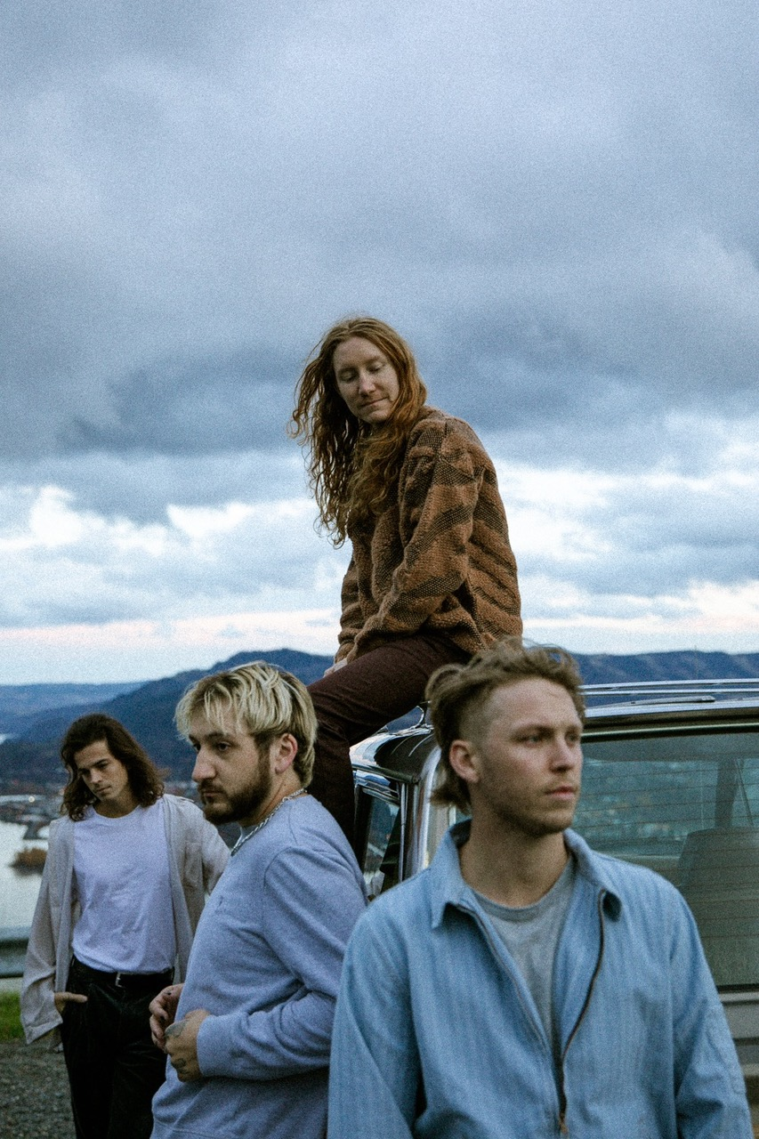

*(Photo credit: Ashley Osborn)*

**About flor**

flor finds light in the promise of a new day. The Hood River, OR quartet—Zach Grace [vocals, guitar], Dylan Bauld [bass], McKinley Kitts [guitar], and Kyle Hill [drums]—excavate unshakable melodies from jubilant synths, buoyant beats, and lush guitars as they relay a coming-of-age story all their own. The story began as high school kids in McKinley’s garage. The band quietly generated hundreds of millions of streams in the wake of their 2016 debut *come out. you*’*re hiding*. In 2019, *ley lines* only accelerated their momentum buoyed by tracks including “white noise,” “slow motion,” and “dancing around”. Critical acclaim followed from *Nylon*, *Billboard*, *Paste,* and *Ones To Watch* who hailed the album as “*an exhilarating balancing act*.*”* They concluded a successful headline tour at the top of 2020 only to face the harsh reality of the Global Pandemic with the rest of us. Once it became safe enough to do so, the musicians congregated back in Los Angeles at Dylan’s studio for a series of writing sessions. This time around, they built the bulk of the songs face-to-face together inspired by favorite records from the likes of MGMT, Phoenix, The Killers, and M83. Now, flor shines brighter than ever on their third full-length album, *Future Shine* [Fueled By Ramen].

[https://www.florsounds.com/](https://nam04.safelinks.protection.outlook.com/?url=https%3A%2F%2Fwww.florsounds.com%2F&data=04%7C01%7CSydneyWorden%40elektra.com%7Cc2a217e46ea34e22654a08da0cd5734b%7C8367939002ec4ba1ad3d69da3fdd637e%7C0%7C0%7C637836408172870169%7CUnknown%7CTWFpbGZsb3d8eyJWIjoiMC4wLjAwMDAiLCJQIjoiV2luMzIiLCJBTiI6Ik1haWwiLCJXVCI6Mn0%3D%7C3000&sdata=0X2fzTuZMFqpGxXxoh6mr3L4XIEIz%2FncwcYhb9MOjBs%3D&reserved=0)

[Facebook](https://nam04.safelinks.protection.outlook.com/?url=https%3A%2F%2Fwww.facebook.com%2Fflorsounds&data=04%7C01%7CSydneyWorden%40elektra.com%7Cc2a217e46ea34e22654a08da0cd5734b%7C8367939002ec4ba1ad3d69da3fdd637e%7C0%7C0%7C637836408172870169%7CUnknown%7CTWFpbGZsb3d8eyJWIjoiMC4wLjAwMDAiLCJQIjoiV2luMzIiLCJBTiI6Ik1haWwiLCJXVCI6Mn0%3D%7C3000&sdata=RlRXcKEiLolnD9Z30NjH%2F%2FeTe8v6DXOTc0soroYnyJE%3D&reserved=0) | [Twitter](https://nam04.safelinks.protection.outlook.com/?url=https%3A%2F%2Ftwitter.com%2Fflor&data=04%7C01%7CSydneyWorden%40elektra.com%7Cc2a217e46ea34e22654a08da0cd5734b%7C8367939002ec4ba1ad3d69da3fdd637e%7C0%7C0%7C637836408172870169%7CUnknown%7CTWFpbGZsb3d8eyJWIjoiMC4wLjAwMDAiLCJQIjoiV2luMzIiLCJBTiI6Ik1haWwiLCJXVCI6Mn0%3D%7C3000&sdata=WfJkejy98hanP60b6muIAh4nSP6pXp%2B%2Fq7KCPz8qOEw%3D&reserved=0) | [Instagram](https://nam04.safelinks.protection.outlook.com/?url=https%3A%2F%2Fwww.instagram.com%2Fflor%2F&data=04%7C01%7CSydneyWorden%40elektra.com%7Cc2a217e46ea34e22654a08da0cd5734b%7C8367939002ec4ba1ad3d69da3fdd637e%7C0%7C0%7C637836408172870169%7CUnknown%7CTWFpbGZsb3d8eyJWIjoiMC4wLjAwMDAiLCJQIjoiV2luMzIiLCJBTiI6Ik1haWwiLCJXVCI6Mn0%3D%7C3000&sdata=g7MJpW5lzyUvr9i1TxZDVsnCnFioKY%2B19Cnv8kUQWNo%3D&reserved=0) | [YouTube](https://nam04.safelinks.protection.outlook.com/?url=https%3A%2F%2Fwww.youtube.com%2Fflorsounds&data=04%7C01%7CSydneyWorden%40elektra.com%7Cc2a217e46ea34e22654a08da0cd5734b%7C8367939002ec4ba1ad3d69da3fdd637e%7C0%7C0%7C637836408172870169%7CUnknown%7CTWFpbGZsb3d8eyJWIjoiMC4wLjAwMDAiLCJQIjoiV2luMzIiLCJBTiI6Ik1haWwiLCJXVCI6Mn0%3D%7C3000&sdata=4QJzxCHSIwGEvNzu9kpYqhGZu8Oxi%2FSMGFHSCg2aILs%3D&reserved=0)

**Press contact:**

Collin Citron / [collincitron@elektra.com](mailto:collincitron@elektra.com)