GRANDSON ANNOUNCES 'DEATH OF AN OPTIMIST’ DELUXE ALBUM OUT DECEMBER 3RD VIA FUELED BY RAMEN — THE ANNIVERSARY OF THE ALBUM’S RELEASE

PLATINUM-SELLING ALT ROCKER RELEASES “DROP DEAD” WITH KESHA & TRAVIS BARKER TODAY

WATCH THE VIDEO HERE AND READ MORE VIA ROLLING STONE

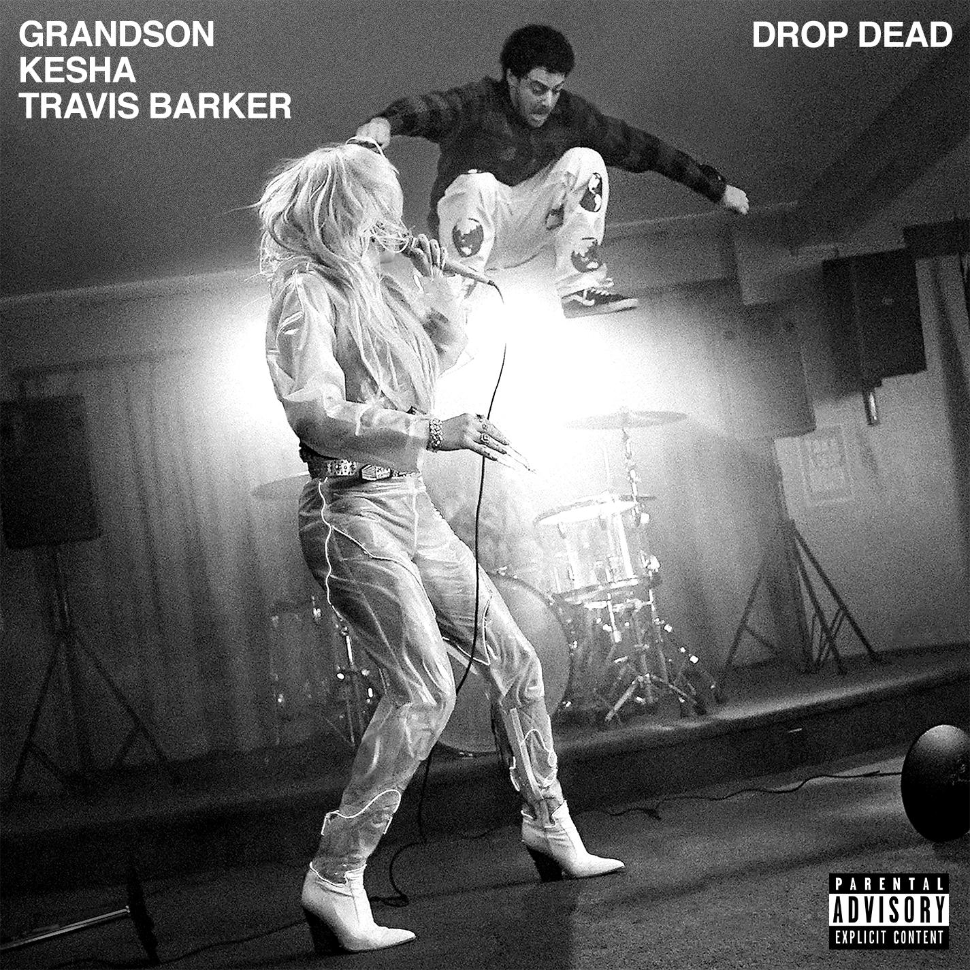

OCTOBER 29, 2021 - Today, platinum-selling alt-rocker grandson announces his new ‘Death of An Optimist’ Deluxe Album out December 3rd via Fueled by Ramen — the one year anniversary of the album’s original release — and releases “Drop Dead” with GRAMMY-nominated pop superstar Kesha and Travis Barker. Towing the line between pop and rock, the track is a headbanging statement, infused with Kesha’s vigor and defiant filled vocals, Barker’s rollicking drumming and grandson’s energetic & poignant lyricism.

The new visual, which is out today, follows the artist’s new friend — a large, furry monster who traverses the hero's journey and ultimately finds love — interspersed with spirited scenes of Kesha and grandson rocking out at their own private concert.

Watch here: https://youtu.be/qWHZRvgFKy0
Read more via Rolling Stone: https://www.rollingstone.com/music/music-news/grandson-kesha-travis-barker-drop-dead-new-song-1249663/

Originally by grandson and comprised of the underlying optimism felt in so many Blink182 songs at the top of mind, “Drop Dead” focuses on the idea that humans have the capacity to come up with solutions to the world’s biggest problems, including the one dimensional tribalism exacerbated through social media and the growing desperation of inequality.

“Drop Dead is a song I wrote with Travis Barker and Kevin Hissink in 2020 about making peace with the fact that things don’t always end like the movies,” says grandson. “Being brave and standing for what you believe won’t always end looking the way you hope it will, with the crowd cheering and the end credits rolling. Accept my inevitable shortcomings, deal with the imperfections of life, and get to work being the best version of yourself. I met Kesha through some mutual friends and she just completely embodies what this song is about, she’s a badass with an incredible voice for rock and roll!”

“I loved working on this song with grandson and Travis. From the first listen, I immediately related to the energy of it. To me, it is a self-aware, defiant anthem of proud wild imperfection. It’s a “give no fucks, judge me I don’t care, this is me take it or leave it, and while you’re at it, get out of my way” song,” says Kesha. “It’s always so special to be able to collaborate with an artist who knows who they are, and Jordan’s message of honesty and unapologetically being who he is aligns so much with who I am. Shooting the video was a shit show mess of fun. grandson's energy is high-vibe all the way and we really had as much fun as it looks.”

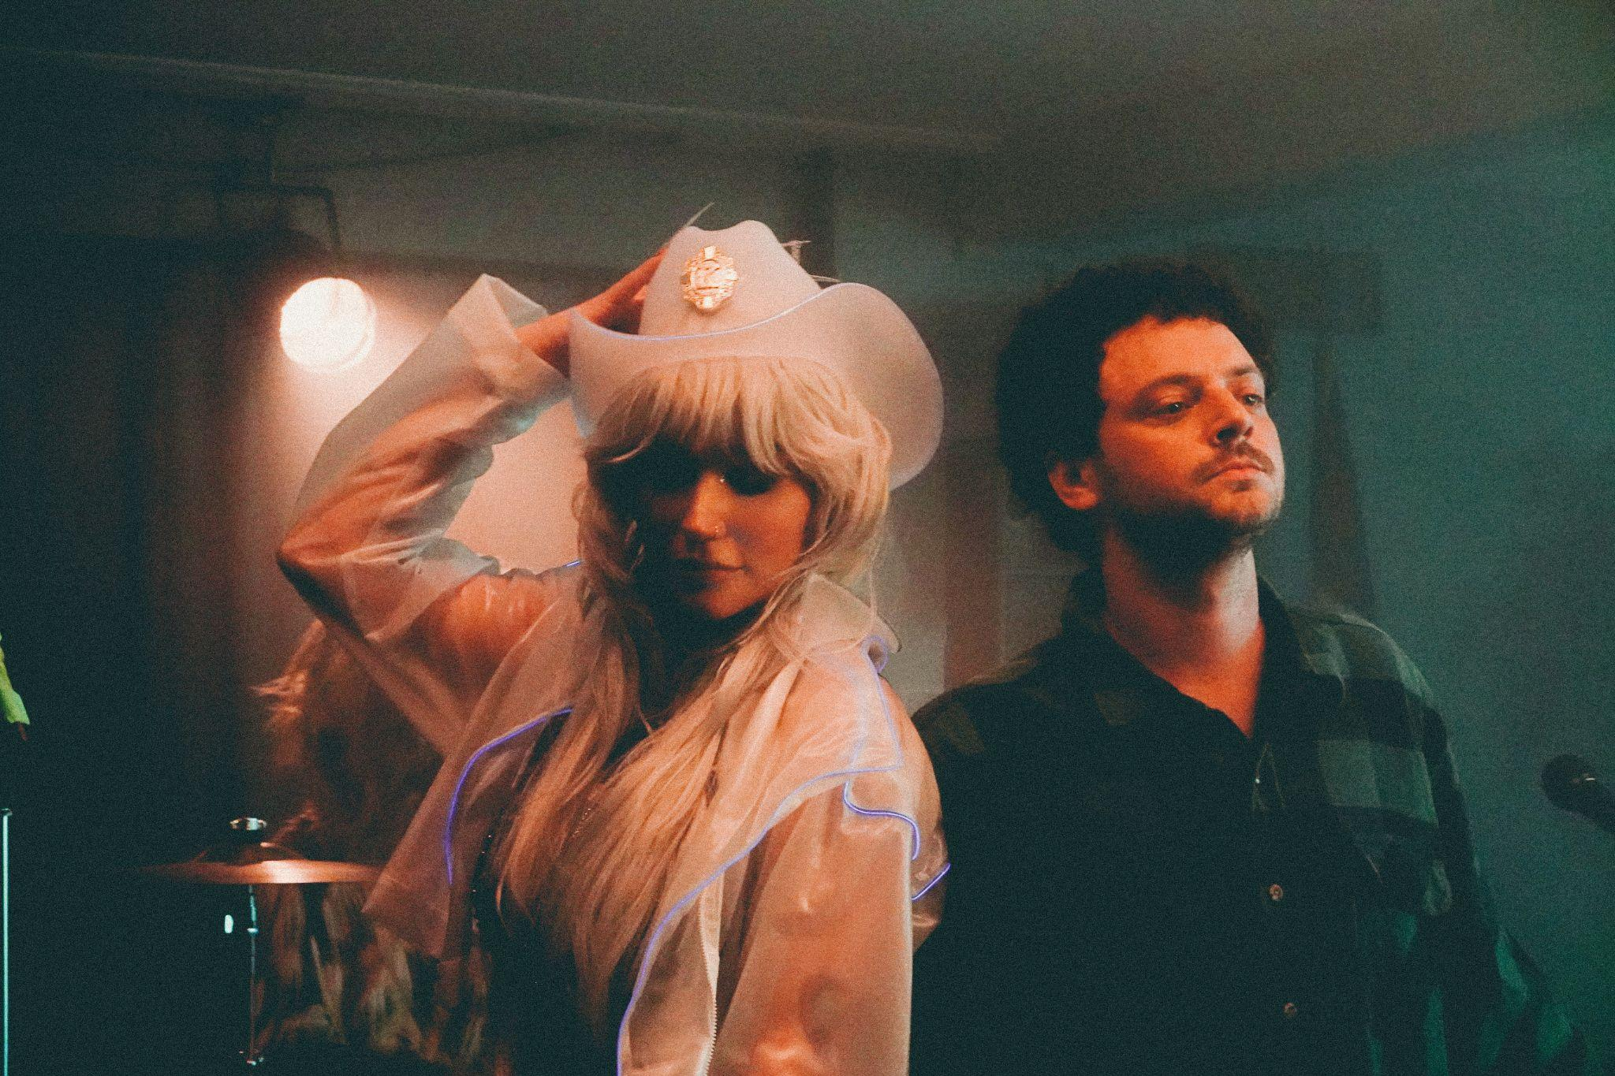
Photo Credit: Jon Frydman

“Drop Dead” with Kesha and Travis Barker follows grandson’s collaboration with Grammy-nominated R&B singer Jessie Reyez on “Rain,” the official single of The Suicide Squad, both of which will be included on the upcoming Death of an Optimist Deluxe Album.

The enchanting “Rain” video emulates the underground, grunge personas of The Suicide Squad. Electric neon lighting highlights the fierce and sultry Reyez and grandson as they fight their way out of getting captured like true Super-Villains.

Watch the video for “Rain” here: https://www.youtube.com/watch?v=vTVUAXfyGqs

Recently, grandson teamed up with friend, mentor and two-time Grammy winning rock-star Tom Morello for a brand new live performance of their collaboration “Hold the Line” from Morello’s new album The Atlas Underground Fire.

Watch Tom Morello & grandson perform “Hold the Line” here: https://www.youtube.com/watch?v=Yv-0LkDouRs

ABOUT GRANDSON
grandson is the pseudonym of Canadian/American alternative artist Jordan Benjamin. He takes elements of his rock and roll, hip hop, and electronic music roots and combines them to tell stories of reclaiming power over one’s life, confronting social issues facing his generation, and opening up about struggles with addiction and mental health. Since releasing his Modern Tragedy EP series, grandson has toured extensively across North America, Russia, and Europe, accumulated hundreds of millions of streams online, and received co-signs from the biggest names in rock and roll and progressive politics, from Tom Morello to Bernie Sanders. grandson’s debut album, 'Death Of An Optimist,' is a body of work that conflates personal anxieties with political realities. As the protagonist, grandson simultaneously explores the dark underbelly of his unrelenting optimism for change, by creating an antagonist, X. The record delivers a subtle A-side/B-side structure totaling twelve tracks that follow grandson and X’s dueling world views. Most recently, the platinum-selling alt-rocker collaborated with Grammy-nominated singer-songwriter, Jessie Reyez for "Rain," the exclusive single from the James Gunn-directed superhero film 'The Suicide Squad.' Additionally, for the end title sequence of the film, grandson joined forces with Chicago rapper Vic Mensa and Australian rapper Masked Wolf for "Oh No!!!" (From The Suicide Squad)."

ABOUT KESHA
Kesha attracts a diverse, passionate, and socially-engaged global audience who believe in the messages behind her music. Over her career, she has earned 10 Top Ten singles, over a billion views on YouTube, 2 number one albums, 4 number one songs at top 40 radio, and nearly 40 million followers across social media. Kesha’s latest album 'High Road' was called a body of work “wise and wild in equal measure” (Billboard), that “electrifies from the inside out” (American Songwriter) and “strikes a believable balance between vulnerability and the bluster she made her name on” (Stereogum). Her previous album 'Rainbow', called "an artistic feat" by Entertainment Weekly and "the best music of her career" by Rolling Stone, earned Kesha the first GRAMMY nominations of her career.

Kesha’s ventures outside of music include a top rated TV program, an award winning film, a book, a cruise, a podcast, and a cosmetics line. Most recently Kesha starred in the scripted sci-fi podcast Electric Easy (which included her original song ”Nothing Without Your Love”) as well as announced a forthcoming 2022 supernatural television show via Discovery+.

As a songwriter she has penned her own music as well as songs for artists including Britney Spears, Ariana Grande, The Veronicas, and Miley Cyrus. Kesha is an animal rights crusader as the Humane Society International's first Global Ambassador and a passionate advocate for equality, being honored with the 2016 Human Rights Campaign Visibility Award. In 2016 she won Billboard's Women in Music Trailblazer Award and in 2018 she was named one of Time Magazine's Time 100, their list of the most influential people in the world.

GRANDSON ON THE WEB:
http://www.grandsonmusic.com
https://www.instagram.com/grandson
https://www.tiktok.com/grandson
https://facebook.com/grandsonmusic
https://twitter.com/grandson
https://grandson.lnk.to/spotify

KESHA ON THE WEB:
https://www.keshaofficial.com/
https://www.facebook.com/kesha
https://www.youtube.com/user/keshaVEVO
https://www.instagram.com/iiswhoiis/

