grandson & Jessie Reyez Team Up For The Suicide Squad Exclusive New Single “Rain”

Track Featured In New The Suicide Squad Official Trailer – Watch Now

James Gunn’s All-New Superhero Action Adventure Film The Suicide Squad Out August 6th

Listen Here & Watch The Suicide Squad Trailer Here

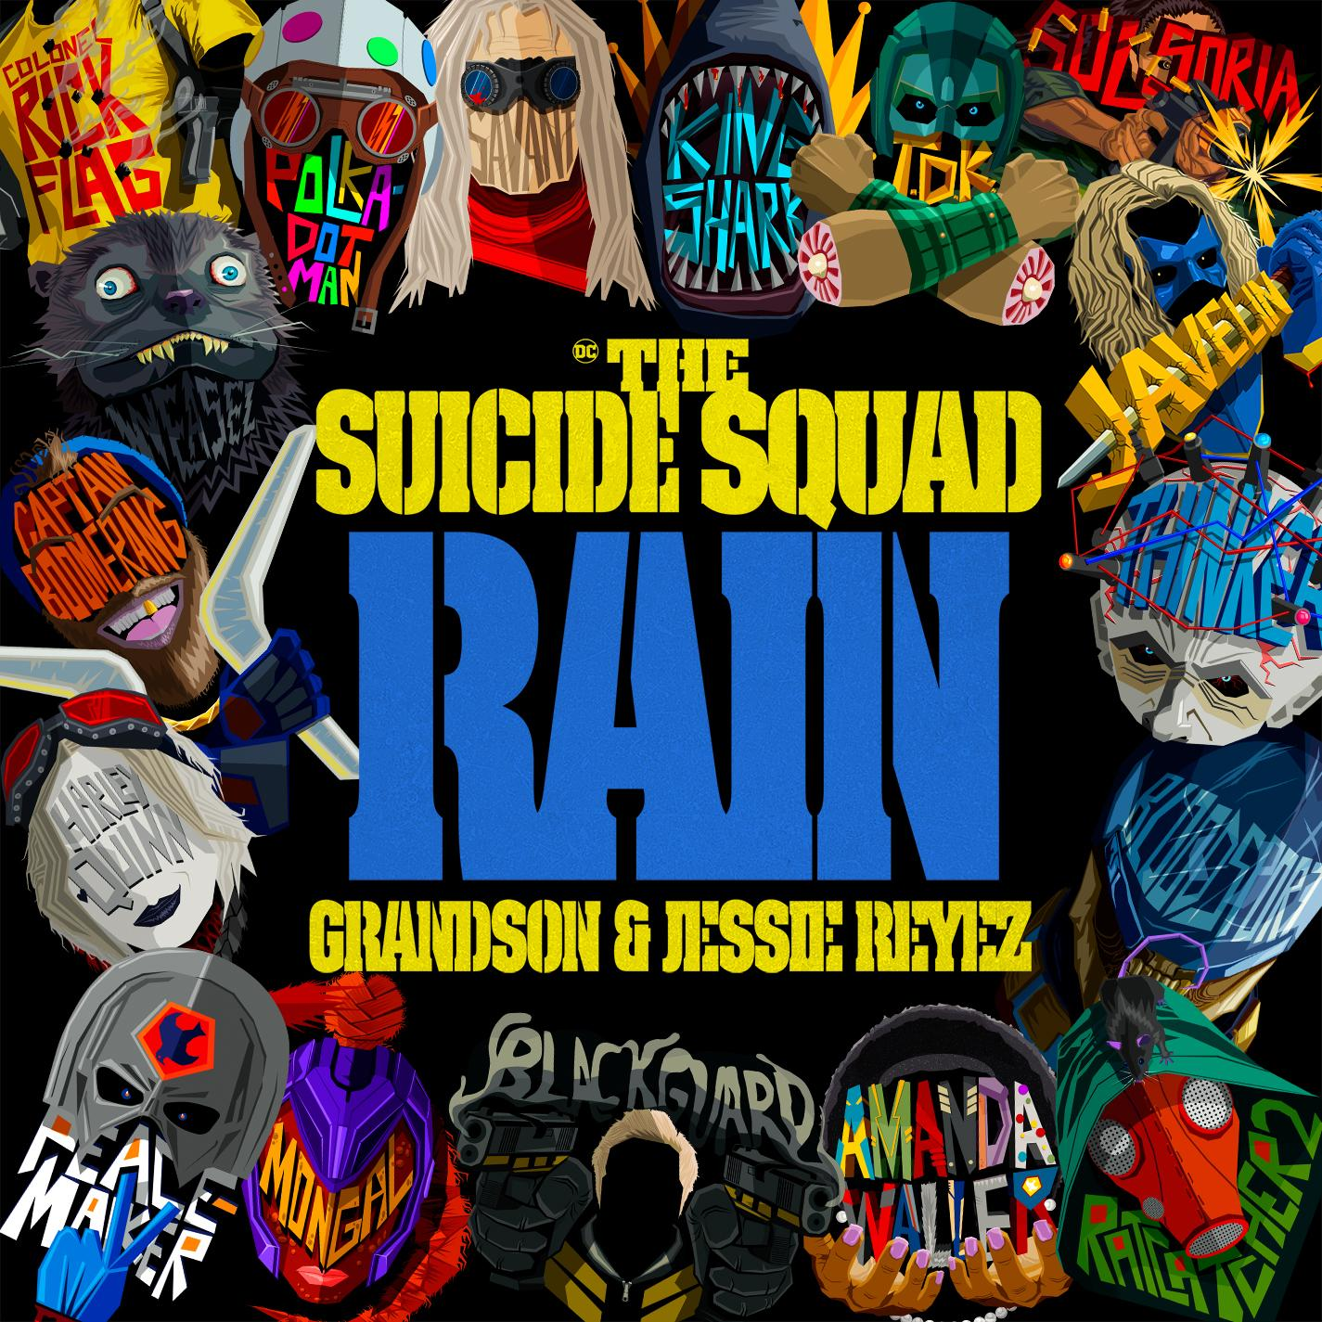
“Rain” single artwork
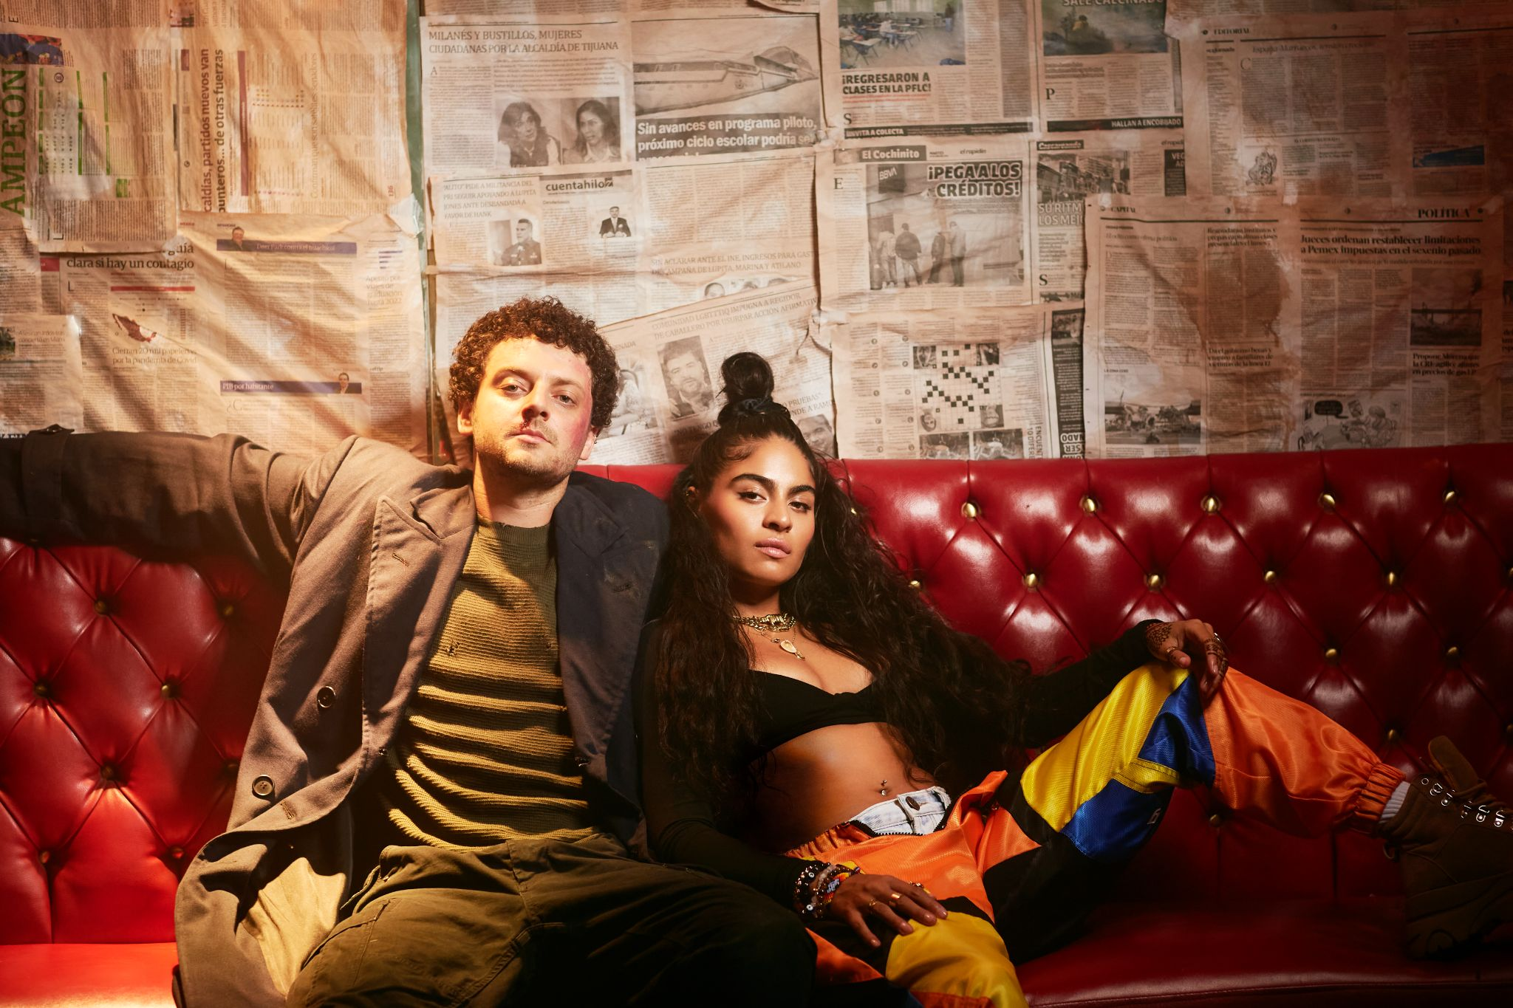
grandson & Jessie Reyez

JUNE 23, 2021 - Alt-rocker grandson and Grammy-nominated singer-songwriter Jessie Reyez have teamed up for “Rain,” the brand-new and exclusive single for writer/director James Gunn’s all-new movie, The Suicide Squad. “Rain” is also featured in the new official trailer for the upcoming film, which will be released August 6th – watch the trailer HERE.

grandson and Reyez both have individual songs in the upcoming superhero action adventure film and took the opportunity to team up for a commanding collaboration with “Rain.” Next month, an official companion visual for the track will be released featuring grandson and Reyez each embracing their inner Super-Villain.

“Rain” is about how the shadows in life accentuate the sunshine; how even though tough times are ahead, you know hope is just around the corner… “I do not mind / The rain sometimes /
Oh That’s the only way the roses / Bloom.” As two artists that inspire and evoke change, the song flaunts their combined palpable sincerity and sense of emotional transparency. Reyez’s silky vocals provide an added layer of texture, as grandson and the pop star alternate verses and come together for an epic, belting chorus.

Listen to “Rain” here: https://grandson.lnk.to/rain
Watch The Suicide Squad Trailer Here: https://youtu.be/eg5ciqQzmK0

“‘Rain’ is the theme song for making sense of personal tragedy,” shares grandson. “Through this track, I hope others find reassurance that whatever difficulty they’re going through leads to a broader, fuller perspective on life’s beauty somewhere down the road.”

“I found James Gunn as a mentor and friend during the pandemic, and we began sharing our work as I finished my album and he finished his movie,” grandson continues. “When he heard ‘Rain’ it was clear that it spoke to him. I had been a fan of Jessie for years through mutual collaborators in the Toronto/LA scene, and knew she would resonate as well and offer her own unique contribution to bring this one to the finish line.”

“When grandson first played me ‘Rain’ I felt it pierced directly to the emotional heart of ‘The Suicide Squad,’” says Gunn. “Months later, I still haven’t stopped singing it in the shower. Having Jessie on the track, another of my favorite new artists, is simply icing on the cake.”

“I respect grandson as an artist so of course I was really excited to work with him; when he called me up to bat to feature on “Rain”, it was a no-brainer,” says Jessie Reyez. “I’m also a fan of James Gunn and his work, so to be able to contribute a small part of my creativity to the world of Suicide Squad is an honor.”

grandson, who has an incredibly engaging live show, is set to play several prestigious festivals, like Firefly, Lollapalooza and more throughout the rest of the year. See below for full tour routing.

“Rain” follows grandson’s live rendition of hit radio single “Dirty,” and his debut album ‘Death Of An Optimist’ (released December 2020 via Fueled by Ramen). ‘Death of an Optimist’ articulates the tension between grandson’s hope for the future and the challenges he faces. Described by the rocker as a “horror story with a happy ending,” the cohesive record brings together an eclectic group of collaborators including engineer Andrew Dawson (Kanye West), Linkin Park’s Mike Shinoda, Blink-182’s Travis Barker, producer Krupa (Zero 9:36), and Boonn (grandson’s longtime musical partner).

Listen here: https://grandson.lnk.to/doao

grandson Tour Routing:
Thurs, Jul 29 - Subterranean - Chicago, IL
Fri, Jul 30 - Lollapalooza Festival - Chicago, IL
Sat, Aug 28 - Wonderbus Festival - Columbus, OH
Mon, Aug 30 - New York State Fair - Syracuse, NY
Fri, Sept 3 - Rocklahoma Festival - Pryor, OK
Sun, Sept 12 - Fiddler's Green | KTCL Radio Show - Denver, CO
Sun, Sept 19 - PointFest - St. Louis, MO
Sat, Sept 25 - Louder Than Life Festival - Louisville, KY
Sun, Sept 26 - Firefly Festival - Dover, DE
Sun, Oct 10 - Aftershock Festival - Sacramento, CA
Thus, Nov 11 - Welcome to Rockville Festival - Daytona Beach, FL
Sat, Jan 22, 2022 - Thurs, Jan 27th, 2022 - Shiprocked Cruise

Praise for grandson:

“buzzsaw of righteous poetry”
— Billboard

“a soundtrack for a society on the edge of collapse”
— NME

“Angsty-dripped, polemical songwriting, exploring the tug-of-war between blind optimism and anxiety-inducing reality”
— Interview Magazine

“rock ‘n’ roll rebel who is strident and crystal clear”
— Alternative Press

“explores the area between hope and apathy, urgent anger and frustration”
— Under the Radar

“rock’s new leader of the resistance”
— Rock Sound

ABOUT GRANDSON:
grandson is the pseudonym of Canadian/American alternative artist Jordan Benjamin. He takes elements of his rock and roll, hip hop, and electronic music roots and combines them to tell stories of reclaiming power over one’s life, confronting social issues facing his generation, and opening up about struggles with addiction and mental health. Since releasing his Modern Tragedy EP series, grandson has toured extensively across North America, Russia, and Europe, accumulated hundreds of millions of streams online, and received co-signs from the biggest names in rock and roll and progressive politics, from Tom Morello to Bernie Sanders. grandson’s debut album, Death Of An Optimist, is a body of work that conflates personal anxieties with political realities. As the protagonist, grandson simultaneously explores the dark underbelly of his unrelenting optimism for change, by creating an antagonist, X. An ambitious project, grandson delivers a subtle A-side/B-side structure totaling twelve tracks, following grandson and X’s dueling world views. Through DOAO, grandson delivers an overwhelming urgency to do something, “After the hardest year of our lives, it’s time to confront the reflection staring back at you, because only in doing so can you know who you truly are," he says. “Showcasing a conflicted soul for intense scrutiny has the benefit of not dictating what is right or wrong. It just shows that we’re in this together.”

GRANDSON ON THE WEB:
http://www.grandsonmusic.com
https://www.instagram.com/grandson
https://www.tiktok.com/grandson
https://facebook.com/grandsonmusic
https://twitter.com/grandson
https://grandson.lnk.to/spotify

ABOUT JESSIE REYEZ:
Grammy-nominated singer-songwriter and rising global superstar Jessie Reyez released her debut studio album Before Love Came To Kill Us via FMLY / Island Records to critical acclaim last spring, earning recognition from The NY Times, Pitchfork, Rolling Stone, Variety, and more. The album was an early contender for one of the best albums of the year with over 350M global streams and charting in the Top 5 on Billboard's R&B album chart. In just a couple short years, Jessie has been nominated for a Grammy award for Best Urban Contemporary Album for her sophomore EP Being Human In Public, won a Juno Award for 2020’s R&B/Soul Recording of The Year, and just made history by becoming the first ever Latin Canadian artist to win a Juno for Best Music Video in 2021. Jessie graced the covers of Remezcla, NME, Galore, ILY Mag, and VIBE VIVA which donned her “The People’s Pop Star.” She’s successfully headlined a tour, performed at a plethora of music festivals, supported Billie Eilish on her U.S. tour, and brought her performances to the screen with appearances on the One World: Together At Home special broadcast and Jimmy Kimmel Live (From His House)! Jessie recently became the first person and woman of color to perform both the American and Canadian national anthems for the NBA playoff games atop of the CN Tower in Toronto.

Praise for Jessie Reyez:

“No one else sounds like Jessie Reyez”
— Time

“A powerful voice when the world needs one”
— Variety

“Her music, though it’s categorized as R&B, pulls together the impulses of folky singer-songwriters and syllable-spitting rappers as well as pop melody and hip-hop impact”
— New York Times

“The powerhouse singer’s voice is chameleonic and present in every guise”
— Pitchfork

"her soulful voice and brutally honest lyrics have garnered her fans around the world"
— NPR

JESSIE REYEZ ON THE WEB:
https://www.instagram.com/jessiereyez/
https://twitter.com/Jessiereyez
https://www.facebook.com/MusicJessieReyez
https://www.youtube.com/channel/UCSHatw5t9xkBrFsCssXgMNw
https://soundcloud.com/jessiereyez

For More Information on grandson, Please Contact:

Mikaela Duhs
Shore Fire Media
mduhs@shorefire.com

Rebecca Shapiro
Shore Fire Media
rshapiro@shorefire.com

For More Information on Jessie Reyez, Please Contact:

Dana Meyerson
Biz 3
dana@biz3.net

Bria Fisher
Biz 3
bria@biz3.net

ABOUT THE SUICIDE SQUAD:
From writer/director James Gunn comes Warner Bros. Pictures’ superhero action adventure The Suicide Squad, featuring a collection of the most degenerate delinquents in the DC lineup.

Welcome to hell—a.k.a. Belle Reve, the prison with the highest mortality rate in the US of A. Where the worst Super-Villains are kept and where they will do anything to get out—even join the super-secret, super-shady Task Force X. Today’s do-or-die assignment? Assemble a collection of cons, including Bloodsport, Peacemaker, Captain Boomerang, Ratcatcher 2, Savant, King Shark, Blackguard, Javelin and everyone’s favorite psycho, Harley Quinn. Then arm them heavily and drop them (literally) on the remote, enemy-infused island of Corto Maltese. Trekking through a jungle teeming with militant adversaries and guerrilla forces at every turn, the Squad is on a search-and-destroy mission, with only Colonel Rick Flag on the ground to make them behave…and Amanda Waller’s government techies in their ears, tracking their every movement. And as always, one wrong move and they’re dead (whether at the hands of their opponents, a teammate, or Waller herself). If anyone’s laying down bets, the smart money is against them—all of them.

The film stars Margot Robbie, Idris Elba, John Cena, Joel Kinnaman, Jai Courtney, Peter Capaldi, David Dastmalchian, Daniela Melchior, Michael Rooker, Alice Braga, Pete Davidson, Joaquín Cosio, Juan Diego Botto, Storm Reid, Nathan Fillion, Steve Agee, Sean Gunn, Mayling Ng, Flula Borg, Jennifer Holland and Tinashe Kajese, with Sylvester Stallone, and Viola Davis.

Gunn directs from his own screenplay, based on characters from DC. The film is produced by Charles Roven and Peter Safran, with Zack Snyder, Deborah Snyder, Walter Hamada, Chantal Nong Vo, Nikolas Korda and Richard Suckle executive producing.

Warner Bros. Pictures Presents An Atlas Entertainment/A Peter Safran Production, A James Gunn Film, The Suicide Squad. The film will be distributed worldwide by Warner Bros. Pictures. It is set for release nationwide in theaters and IMAX on August 6, 2021 and will be available on HBO Max in UHD, HDR10, Dolby Vision and Dolby Atmos on supported devices for 31 days from theatrical release. This film has been rated R for strong violence and gore, language throughout, some sexual references, drug use and brief graphic nudity.
www.thesuicidesquad.com

