GRANDSON ANNOUNCES OFFICIAL DEBUT LP DEATH OF AN OPTIMIST

OUT DECEMBER 4TH VIA FUELED BY RAMEN

SHARES NEW SINGLE “DIRTY”

“A BUZZSAW OF RIGHTEOUS POETRY” - BILLBOARD

“DO YOU HAVE ENOUGH LOVE IN YOUR HEART
TO GO AND GET YOUR HANDS DIRTY?”

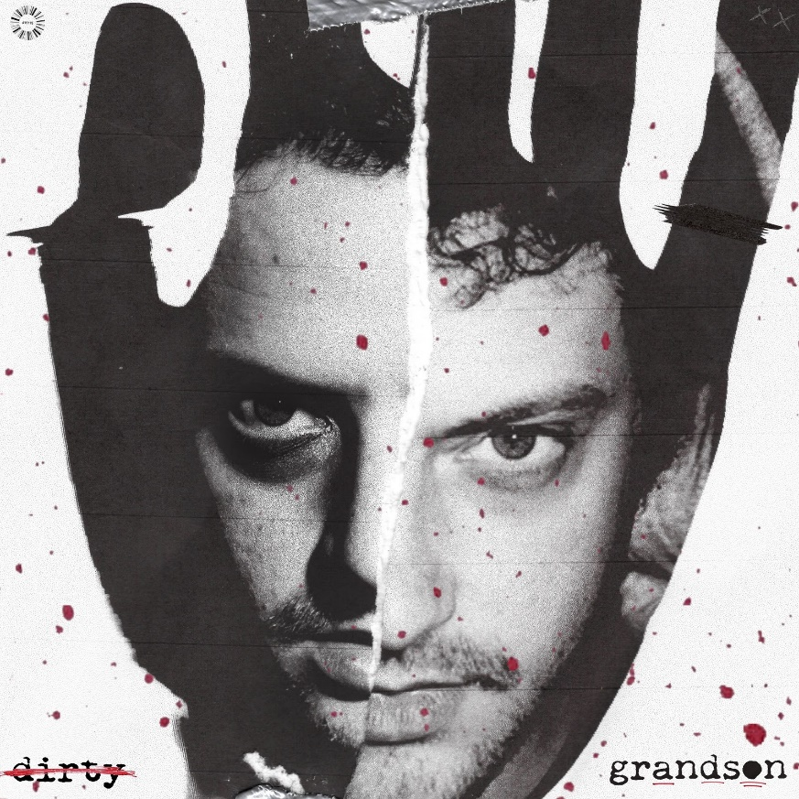
“Dirty”

Today, grandson announces his official full-length debut, Death of an Optimist, out December 4th through Fueled By Ramen. Following grandson’s debut EP trilogy of Modern Tragedy 1, 2, and 3, which turned Canadian-American singer, songwriter, and musician Jordan Edward Benjamin into a vocal spokesperson on some of today’s most pressing political and social issues, Death of an Optimist continues grandson’s dynamic search for meaningful change with some of his most clear-eyed and assertive songwriting yet.

“It is both an origin story and an obituary navigating hope, anxiety and the state of optimism in 2020,” grandson says about the upcoming record.

Presave Death of an Optimist here: https://grandson.lnk.to/doao

grandson’s new single “Dirty,” is out now. The accompanying video, directed by grandson’s frequent collaborator Karl Junquist (“Identity” & “Riptide”) features the “genre-denier” (Alt Press) in an interrogation room and prison-like space battling a dual personality.

Listen + Watch the video for “Dirty”: https://youtu.be/bRaMatWRK50

The new album includes recent singles “Identity” (“Explosive” - NME) and “Riptide,” co-produced by Linkin Park’s Mike Shinoda, as well as, a collection of songs that sonically dance the line between emo guitars and tiktok beats.

Death of an Optimist Album Cover

Death of an Optimist Tracklist:

1. Death of an Optimist // Intro
2. In Over My Head
3. Identity
4. Left Behind
5. Dirty
6. The Ballad of G and X // Interlude
7. We Did It
8. WW3
9. Riptide
10. Pain Shopping
11. Drop Dead
12. Welcome to Paradise // Outro

Check out grandson’s recent feature on Dillon Francis’ remix of Oliver Tree’s “[Cash Machine].” His other 2020 collaborations include works with X Ambassadors, phem, Dreamers, K.Flay, and Zero 9:36, and KennyHoopla.

Grandson press photo/ Credit: Ashley Osborn

grandson, with a sound best described as “a buzzsaw of righteous poetry” (Billboard), has been heard in Riverdale, Marvel’s Runaways, and UFC fight promotions. His track “oh no!!!” was featured as the soundtrack to Warner Brothers’ Suicide Squad reveal trailer and in a recent cover story, Rock Sound called grandson “rock’s new leader of the resistance.” Check out grandson’s epic Seth Meyers performance of “Blood // Water,” the winner of the 2019 SOCAN Songwriting Prize: WATCH HERE.

grandson on the web:
https://shorefire.com/roster/grandson
https://twitter.com/grandson/
https://www.instagram.com/grandson/
https://www.facebook.com/grandsonmusic/

CONTACT:

Nina Lee
nlee@shorefire.com

Mikaela Duhs
mduhs@shorefire.com

Ross Anderson
RossAnderson@elektra.com

