GRANDSON RELEASES “WE DID IT”

LISTEN HERE

DEBUT ALBUM DEATH OF AN OPTIMIST OUT DECEMBER 4TH VIA FUELED BY RAMEN

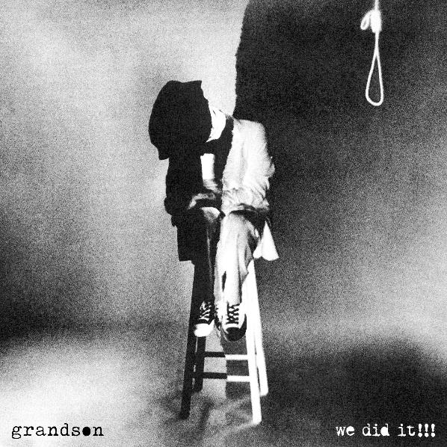

“BUZZSAW OF RIGHTEOUS POETRY”
— BILLBOARD

“A SOUNDTRACK FOR A SOCIETY ON THE EDGE OF COLLAPSE”
—NME

“ROCK ‘N’ ROLL REBEL WHO IS STRIDENT AND CRYSTAL CLEAR”
— ALT PRESS

NOVEMBER 13, 2020 - Today, Canadian-American singer, songwriter, and musician grandson releases “We Did It” the latest single off his debut album, Death of an Optimist, out December 4th via Fueled by Ramen. The explosive track is a critique of premature celebration. Grandson’s distorted vocals provide a sense of urgency — flying high above rollicking guitar riffs and expansive electronic drum patterns; “We Did It” is a shot of adrenaline with a message.

Listen and watch the visualizer here: https://grandson.lnk.to/wedidit

Read More via Under the Radar HERE.

“It’s like being jumped by all your negative thoughts, ganging up on you at once, on your way home from the grocery store," grandson adds about the track.

Death of an Optimist continues grandson’s dynamic search for meaningful change with some of his most clear-eyed and assertive songwriting yet. The twelve track collection of songs sonically dance the line between emo guitars and tiktok beats.“It is both an origin story and an obituary navigating hope, anxiety and the state of optimism in 2020,” grandson says about the upcoming record.

Pre-save Death of an Optimist here: https://grandson.lnk.to/doao

Recently released single, “Dirty” is “an elbow to the ribs to anybody who’s watching today’s apocalyptic political theater,” (Buzzbands LA). The accompanying video, directed by grandson’s frequent collaborator Karl Junquist (“Identity” & “Riptide”) features the “genre-denier” (Alt Press) in an interrogation room and prison-like space battling a dual personality.

Listen + watch the video for “Dirty”: https://youtu.be/bRaMatWRK50

The new album includes singles “Identity” (“Explosive” - NME) and “Riptide,” co-produced by Linkin Park’s Mike Shinoda. grandson also recently released a Linkin Park cover for Spotify Singles — recharging the riffs of “One Step Closer” with punchy production and glitchy electronics

Listen to the track exclusively on Spotify here.

Death of an Optimist follows a series EPs, Modern Tragedy 1, 2, and 3, which turned “rock’s new leader of the resistance” (Rock Sound) into a vocal spokesperson on some of today’s most pressing political and social issues.

On October 30th (mischief night), grandson presented a special stunt to make a statement about voting and the state of the world in 2020. The pop-up art installation saw pine box coffins placed in two different Los Angeles locations. The wood boxes were branded with Death of an Optimist and featured anxiety inducing-paraphernalia including Trump, Covid, Global Warming, and more.

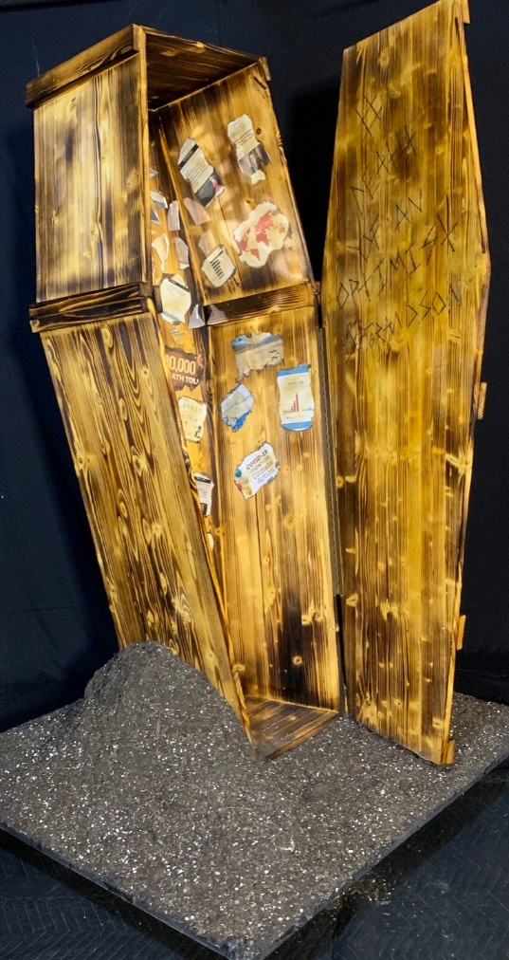

ABOUT GRANDSON:
Grandson is the pseudonym of Canadian/American alternative artist Jordan Benjamin. He takes elements of his rock and roll, hip hop and electronic music roots and combines them to tell stories of reclaiming power over one’s life, confronting social issues facing his generation, and opening up about struggles with addiction and mental health. Since releasing his Modern Tragedy EP series, grandson has toured extensively across North America, Russia, and Europe, accumulated hundreds of millions of streams online, and received co-signs from the biggest names in rock and roll and progressive politics, from Tom Morello to Bernie Sanders.

Now, grandson is ready to release his debut album, Death of an Optimist. This body of work conflates personal anxieties with political realities. As the protagonist, grandson simultaneously explores the dark underbelly of his unrelenting optimism for change, by creating an antagonist, X. An ambitious project, grandson delivers a subtle A-side/B-side structure totaling twelve tracks, following grandson and X’s dueling world views. Through DOAO, grandson delivers an overwhelming urgency to do something, “After the hardest year of our lives, it’s time to confront the reflection staring back at you, because only in doing so can you know who you truly are," he says. Showcasing a conflicted soul for intense scrutiny has the benefit of not dictating what is right or wrong. It just shows that we’re in this together.”

GRANDSON ON THE WEB:
https://shorefire.com/roster/grandson
https://twitter.com/grandson/
https://www.instagram.com/grandson/
https://www.facebook.com/grandsonmusic/

