FOR IMMEDIATE RELEASE
APRIL 14, 2022

GUCCIHIGHWATERS RELEASES MAJOR LABEL DEBUT SINGLES “CRASH MY CAR” AND “DEVIL ON MY SHOULDER”
LISTEN HERE | WATCH THE “CRASH MY CAR” MUSIC VIDEO HERE

NEW EP EXPECTED THIS SPRING VIA PUBLIC CONSUMPTION
U.S. TOUR SUPPORTING NOTHING,NOWHERE. KICKS OFF NEXT WEEK
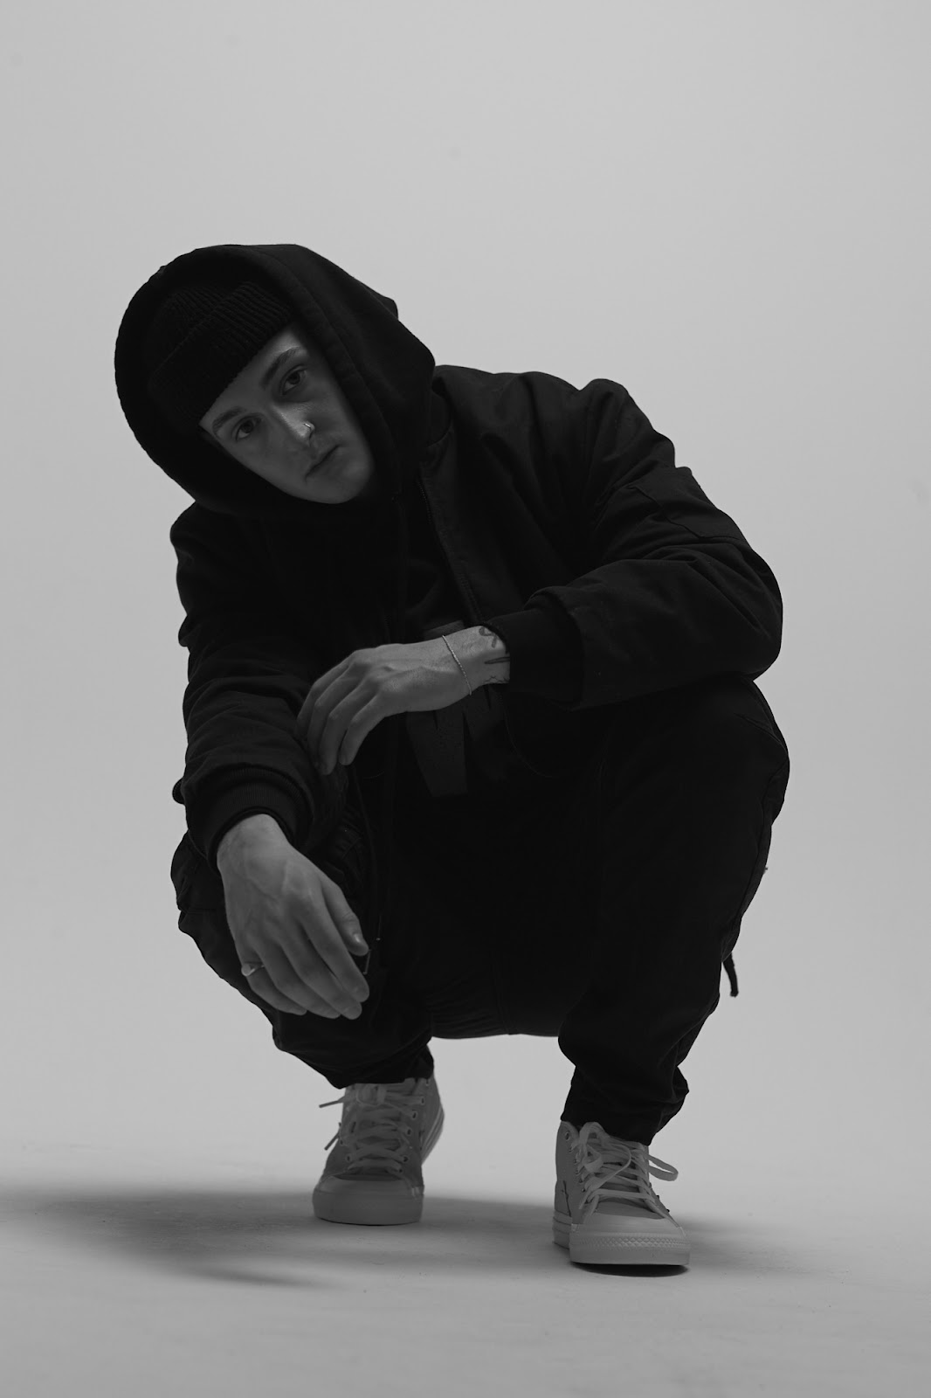
Photo credit: Jonathan Weiner
Genre-defying artist, producer, and songwriter guccihighwaters has announced his signing to Public Consumption in partnership with Elektra Music Group. To celebrate the announcement, he shared two brand new singles entitled “Crash My Car” and “Devil On My Shoulder.” Both tracks are available to stream and download beginning today HERE. Watch a Brent Campanelli-directed official music video for “Crash My Car” on guccihighwaters’ YouTube channel HERE.
“It’s definitely a new era,” guccihighwaters shares. “I wanted the vocals, lyrics, and production to be better. I approached the music from a different perspective altogether. I really tried to push boundaries. It’s my graduation.”
“Crash My Car” evinces his natural progression, preserving the unbridled emotion he’s known for and enhancing his signature style with a cinematic synth-driven sheen, while “Devil On My Shoulder” enraptures with its laid back groove. Both tracks will appear on guccihighwaters’ forthcoming EP, expected this spring.
Last year, guccihighwaters reached critical mass with the release of his album, joke’s on you. Arriving to widespread acclaim, KERRANG! promised, “Whatever genre you label the tunes, the music of guccihighwaters doesn’t joke around when it comes to conveying emotion in its rawest form.” Alt Press lauded the “accomplished artist poised to be a star,” while Ones To Watch proclaimed, “the sounds from singer/producer Morgan Murphy are as raw as it gets.” Billboard applauded standout single “rock bottom” [feat. nothing,nowhere.] as “the highlight of guccihighwaters’ joke’s on you album,” and NME praised the track as “an introspective blend of alt-rock and dark hip-hop flourishes - a marked progression from the online emo scene.”
Next week, guccihighwaters will hit the road in North America supporting nothing,nowhere.. The 25-city trek kicks off on April 21 in Asbury Park, NJ at The Stone Pony, crisscrosses the country, and concludes on May 27 in New York, NY at Irving Plaza. The bill also includes Poorstacy, carolesdaughter, and Snarls. This fall, guccihighwaters will support nothing,nowhere. on tour in Europe. A complete list of upcoming tour dates can be found below. Tickets for all shows are available HERE.
Stay tuned for more from guccihighwaters soon.
guccihighwaters North American Tour Dates
April 21, 2022 – Asbury Park, NJ – The Stone Pony
April 22, 2022 – Baltimore, MD – Baltimore Soundstage
April 23, 2022 – Philadelphia, PA – Theatre Of Living Arts
April 24, 2022 – Boston, MA – Paradise Rock Club
April 26, 2022 – Greensboro, NC – The Blind Tiger
April 28, 2022 – Miami, FL – Gramps
April 29, 2022 – Tampa, FL – The Orpheum
April 30, 2022 – Athens, GA – 40 Watt Club*
May 02, 2022 – Houston, TX – White Oak Music Hall
May 03, 2022 – San Antonio, TX – Paper Tiger
May 05, 2022 – Tempe, AZ – Tempe Marketplace
May 06, 2022 – Pomona, CA – The Glass House
May 07, 2022 – San Diego, CA – The Observatory North Park
May 08, 2022 – Los Angeles, CA – The Belasco
May 11, 2022 – San Francisco, CA – Great American Music Hall
May 13, 2022 – Portland, OR – Hawthorne Theatre
May 14, 2022 – Seattle, WA – Neptune Theatre
May 15, 2022 – Salt Lake City, UT – The Grand Room @ The Complex
May 17, 2022 – Denver, CO – The Gothic Theatre
May 19, 2022 – Lawrence, KS – The Granada
May 20, 2022 – Chicago, IL – House Of Blues
May 21, 2022 – Detroit, MI – The Majestic Theatre
May 22, 2022 – Cleveland, OH – Beachland Ballroom & Tavern
May 24, 2022 – Toronto, ON – The Opera House
May 25, 2022 – Pittsburgh, PA – Mr. Smalls Theatre
May 27, 2022 – New York, NY – Irving Plaza

guccihighwaters European Tour Dates
November 26, 2022 – Brussels, Belgium – Ancienne Belgique
November 27, 2022 – Cologne, Germany – Kantine
November 28, 2022 – Haarlem, Netherlands – Patronaat
November 30, 2022 – Copenhagen, Denmark – Pumpehuset
December 01, 2022 – Hamburg, Germany – Uebel & Gefährlich
December 02, 2022 – Berlin, Germany – Gretchen
December 03, 2022 – Warsaw, Poland – Klub Proxima
December 05, 2022 – Prague, Czech Republic – Lucerna
December 06, 2022 – Budapest, Hungary – Akvarium Klub
December 07, 2022 – Vienna, Austria – Grelle Forelle
December 09, 2022 – Milan, Italy – Magnolia
December 10, 2022 – Zurich, Switzerland – Exil Club
December 11, 2022 – Munich, Germany – Freiheitshalle
December 12, 2022 – Paris, France – Les Etoiles
December 14, 2022 – Madrid, Spain – Sala Nazca
December 15, 2022 – Barcelona, Spain – Sala La Nau

GUCCIHIGHWATERS
“CRASH MY CAR” AND “DEVIL ON MY SHOULDER”
AVAILABLE NOW
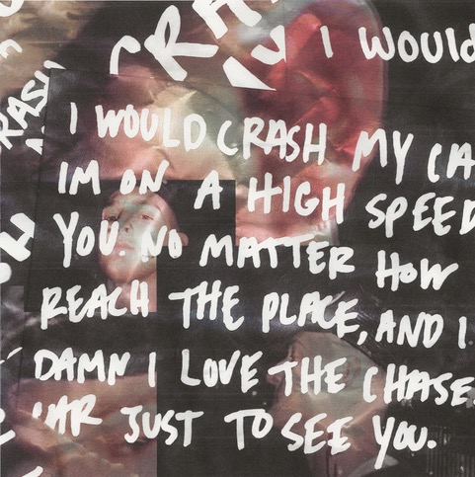

About guccihighwaters:
guccihighwaters glides through a soundscape familiar enough to catch your attention, yet futuristic enough to hold it. The artist, singer, and producer not only blurs the lines between alternative, R&B, and hip-hop, but also the boundaries between yesterday, today, and tomorrow. Growing up in between Long Beach, NY and Ireland, he maintained a diehard passion for music. After discovering Yung Lean at 18-year-old, he crafted beats all night. A year into this evening ritual, he picked up a microphone and penned lyrics to anesthetize the pain of his first breakup. His first collection of songs comprised the post death EP in 2017. Among many standouts, the fan favorite “i’m so sick of this” gathered 51.6 million Spotify streams and counting. In its wake, he unleashed music at a prolific pace, including multiple EPs and his 2021 full-length debut, joke’s on you. Along the way, he toured with Lund, Lil Lotus, Smrtdeath, guardin, and nothing,nowhere. Posting up hundreds of millions of streams and earning acclaim from Billboard, OnesToWatch, NME, Upset, Kerrang!, Alternative Press, and many others, he continues to look ahead on his forthcoming major label debut EP for Public Consumption/Elektra Music Group, introduced by lead singles “Crash My Car” and “Devil On My Shoulder.”
# # #

CONNECT WITH GUCCIHIGHWATERS
guccihighwaters.com
Facebook
Instagram
Twitter
YouTube

Press Contacts:
Collin Citron / CollinCitron@Elektra.com
Sarah Goldstein / SarahGoldstein@Elektra.com

