FOR IMMEDIATE RELEASE
May 06, 2022

GUCCIHIGHWATERS ANNOUNCES MAJOR LABEL DEBUT EP
HEARTBREAK HIGHWAY
OUT MAY 20 VIA PUBLIC CONSUMPTION | PRE-ORDER HERE

NEW SINGLE AND MUSIC VIDEO “THE CHASE” AVAILABLE NOW
WATCH THE OFFICIAL MUSIC VIDEO HERE

U.S. TOUR DATES WITH NOTHING,NOWHERE. CURRENTLY UNDERWAY

Photo credit: Jonathan Weiner

Genre-defying artist, producer, and songwriter guccihighwaters has announced his major label debut EP, Heartbreak Highway, a six-track collection set for arrival on May 20th via Public Consumption in partnership with Elektra Music Group. To celebrate the announcement, guccihighwaters has unveiled his brand new, synth-driven single “The Chase,” which arrives alongside an eerie Brent Campanelli-directed official music video streaming now on guccihighwaters’ official YouTube channel. The Heartbreak Highway EP is available for preorder now.

“‘The Chase’ is the sequel to the story I start to tell in ‘Crash My Car,’” states guccihighwaters. “My producer, Courtney [Ballard], played a bunch of eighties beats for me - I was into a lot of synth-revival music, so it was cool to hear where it came from. I took the synths and the drum grooves and morphed my style to fit those elements. It felt natural.”
The artist expanded on the EP, adding, “Heartbreak Highway is the start of a new era for me - we elevated production, lyrics, instrumentals, and visuals until it all clicked. I feel like I’m still only in the beginning of learning about who I am as an artist and am grateful to the old fans and new who are coming along for the ride.”
guccihighwaters announced his signing to Public Consumption last month alongside the release of Highway Heartbreak EP tracks “Crash My Car” and “Devil On My Shoulder.” Signifying a new era in guccihighwaters’ ever-evolving sound, the songs arrived to immediate praise from Alt Press, Consequence, Ones To Watch, and more. Both tracks are available to stream and download now HERE. Watch the official music video for “Crash My Car” HERE.

Last year, guccihighwaters reached critical mass with the release of his album, joke’s on you. Arriving to widespread acclaim, KERRANG! promised, “Whatever genre you label the tunes, the music of guccihighwaters doesn’t joke around when it comes to conveying emotion in its rawest form.” Alt Press lauded the “accomplished artist poised to be a star,” while Ones To Watch proclaimed, “the sounds from singer/producer Morgan Murphy are as raw as it gets.” Billboard applauded standout single “rock bottom” [feat. nothing,nowhere.] as “the highlight of guccihighwaters’ joke’s on you album,” and NME praised the track as “an introspective blend of alt-rock and dark hip-hop flourishes - a marked progression from the online emo scene.”

guccihighwaters is currently on the road in North America supporting nothing,nowhere. The 25-city trek kicked off last month and will conclude on May 27 in New York, NY at Irving Plaza. The bill also includes Poorstacy, carolesdaughter, and Snarls. This fall, guccihighwaters will support nothing,nowhere. on tour in Europe. A complete list of upcoming tour dates can be found below. Tickets for all shows are available HERE.

Stay tuned for more from guccihighwaters soon.

guccihighwaters North American Tour Dates
May 06, 2022 – Pomona, CA – The Glass House
May 07, 2022 – San Diego, CA – The Observatory North Park
May 08, 2022 – Los Angeles, CA – The Belasco
May 11, 2022 – San Francisco, CA – Great American Music Hall
May 13, 2022 – Portland, OR – Hawthorne Theatre
May 14, 2022 – Seattle, WA – Neptune Theatre
May 15, 2022 – Salt Lake City, UT – The Grand Room @ The Complex
May 17, 2022 – Denver, CO – The Gothic Theatre
May 19, 2022 – Lawrence, KS – The Granada
May 20, 2022 – Chicago, IL – House Of Blues
May 21, 2022 – Detroit, MI – The Majestic Theatre
May 22, 2022 – Cleveland, OH – Beachland Ballroom & Tavern
May 24, 2022 – Toronto, ON – The Opera House
May 25, 2022 – Pittsburgh, PA – Mr. Smalls Theatre
May 27, 2022 – New York, NY – Irving Plaza

guccihighwaters European Tour Dates
November 26, 2022 – Brussels, Belgium – Ancienne Belgique
November 27, 2022 – Cologne, Germany – Kantine
November 28, 2022 – Haarlem, Netherlands – Patronaat
November 30, 2022 – Copenhagen, Denmark – Pumpehuset
December 01, 2022 – Hamburg, Germany – Uebel & Gefährlich
December 02, 2022 – Berlin, Germany – Gretchen
December 03, 2022 – Warsaw, Poland – Klub Proxima
December 05, 2022 – Prague, Czech Republic – Lucerna
December 06, 2022 – Budapest, Hungary – Akvarium Klub
December 07, 2022 – Vienna, Austria – Grelle Forelle
December 09, 2022 – Milan, Italy – Magnolia
December 10, 2022 – Zurich, Switzerland – Exil Club
December 11, 2022 – Munich, Germany – Freiheitshalle
December 12, 2022 – Paris, France – Les Etoiles
December 14, 2022 – Madrid, Spain – Sala Nazca
December 15, 2022 – Barcelona, Spain – Sala La Nau

GUCCIHIGHWATERS
HEARTBREAK HIGHWAY EP – OUT MAY 20TH
PRE-ORDER NOW
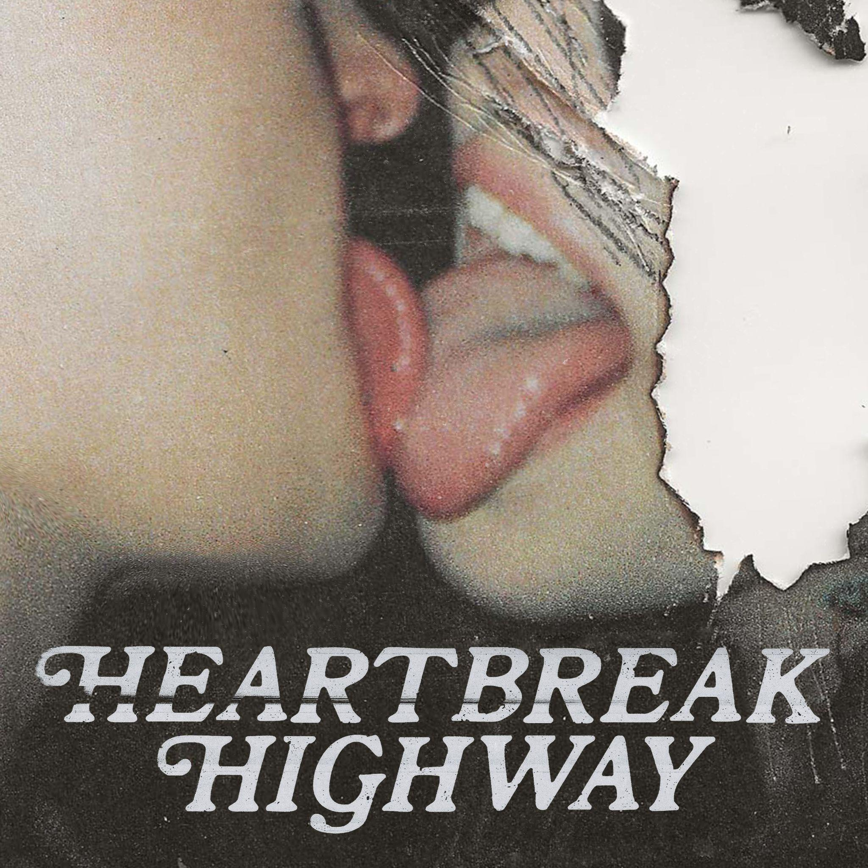

Heartbreak Highway EP Tracklisting
1. Crash My Car
2. Dancing With The Stars
3. Believe
4. Devil On My Shoulder
5. Roses
6. The Chase

About guccihighwaters:
guccihighwaters glides through a soundscape familiar enough to catch your attention, yet futuristic enough to hold it. The artist, singer, and producer not only blurs the lines between alternative, R&B, and hip-hop, but also the boundaries between yesterday, today, and tomorrow. Growing up in between Long Beach, NY and Ireland, he maintained a diehard passion for music. After discovering Yung Lean at 18-year-old, he crafted beats all night. A year into this evening ritual, he picked up a microphone and penned lyrics to anesthetize the pain of his first breakup. His first collection of songs comprised the post death EP in 2017. Among many standouts, the fan favorite “i’m so sick of this” gathered 51.6 million Spotify streams and counting. In its wake, he unleashed music at a prolific pace, including multiple EPs and his 2021 full-length debut, joke’s on you. Along the way, he toured with Lund, Lil Lotus, Smrtdeath, guardin, and nothing,nowhere. Posting up hundreds of millions of streams and earning acclaim from Billboard, OnesToWatch, NME, Upset, Kerrang!, Alternative Press, and many others, he continues to look ahead on his forthcoming major label debut Heartbreak Highway EP for Public Consumption/Elektra Music Group.

# # #

CONNECT WITH GUCCIHIGHWATERS
guccihighwaters.com
Facebook
Instagram
Twitter
YouTube

Press Contacts:
Collin Citron / CollinCitron@Elektra.com
Sarah Goldstein / SarahGoldstein@Elektra.com

