GUCCIHIGHWATERS SHARES “ROSES” OFFICIAL VIDEO
WATCH HERE

MAJOR LABEL DEBUT EP HEARTBREAK HIGHWAY
AVAILABLE NOW VIA PUBLIC CONSUMPTION | LISTEN HERE

Photo credit: Jonathan Weiner

JULY 27, 2022 – Genre-defying artist, producer, and songwriter guccihighwaters has shared the official video for “Roses” from his major label debut EP, heartbreak highway. Directed by Ross Ginsberg, the gritty visual encapsulates the track’s reflection on a toxic relationship. The “Roses” video is streaming now on guccihighwaters’ official YouTube channel.

Last month, guccihighwaters shared the official video for “Dancing With The Stars,” a glitched-out visual which found the artist exploring a night across New York City. In May, guccihighwaters shared the six-track heartbreak highway EP and unveiled an official music video for intimate piano ballad, “believe.” heartbreak highway is available now via Public Consumption HERE. The artist also wrapped up North American tour dates supporting nothing,nowhere. and will head back out on the road in the UK and Europe with nothing,nowhere. this fall. A complete list of upcoming tour dates can be found below. Tickets for all shows are available HERE.

In late 2021, guccihighwaters holed up in a Los Angeles studio with producer Courtney Ballard [Waterparks]. He absorbed the spirit of diverse inspirations, ranging from Lionel Richie’s “Dancing on the Ceiling” and the Drive Original Motion Picture Soundtrack to The Weeknd. “Courtney played a bunch of eighties beats for me,” guccihighwaters recalls. “I was into a lot of synth-revival music, so it was cool to hear where it came from. I took the synths and the drum grooves and morphed my style to fit those elements. It felt natural.”

guccihighwaters announced his signing to Public Consumption in April alongside the release of tracks “crash my car” and “devil on my shoulder.” Earlier this month, he formally announced the heartbreak highway EP and unveiled the synth-driven single “the chase'' alongside an official music video. Signifying a new era in guccihighwaters’ ever-evolving sound, the EP’s early releases arrived to immediate praise from Alt Press, Consequence, Ones To Watch, and more.

heartbreak highway follows guccihighwaters’ 2021 album joke’s on you. Arriving to widespread acclaim, KERRANG! promised, “Whatever genre you label the tunes, the music of guccihighwaters doesn’t joke around when it comes to conveying emotion in its rawest form.” Alt Press lauded the “accomplished artist poised to be a star,” while Ones To Watch proclaimed, “the sounds from singer/producer Morgan Murphy are as raw as it gets.” Billboard applauded standout single “rock bottom” [feat. nothing,nowhere.] as “the highlight of guccihighwaters’ joke’s on you album,” and NME praised the track as “an introspective blend of alt-rock and dark hip-hop flourishes - a marked progression from the online emo scene.”

guccihighwaters UK and European Tour Dates
November 12, 2022 - Leeds, UK - Drown U Out
November 13, 2022 - Oxford, UK - O2 Academy 2
November 14, 2022 - Nottingham, UK - Bodega Social Club
November 15, 2022 - Newcastle, UK - The Cluny
November 17, 2022 - Glasgow, UK - SWG3 Studio Warehouse
November 18, 2022 - Manchester, UK - Club Academy
November 19, 2022 - Dublin, Ireland - Dublin Academy Green Room
November 20, 2022 - Belfast, UK - Limelight 2
November 22, 2022 - Birmingham, UK - O2 Academy 2
November 23, 2022 - Bristol, UK - The Fleece
November 24, 2022 - London, UK - Electric Ballroom
November 26, 2022 - Brussels, Belgium - Ancienne Belgique
November 27, 2022 - Cologne, Germany - Kantine
November 28, 2022 - Haarlem, Netherlands - Patronaat
November 30, 2022 - Copenhagen, Denmark - Pumpehuset
December 01, 2022 - Hamburg, Germany - Uebel & Gefährlich
December 02, 2022 - Berlin, Germany - Gretchen
December 03, 2022 - Warsaw, Poland - Klub Proxima
December 05, 2022 - Prague, Czech Republic - Lucerna
December 06, 2022 - Budapest, Hungary - Akvarium Klub
December 07, 2022 - Vienna, Austria - Grelle Forelle
December 09, 2022 - Milan, Italy - Magnolia
December 10, 2022 - Zurich, Switzerland - Exil Club
December 11, 2022 - Munich, Germany - Freiheitshalle
December 12, 2022 - Paris, France - Les Etoiles
December 14, 2022 - Madrid, Spain - Sala Nazca
December 15, 2022 - Barcelona, Spain - Sala La Nau

GUCCIHIGHWATERS
HEARTBREAK HIGHWAY EP
LISTEN HERE
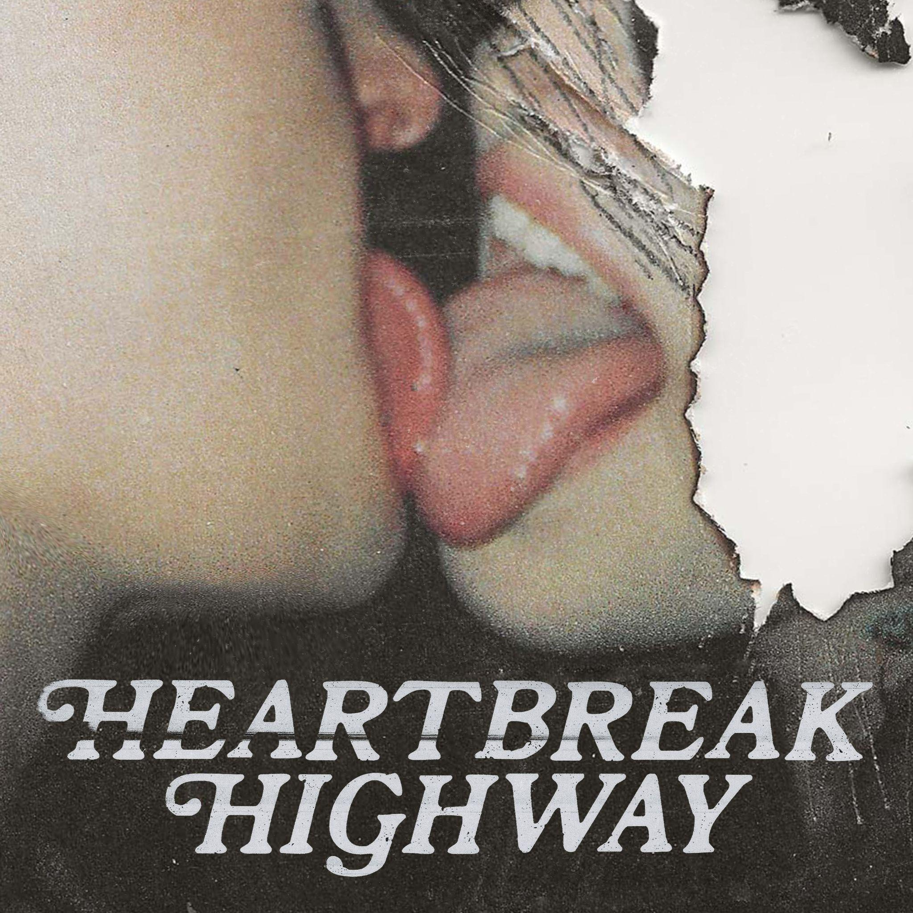

heartbreak highway EP Tracklisting
1. crash my car
2. dancing with the stars
3. believe
4. devil on my shoulder
5. roses
6. the chase

About guccihighwaters:
guccihighwaters glides through a soundscape familiar enough to catch your attention, yet futuristic enough to hold it. The artist, singer, and producer not only blurs the lines between alternative, R&B, and hip-hop, but also the boundaries between yesterday, today, and tomorrow. Growing up in between Long Beach, NY and Ireland, he maintained a diehard passion for music. After discovering Yung Lean at 18-year-old, he crafted beats all night. A year into this evening ritual, he picked up a microphone and penned lyrics to anesthetize the pain of his first breakup. His first collection of songs comprised the post death EP in 2017. Among many standouts, the fan favorite “i’m so sick of this” gathered 51.6 million Spotify streams and counting. In its wake, he unleashed music at a prolific pace, including multiple EPs and his 2021 full-length debut, joke’s on you. Along the way, he toured with Lund, Lil Lotus, Smrtdeath, guardin, and nothing,nowhere. Posting up hundreds of millions of streams and earning acclaim from Billboard, OnesToWatch, NME, Upset, Kerrang!, Alternative Press, and many others, he continues to look ahead on his major label debut heartbreak highway EP for Public Consumption/Elektra Music Group.

# # #

CONNECT WITH GUCCIHIGHWATERS
guccihighwaters.com
Facebook
Instagram
Twitter
YouTube

Press Contacts:
Collin Citron / CollinCitron@Elektra.com
Sarah Goldstein / SarahGoldstein@Elektra.com

