JXDN PERFORMS STUNNING LIVE SET
FOR KROQ + ALT 92.3 – WATCH HERE
INCLUDING HIT SINGLES “BETTER OFF DEAD” + “ANGELS & DEMONS”

BREAKOUT ARTIST TO RELEASE NEW TRACK WITH NESSA BARRETT ON FEB 19

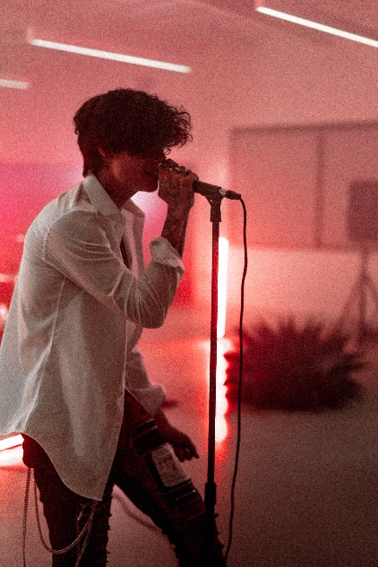
JXDN PRESS PHOTOS HERE
February 11, 2020 – Breakout singer-songwriter jxdn continues to establish himself as rock’s fastest rising star as he gears up for the release of his debut album Tell Me About Tomorrow with new live performances, collaborations, and appearances.

Listeners and viewers nationwide got their first glimpse at a live performance from the emerging rockstar this past Sunday with a dynamic set across all RADIO.COM Alternative stations this, including LA’s world famous KROQ and ALT 92.3, New York’s NEW Alternative. The entire performance is now available online to watch HERE and includes his current single “Better Off Dead” - which debuted at #37 on Billboard’s Hot Rock & Alt Chart - alongside previous releases “Angels & Demons,” “So What!” and his recent pop-punk cover of Olivia Rodrigo’s hit “Driver’s License” which has received critical praise from the likes of Billboard and NME, among others.

Tomorrow, he will be a featured guest on Valentine’s Day in Hell, a six-part scripted musical-comedy-horror podcast ahead of the holiday. A new track “This Ain’t A Scene” will be released in tandem with his episode drop. Alongside jxdn, the cast includes iann dior, Carlie Hansen, Oliver Tree, Phem, Tyler Posey and Adam Carolla as the devil. Valentine’s Day in Hell is the sequel to Halloween in Hell, which accumulated over one million downloads last October and starred Machine Gun Kelly, 24kGoldn and dior.

jxdn will be featured on Nessa Barrett’s newest track “la di die” out February 19 – the duo announced the song last week across their social platforms to eagerly anticipating fans. He is also featured in Alternative Press iconic “The 100 Artists You Need To Know” issue, which makes its return from the aughts and will be on stands mid-February.

Currently the first artist signed to Travis Barker’s DTA Records, a worldwide joint venture with Elektra Music Group, jxdn reaches 16.5 million followers across social platforms and has surpassed 300 million worldwide streams to date. He continues to garner massive critical praise as he nears the arrival of his debut album, expected in 2021:

“POP-PUNK REVIVALIST … UNDENIABLY IMPRESSIVE… PERFECTLY-PITCHED VOCALS”
- Variety

“AUGUST CHARTBREAKER: FUSING THE WORLDS OF ROCK AND HIP-HOP… bringing ROCK INTO THE TIKTOK ERA”
- Billboard

“jxdn gives POP PUNK a MODERN TWIST”
- Entertainment Weekly

“jxdn has launched his ENTIRE CAREER in ONE [YEAR]…”
- NME

“POWERFUL VOCALS infused with EMO-RAP INFLUENCES and ROCK STAR ENERGY”
– Alternative Press

“SOON TO BE ROCKSTAR”
- VMAN

“RISING STAR jxdn is well on his way to BIOPIC STATUS AT ONLY 19”
- Forbes

connect with jxdn:
instagram | twitter | tik tok | youtube | spotify | apple music | jxdnmusic.com

About jxdn:
Born in Dallas as Jaden Hossler, jxdn (pronounced jay-den) initially gained prominence on TikTok, parlaying his massive following into a breakout music career. In January 2020, he independently released “Comatose”, which landed on more than 40 global charts. His explosive success quickly garnered the attention of Travis Barker, who signed him as the first artist on his imprint, DTA Records, a worldwide joint venture with Elektra Music Group. He released his label debut single “Angels & Demons” in May followed by “So What!” in July, both of which landed in the Top 10 of Billboard’s Hot Rock & Alternative Song’s Chart; with “So What!” notably peaking at #20 on Alternative Radio. He most recently teamed up with fellow breakout artist iann dior for “Tonight.” The track combines their signature genre-blurring style of rock, pop and rap. Cementing his rising rockstar status, jxdn debuted at No. 9 on Rolling Stone’s Breakthrough 25 chart, was featured as Billboard’s August 2020 Chartbreaker, and was included in Billboard’s 2020 annual 21 Under 21 list. Additionally, jxdn has garnered critical acclaim from Entertainment Weekly, MTV, Alternative Press, VMAN, Consequence of Sound, PEOPLE and Forbes, among others. jxdn has surpassed 300 million worldwide streams to date and reaches more than 16.5 million followers across social platforms. He is currently at work on his highly anticipated debut album Tell Me About Tomorrow, expected early 2021.

Press Contacts
full coverage communications
Natasha Desai & Lauren Morris
natasha@fullcov.com | lauren.morris@fullcov.com
Elektra Music Group
Glenn Fukushima & Ross Anderson
GlennFukushima@elektra.com | RossAnderson@elektra.com

