JXDN RELEASES NEW TRACK “PRAY”

POWERFUL SONG SHEDS LIGHT ON PERSONAL MENTAL HEALTH STRUGGLES

OFFICIAL MUSIC VIDEO PREMIERING NEXT WEEK

BREAKOUT ARTIST NAMED BILLBOARD’S AUGUST CHARTBREAKER

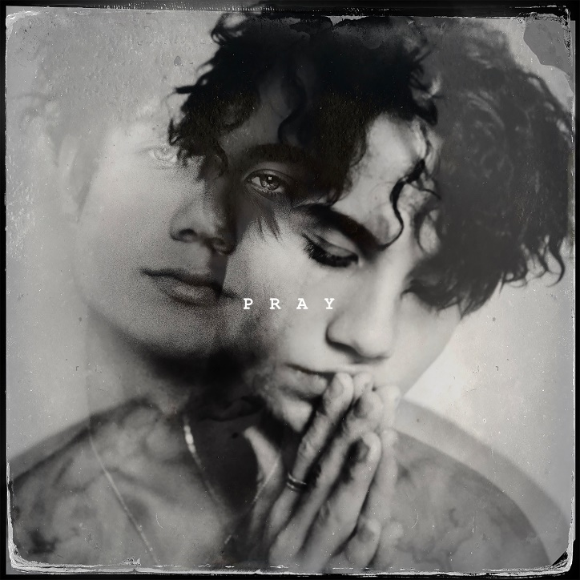
DOWNLOAD “PRAY” ARTWORK & JXDN PRESS PHOTOS HERE
artwork courtesy DTA Records/Elektra | press photos credit: Katarina Benzova

August 20, 2020 – With his swift musical rise showing no signs of slowing, breakout artist jxdn unveils his most personal song to date today with the release of “Pray” – available everywhere now. Watch the lyric video here.

The track offers a deeply honest, intimate, and grit-filled exploration of his struggles with depression, which included two suicide attempts. Juxtaposing a consistent sonic cadence against lyrical duality throughout its verses, “Pray” culminates in a powerful showing of resilience, courage, and hope.

“the beginning of the song was my mindset for a long period of time,” jxdn says of the track. “by the grace of God i found hope. prayers don’t have to be pretty, i simply changed my prayer from death to life. i thought i had nothing and no one but little did i know i had millions of people who were counting on me making it through. i love you, God loves you, and you are not alone.”

Fans have been eagerly awaiting the song’s release ever since jxdn began teasing it across his social platforms last month, calling it “a cry for help when i was at the lowest point in my life” in a tweet that has since garnered 37k likes. The accompanying music video is set to arrive next week.

As a committed advocate for destigmatizing mental health, “Pray” serves as one of the most important moments in jxdn’s growing artist journey – a song with a purpose and message of comfort to anyone who may be similarly struggling that they are not alone.

jxdn recently opened up to Forbes about how his journey has provide him a newfound appreciation for his life today, saying: “Pain is a very important thing for people. A lot of people try to run from it. I did for most of my life, but you can't escape pain. What you can do is choose how you let it affect you. You can either let it destroy you, or you can let it change you and help you become a better person.”

IF YOU ARE IN EMOTIONAL DISTRESS OR SUICIDAL CRISIS, YOU ARE NOT ALONE.
CALL THE NATIONAL SUICIDE PREVENTION LIFELINE AT 1-800-273-8255 TO SPEAK WITH A TRAINED COUNSELOR.
IT’S FREE, CONFIDENTIAL, AND AVAILABLE 24/7.

The first artist signed to Travis Barker’s imprint, DTA Records, a worldwide joint venture with Elektra Music Group, jxdn (pronounced jay-den) released his label debut single “Angels & Demons” in May and the follow-up single “So What!” in July, which are climbing the Top 40 Pop & Alternative radio charts respectively. He is currently featured as Billboard’s August Chartbreaker and Entertainment Weekly proclaims he “gives pop punk a modern twist” while VMAN dubs him a “soon to be rockstar.” jxdn has surpassed 110 million worldwide streams to date and reaches more than 14 million followers across social platforms.
connect with jxdn:
instagram | twitter | tik tok | youtube | spotify | apple music | jxdnmusic.com

“PRAY” LYRIC VIDEO EMBED:
<iframe width="560" height="315" src="https://www.youtube.com/embed/oH9gM9_85oU" frameborder="0" allow="accelerometer; autoplay; encrypted-media; gyroscope; picture-in-picture" allowfullscreen></iframe>

“PRAY” LYRICS:
HEAVEN ONLY KNOWS WHEN I’M IN HELL
NONE OF MY FRIENDS CAN EVEN TELL
I WANNA FUCKING DIE BUT I NEVER SAY IT
SICK OF GETTING HIGH BUT I DO THE SAME SHIT
I CAN’T EVEN CRY SO I TRY TO FAKE IT
I HATE IT

I PRAY TO GOD LET ME DIE IN MY SLEEP
I PRAY TO GOD LET ME DIE IN MY SLEEP
YOU’RE AS SICK AS ALL THE SECRETS YOU KEEP
BUT THE TRUTH IS I DON’T WANNA BE ME
I PRAY TO GOD LET ME DIE IN MY SLEEP

NOW I’M WAKING UP AND I’M NOT DEAD
LIVING OFF THE WORDS I KNOW YOU SAID
I FEEL LIKE I’M ALIVE AND I’M GONNA MAKE IT
MAYBE IF I CRY I DON’T HAVE TO FAKE IT
I’M GIVING UP MY PAIN SO YOU CAN TAKE IT
I HATE IT

I PRAY TO GOD I DON’T DIE IN MY SLEEP
I PRAY TO GOD I DON’T DIE IN MY SLEEP
I’M AS SICK AS ALL THE SECRETS I KEEP
BUT THE TRUTH IS I CAN ONLY BE ME
I PRAY TO GOD I DON’T DIE IN MY SLEEP

I PRAY TO GOD I DON’T DIE IN MY SLEEP
I PRAY TO GOD I DON’T DIE IN MY SLEEP
I PRAY TO GOD I DON’T DIE IN MY SLEEP
AND NOW I’M SICK OF ALL THE SECRETS I KEEP
I PRAY TO GOD LET ME DIE IN MY…

Press Contacts
full coverage communications
Natasha Desai & Lauren Morris
natasha@fullcov.com | lauren.morris@fullcov.com

Elektra Music Group
Glenn Fukushima & Ross Anderson
GlennFukushima@elektra.com | RossAnderson@elektra.com

