JXDN RELEASES “THINK ABOUT ME”
NEW SINGLE & VIDEO OUT NOW

REVEALS DEBUT ALBUM RELEASE DATE + TRACKLIST
TELL ME ABOUT TOMORROW
JULY 2, 2021
PREORDER NOW

“MAKING SOME OF THE MOST EVOCATIVE POP-PUNK OF THE PAST FEW YEARS” - VULTURE

OPENING FOR MACHINE GUN KELLY’S FALL 2021 “TICKETS TO MY DOWNFALL” U.S. TOUR
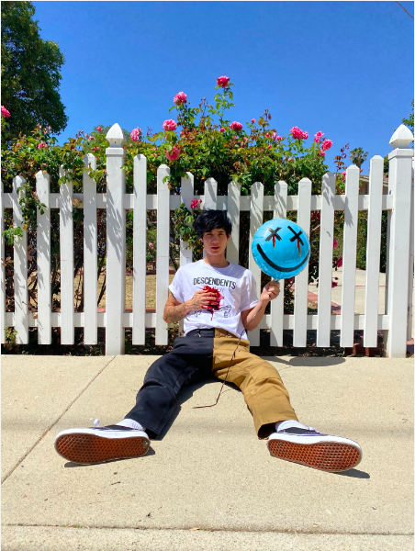
DOWNLOAD PRESS PHOTO HERE (Credit: Mandee Mallonee)
DOWNLOAD ALBUM ART HERE

June 4, 2021 - Today, breakout singer-songwriter jxdn returns with his anthemic new single “Think About Me” - listen here. The instant earworm blends jxdn’s vibrant vocals with Travis Barker’s signature pop-punk production. The track - written by Jaden Hossler (jxdn), Travis Barker, and Andrew Goldstein - comes alongside a music video with callbacks to iconic Nirvana and blink-182 videos. WATCH HERE.

Additionally, jxdn has announced his highly-anticipated debut album, Tell Me About Tomorrow, will be released on July 2, 2021 via DTA Records. The album is now available for preorder here.

The 18-track album - produced by Barker - is comprised of 14 new songs, including a feature from Machine Gun Kelly on “Wanna Be.” Full tracklisting can be found below, which includes jxdn’s critically acclaimed singles, “So What!,” “Tonight” ft. iann dior, “Better Off Dead,” and his smash hit “Angels & Demons.”

“This single is the perfect introduction to Tell Me About Tomorrow -- I’m so proud of what Travis and I have created and can’t wait for the world to hear it,” says jxdn.

jxdn was most recently announced as direct support for Machine Gun Kelly’s Fall 2021 “Tickets To My Downfall” U.S. Tour. The rising rockstar will also perform at some of the year’s largest festivals including Lollapalooza, Austin City Limits, Firefly, and Reading and Leeds.

2021 shows no signs of jxdn’s ascent slowing down as he continues to add to an already impressive list of accolades. The breakout artist made his television performance debut, showcasing his undeniable stage presence on Jimmy Kimmel Live!. Additionally, he received a 2021 iHeartRadio Music Award nomination, performed on The Ellen DeGeneres Show, and his label debut single, “Angels & Demons,” surpassed 100 million streams on Spotify alone.

TELL ME ABOUT TOMORROW TRACKLISTING:
1. INTRO
2. PILLS
3. THINK ABOUT ME
4. WANNA BE (feat. Machine Gun Kelly)
5. A WASTED YEAR
6. ANGELS & DEMONS
7.I NTERLUDE
8. ONE MINUTE
9. BRAINDEAD
10. TONIGHT (feat. iann dior)
11. FUCKED UP
12. SO WHAT!
13. ANGELS & DEMONS PT. 2
14. BETTER OFF DEAD
15. DTA
16. LAST TIME
17. NO VANITY
18. TELL ME ABOUT TOMORROW

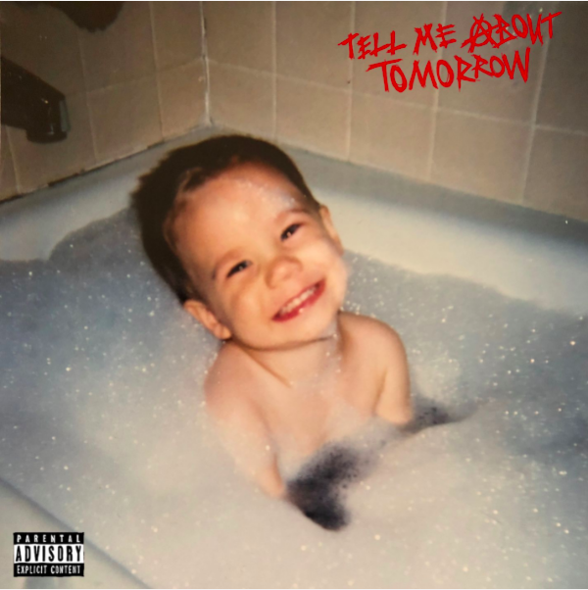

connect with jxdn:
instagram | twitter | tik tok | youtube | spotify | apple music | jxdnmusic.com

About jxdn:
Born in Dallas as Jaden Hossler, jxdn (pronounced jay-den) initially gained prominence on TikTok, parlaying his massive following into a breakout music career. In January 2020, he independently released “Comatose”, which landed on more than 40 global charts. His explosive success quickly garnered the attention of Travis Barker, who signed him as the first artist on his imprint, DTA Records, a worldwide joint venture with Elektra Music Group. He released his label debut single “Angels & Demons” in May followed by “So What!” in July, both of which landed in the Top 10 of Billboard’s Hot Rock & Alternative Song’s Chart; with “So What!” notably peaking at #20 on Alternative Radio. In October, he teamed up with fellow breakout artist iann dior for “Tonight.” The track combines their signature genre-blurring style of rock, pop and rap. He capped off the year with the release of “Better Off Dead” in December. Cementing his rising rockstar status, jxdn debuted at No. 9 on Rolling Stone’s Breakthrough 25 chart, was featured as Billboard’s August 2020 Chartbreaker, and was included in Billboard’s 2020 annual 21 Under 21 list. Additionally, jxdn has garnered critical acclaim from Entertainment Weekly, MTV, Alternative Press, VMAN, Consequence of Sound, PEOPLE and Forbes, among others. He has performed on Jimmy Kimmel Live! and The Ellen DeGeneres Show. jxdn has surpassed 340 million worldwide streams to date and reaches more than 17.3 million followers across social platforms. He is currently at work on his highly anticipated debut album Tell Me About Tomorrow arrives July 2, 2021.

jxdn Press Contacts:
full coverage communications
Natasha Desai & Lauren Morris
natasha@fullcov.com | lauren.morris@fullcov.com
Elektra Music Group
Glenn Fukushima & Ross Anderson
GlennFukushima@elektra.com | RossAnderson@elektra.com

