JXDN ANNOUNCES
TELL ME ABOUT TOMORROW WORLD TOUR

BREAKOUT ARTIST’S FIRST SOLO HEADLINE TOUR LAUNCHES SEPTEMBER 18, 2021

40-DATE TREK SPANS U.S., U.K. & EUROPE THROUGH MAY 2022

“JXDN IS NEXT… READY FOR POP-PUNK SUPERSTARDOM” - SPIN

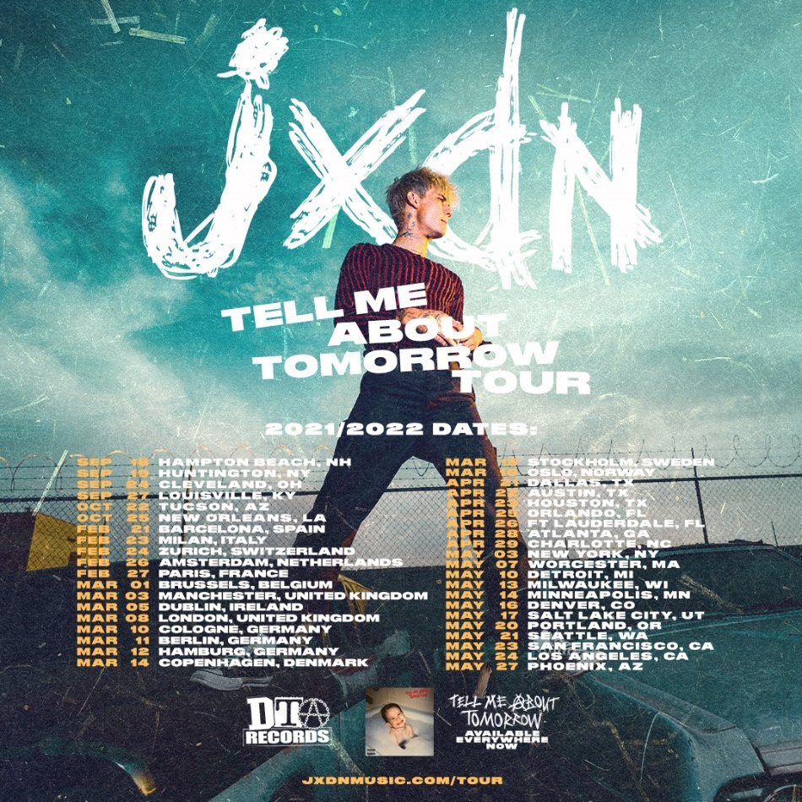
DOWNLOAD TELL ME ABOUT TOMORROW WORLD TOUR ADMAT HERE
DOWNLOAD JXDN PRESS PHOTOS HERE (CREDIT: CYNTHIA PARKHURST)

July 20, 2021 – Breakout artist jxdn is set to embark on another milestone in his rapidly rising career journey, announcing his TELL ME ABOUT TOMORROW WORLD TOUR in support of his debut album Tell Me About Tomorrow. The 40-date trek marks his first solo headline tour and begins September 18 in Hampton Beach, NH before continuing across the U.S., U.K. and Europe through May 2022.

Pre-sales for the TELL ME ABOUT TOMORROW WORLD TOUR begin Wednesday, July 21 at 10am local time through Thursday, July 22 at 10pm local time. General on sale begins Friday, July 23 at http://www.jxdnmusic.com/tour.

“My entire life I’ve been dreaming of this moment,” jxdn says of the tour announcement. “My fans mean the world to me and the support they’ve shown me has been more than I could have ever asked for. I can’t wait to perform my album and hopefully do for them what Juice WRLD did for me. It only takes one moment to change a life.”

This past Saturday, jxdn played his first ever full live show at Los Angeles’ famed The Roxy Theatre – presented by LivAte/NOCAP – punctuating live performances of tracks off Tell Me About Tomorrow in an unfaltering, exuberant display in which Variety proclaimed he “fit the bill of a rockstar as he bounced around the stage, feeding off the energy of his live band.”

The Aquarian added that jxdn “demolished the stage” and acclaimed his “high energy stage presence” as “riveting.” Noting that “the most mesmerizing aspect of the live stream was just how spot-on [the] rockstar’s voice was… furthering his authenticity and proving that there are no frills, no auto-tune, and no doubt about the top tier quality of this rising musician’s musicianship.”

jxdn’s high energy show featured surprise appearances from Travis Barker, iann dior and Nessa Barrett. Variety hailed jxdn’s performance of “Tonight” with dior “a highlight of the set due to their light-hearted performance chemistry.” It also included moments that displayed his vocal versatility, including an acoustic performance of his July 2020 single “So What!” which Variety said “proved his talent outside of the recording studio.”

He will continue to bring his dynamic live show to fans as direct support for Machine Gun Kelly’s sold out “Tickets To My Downfall” U.S. Tour this fall in addition to performing at some of the year’s largest festivals including Lollapalooza, Austin City Limits, Firefly, and Reading and Leeds. For information and details for all of jxdn’s live dates, please visit www.jxdnmusic.com/tour.

The announcement of the TELL ME ABOUT TOMORROW WORLD TOUR comes on the heels of jxdn’s highly anticipated debut album Tell Me About Tomorrow, which was released July 2 via Travis Barker’s DTA Records – listen to the record HERE. The 18-track energetic pop-punk album is an undeniable showing of jxdn’s rising rockstar status, filled with catchy hooks, infectious melodies, and incredible vocals from jxdn that pay tribute to pop-punk’s roots while showcasing his own modern, fresh sound.

In addition to a fast start on the Billboard charts – #3 Alternative New Artist Albums, #5 Top New artist Albums, #11 Digital Albums, among others – critical acclaim for Tell Me About Tomorrow, which was produced by Barker, has poured in since its arrival:

“AN ALBUM THAT BOTH CEMENTS [JXDN’S] PLACE IN THE CURRENT POP-PUNK REVIVAL – AND SHOWS THAT HE’S ONLY GETTING STARTED” - NYLON

“A DELIRIOUSLY CATCHY POP-PUNK EFFORT” – SPIN

“TELL ME ABOUT TOMORROW IS PACKED WITH PLENTY OF POP-PUNK ESSENTIALS” – MTV NEWS

“JXDN LIGHTS THE WORLD ON FIRE WITH DEBUT LP… THE 18 TRACKS STAND TALL” – AMERICAN SONGWRITER

“TELL ME ABOUT TOMORROW IS AS HARROWING AS IT IS BOUNCY AND ROCKING. IT IS FIERY IN MUSICALITY AND LYRICALLY POIGNANT” – THE AQUARIAN

“A HIGH-ENERGY, INTROSPECTIVE AND OVERALL IMPRESSIVE DEBUT” – EUPHORIA. MAGAZINE

The album’s lead single “Wanna Be” is an epic collaboration with Machine Gun Kelly and impacts Alternative Radio this month. Watch the music video featuring both stars HERE. Tell Me About Tomorrow also includes jxdn’s hit singles, “Think About Me,” “So What!,” “Tonight” ft. iann dior, “Better Off Dead,” and the RIAA gold-certified “Angels & Demons.”

jxdn – Tell Me About Tomorrow World Tour 2021-2022
Date | City | Venue
September 18, 2021 | Hampton Beach, NH | Casino Ballroom
September 19, 2021 | Huntington, NY | Paramount
September 24, 2021 | Cleveland, OH | House of Blues
September 27, 2021 | Louisville, KY | Headliners Music Hall
October 22, 2021 | Tucson, AZ | Encore
October 25, 2021 | New Orleans, LA | House of Blues
February 21, 2022 | Barcelona, Spain | Sala Apolo
February 23, 2022 | Milan, Italy | Fabrique
February 24, 2022 | Zurich, Switzerland | Komplex 457
February 26, 2022 | Amsterdam, Netherlands | Melkweg Max
February 27, 2022 | Paris, France | Le Bataclan
March 1, 2022 | Brussels, Belgium | Le Madeleine
March 3, 2022 | Manchester, UK | Manchester Academy
March 5, 2022 | Dublin, Ireland | Academy
March 8, 2022 | London, UK | O2 Kentish Town
March 10, 2022 | Cologne, Germany | Kantine
March 11, 2022 | Berlin, Germany | Kesselhaus
March 12, 2022 | Hamburg, Germany | Gruenspan
March 14, 2022 | Copenhagen, Denmark | VEGA Main Hall
March 15, 2022 | Stockholm, Sweden | Fryhuset-Klubben
March 16, 2022 | Oslo, Norway | Vulkan Arena
April 21, 2022 | Dallas, TX | The Studio at The Factory
April 22, 2022 | Austin, TX | Scoot Inn
April 23, 2022 | Houston, TX | Warehouse Live Ballroom
April 25, 2022 | Orlando, FL | Beacham Theater
April 26, 2022 | Ft. Lauderdale, FL | Revolution
April 28, 2022 | Atlanta, GA | Center Stage
April 29, 2022 | Charlotte, NC | Amos Southend
May 3, 2022 | New York, NY | Webster Hall
May 7, 2022 | Worcester, MA | Palladium
May 10, 2022 | Detroit, MI | St. Andrew’s Hall
May 13, 2022 | Milwaukee, WI | The Rave / Eagles Ballroom
May 14, 2022 | Minneapolis, MN | The Fillmore
May 16, 2022 | Denver, CO | The Summit
May 17, 2022 | Salt Lake City, UT | Rockwell at The Complex
May 20, 2022 | Portland, OR | Crystal Ballroom
May 21, 2022 | Seattle, WA | Showbox SoDo
May 23, 2022 | San Francisco, CA | Regency Ballroom
May 24, 2022 | Los Angeles, CA | The Fonda Theatre
May 27, 2022 | Phoenix, AZ | The Van Buren

connect with jxdn:
instagram | twitter | tik tok | youtube | spotify | apple music | jxdnmusic.com

About jxdn:
Born in Dallas as Jaden Hossler, jxdn (pronounced jay-den) initially gained prominence on TikTok, parlaying his massive following into a breakout music career. In January 2020, he independently released “Comatose”, which landed on more than 40 global charts. His explosive success quickly garnered the attention of Travis Barker, who signed him as the first artist on his imprint, DTA Records, a worldwide joint venture with Elektra Music Group. He released his label debut single “Angels & Demons” in May followed by “So What!” in July, both of which landed in the Top 10 of Billboard’s Hot Rock & Alternative Song’s Chart; with “So What!” notably peaking at #20 on Alternative Radio. In October, he teamed up with fellow breakout artist iann dior for “Tonight.” The track combines their signature genre-blurring style of rock, pop and rap. He capped off the year with the release of “Better Off Dead” in December. Cementing his rising rockstar status, jxdn debuted at No. 9 on Rolling Stone’s Breakthrough 25 chart, was featured as Billboard’s August 2020 Chartbreaker, and was included in Billboard’s 2020 annual 21 Under 21 list. Additionally, jxdn has garnered critical acclaim from Entertainment Weekly, MTV News, Alternative Press, NYLON, VMAN, Consequence of Sound, PEOPLE and Forbes, among others. He has performed on Jimmy Kimmel Live! and The Ellen DeGeneres Show and garnered a 2021 iHeartRadio Music Award nomination. jxdn has surpassed 400 million worldwide streams to date and reaches more than 22 million followers across social platforms. His highly anticipated debut album Tell Me About Tomorrow is available everywhere now and he will embark on his TELL ME ABOUT TOMORROW WORLD TOUR across the U.S., U.K. and Europe beginning September 2021 through May 2022.

