JXDN TEAMS UP WITH IANN DIOR FOR “TONIGHT”
OUT NOW
EXCLUSIVE FIRST PLAY IN FUTURE ARTISTS ON RADIO 1 WITH JACK SAUNDERS
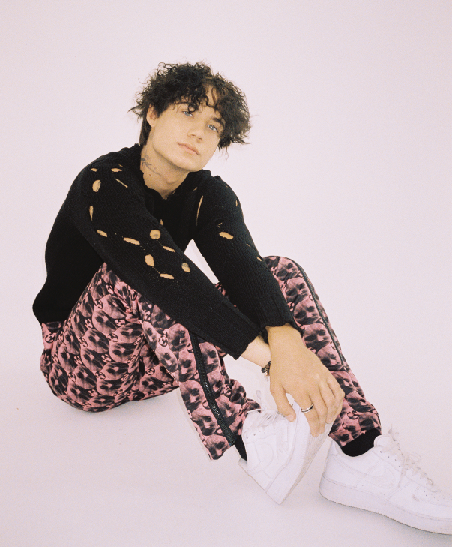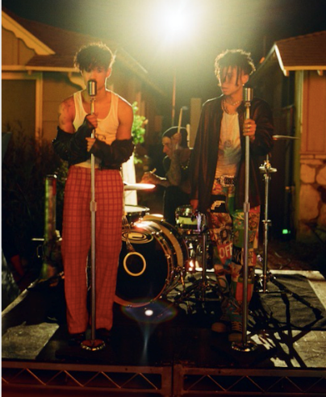
DOWNLOAD “TONIGHT” ARTWORK HERE
JXDN PRESS PHOTOS HERE (CREDIT: ASHLEY OSBORN)
JXDN X IANN DIOR PRESS PHOTOS HERE (CREDIT: KAI CHU)
October 21, 2020 – Today, breakout singer-songwriter jxdn unveils his latest must-hear single “Tonight” featuring fellow breakout singer/songwriter/rapper Iann Dior - listen here. The track received an exclusive first play on BBC Radio 1’s Future Artists with Jack Saunders. The lyric video for the song can be seen here. An official music video featuring both stars is coming soon.

“Tonight” sees the two up-and-coming artists join forces to combine their signature genre-blurring style of rock, pop and rap for a surefire hit. The track features Travis Barker’s signature drums and production, and was written by Jaden Hossler (jxdn), Barker, Iann Dior, Nick Bailey, Aldae, and Dru Decaro.

The single is latest release from jxdn as he continues to tease his highly-anticipated full-length debut, expected later this year. The rising star continues to gain massive critical praise:

“AUGUST CHARTBREAKER: FUSING THE WORLDS OF ROCK AND HIP-HOP… bringing ROCK INTO THE TIKTOK ERA”
- Billboard

“jxdn gives POP PUNK a MODERN TWIST”
- Entertainment Weekly

“RISING STAR jxdn is well on his way to BIOPIC STATUS AT ONLY 19”
- Forbes

“SOON TO BE ROCKSTAR”
- VMAN

“POWERFUL VOCALS infused with EMO-RAP INFLUENCES and ROCK STAR ENERGY”
– Alternative Press

“ROCKSTAR ON THE RISE”
– People Magazine

jxdn (pronounced jay-den) is the first artist signed to Barker’s imprint, DTA Records, a worldwide joint venture with Elektra Music Group. He released his label debut single “Angels & Demons” in May followed by “So What!” in July, which is currently at #23 at Alternative Radio. jxdn has surpassed 170 million worldwide streams to date and reaches more than 16 million followers across social platforms.

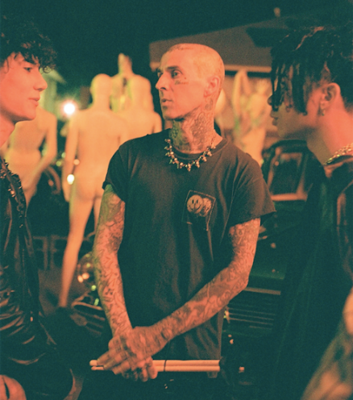

connect with jxdn:
instagram | twitter | tik tok | youtube | spotify | apple music | jxdnmusic.com

About jxdn:
Born in Dallas as Jaden Hossler, jxdn (pronounced jay-den) initially gained prominence on TikTok, attracting more than 8 million followers through a consistent stream of engaging content. His artist and songwriting career jumpstarted in January 2020 with the independent release of “Comatose,” which debuted in the top 25 on Billboard’s Rock Digital Song Sales chart in March and has landed on more than 40 global charts to date. His explosive success quickly gained the attention of Barker, who signed him as the first artist on his imprint, DTA Records, a worldwide joint venture with Elektra Music Group. jxdn went on to release three more singles, including “Pray,” a powerful song about his own struggles with depression. He debuted at No. 9 on Rolling Stone’s Breakthrough 25 chart in July and was featured as Billboard’s Chartbreaker for the month of August. jxdn reaches over 16 million followers across social platforms and has surpassed 170 million total global streams.
Press Contacts
full coverage communications
Natasha Desai & Lauren Morris
natasha@fullcov.com | lauren.morris@fullcov.com
Elektra Music Group
Glenn Fukushima & Ross Anderson
GlennFukushima@elektra.com | RossAnderson@elektra.com

