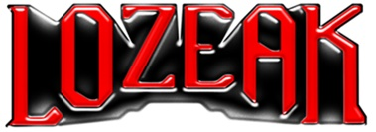

lozeak UNVEILS THUNDERING NEW SINGLE,
“NO SAVING YOU”
LISTEN HERE
ELTON JOHN PLAYED lozeak’s LATEST SONG “HATE ME TOO” ON HIS ROCKET HOUR SHOW ON APPLE MUSIC

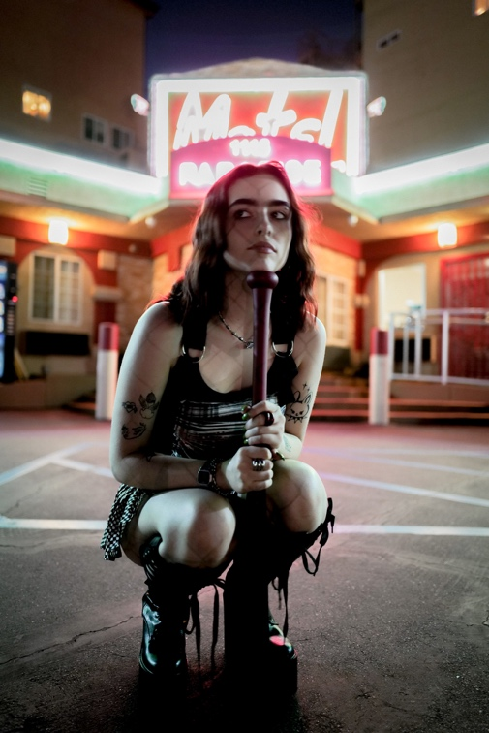
DOWNLOAD HI-RES PRESS IMAGE HERE
CREDIT: Tyler Nichols

“…a force to be reckoned with” – WONDERLAND

“A future rockstar in waiting” – THE LINE OF BEST FIT

“…breaking boundaries with her genre-less vibe and no-rules style” – TMRW

(May 5, 2022) – LOS ANGELES, CA – London-based artist lozeak is proving why she is one of the most talked-about rising stars with the release of her new single “No Saving You,” out today via Elektra/Parlophone. The song is available now on all streaming platforms.

A thundering and instantly infectious track – produced by Tommy Baxter (Dua Lipa) and co-written with Baxter and Cleo Tighe (Kehlani, Charli XCX) – “No Saving You” is dedicated to calling time on that friend who keeps coming to you for advice but never takes it.
Of the single, lozeak says, “For me, this song was a release of all my inner thoughts about being used as a friend, and also coming to terms with the fact that it’s okay to walk away from friendships that feel unhealthy. I’m sure everyone has those friends where they feel used for advice or for a literal ‘free therapist,’ and not much more. I made this song with two of my favorite people, Cleo and Tommy. I also can’t believe my first three releases are about friendships... maybe I am the problem,” she adds with a laugh.

With her signature cherry-red hair and thick brows, lozeak has already cultivated a huge online following off the back of her covers and TikTok videos (over 609k followers and 47 million likes). Now she is showing that she has a sound all of her own, and the capabilities to create big, diaristic pop music with a scuzzy edge to it. Her music is winning over famous fans, with Elton John playing her latest single “Hate Me Too” on his Rocket Hour show on Apple Music, in addition to Bring Me The Horizon’s Oli Sykes, Radio 1’s Jack Saunders, and Frank Carter all championing her sound.

The story of lozeak starts in 2003 in Norwich with two music-obsessed parents blasting drum and bass awaiting the birth of their second child in an attempt to imbue rhythm and a flare for music into her DNA. It worked. A childhood spent exploring the sounds of Luther Vandross, Madonna and Amy Winehouse gave way to her teenage years when she transitioned to diverse artists like Avril Lavigne, Kehlani and Radiohead – inspiring her grungy, rock-pop edge of today. With a huge online fanbase eagerly awaiting her next move, she is quickly establishing herself as the artist to watch out for in 2022.

lozeak
“NO SAVING YOU”
AVAILABLE HERE

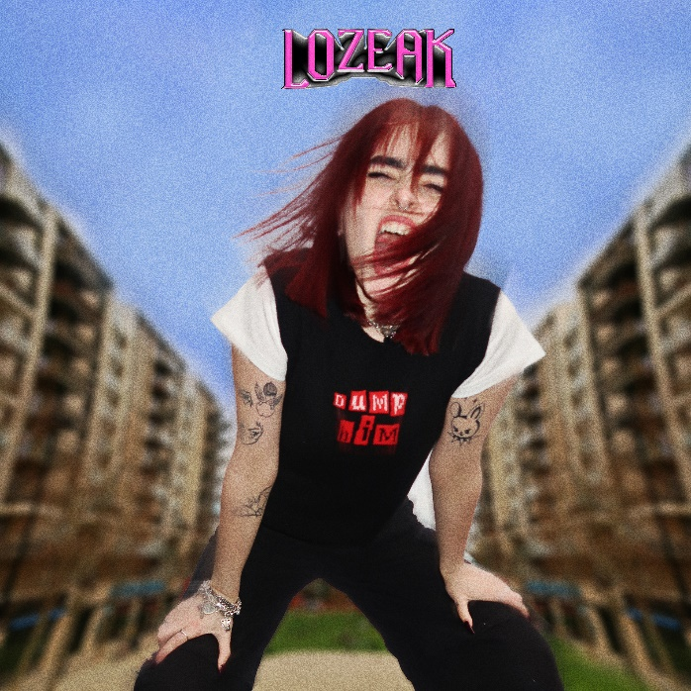

Connect with lozeak:
Instagram
TikTok
YouTube

# # #

PRESS CONTACT:
Nathalie Rubin
NathalieRubin@elektra.com

