NOTHING,NOWHERE. SHARES “FAKE FRIEND” OFFICIAL VIDEO

WATCH IT HERE

NEW ALBUM TRAUMA FACTORY ARRIVES FEBRUARY 19TH

PHOTO CREDIT: DAN BROWN

JANUARY 19, 2021 – DCD2 / Fueled By Ramen artist nothing,nowhere. has shared an official music video for his latest single, “Fake Friend,” which is streaming today. The Mason Mercer directed video spirals over nothing,nowhere.’s seamless alchemy of alternative, pop, rap, and punk as lilting verses bleed into a distorted proclamation, “I don’t need a fake friend.”

nothing,nowhere. elaborated on the new video explaining, “I was always so enamored by the over the top 90’s commercials as a kid. There is something comforting looking back at them now. The ‘Fake Friend’ music video combines the comfort and simplicity of the 90’s, with the never-ending stimulation of the 2020’s. We wanted to visually tell the backstory of this ‘Fake Friend’ and show how technology and social media can deteriorate you.”

“Fake Friend” recently debuted on Billboard’s “Alternative Airplay” chart at #34 with the most increased plays at the format, and is featured on nothing,nowhere.’s widely anticipated new full-length album, TRAUMA FACTORY, which set to arrive February 19th [album art / tracklist below]. Pre-orders for TRAUMA FACTORY are live today at www.nothingnowhere.net featuring exclusive limited-edition vinyl and merch. Each pre-order receiving instant grat downloads of “fake friend” as well as previously released singles: “lights (4444),” “pretend,” “DEATH,” “nightmare,” and, most recently, “blood” (Feat. KennyHoopla & JUDGE).

Over the course of 15 tracks, TRAUMA FACTORY cuts deep and finds nothing,nowhere. once again emerging from darkness, shedding external expectation, and moving forward into the glow of pure creation. Whether it be the anesthetized beats and intoxicating lull of “love or chemistry,” the cold piano-laden longing of “crave,” or the emotional immediacy of “upside down,” nothing,nowhere. paints from a wide palette of pain.

“TRAUMA FACTORY is an accumulation of songs written during a confusing time. it is about accepting the present and following your true north through the pain and suffering of human life,” nothing,nowhere. revealed He added, “I wanted to make an album that was truly genreless and inspire others to challenge themselves artistically. I believe the most inspiring art is unpredictable and unrestrictive. to me that’s what TRAUMA FACTORY is.”

Earlier this year, The New York Times hailed “DEATH” as a “Scabrous, immensely satisfying emotional expurgation from Joe Mulherin that deploys early Beastie Boys drums and Rage Against the Machine bark-rapping in service of a rap-rock revival bathed in righteousness.” Last year, he teamed up with Travis Barker for the collaborative EP, bloodlust. bloodlust was highlighted by lead single “destruction,” which debuted via The FADER with Kerrang! declaring “bloodlust feels like another world. From start to finish it envelops you in its hazy, muted soundscapes.” bloodlust followed a prolific string of singles from nothing,nowhere. - “call back,” “dread,” and “ornament,” – and arrived just a year after the release of his acclaimed 2018 LP, ruiner. The sophomore LP features album standouts “ruiner” and “rejecter,” which Pigeons & Planes declared, “perfectly exemplify why nothing,nowhere.'s music is so exciting… he's crafted a world of sound that's both fresh and recognizable.” The FADER remarked, “The new record is a stimulating blend of singing, hip-hop, and live instrumentation, all fused together with emo and alternative stylings.” nothing,nowhere.’s 2017 debut album, reaper, was met with critical praise led by the singles “hopes up (Ft. Dashboard Confessional)” and “skully.” The album made a massive impact upon its DCD2/Equal Vision release with The New York Times’ Jon Caramanica placing it at #1 on his list of 2017’s best. reaper “synthesizes the second-wave emo of the early to mid-2000s with the rattling hip-hop low end of the last few years,” he wrote. “(reaper) is one of the most promising pop albums of the year…” Rolling Stone declared “reaper finds him tonally evoking the glory years of 2000s emo-punk without necessarily replicating it.”

nothing,nowhere. is the musical endeavor of Vermont songwriter, singer and guitarist Joe Mulherin. For Mulherin, nothing,nowhere. is about a connection. It’s one he finds with fans around the world, who gather to see him play on tour and to listen to his songs online. It’s that connection that urges the singer to place his fears aside and step onstage each night to share his art. He sees the potential to help, to make a change, however small it may be and that is why he brings his music out of the Vermont wildness.
TRAUMA FACTORY

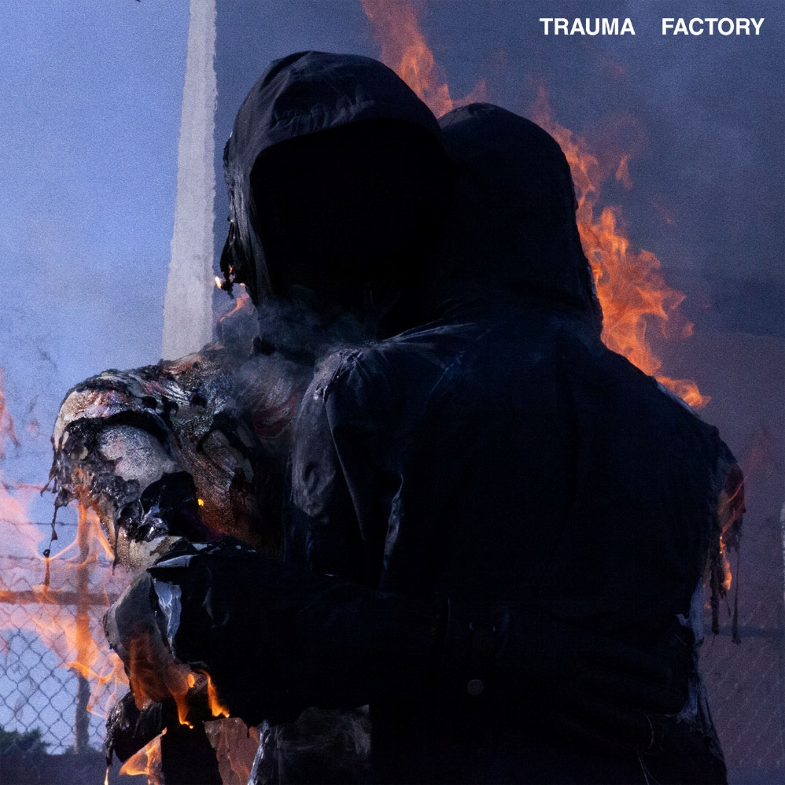

01. “trauma factory”
02. “lights (4444)”
03. “buck”
04. “love or chemistry”
05. “exile”
06. “upside down”
07. “pain place” (feat. MISOGI)
08. “fake friend”
09. “death”
10. “pretend”
11. “blood” (feat. KennyHoopla & JUDGE)
12. “nightmare”
13. “crave”
14. “real”
15. “barely breathing”

For more information on nothing,nowhere.:
OFFICIAL – YOUTUBE – SPOTIFY – APPLE MUSIC
SOUNDCLOUD – FACEBOOK – INSTAGRAM – TWITTER

Contact:
Ross Anderson / RossAnderson@Elektra.com

