NOTHING,NOWHERE.
SHARES NEW SINGLE & MUSIC VIDEO - “PIECES OF YOU”

ON TOUR NOW IN NORTH AMERICA

TICKETS AVAILABLE AT WWW.NOTHINGNOWHERE.NET

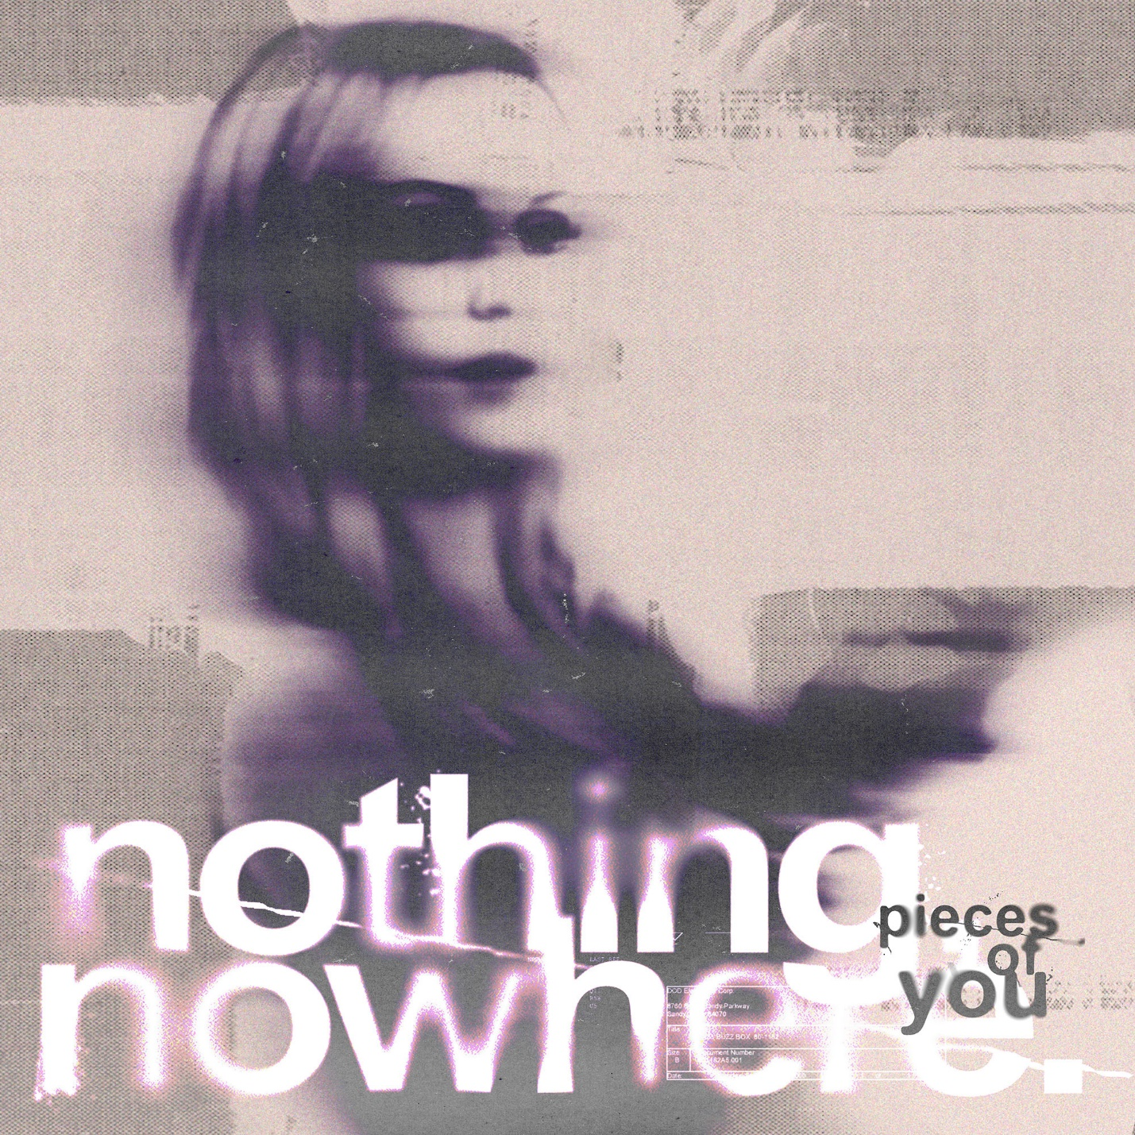

NOTHING,NOWHERE. – “PIECES OF YOU” [OFFICIAL VIDEO]
YOUTUBE: https://youtu.be/YErEZo38-VQ

OCTOBER 6, 2021 – DCD2 / Fueled By Ramen artist nothing,nowhere. has released a brand-new single, “Pieces of You.” The track is available today on all streaming platforms and is accompanied by a Max Moore directed official music video streaming now on nothing,nowhere.’s YouTube channel.

Elaborating on the new single, nothing,nowhere. shared “’Pieces of You’ is about being infatuated with someone and feeling vulnerable; like the ground can disappear from your feet at any second.”

nothing,nowhere. is currently out on tour in the U.S., performing a headline show tonight, October 6th at The Fillmore in Philadelphia, PA. Later this month he will link up with labelmates All Time Low for a run of North American dates and then head overseas in early 2022 to support Neck Deep in the U.K. Following the U.K. dates, nothing,nowhere. will embark on a full headline European tour which will see him performing in various international markets for the first time ever [full tour itinerary below]. For tickets and more information on nothing.nowhere’s upcoming live dates, visit www.nothingnowhere.net.

“Pieces of You” follows the release of nothing,nowhere.’s celebrated new album TRAUMA FACTORY which arrived earlier this year. Available on all streaming platforms, TRAUMA FACTORY finds nothing,nowhere. once again emerging from darkness, shedding external expectation, and moving forward into the glow of pure creation. TRAUMA FACTORY is highlighted by “fake friend,” nothing,nowhere.’s first song ever to enter Billboard’s “Alternative Airplay” chart. The track is joined by a Mason Mercer directed official music video which spirals over nothing,nowhere.’s seamless alchemy of alternative, pop, rap, and punk.

The New York Times hailed TRAUMA FACTORY track, “DEATH,” as a “Scabrous, immensely satisfying emotional expurgation from Joe Mulherin that deploys early Beastie Boys drums and Rage Against the Machine bark-rapping in service of a rap-rock revival bathed in righteousness.” CLASH declared, “While human suffering or pain isn’t joyous, the special craft of nothing,nowhere. most certainly is,” and FLOOD praised album cut “lights (4444)” for its “minimalist trap beat,” adding it “sounds like a GothBoiClique single steeped in a turn-of-the-century boy-band aesthetic.” The FADER hailed early single “blood” (Feat. KennyHoopla and JUDGE) as “a strapping collaboration,” while UPROXX avowed, “it’s clear that there’s a lot more going into Joe Mulherin’s production style,” celebrating the song’s “hip-hop beats and a driving distorted bass line.”

nothing,nowhere. summarized the body of work detailing, “TRAUMA FACTORY is an accumulation of songs written during a confusing time. it is about accepting the present and following your true north through the pain and suffering of human life,” nothing,nowhere. revealed He added, “I wanted to make an album that was truly genreless and inspire others to challenge themselves artistically. I believe the most inspiring art is unpredictable and unrestrictive. to me that’s what TRAUMA FACTORY is.”

nothing,nowhere. is the musical endeavor of Vermont songwriter, singer and guitarist Joe Mulherin. For Mulherin, nothing,nowhere. is about a connection. It’s one he finds with fans around the world, who gather to see him play on tour and to listen to his songs online. It’s that connection that urges the singer to place his fears aside and step onstage each night to share his art. He sees the potential to help, to make a change, however small it may be and that is why he brings his music out of the Vermont wildness.

NOTHING,NOWHERE.
2021 – 2022 TOUR DATES
* Headline Dates
** Supporting All Time Low
% Supporting Neck Deep
# Festival Date

OCT 6 - THE FILLMORE PHILADELPHIA - PHILADELPHIA, PA*
OCT 8 - SONGBYRD MUSIC HOUSE - WASHINGTON, DC*
OCT 10 - MERCY LOUNGE - NASHVILLE, TN*
OCT 13 - AVONDALE BREWING COMPANY - BIRMINGHAM, AL**
OCT 15 - THE NATIONAL - RICHMOND, VA**
OCT 16 - THE RITZ - RALEIGH, NC**
OCT 17 - THE FILLMORE CHARLOTTE - CHARLOTTE, NC**
OCT 19 - COLLEGE STREET MUSIC HALL - NEW HAVEN, CT**
OCT 20 - TOWN BALLROOM - BUFFALO, NY**
OCT 21 - TOWN BALLROOM - BUFFALO, NY**
OCT 22 - HISTORY - TORONTO, CANADA**
OCT 23 - GLC LIVE AT 20 MONROE - GRAND RAPIDS, MI**
OCT 24 - OLD FORESTER'S PARISTOWN HALL - LOUISVILLE, KY**
OCT 27 - THE DISTRICT - SIOUX FALLS, SD**
OCT 28 - VAL AIR BALLROOM - WEST DES MOINES, IA**
OCT 30 - FILLMORE MINNEAPOLIS - MINNEAPOLIS, MN**
OCT 31 - BURTON CUMMINGS THEATRE - WINNIPEG, CANADA**
NOV 2 - UNION HALL - EDMONTON, CANADA**
NOV 3 - MACEWAN HALL CONCERTS - CALGARY, CANADA**
NOV 5 - VOGUE THEATRE - VANCOUVER, CANADA**
NOV 6 - ROSELAND THEATER - PORTLAND, OR**
NOV 7 - SHOWBOX SODO - SEATTLE, WA**
NOV 10 - FOX THEATER - OAKLAND, CA**
NOV 11 - HOLLYWOOD PALLADIUM - LOS ANGELES, CA**
NOV 12 - HUMPHREYS CONCERTS BY THE BAY - SAN DIEGO, CA**
NOV 13 - VALLEY BAR - PHOENIX, AZ*
NOV 15 - 89TH STREET OKC - OKLAHOMA CITY, OK*
NOV 16 - THE OUTLAND - SPRINGFIELD, MO*
NOV 18 - SKULLYS MUSIC DINER - COLUMBUS, OH*
DEC 19 - UNSILENT NIGHT - DALLAS, T X#
JAN 11 - O2 ACADEMY BIRMINGHAM - BIRMINGHAM, UNITED KINGDOM %
JAN 12 - O2 ACADEMY BRISTOL - BRISTOL, UNITED KINGDOM %
JAN 13 - O2 ACADEMY BRIXTON - LONDON, UNITED KINGDOM %
JAN 14 - O2 VICTORIA WAREHOUSE - STRETFORD, UNITED KINGDOM %
JAN 16 - O2 ACADEMY NEWCASTLE - NEWCASTLE UPON TYNE, UNITED KINGDOM %
JAN 17 - ASSEMBLY ROOMS - EDINBURGH, UNITED KINGDOM %
JAN 18 - BARROWLAND BALLROOM - GLASGOW, UNITED KINGDOM %
JAN 19 - O2 ACADEMY LEEDS - LEEDS, UNITED KINGDOM %
JAN 21 - LES ÉTOILES - PARIS, FRANCE*
JAN 22 - ANCIENNE BELGIQUE - BRUSSELS, BELGIUM*
JAN 23 - DIE KANTINE - COLOGNE, GERMANY*
JAN 24 - PATRONAAT - HAARLEM, NETHERLANDS*
JAN 26 - PUMPEHUSET - COPENHAGEN, DENMARK*
JAN 27 - GRUENSPAN - HAMBURG, GERMANY*
JAN 28 - TECHNIKUM - MÜNCHEN, GERMANY*
JAN 29 - EXIL - ZURICH, SWITZERLAND*
JAN 31 - NAZCA CLUB MADRID - MADRID, SPAIN*
FEB 1 - SALA LA NAU - BARCELONA, SPAIN*
FEB 3 - MAGNOLIA - MILANO, ITALY*
FEB 4 - HALL - PADOVA, ITALY*
FEB 5 - DÜRER KERT - BUDAPEST, HUNGARY*
FEB 6 - GRELLE FORELLE - VIENNA, AUSTRIA*
FEB 8 - LUCERNA MUSIC BAR - PRAGUE, CZECH REPUBLIC*
FEB 9 - GRETCHEN - BERLIN, GERMANY*
FEB 10 - PROXIMA - WARSAW, POLAND*
FEB 12 - AKAKAO - SANKT-PETERBURG, RUSSIA*
FEB 13 - AGLOMERAT - MOSKVA, RUSSIA*

For more information on nothing,nowhere.:
OFFICIAL – YOUTUBE – SPOTIFY – APPLE MUSIC
SOUNDCLOUD – FACEBOOK – INSTAGRAM – TWITTER

Contact:
Ross Anderson / RossAnderson@Elektra.com

