NOTHING,NOWHERE. ANNOUNCES NEW ALBUM TRAUMA FACTORY

SHARES NEW SINGLE “FAKE FRIEND”

TRAUMA FACTORY ARRIVES FEBRUARY 19TH

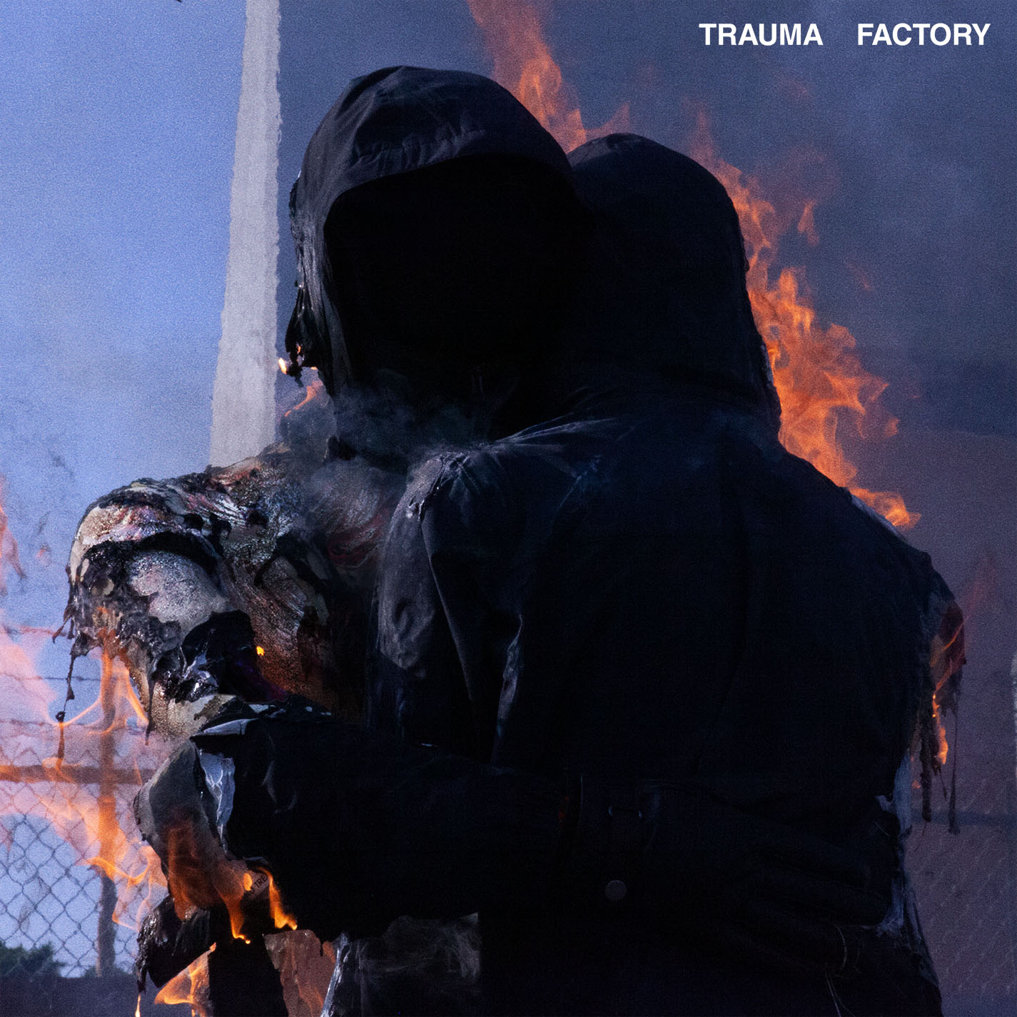

NOTHING,NOWHERE. – “FAKE FRIEND”
LINKFIRE: https://nothingnowhere.lnk.to/traumafactory
VISUALIZER: https://youtu.be/UwsXff4Vl-0

DECEMBER 7, 2020 –DCD2 / Fueled By Ramen artist nothing,nowhere. has announced details of his widely anticipated new full-length album, TRAUMA FACTORY, set to arrive February 19, 2021 [tracklist below]. Previewing the forthcoming collection, nothing,nowhere. has also shared the brand-new single “fake friend,” which is available today on all streaming platforms and accompanied by a visualizer streaming on his YouTube channel. Illustrating his seamless alchemy of alternative, pop, rap, and punk, “fake friend” glides over shimmering guitars as lilting verses bleed into a distorted proclamation, “I don’t need a fake friend.”

nothing,nowhere. commented on the new album detailing, “TRAUMA FACTORY is an accumulation of songs written during a confusing time. it is about accepting the present and following your true north through the pain and suffering of human life. I wanted to make an album that was truly genreless and inspire others to challenge themselves artistically. I believe the most inspiring art is unpredictable and unrestrictive. to me that’s what TRAUMA FACTORY is.

Pre-orders for TRAUMA FACTORY are live today at www.nothingnowhere.net featuring exclusive limited-edition vinyl and merch. Each pre-order receiving instant grat downloads of “fake friend” as well as previously released singles: “lights (4444),” “pretend,” “DEATH,” “nightmare,” and, most recently, “blood” (Feat. KennyHoopla & JUDGE).

Over the course of 15 tracks, TRAUMA FACTORY cuts deep and finds nothing,nowhere. once again emerging from darkness, shedding external expectation, and moving forward into the glow of pure creation. Whether it be the anesthetized beats and intoxicating lull of “love or chemistry,” the cold piano-laden longing of “crave,” or the emotional immediacy of “upside down,” nothing,nowhere. paints from a wide palette of pain.

Earlier this year, The New York Times hailed “DEATH” as a “Scabrous, immensely satisfying emotional expurgation from Joe Mulherin that deploys early Beastie Boys drums and Rage Against the Machine bark-rapping in service of a rap-rock revival bathed in righteousness.” Last year, he teamed up with Travis Barker for the collaborative EP, bloodlust. bloodlust was highlighted by lead single “destruction,” which debuted via The FADER with Kerrang! declaring “bloodlust feels like another world. From start to finish it envelops you in its hazy, muted soundscapes.” bloodlust followed a prolific string of singles from nothing,nowhere. - “call back,” “dread,” and “ornament,” – and arrived just a year after the release of his acclaimed 2018 LP, ruiner. The sophomore LP features album standouts “ruiner” and “rejecter,” which Pigeons & Planes declared, “perfectly exemplify why nothing,nowhere.'s music is so exciting… he's crafted a world of sound that's both fresh and recognizable.” The FADER remarked, “The new record is a stimulating blend of singing, hip-hop, and live instrumentation, all fused together with emo and alternative stylings.” nothing,nowhere.’s 2017 debut album, reaper, was met with critical praise led by the singles “hopes up (Ft. Dashboard Confessional)” and “skully.” The album made a massive impact upon its DCD2/Equal Vision release with The New York Times’ Jon Caramanica placing it at #1 on his list of 2017’s best. reaper “synthesizes the second-wave emo of the early to mid-2000s with the rattling hip-hop low end of the last few years,” he wrote. “(reaper) is one of the most promising pop albums of the year…” Rolling Stone declared “reaper finds him tonally evoking the glory years of 2000s emo-punk without necessarily replicating it.”

nothing,nowhere. is the musical endeavor of Vermont songwriter, singer and guitarist Joe Mulherin. For Mulherin, nothing,nowhere. is about a connection. It’s one he finds with fans around the world, who gather to see him play on tour and to listen to his songs online. It’s that connection that urges the singer to place his fears aside and step onstage each night to share his art. He sees the potential to help, to make a change, however small it may be and that is why he brings his music out of the Vermont wildness.

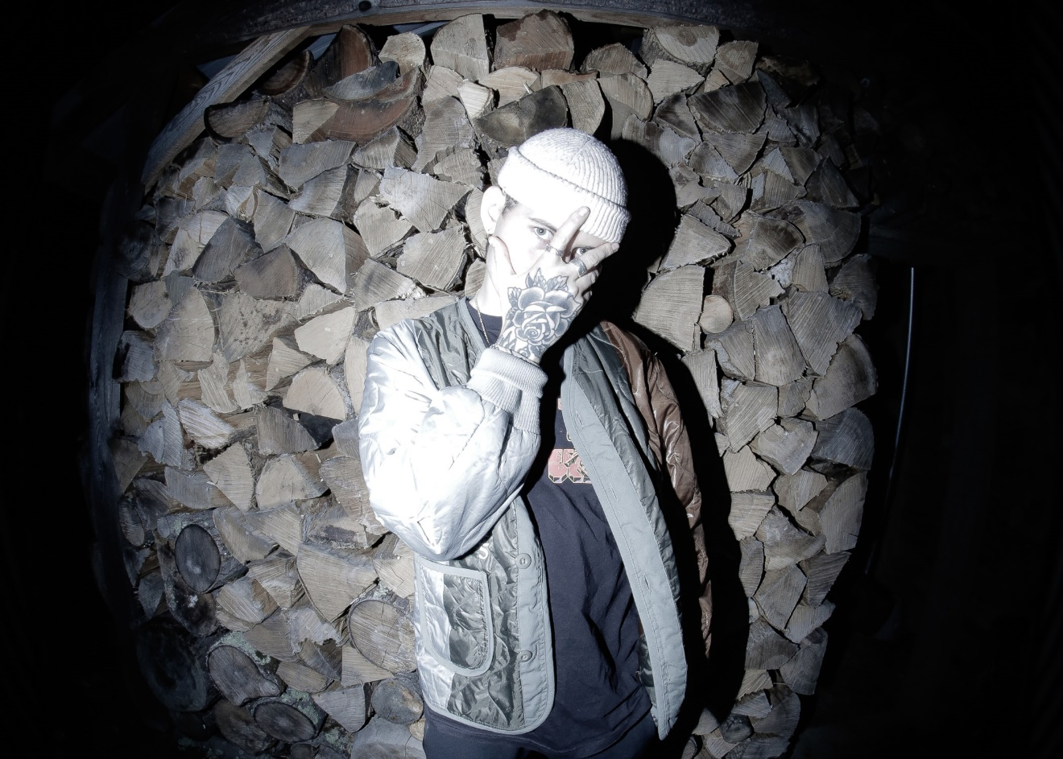
PHOTO CREDIT: KATE FITZGERALD

TRAUMA FACTORY Tracklist
01. “trauma factory”
02. “lights (4444)”
03. “buck”
04. “love or chemistry”
05. “exile”
06. “upside down”
07. “pain place” (feat. MISOGI)
08. “fake friend”
09. “death”
10. “pretend”
11. “blood” (feat. KennyHoopla & JUDGE)
12. “nightmare”
13. “crave”
14. “real”
15. “barely breathing”

For more information on nothing,nowhere.:
OFFICIAL – YOUTUBE – SPOTIFY – APPLE MUSIC
SOUNDCLOUD – FACEBOOK – INSTAGRAM – TWITTER

Contact:
Ross Anderson / RossAnderson@Elektra.com

