NOTHING,NOWHERE. RELEASES NEW ALBUM TRAUMA FACTORY

SHARES OFFICIAL MUSIC VIDEO FOR “UPSIDE DOWN”

LISTEN TO TRAUMA FACTORY HERE

PHOTO CREDIT: DAN BROWN

NOTHING,NOWHERE. – “UPSIDE DOWN” [OFFICIAL VIDEO]
YOUTUBE: https://youtu.be/LBgPh3SJVg0

FEBRUARY 19, 2021 – DCD2 / Fueled By Ramen artist nothing,nowhere. has released his widely anticipated new album TRAUMA FACTORY. Available today on all streaming platforms, TRAUMA FACTORY finds nothing,nowhere. once again emerging from darkness, shedding external expectation, and moving forward into the glow of pure creation.

To celebrate the release of the new album, nothing,nowhere. has also shared an official music video for his single “upside down” which is streaming now on his YouTube channel. Commenting on the track, nothing,nowhere. shared, “We’ve all had our fair share of unhealthy relationships. ‘upside down’ is about a lost love and the inability to accept the new and painful circumstances.”

TRAUMA FACTORY is highlighted by “fake friend,” nothing,nowhere.’s first song ever to enter Billboard’s “Alternative Airplay” chart, nearing Top 25 at the format this week. “fake friend” is joined by a Mason Mercer directed official music video which spirals over nothing,nowhere.’s seamless alchemy of alternative, pop, rap, and punk.

The New York Times hailed TRAUMA FACTORY track, “DEATH,” as a “Scabrous, immensely satisfying emotional expurgation from Joe Mulherin that deploys early Beastie Boys drums and Rage Against the Machine bark-rapping in service of a rap-rock revival bathed in righteousness.” CLASH declared, “While human suffering or pain isn’t joyous, the special craft of nothing,nowhere. most certainly is,” and FLOOD praised album cut “lights (4444)” for it’s “minimalist trap beat,” adding it “sounds like a GothBoiClique single steeped in a turn-of-the-century boy-band aesthetic.” The FADER hailed early single “blood” (Feat. KennyHoopla and JUDGE as “a strapping collaboration” while UPROXX avowed, “it’s clear that there’s a lot more going into Joe Mulherin’s production style,” celebrating the song’s “hip-hop beats and a driving distorted bass line.”

nothing,nowhere. summarized the body of work detailing, “TRAUMA FACTORY is an accumulation of songs written during a confusing time. it is about accepting the present and following your true north through the pain and suffering of human life,” nothing,nowhere. revealed He added, “I wanted to make an album that was truly genreless and inspire others to challenge themselves artistically. I believe the most inspiring art is unpredictable and unrestrictive. to me that’s what TRAUMA FACTORY is.”

In 2019 nothing,nowhere. teamed up with Travis Barker for the collaborative EP, bloodlust. bloodlust was highlighted by lead single “destruction,” which debuted via The FADER with Kerrang! declaring “bloodlust feels like another world. From start to finish it envelops you in its hazy, muted soundscapes.” bloodlust followed a prolific string of singles from nothing,nowhere. - “call back,” “dread,” and “ornament,” – and arrived just a year after the release of his acclaimed 2018 LP, ruiner. The sophomore LP features album standouts “ruiner” and “rejecter,” which Pigeons & Planes declared, “perfectly exemplify why nothing,nowhere.'s music is so exciting… he's crafted a world of sound that's both fresh and recognizable.” The FADER remarked, “The new record is a stimulating blend of singing, hip-hop, and live instrumentation, all fused together with emo and alternative stylings.” nothing,nowhere.’s 2017 debut album, reaper, was met with critical praise led by the singles “hopes up (Ft. Dashboard Confessional)” and “skully.” The album made a massive impact upon its DCD2/Equal Vision release with The New York Times’ Jon Caramanica placing it at #1 on his list of 2017’s best. reaper “synthesizes the second-wave emo of the early to mid-2000s with the rattling hip-hop low end of the last few years,” he wrote. “(reaper) is one of the most promising pop albums of the year…” Rolling Stone declared “reaper finds him tonally evoking the glory years of 2000s emo-punk without necessarily replicating it.”

nothing,nowhere. is the musical endeavor of Vermont songwriter, singer and guitarist Joe Mulherin. For Mulherin, nothing,nowhere. is about a connection. It’s one he finds with fans around the world, who gather to see him play on tour and to listen to his songs online. It’s that connection that urges the singer to place his fears aside and step onstage each night to share his art. He sees the potential to help, to make a change, however small it may be and that is why he brings his music out of the Vermont wildness.

[album art / tracklisting below]

TRAUMA FACTORY

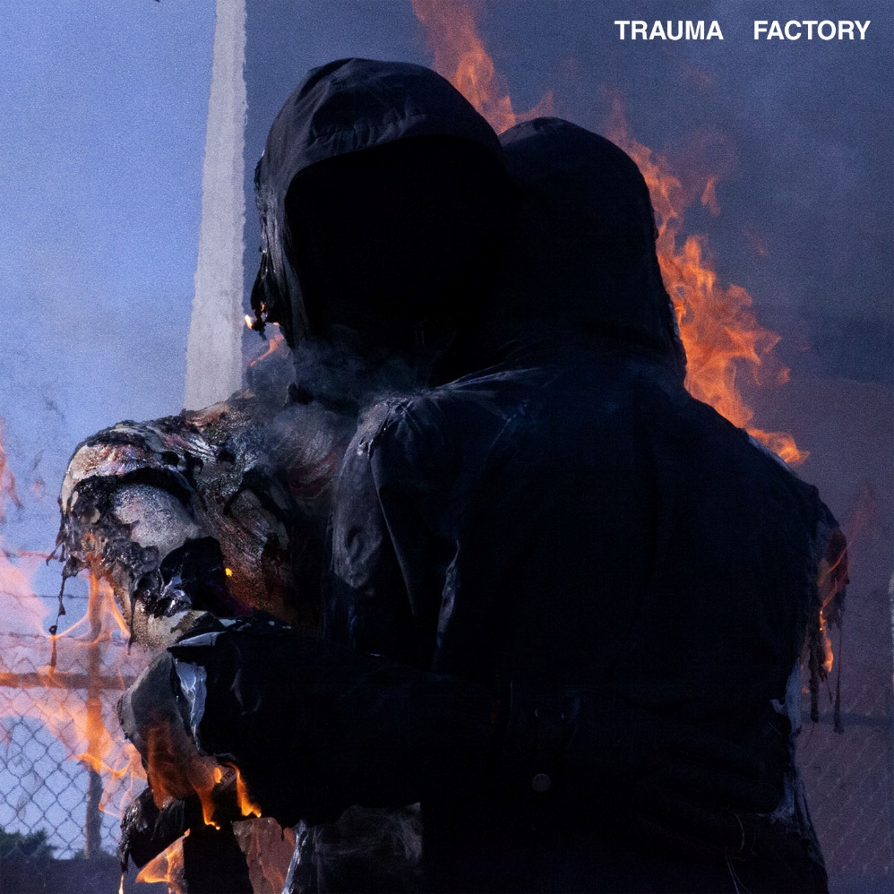

01. “trauma factory”
02. “lights (4444)”
03. “buck”
04. “love or chemistry”
05. “exile”
06. “upside down”
07. “pain place” (feat. MISOGI)
08. “fake friend”
09. “death”
10. “pretend”
11. “blood” (feat. KennyHoopla & JUDGE)
12. “nightmare”
13. “crave”
14. “real”
15. “barely breathing”

For more information on nothing,nowhere.:
OFFICIAL – YOUTUBE – SPOTIFY – APPLE MUSIC
SOUNDCLOUD – FACEBOOK – INSTAGRAM – TWITTER

Contact:
Ross Anderson / RossAnderson@Elektra.com

